

Year 11-12 Transition Pack:
- Level
Mathematics



Introduction

Thank you for choosing to study A-level mathematics at George Salter Academy. A-level mathematics is an exciting and challenging course where you will be extending your mathematical skills and techniques learnt at GCSE to understand coherence and progression in mathematics and how different areas of mathematics are connected. You will also learn new mathematical concepts which you would not have encountered before.
This course is suitable for those who achieved a grade 6 or higher in GCSE mathematics. An interest/enjoyment in mathematics is desirable as you will be spending a good amount of time doing maths independently throughout the two years.
A-level mathematics can lead you to many careers including engineering, economics, accountancy, architecture, computer science and the healthcare sector.

Course Overview
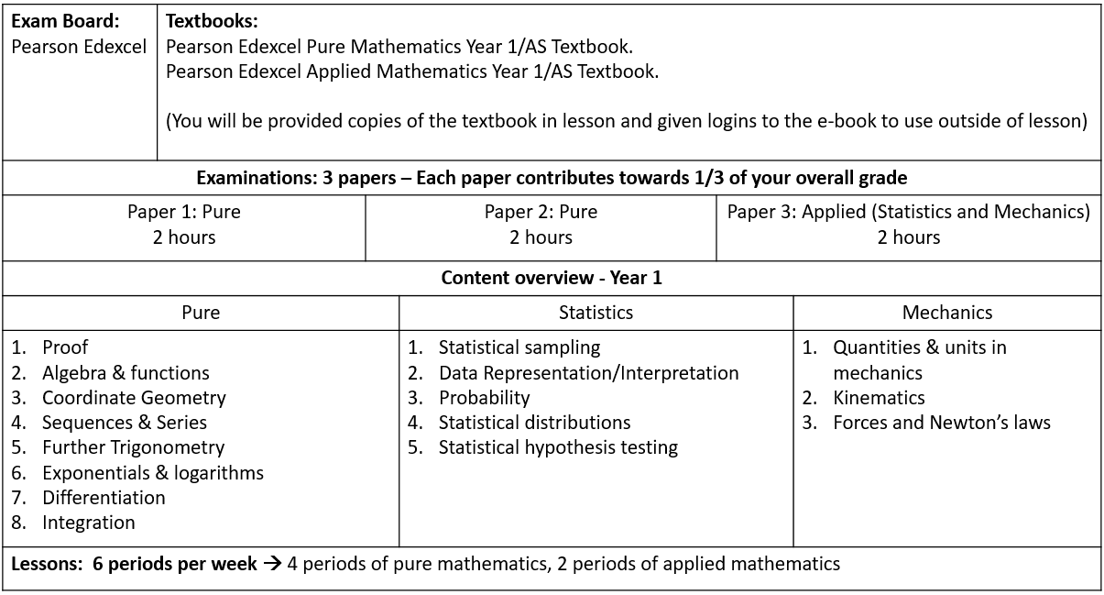

Articles to Read

Websites

If you want to have a taste of what A-level maths involve, here are links to some Bicen Maths video playlists:
A-level Pure 1 Ch.1
A-level Pure 1 Ch.6
A-level Pure 1 Ch.8

If you are unable to access the links, you can find them on YouTube by searching ‘Bicen Maths’.

Books

If you are interested in learning some intriguing things about maths that you may not have learnt before, here are a few choices.
(Please do not buy any of these. Many pages of these can be read on Google Books for free or within your library).
- Alex’s Adventures in Numberland by Alex Bellos
- Cabinet of Mathematical Curiosity by Ian Stewart
- The num8er My5teries by Marcus De Sautoy
- How Many Socks Make a Pair? Surprisingly Interesting Maths by Rob Eastaway
- The Curious Incident of The Dog in the Night-time by Mark Haddon
- The Penguin Dictionary of Curious and Interesting Numbers by David Wells
- The Calculus Wars by Jason Socrates Bardi
- The Code Book by Simon Singh

Summer Activity- Due second week in September

It is vitally important that you spend some time working through the questions in this booklet over the summer - you will need to have a good knowledge of these topics before you commence the course in September.
A-Level mathematics is a demanding course and good skills in the areas covered within this booklet will be paramount to your success.
The exercises in this booklet will ensure that you are ready for the exciting challenges of becoming an A-level student in September.

Instructions:
Complete all ‘Introduce’ and ‘Strengthen’ questions in the booklet. This is the minimum requirement.
It is recommended to also try as many ‘Deepen’ questions so you are best prepared for A-level mathematics.

Use the videos on these websites to help with answering the questions in this booklet:
https://www.mathsgenie.co.uk/gcse.html
https://corbettmaths.com/contents/

You must bring all your work with you in your first maths lesson in the second week of September.
You will be tested in September to see how well you understand these topics.
Have a great summer, we are looking forward to seeing you in September!!

Transition booklet topics
Simplifying expressions | Linear Simultaneous equations
Operations with algebraic fractions | Straight-line graphs
Solving quadratic equations | Right-angled trigonometry
Quadratic graphs | Further trigonometry

Key facts and formulae:

The Quadratic formula:

The solution of ax ² + bx + c = 0 where a ≠ 0
-b ± b² - 4ac
x = 2a

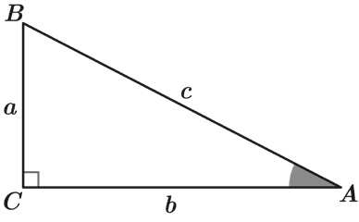
Trigonometry:

In any right-angled triangle ABC where a, b and c are the length of the sides and c is the hypotenuse:
c

sinA = a
c
cosA = b
tanA = a

b

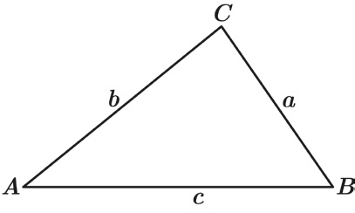
In any triangle ABC where a, b and c are the length of the sides:

sine rule:
a
sinA

b
sinB
=

c
sinC
=

© Sparx limited
Page 3
cosine rule: a² = b² + c² - 2bc cosA

Simplifying expressions Introduce

Q1 Fully simplify the expression 4y ⁵ x 3y ²

Answer:

Q2 Simplify (h⁻⁵)3
Give your answer without any negative indices.

Answer:

Q3 Write
2t ⁶u
8t ³

as a fraction in its simplest form.

Answer:

Simplifying expressions Introduce

Q4 Fully simplify t 3 2
( )
u5

Answer:

Q5 Write
33xy + 9x 18x

as a fraction in its simplest form.

Answer:

Q6 Fully simplify
6a + 42
a² + 11a + 28

Answer:

Simplifying expressions Strengthen

(3a)2

Q1 Write
54ak
as a fraction in its simplest form.

Answer:

Q2 Fully simplify (64g
1
8h4) 2

Answer:

Q3 Fully simplify
x + 2 2x² - 31x - 70

Answer:

Simplifying expressions Deepen

Q1 Work out the values of a, b and c in the equality below.

2x20y4 x 12x4y26
(2xy²)3
= ax^{b}y^{c}

Answer:
a =
b =
c =

Q2 Work out what expression should replace the ? in the equivalent fractions below.

? 2n 12r⁴(t + 6) = 3r

Answer: ? =

Q3 ax² + bx + c dx² - 25

simplifies to give
x - 4 2x - 5

Work out the values of a, b, c and d in the original fraction.

Answer:

a =

b =

c =

d =

Operations with algebraic fractions Introduce

Q1 Fully simplify
14a x b b 2

Answer:

Q2 Fully simplify
6a v
÷ 2a 5

Give your answer as a fraction.

Answer:

Q3 Fully simplify the expression below to give a single fraction.

n + 2
5
+ 6n 7

Answer:

Operations with algebraic fractions Strengthen

Q1 Fully simplify
2 x
5a + 4
45a + 36

a

Give your answer as a fraction.

Answer:

Q2 Fully simplify
6x - (5x - 7)(x + 1)
1
5x - 7

Give your answer fully factorised.

Answer:

Operations with algebraic fractions Strengthen

Q3 Write the following as a single fraction in its simplest form:

2x ² - 11x + 12
x + 5
÷ (4x ² - 6x )

Give your answer fully factorised.

Answer:

Q4 Fully simplify
4ab² x

k
3ak 12k
x 7 5ab

Give your answer as a fraction.

Answer:

Operations with algebraic fractions Deepen

Q1 Fully simplify
7
36 - x ²
-
3
6 + x

Give your answer fully factorised.

Answer:

Q2 Write the following as a single fraction in its simplest form:

6 - (x + 4) ÷
x ² + 11x + 28
x - 7

Give your answer fully factorised.

Answer:

Solving quadratic equations Introduce

Q1 Find the two solutions to the equation (x - 9)(x + 5) = 0

Answer:

Q2 Solve this equation by factorising:
y ² + 3y - 10 = 0

Answer:

Q3 Solve this equation by factorising: 12 - 8w + w ² = 0

Answer:

Solving quadratic equations Introduce

Q4 Using the quadratic formula, solve 4x ² + 16x + 15 = 0

Answer:

Q5 Solve this equation by factorising: 2m ² - 11m + 5 = 0

Answer:

Solving quadratic equations Strengthen

Q1 Using the quadratic formula, solve y ² - 6y + 7 = 0 Give your answer in the form a ± b

Answer:

Q2 Solve the equation below using factorising.
6y ² - 11y - 10 = 0

Answer:

Solving quadratic equations Strengthen

Q3 Using the quadratic formula, solve 6x ² - 35 = -11x

Answer:

Q4 Solve 3r ( 3r - 4 ) = 2
Give your answers to 2 d.p.

Answer:

Solving quadratic equations Deepen

Q1 Solve x (x + 4) - 4(5x + 9) = 0

Answer:

Q2 Jessica thinks of a positive number, n, which is less than 1 She adds this number to its reciprocal and gets 2.9
Work out the value of n .
Give your answer as a fraction in its simplest form.

Answer:

Solving quadratic equations Deepen

Q3 Solve
4
y - 1
-
5
y + 2
= 3

y

Answer:

Q4 x =
-3 ± 29
2

There is only one equation of the form x ² + bx + c = 0 that gives these values of x
as solutions.
Work out the values of b and c.

Answer: b = c =

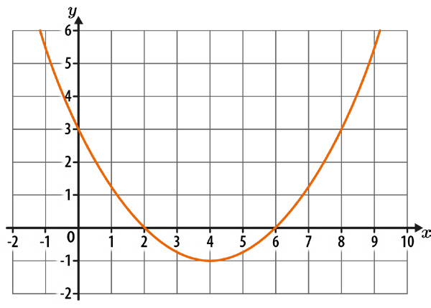
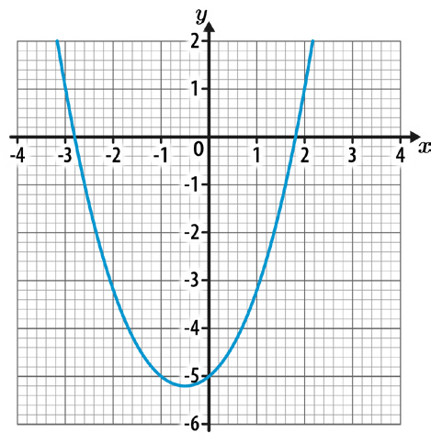
Quadratic graphs Introduce

Q1 Write down the coordinates of the roots of the quadratic curve shown below.

Answer: ( , ) and ( , )

Q2 Here is the graph of the function y = x ² + x - 5
Estimate the solutions to x ² + x - 5 = 0 Give your answers to 1 d.p.

Answer:

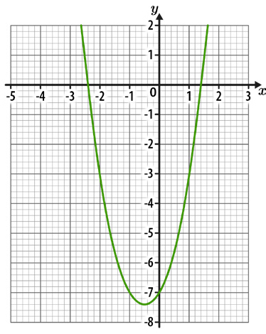
Quadratic graphs Introduce

Q3 The diagram below shows the graph of the function y = 2x ² + 2x - 7 Work out the solutions to 2x ² + 2x - 7 = -3

Answer:

Q4 a) Write x ² + 6x + 11 in the form (x + c)² + d, where c and d are numbers.

Answer: a)

b) Hence, write down the coordinates of the turning point on the curve
y = x ² + 6x + 11

Answer: b) ( , )

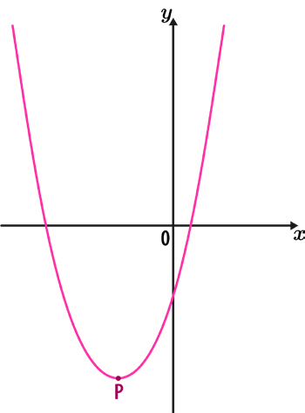
Quadratic graphs Strengthen

Q1 The diagram below shows a sketch of the curve y = x ² + 8x - 10 P is the turning point of the curve.
Work out the coordinates of P.

Answer: ( , )

Q2 Work out the coordinates of the turning point of the curve y = x ² - 5x + 1

Answer: ( , )

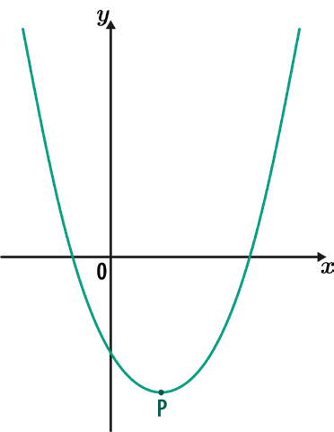
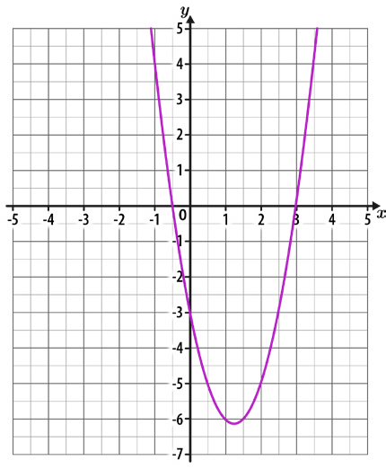
Quadratic graphs Strengthen

Q3 The diagram below shows a sketch of the curve y = 3x² - 6x - 10 P is the turning point of the curve.
Work out the coordinates of P.

Answer: ( , )

Q4 The diagram below shows the graph of y = 2x ² - 5x - 3
Use the diagram to estimate the solutions to 2x ² - 5x - 3 = -2x + 2 Give any decimal answers to 1 d.p.

Answer:

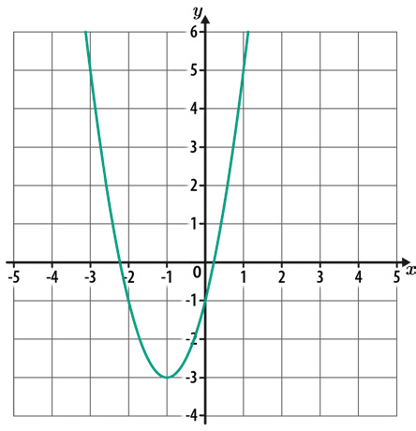
Quadratic graphs Deepen

Q1 The diagram below shows the graph of y = 2x² + 4x - 1
The equation 2x ² + 4x - 1 = k has solutions at x = -3 and x = 1
What is the value of k?

Answer: k =

Q2 A curve has the equation y = x ² + ax + b, where a and b are numbers.
The turning point of the curve is (5, 4) Work out the values of a and b.

Answer: a = b =

Quadratic graphs Deepen

Q3 A curve has the equation y = -x ² + 16x - 65
- Work out the turning point of the curve.

Answer: a) ( , )

- By considering the position of the turning point and the shape of the curve, work out how many real roots y = -x ² + 16x - 65 has.

Answer: b)

Linear simultaneous equations Introduce

Q1 Solve the following simultaneous equations: 6x + y = 22
2x + y = 10

Answer:

x =

y =

Q2 Solve the following simultaneous equations: 7x - 4y = 20
2x + 4y = 16

Answer:
x =
y =

Linear simultaneous equations Introduce

Q3 Solve the following simultaneous equations: 15a - 4b = 25
5a + 2b = 25

Answer:

a =

b =

Q4 Solve the following simultaneous equations: 2x + 3y = 8
3x + 4y = 11

Answer:
x =
y =

Linear simultaneous equations Strengthen

Q1 Solve the following simultaneous equations: 7x + 5y = 8
3x - 2y = -9

Answer:

x =

y =

Q2 Solve the following simultaneous equations: 6x + 7y = 5
9x + 13y = -10

Answer:
x =
y =

Linear simultaneous equations Strengthen

Q3 Solve the following simultaneous equations:
7y + 2x = 23
2
5y + 3x = 9

Answer:

x =

y =

Q4 Solve the following simultaneous equations:
4.6t + 8.1u = 104
3.8t - 2.7u = -8

Answer:
t =
u =

Linear simultaneous equations Deepen

Q1 Solve the following simultaneous equations: 3x = 3 - 4y
12y + 11 = -5x

Answer:
x =
y =

Q2 Find the values of x, y and a by solving the following simultaneous equations: 6x - 7y = -10
12x - 5y = 16
2x + ay = 10

Answer:
x =
y =
a =

Linear simultaneous equations Deepen

Q3 Solve the following simultaneous equations:

4 1
=
7x - 4 6y
5x = 4 3y + 2

Answer:

x =

y =

Q4 Solve the following simultaneous equations:
2x = 4(7 - 2y)
3(5x - 13y) = 81

Answer:

x =

y =

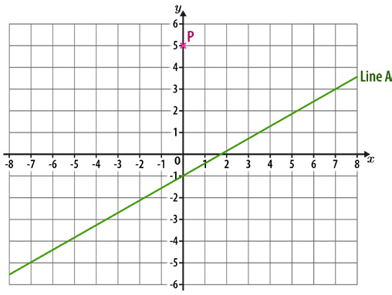
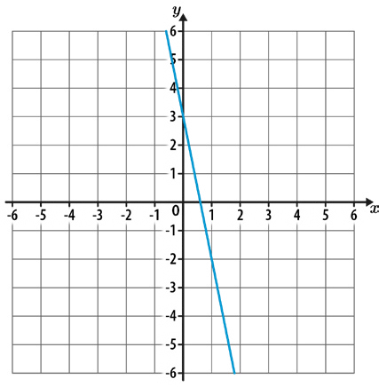
Straight-line graphs Introduce

Q1 Work out the equation of the straight line shown below.

Answer:

Q2 Work out the equation of the straight line that is parallel to line A and passes through point P.

Answer:

Q3 Line A has the equation 2y - 10 = 16x Line B is perpendicular to Line A.

What is the gradient of Line B?

Answer:

Straight-line graphs Introduce

Q4 A straight line has a gradient of 3 and passes through the point (2, 10) Work out the equation of the line.

Answer:

Q5 Work out the equation of the straight line that passes through (2, 3) and (5, 18)

Answer:

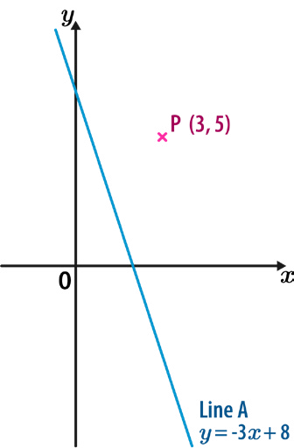
Straight-line graphs Strengthen

Q1 A straight line has a gradient of - 3 , and passes through the point (32, 12) Work out the equation of the line.
4

Answer:

Q2 The diagram below shows point P and Line A.
Line B is perpendicular to line A and passes through point P. What is the equation of line B?

Answer:

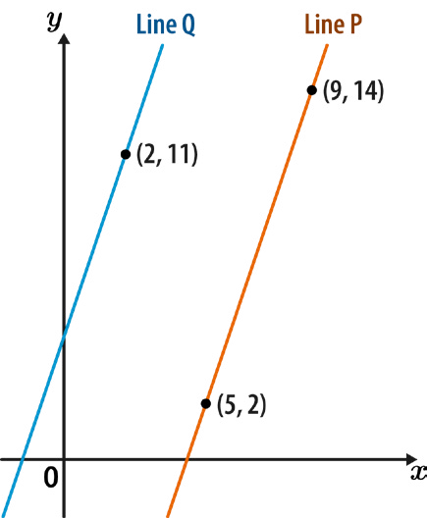
Straight-line graphs Strengthen

Q3 Work out the equation of the straight line that passes through (1, -7) and (6, 8)

Answer:

Q4 The graph below shows line P and line Q. Line Q is parallel to line P.

What is the equation of line Q?

Answer:

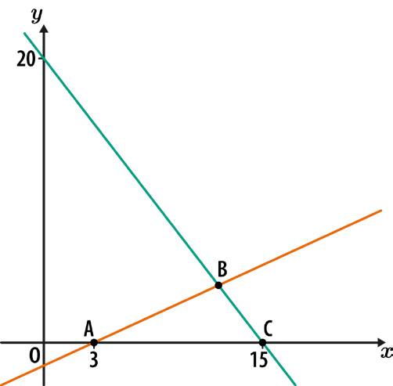
Straight-line graphs Deepen

Q1 Write an expression, in terms of h, for the gradient of a line perpendicular to the line segment joining (3h, 20) to (6h, 8)
Give your answer as a fully simplified fraction.

Answer:

Q2 The triangle ABC has an area of 24 square units.
What are the coordinates of point B?

Answer: ( , )

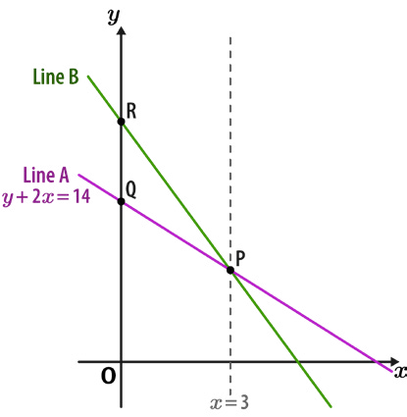
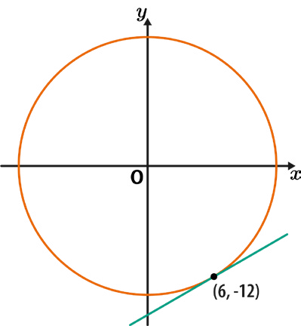
Straight-line graphs Deepen

Q3 Line A has the equation y + 2x = 14
The gradient of line B is twice the gradient of line A.

Work out the ratio of the length of OQ to the length of OR. Give your answer in its simplest form.

Answer:

Q4 A circle, centre O, passes through the point (6, -12), as shown.
Work out the equation of the tangent to the circle at this point.
Give your answer in the form y = mx + c, where m and c are integers or fractions in their simplest form.

Answer:

Right-angled trigonometry Introduce

Q1 Work out the length g.
Give your answer to 1 d.p.

Not drawn accurately

Answer: mm

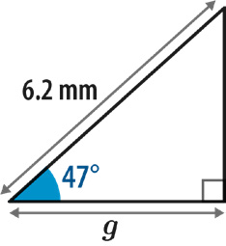
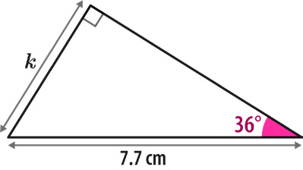
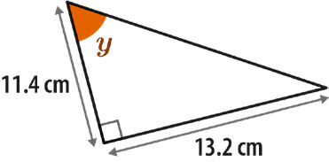

Q2 Work out the length k.
Give your answer to 1 d.p.

Not drawn accurately

Answer: cm

Q3 Calculate the size of angle y.
Give your answer to the nearest integer.

Not drawn accurately

Answer: °

Right-angled trigonometry Strengthen

Q1 Calculate the length y.
Give your answer to 2 d.p.

Not drawn accurately

Answer: m

Q2 Calculate the size of angle BAC. Give your answer to 1 d.p.

Not drawn accurately
Answer: °

Q3 What is the size of angle x? Give your answer to 1 d.p.

Not drawn accurately

Answer: °

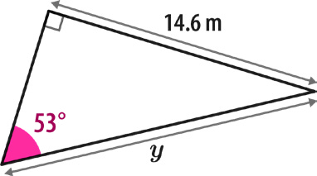
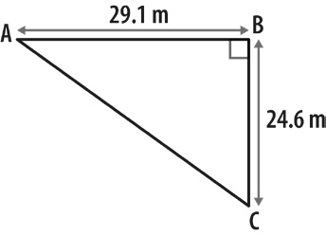
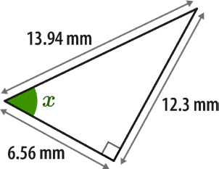

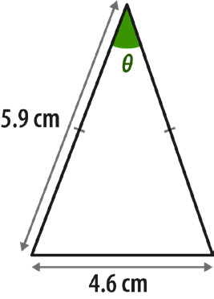
Right-angled trigonometry Deepen

Q1 Calculate the size of angle 0-.
Give your answer to 1 d.p.

Not drawn accurately

Answer: °

Q2 Work out the length y.
Give your answer to 2 d.p.

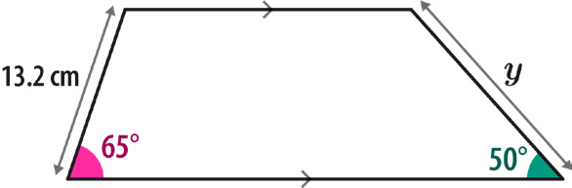
Not drawn accurately

Answer: cm

Right-angled trigonometry Deepen

Q3 The graph below shows the line with equation y = 5x + 2 The axes both have the same scale.
Calculate the size of angle 0-.
Give your answer in degrees to the nearest integer.

Not drawn accurately

Answer: °

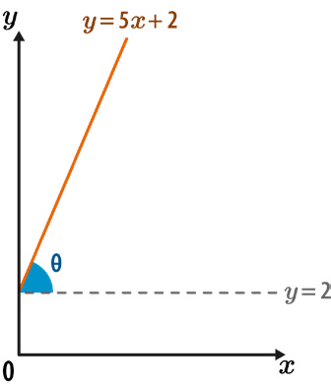
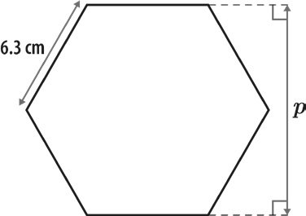

Q4 The shape below is a regular hexagon.
Use trigonometry to calculate the distance p. Give your answer in centimetres to 2 d.p.

Not drawn accurately

Answer: cm

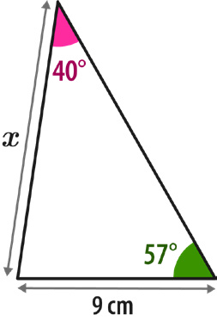
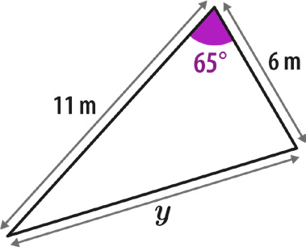
Further trigonometry Introduce

Q1 Using the sine rule, calculate the length x.
Give your answer to 1 d.p.

Not drawn accurately

Answer: cm

Q2 Using the cosine rule, work out the length y.
Give your answer to 1 d.p.

Not drawn accurately

Answer: m

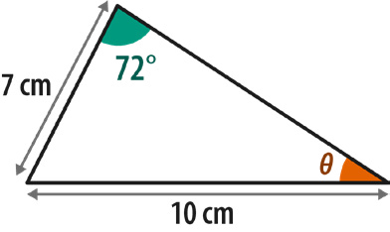
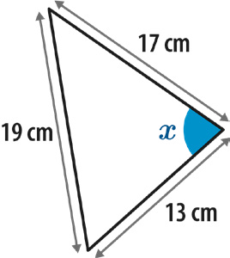
Further trigonometry Introduce

Q3 Use the sine rule to calculate angle 0-.
Give your answer to 1 d.p.

Not drawn accurately

Answer: °

Q4 Use the cosine rule to calculate the size of angle x.
Give your answer to the nearest degree.

Not drawn accurately

Answer: °

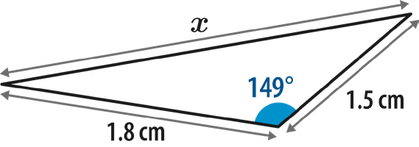
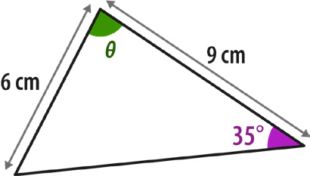
Further trigonometry Strengthen

Q1 Work out length x.
Give your answer to 1 d.p.

Not drawn accurately

Answer: cm

Q2 All the angles in the triangle below are acute.
Calculate the angle 0- to 1 d.p.

Not drawn accurately

Answer: °

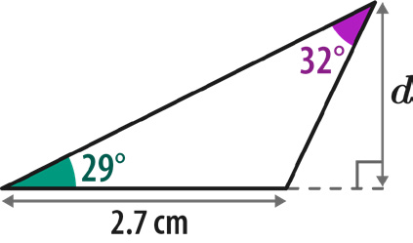
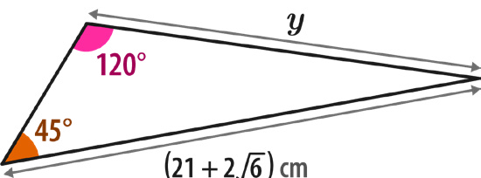
Further trigonometry Deepen

Q1 Calculate the length d.
Give your answer to 2 s.f.

Not drawn accurately

Answer: cm

Q2 Work out the length y in the triangle below.
Give your answer in its simplest form, rationalising the denominator if necessary.

Not drawn accurately

Answer: cm

Further trigonometry Deepen

Q3 Using the information below, work out the value of x.

sinA = 4
5
sinB = 3
4

Not drawn accurately

Answer:

Q4 Given that cos0- = 1 in the triangle below, show that y² = ax ² + bx + c where a, b
8
and c are numbers.
What are the values of a, b and c?

Not drawn accurately

Answer:
a =
b =
c =





