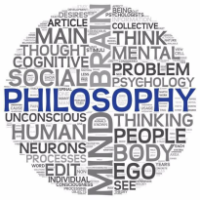
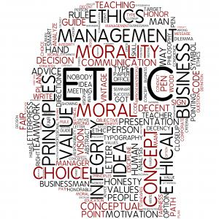

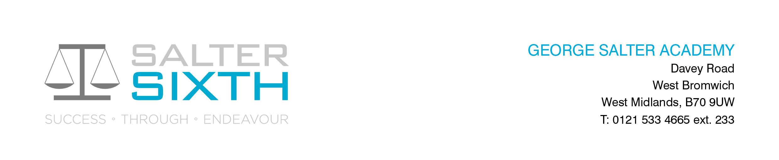

Year 11-12 Transition Pack:
A Level
Religious Education
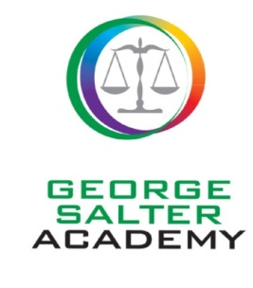

Welcome!

First of all welcome to Philosophy, Religion and Ethics. This transition pack is designed to help you prepare for this new course that you are interested in taking in September.

The pack includes an overview of what you will study during the first year of the course, should you join it, together with a series of introductory tasks for you to work through. The tasks are designed to help you get to grips with some of the key scholars and terms within the A-Level course, some are suggested and some are compulsory.

Philosophy, Religion and Ethics is very different to the Religious Studies GCSE you may have studied. The course contains 3 components – Philosophy, Christian Thought and Ethics. Through the 3 components, you will study questions such as:

- How do we know what’s right and wrong?
- Is there such a thing as a truly good or bad act, or is it all just opinion?
- Do we have a conscience?
- Do we have a soul?
- Is there a God?
- Is there life after death?
- Why should we follow authority figures?

You will explore these questions, and many more, during the course, whilst developing skills in reasoning, arguing with evidence, evaluating and justifying viewpoints.

Having an A-Level in this subject will prepare you well for any Theology or Philosophy course at university as well as any Humanities based degree course. It complements subjects such as Classic Civilizations, History, Law, Sociology and Psychology, as well as any literacy based subject such as English.

This qualification will support candidates working towards careers in teaching, education as a whole, counselling, health care, law, criminology, social work, public services, business and more.

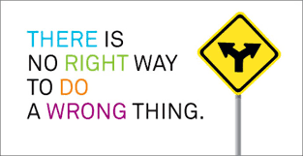

Topics you will study during the first year of the course...

Philosophy
Ancient Philosophical Influences | You will look at 3 of the first philosophers, their beliefs and how their philosophy has influenced ideas today. We will study Socrates and Socratic Method, Plato, his analogy of the cave and his world of forms along with a focus on Plato’s idea of the form of the good and Aristotle, his 4 causes and his idea of Prime Mover
Soul mind and body | In this topic we will study how different philosophical thinkers believe the soul, mind and body are connected. The three main thinkers we will study are Plato, Aristotle and Descartes and we will look at their approaches to Dualism, Materialism and Substance Dualism. However, we will also study more contemporary thinkers such as Richard Dawkins and his ideas surrounding mimetic theory.
Arguments based on observation | In this topic we will study how different philosophers believe that through observation and experience of the natural world around us, this can lead to the conclusion that God created the universe. We will look at two main arguments, the Teleological argument and the Cosmological argument in this topic, evaluating their strengths and weaknesses in attempting to prove God’s existence.
Arguments based on reason | In this topic we will study how different philosophers believe that through logic and our innate sense of understanding, God’s existence can be proved. The main philosophers we will look at in this topic are Anselm, Gaunilo, Aquinas and Plantinga. The Ontological argument can be used as an alternative to the Teleological and the Cosmological argument and again, as always, we will make sure to evaluate its strengths and weaknesses in attempting to prove God’s existence.
Religious Experience | Religious experience can be difficult to define, and difficult for people to put into words to describe if they have had such an experience. This topic explores these encounters.
The problem of evil | The topic explores how the problem of evil is both a logical problem and an evidential problem. It looks into the problem of evil and the responses to it.

Religious Thought
Augustine | In this topic, we will look into the thought of Augustine. Augustine taught that human nature has been fatally damaged because of the fall of Adam and Eve. He taught that people are created by God, they are fallen in nature and can be redeemed. He taught that the only hope of salvation is through the Grace of God.
Death and the afterlife | Through this, we will look into the different Christian beliefs about what will happen after death. There are many different interpretations which have been given to different ideas and teachings, including that Christians have souls that can survive the death of a body.
Knowledge of God's existence | In religion, the question is raised of how limited human beings who live in a physical world bound by time and space can have knowledge of an infinite God. In this topic, we look at how Christians make a distinction between natural and revealed theology.
The person of Jesus | Who was Jesus? This is a key question in Christianity that we will look into, including if he was a revolutionary and a teacher of wisdom.
Christian Moral Principles | This topic is based on the teachings of the Bible, especially Jesus’ moral teachings. It looks into the moral guidance that Christians follow and which sources of authority for Christians should take precedence.
Christian Moral Action | This topic is linked with the one above; Christian moral principles can lead Christians into conflict with authorities. We will look into Dietrich Bonhoeffer whose Christian faith led him to oppose Nazism.

Ethics
Natural Law | In this topic, we look into Natural law, which is the Christian tradition based around the thinking of Thomas Aquinas. It is a system of Ethics based on the principle that there is such a thing as human nature and we should live in accordance with human nature and should aim to fulfill our purpose.
Situation Ethics | Situation Ethics is a topic based on the writings of Joseph Fletcher, in 1966 he gave his approach to moral thinking; agape love.
Kantian Ethics | In Kantian ethics we study, Immanuel Kant who was an important German philosopher who believed there was a universal, objective moral law that we can access through our reason.
Utilitarianism | This is a theory that tries to create the greatest happiness for the greatest number, it focuses on the action rather than the motivation of the individual.
Euthanasia | This topic is an applied Ethic. It is a contraversial topic, Euthanasia means a ‘good death’, this topic raises questions whether poeple should have a right to end their own lives or the lives of others at a time of their choosing. Natural Law and Situation Ethics get applied to Euthanasia.
Business Ethics | This topic is also an applied Ethic. It is an area of Ethics that considers the duties and responsibilities that a business has to it's workers, it's customers and other members of society. Kantian Ethics and Utilitarianism is applied to Business Ethics.

Below you will find suggested reading lists, videos and podcasts, alongside these there are suggested tasks that you can do (these are optional, but helpful).

Later on in the booklet, there are some tasks that are compulsory; these will give you the grounding you need to bridge the gap between your GCSE and A-Level.
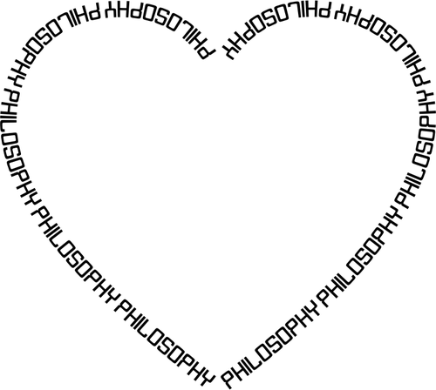



Philosophy, Religion and Ethics- Suggested Reading List

Brief Introductory Reading:

- Blackburn, S. Think, OUP 2001
- Craig, E. Philosophy: A Very Short Introduction, OUP 2002
- Law, S. The Philosophy Files, Orion 2002; The Outer Limits, Orion 2003; The Philosophy Gym, Hodder Headline 2003
- Nagel, T. What Does It All Mean?, OUP 1987 (reprinted 2004)
- Warburton, N. Philosophy: The Basics (5th ed.), Routledge 2012

Philosophy:
- Gaarder, J. ( 1995) Sophie’s World , London : Phoenix House
- Davies, B. (1993) An Introduction to the Philosophy of Religion, Oxford: Oxford University Press
- Annas, J. (1998) An Introduction to Plato’s Republic, Oxford: Oxford University Press, (particularly Chapters 9-10)

Ethics:
- Vardy, P.(1999) The Puzzle of Ethics, SCM Press
- Norman, R. (1998) The Moral Philosophers, Oxford: Oxford University Press

Religious Thought:
- McGrath, A. (2015) Christianity: An Introduction, Blackwell Publishing.

Reading List Tasks:

For each of the texts you read, you could summarise the key points in one of the following ways:

• Write a review of the book, outlining which were the most useful sections and whether you enjoyed the book/ why/ why not.
• List any key terms from the text in a vocabulary list, researching their meanings (if not clear from the text) and recording these.
• Create a picture mind-map of the key ideas. Use doodles and images to illustrate these. For a guide to mind-mapping, see this short video: https://www.youtube.com/watch?v=wLWV0XN7K1g



Philosophy, Religion and Ethics - Suggested Video Resources and Tasks

Watch the videos below, choosing one to focus on for your task. Write a list of discussion points/ questions it raises. Choose (at least) one of your questions and draft at least three possible answers that might be given.

- https://www.ted.com/talks/kwame_anthony_appiah_is_religion_good_or_bad_this_is_a_trick_question/transcript#t-22290 Ted Talk by Kwame Anthony Appiah - Is religion good or bad? (This is a trick question)
- https://www.ted.com/talks/damon_horowitz/transcript Ted Talk by Damon Horowitz – We Need a Moral Operating System
- https://www.ted.com/talks/tom_honey_on_god_and_the_tsunami/transcript Ted Talk by Tom Honey – Why Would God Create A Tsunami?
- https://www.youtube.com/watch?v=e8MzPmkNsgU Debate: Atheist vs Christian (Christopher Hitchens vs William Lane Craig)

Films/ TV:

- Watch The Matrix (film). Note down your thoughts on the themes of truth, perception and reality.
- Watch Lost (TV series). What moral and ethical points does this raise?
- Watch Sliding Doors (film). Do you think your life is predestined (set out for you) or can you control your own fate?

Audio Resources:

- Listen to The Moral Maze on BBC Radio 4. (Available programmes vary over time) https://www.bbc.co.uk/programmes/b006qk11
- Note down the key points of argument. Create a flow chart of the main points of discussion.
- Listen to this episode of In Our Time. http://www.bbc.co.uk/programmes/b01mwx64
- Based on these arguments, is it possible to argue that God necessarily exists?
- Listen to this episode of Thinking Allowed. https://www.bbc.co.uk/programmes/b099ypqf How should we help people who are dying?

- Listen to this podcast from Philosophy Now. https://philosophynow.org/podcasts/Free_Will_and_the_BrainTo what extent can we exercise free will? List 10 examples of choices you have made in the last seven days. For each one, consider what factors influenced your choice (habit, parents, media, friends, consideration of consequences, etc).



ONCE A PHILOSOPHER, ALWAYS A PHILOSOPHER!
The Philosophy, Religion and Ethics department would love for you to continue to stay cognitively engaged over the coming weeks and months, despite the cancellation of this year’s exams. The following are suggestions, they are not compulsory, but we would love for you to engage in any that you find interesting.
 | 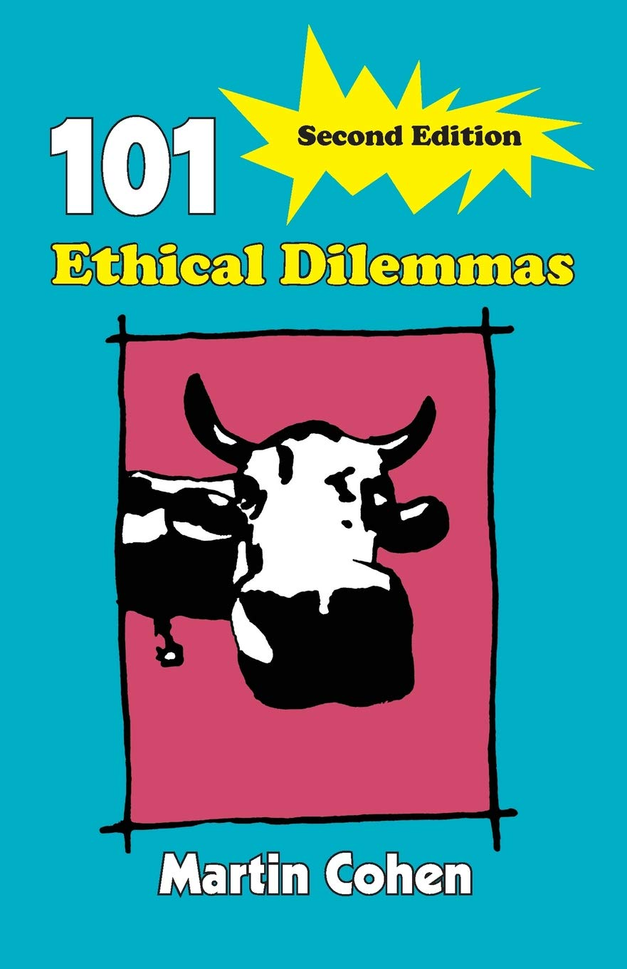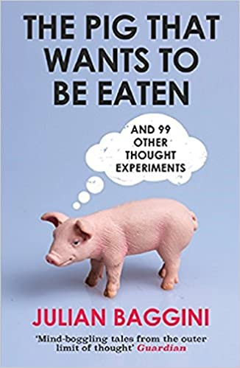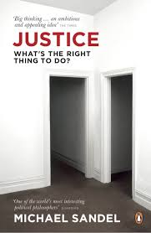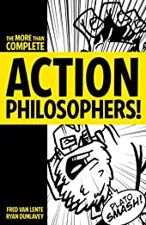  OR The Blackwell Philosophy & Pop Culture Series... Philosophical spins on your favourite series and films (my personal favourites are Harry Potter, Game of Thrones and Breaking Bad!) https://andphilosophy.com/books/

 | www.theguardian.com/world/philosophy  www.lse.ac.uk/philosophy/department-blog/  www.ethicssage.com/  www.logicmatters.net/blogfront/  www.stephenlaw.blogspot.com/ | www.philosophynow.org/  www.blog.practicalethics.ox.ac.uk/  www.rockingphilosophy.com/  www.perfectchaos.blog/category/philosophy/  www.aphilosopher.drmcl.com/

 | 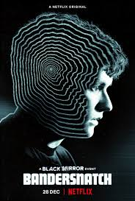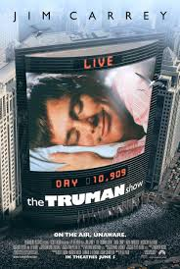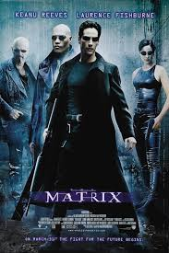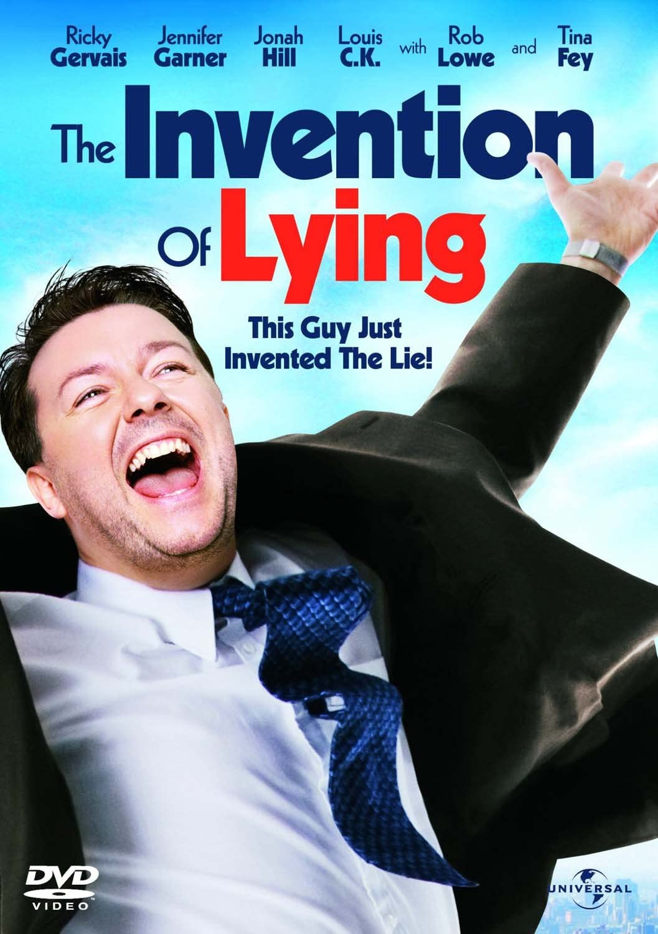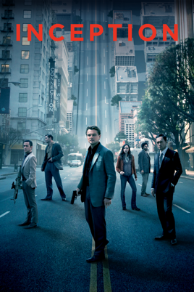

 | www.philosophybites.com/  www.partiallyexaminedlife.com  www.thephilosophyguy.fireside.fm/  www.thepanpsycast.com/panpsycast2/  www.philosophizethis.org/category/episode/ | www.samharris.org/all-episodes/  www.philosophy247.org/  www.abc.net.au/radionational/programs/philosopherszone/  www.bbc.co.uk/programmes/p01gnn05
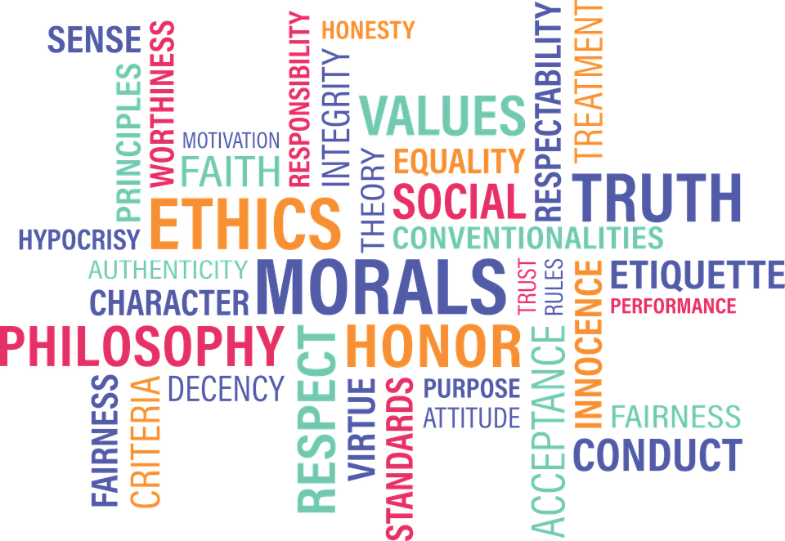

Philosophy, Ethics and Religious Thought - Compulsory Key Terms Introductory Task

As with all subjects, Philosophy, Religion and Ethics will introduce you to lots of key terms, many of which are likely to be new to you. In the table below, some of the key terms introduced during the first year of the course are listed.
Find definitions of each of the terms in relation to this course. Once you have done this create a glossary containing the terms and their meanings. The glossary you create can be a reference document to be used later, so make sure it is well presented and clearly set out.

Philosophy | Religious Thought | Ethics
A Priori | The Fall | Deontological
A posteriori | Redeemed | Eudaimonia
Socratic Method | Grace | Telos
World of forms | Concordia | Synderesis
Analogy | Sin | Primary Precepts
Prime Mover | Will | Secondary Precepts
Soul | Cupiditas | Teleological
Dualism | Caritas | Agape love
Materialism | Concupiscence | Pragmatism
Substance Dualism | Ecclesia | Relativism
Teleological | Resurrection | Personalism
Cosmological | Disembodied existence | Maxims
Inductive | Beatific vision | Duty
Deductive | Parousia | Categorical Imperative
Reasoning | Universalism | Hypothetical Imperative
Purpose | Purgatory | Kingdom of ends
Regularity | Limited election | Summum Bonum
Order | Original Sin | Principle of utility
Analogy | Natural theology | Hedonic calculus
Uncaused Cause | Empiricism | Consequentialism
Unmoved Mover | Immediate Revelation | Quantitative
Necessary | Mediate Revelation | Qualitative
Contingent | Hypostatic union | Act Utilitarian
Ontological | Liberator | Rule Utilitarian
Perfection | Redemption | Non voluntary euthanasia
Predicate | Propositional | Involuntary euthanansia
Reductio Ad Absurdum | Non-propositional | Active euthanasia
Existence | Cheap Grace | Corporate social responsibility
Reality | Costly Grace | Globalisation
Philosophy, Ethics and Religious Thought - Compulsory Philosophy Introductory Task

Task 1
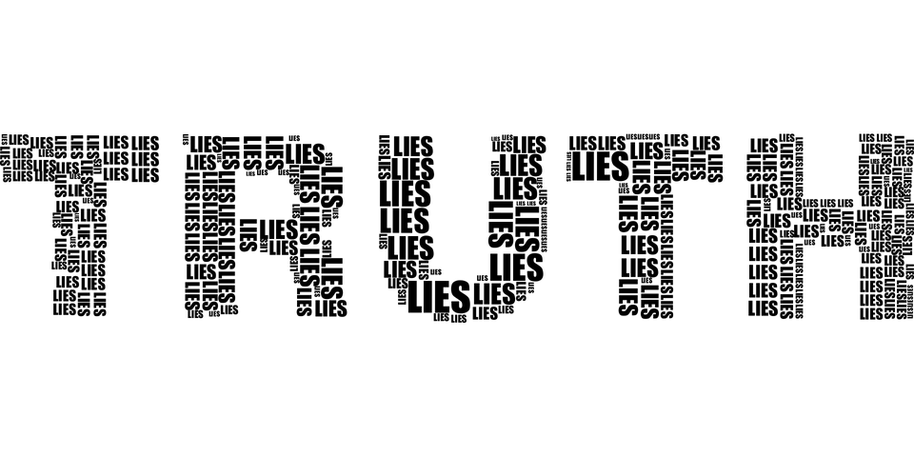
List five facts that you know to be true. For each one, explain how you know it to be true. Are any of your “facts” uncertain? What would have to happen to prove them irrefutably (without question)?
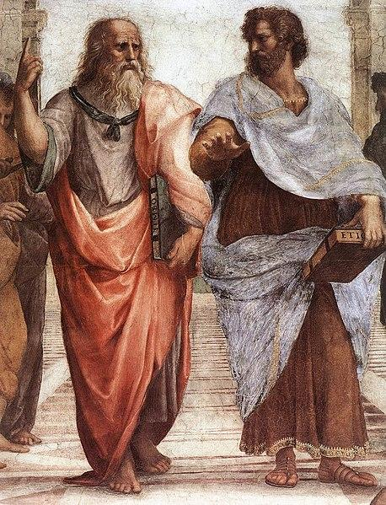
Task 2

Create a fact file of the philosophers Plato, Aristotle and Aquinas.

Include pictures, key facts and a brief outline of their philosophical ideas.
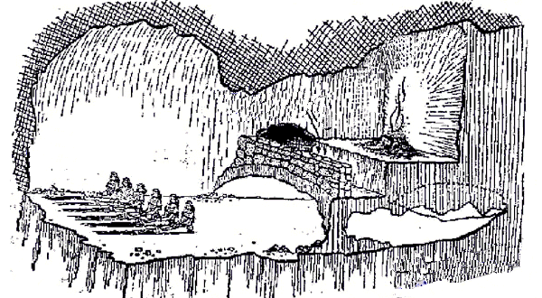
Task 3

Draw a diagram of Plato’s allegory of the cave. On the diagram label each part.

Underneath the labels, tell me what each of the parts represents.

Task 4

Research into Aristotle’s 4 causes.

List 5 items (e.g a table) and identify what each of the causes are of them.

Philosophy, Ethics and Religious Thought - Compulsory Religious Thought Introductory Task

Task 1

Create a piece of work (an A4/A3 piece of paper), representing what you can find out about the Christian belief of Heaven, Hell and Purgatory. Include information, images and where possible colour.

Task 2

Research the parable of the Sheep and the Goats. Summarise the parable somewhere on your above piece of work. Why is this parable important?

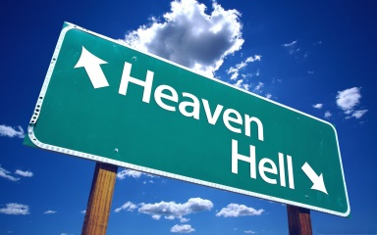

Philosophy, Ethics and Religious Thought - Compulsory Ethics Introductory Task
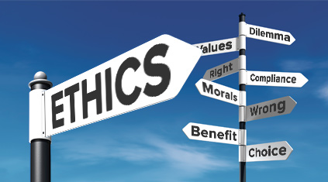
Part 1

Complete some research into moral absolutism and moral relativism. You will find plenty online. Find out what both of these ideas are all about and then respond to the following statement:

‘Moral absolutism is a better approach than moral relativism’. What do you think?

In this task you should write approximately 1-1½ sides (handwritten) or ¾ side (typed) to offer your response to the statement. You should consider both sides of the argument, giving the strengths and weaknesses of both absolutism and relativism, and end with a conclusion which shows your own viewpoint. Give examples where you can to demonstrate the points you are making.

Possible format:
Paragraph 1 - A brief overview of what moral absolutism and moral relativism are all about
Paragraph 2 - Strengths and weaknesses of moral absolutism
Paragraph 3 - Strengths and weaknesses of moral relativism
Paragraph 4 - Conclusion - which approach is best and why? Do you now agree or disagree with the original statement?

You will find lots online about the strengths and weaknesses of both approaches, but you may even think of these for yourself during your research.

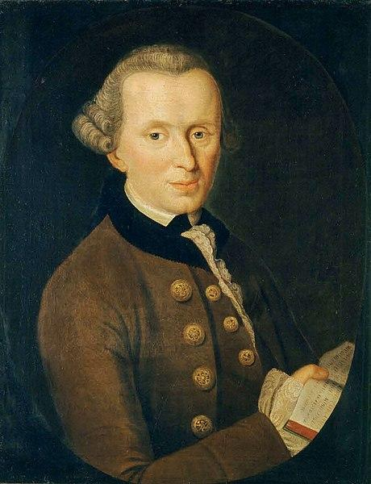
Part 2

Research and look into the four main ethical theories that we will study in AS, you can choose one to create a fact-file or a mind-map (or if you want to, you could do all four!). This will give you a really good basis for September when we begin to delve into the theories! Where possible challenge yourself and include examples, where you apply the theory.

The theories are:

- Natural Law
- Utilitarianism
- Situation Ethics
- Kantian Ethics
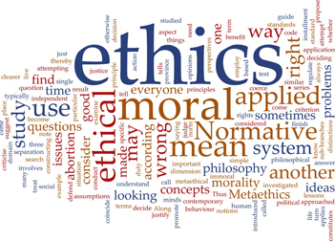
Part 3

Consider your definitions of the following terms:

• Truth, Reality, Good, Evil, Moral, God, Time

For each concept, try to argue against your own definition. Can you see any flaws in your ideas? How might they be criticised? What conclusions can you reach about how we define these concepts?

List five facts that you know to be true. For each one, explain how you know it to be true. Are any of your “facts” uncertain? What would have to happen to prove them irrefutably (without question)?

