

Year 11-12 Transition Pack
A Level
Physics


AQA A-Level Physics Student Guide

Welcome to AQA A-Level Physics!
Physics is the fundamental science that seeks to understand how the universe behaves—from the tiniest particles to the vastness of space. A-level Physics is an exciting and intellectually rewarding subject that challenges you to think critically, solve problems, and explore the laws that govern everything around us. Whether you are fascinated by black holes, curious about quantum mechanics, or interested in how electricity powers your phone, this course will give you the tools to explore these phenomena and more.

Course Overview
The AQA A-level Physics course is designed to build on your GCSE knowledge and take you deeper into the core principles of physics. It combines theoretical understanding with practical skills, preparing you for further study or careers in science, engineering, medicine, and technology.
The course is split into two years of study, typically referred to as Year 12 (AS Level) and Year 13 (A2 Level). However, the full A-level qualification is awarded after completing both years and sitting the final exams at the end of the second year.

Core Content and Modules

Year 12 (AS Level Topics):
1. Measurements and Their Errors – Understanding precision, accuracy, and uncertainty in experiments.
2. Particles and Radiation – Introduction to the standard model, particle interactions, and quantum phenomena.
3. Waves – Properties of waves, interference, diffraction, and the nature of light.
4. Mechanics and Materials – Forces, motion, energy, and the behavior of materials under stress.
5. Electricity – Current, voltage, resistance, and circuits.

Year 13 (A2 Level Topics):
6. Further Mechanics and Thermal Physics – Circular motion, simple harmonic motion, and the laws of thermodynamics.
7. Fields and Their Consequences – Gravitational, electric, and magnetic fields, and their applications.
8. Nuclear Physics – Radioactivity, nuclear decay, and energy from the nucleus.

Optional Module (One of the following):
• Astrophysics
• Medical Physics
• Engineering Physics
• Turning Points in Physics
• Electronics
The school will choose which optional topic you will study.

Practical Skills and Assessment
Throughout the course, you will complete required practicals that develop your experimental skills. These are assessed through written exams and contribute to your Practical Endorsement, which is reported separately on your certificate. The final assessment consists of three written papers at the end of Year 13, covering all content and practical skills.

Exam Structure

Paper 1: Core Content (Year 12 + Part of Year 13)
Topics Covered:
- Measurements and their errors
- Particles and radiation
- Waves
- Mechanics and materials
- Electricity
- Further mechanics (Periodic Motion)
Duration: 2 hours
Marks: 85
Weighting: 34% of A-level
Question Types:
- Short and long answer questions
- Some multiple choice

Paper 2: Core Content (Remaining Year 13 Topics)
Topics Covered:
- Thermal physics
- Fields and their consequences
- Nuclear physics
- Plus assumed knowledge from Paper 1
Duration: 2 hours
Marks: 85
Weighting: 34% of A-level
Question Types:
- Short and long answer questions
- Some multiple choice

Paper 3: Practical Skills + Optional Topic
Section A: Practical skills and data analysis
Section B: One optional topic (e.g., Astrophysics, Medical Physics, etc.)
Duration: 2 hours
Marks: 80
Weighting: 32% of A-level
Question Types:
- Structured questions
- Extended response questions

Practical Endorsement (Non-Exam Assessment)
You will complete 12 required practicals throughout the course.
Your teacher will assess your competency in practical skills.
This is reported as “pass” or “not reported” separately on your certificate.

Required Practicals

Year 1 (AS Level) Required Practicals
1. Investigation into the variation of the frequency of stationary waves on a string with length, tension and mass per unit length of the string.
2. Investigation of interference effects to include the Young’s slit experiment and interference by a diffraction grating.
3. Determination of g by a free-fall method
4. Determination of the Young modulus by a simple method.
5. Determination of resistivity of a wire using a micrometer, ammeter and voltmeter.
6. Investigation of the emf and internal resistance of electric cells and batteries by measuring the variation of the terminal pd of the cell with current in it.

Year 2 (A2 Level) Required Practicals
7. Investigation into simple harmonic motion using a mass–spring system and a simple pendulum.
8. Investigation of Boyle’s (constant temperature) law and Charles’s (constant pressure) law for a gas.
9. Investigation of the charge and discharge of capacitors. Analysis techniques should include log-linear plotting leading to a determination of the time constant RC .
10. Investigate how the force on a wire varies with flux density, current and length of wire using a top pan balance.
11. Investigate, using a search coil and oscilloscope, the effect on magnetic flux linkage of varying the angle between a search coil and magnetic field direction.
12. Investigation of the inverse-square law for gamma radiation.

Recommended Resources
Resource | Type | Link | QR Code
Physics and Maths Tutor  Offers topic-by-topic notes, past paper questions, mark schemes, and model answers. | Website | https://www.physicsandmathstutor.com/physics-revision/a-level-aqa/ | 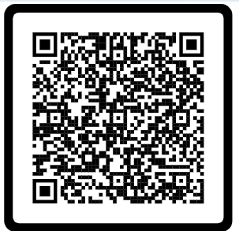
Save my Exams  Clear revision notes, topic questions, and worked solutions tailored to the AQA spec. | Website | https://www.savemyexams.co.uk/a-level/physics/aqa/ | 
Brook Does Physics  Well explained, detailed videos of concepts in physics | YouTube Channel | https://www.youtube.com/@BrookDoesPhysics | 
Revisely  Concise revision notes and summaries. | Website | https://revisely.co.uk/ | 
Khan Academy  Not AQA-specific, but excellent for deepening understanding | Website | https://www.khanacademy.org/science/physics | 
Physics Online  AQA-focused videos with clear explanations and animations. | YouTube Channel | https://www.youtube.com/@PhysicsOnline | 
Science Shorts  Great for concise topic summaries and visual explanations. | YouTube Channel | https://www.youtube.com/@scienceshorts | 
TLPhysics  Past paper walkthroughs and topic-by-topic tutorials. | YouTube Channel | https://www.youtube.com/@TLPhysics | 
A Level Revision  Covers multiple exam boards including AQA | YouTube Channel | https://www.youtube.com/@ALevelRevision | 
CGP Revision Guide  Clear, concise, and exam-focused. Great for quick revision and practice questions. | Revision Guide |  | 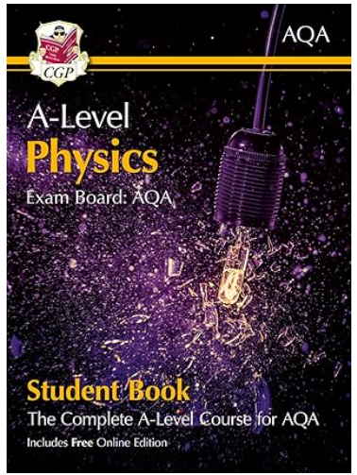
Oxford Revise  Structured around the AQA spec with retrieval practice and exam tips. | Revision Guide |  | 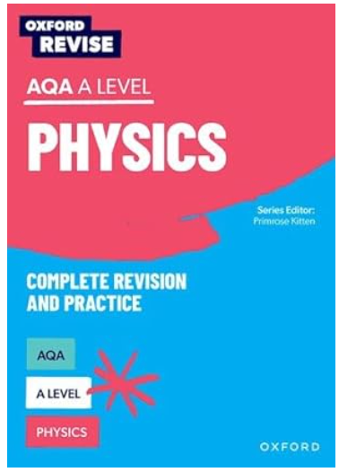
Collins AQA  More detailed, ideal for in-depth study and understanding. | Revision Guide |  | 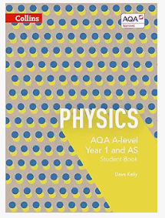

Study Tips for AQA A-Level Physics
1. Understand, Don’t Just Memorise
- Physics is concept-heavy. Try to grasp the underlying principles rather than just memorising formulas.
- Use analogies, diagrams, and real-world examples to make abstract ideas more concrete.
2. Master Practical Skills
- The 12 required practicals aren’t just for the Practical Endorsement—they’re also tested in the written exams.
- Be confident with:
• Using equipment
• Taking accurate measurements
• Calculating uncertainties
• Drawing and interpreting graphs
3. Know the Formula Sheet
- AQA provides a formula sheet in exams, but you still need to know when and how to use each equation.
- Practice rearranging formulas and applying them in different contexts.
4. Practice Problem Solving
- Physics questions often combine multiple topics.
- Work through past papers and mixed-topic questions to build confidence.
- Focus on showing working clearly—marks are often awarded for method.
5. Strengthen Your Maths
- A-level Physics includes a significant amount of maths (about 40% of the marks).
- Key skills include:
• Algebra and rearranging equations
• Trigonometry and vectors
• Graph interpretation
• Calculus (basic differentiation and integration in Year 13)
6. Use the Specification
- The AQA specification is your roadmap—it tells you exactly what you need to know.
- Use it to track your revision and ensure you’re covering everything.
7. Manage Your Time and Wellbeing
- Physics can be challenging—don’t leave revision to the last minute.
- Use tools like Pomodoro timers, revision timetables, and mind maps.
- Take breaks, stay active, and ask for help when needed.
8. Collaborate and Ask Questions
- Discussing problems with classmates or teachers can deepen your understanding.
- Don’t be afraid to ask questions—even the tricky ones!

AQA A-Level Physics Transition Questions
Welcome to AQA A-Level Physics! To help you transition from GCSE to A-Level, here are some questions that review key GCSE concepts and introduce A-Level thinking. Please answer the questions on the next page.

Forces
1. A car accelerates from rest to a speed of 20 m/s in 10 seconds. Calculate the acceleration of the car.
2. Explain the difference between mass and weight. How does gravity affect each?
3. A 5 kg object is acted upon by a force of 15 N. Calculate the acceleration of the object.
4. Describe how Newton's three laws of motion apply to a rocket launch.

Energy
5. Define kinetic energy and potential energy. Provide an example of each.
6. Calculate the kinetic energy of a 2 kg object moving at a speed of 3 m/s.
7. Explain the principle of conservation of energy with an example.
8. A ball is dropped from a height of 10 meters. Calculate its potential energy at the top and its kinetic energy just before hitting the ground.

Electricity
9. Define current, voltage, and resistance. How are they related in Ohm's Law?
10. Calculate the resistance of a circuit with a voltage of 12 V and a current of 3 A.
11. Explain the difference between series and parallel circuits. Provide an example of each.
12. A resistor has a resistance of 10 ohms and is connected to a 5 V battery. Calculate the current flowing through the resistor.

Waves
13. Define frequency, wavelength, and amplitude. How are they related to the speed of a wave?
14. Calculate the speed of a wave with a frequency of 50 Hz and a wavelength of 2 meters.
15. Explain the difference between transverse and longitudinal waves. Provide an example of each.
16. Describe how the Doppler effect changes the frequency of a sound wave as the source moves towards or away from an observer.

Atomic Structure
17. Describe the structure of an atom, including the roles of protons, neutrons, and electrons.
18. Explain the difference between atomic number and mass number.
19. Calculate the number of neutrons in an atom with an atomic number of 8 and a mass number of 16.
20. Describe how isotopes of an element differ from each other. Provide an example.

Answer the Questions here:

