AQA A-LEVEL SOCIOLOGY AT GEORGE SALTER ACADEMY
Miss Lockett
Ever wondered how we developed into the society we are today? How the way you see yourself determines the way people identify you? What inequalities are there within the education system? Why purpose does family and religion serve? Whether men or women are more likely to commit a crime? A-level Sociology will help you to make sense of the society we live in and understand the cultural and identity issues which are relevant to everyday life and affect us all.


So, before you have even opened a sociology textbook you will already have acquired some knowledge of society. Sociology invites us to challenge and question our common sense assumptions about society and develop a sociological imagination. You will learn a number of skills including the use of evidence to support your arguments, how to investigate facts, and critical thinking.

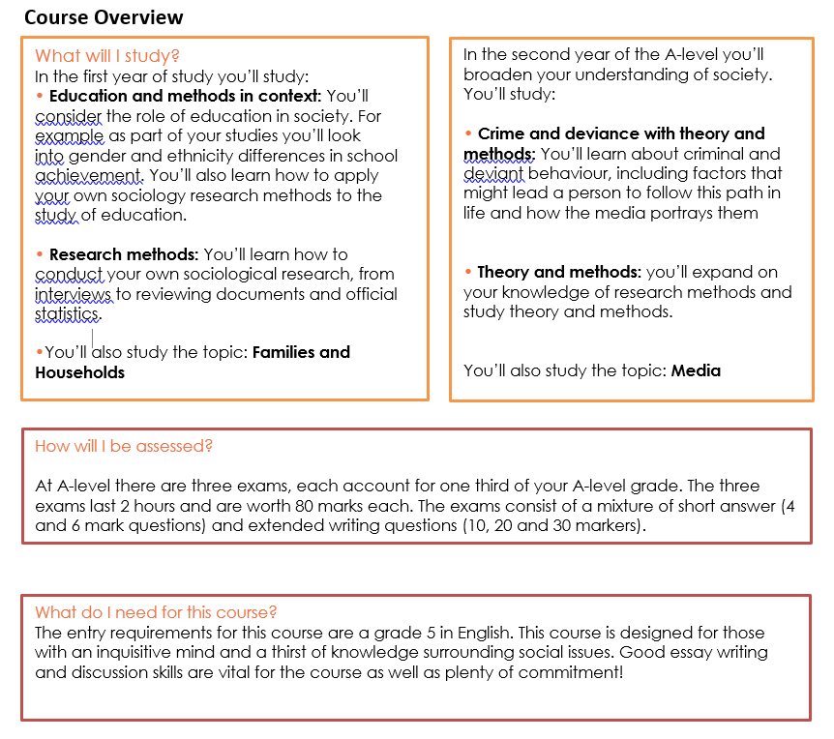
This pack contains a programme of activities and resources to prepare you to start an A Level in Sociology in September. It is aimed to be used after you complete your GCSE throughout the remainder of the summer term and over the summer holidays to ensure you are ready to start your course in September. We hope you enjoy discovering about the world we live in as we do!
Sociology- Summer homework
Over the Summer you will need to complete the following activities to help you ‘hit the ground running’ when you start in September. Please bring the completed activities to your first Sociology lesson.
- Education
In Sociology, we will examine some of the trends and issues surrounding the education system during the course of study. In any topic you would be expected to present real-life examples and accounts in your work.
Task: You are to create a collage of articles, which demonstrate the most significant currents trends and issues in education present based on your findings. These could be about teaching jobs, achievement of certain groups of people for GCSE and A-level.

A good starting point is inspecting the education section of news sites, but also making use of printed newspapers or magazines to ensure you have a variety of information and enabling you to select the most relevant and useful articles and headlines. The collage should be well presented and be a creative revision tool that you can add concepts/articles to and refer to at a later point. Adding subtitles and highlighting key words would be a good idea. You are expected to include at least 5 articles/headlines and be prepared to explain them

- Families and Households
You will study some aspects relating to family and households in depth during the first year of the course, e.g. the domestic division of labour. You need to be prepared in Sociology to always consider different points of view and be critical in your line of thinking.
Task: You must select one of the following statements below and present a discussion on this as a written response:-
- ‘Family life is always a positive experience for people.’
- ‘Men should be out working and women should be at home in a proper family’
- ‘The typical family today is made up of two parents and two children.’
You should write a side of A4, presenting a two-sided argument, with a final conclusion for your statement. You are expected to provide evidence to justify your arguments, rather than simply providing your opinions, e.g. statistical evidence and real-life stories. Use the recommended websites to help you collate additional evidence to use as well as your existing knowledge. We will be looking at the structure and quality of your written response. Any sources that you use should be referenced at the bottom of the page.

Due: W/C Monday 7th September

