Q1.
Sexual reproduction in humans involves the production of egg cells and sperm cells.
(a) Name the type of cell division that produces egg cells and sperm cells.
___________________________________________________________________
(1)
(b) Sexual reproduction produces offspring that are genetically different from each other.
Give two reasons why sexual reproduction causes variation in the offspring.
1 _________________________________________________________________
___________________________________________________________________
2 _________________________________________________________________
___________________________________________________________________
(2)
Polydactyly is an inherited disorder.
The allele for polydactyly is dominant, D.
A person with two copies of the allele d will not have polydactyly.
(c) A person with the genotype DD is homozygous.
What word describes the genotype Dd?
___________________________________________________________________
(1)
(d) A person with the genotype Dd and a person with the genotype dd plan to have a child.
Determine the probability that the child will have polydactyly.
You should:
• complete the Punnett square diagram
• identify any offspring genotype that would have polydactyly.

Probability that the child will have polydactyly = ____________________
(5)
(e) Embryos can be screened for the alleles that cause inherited disorders.
Give two advantages of embryo screening.
1 _________________________________________________________________
___________________________________________________________________
2 _________________________________________________________________
___________________________________________________________________
(2)
(Total 11 marks)
Q2.
This question is about genetics.
(a) Crop plants are genetically modified (GM) for useful characteristics.
Which useful characteristic are crops genetically modified for?
Tick (✓) one box.

Fewer roots | 
Larger yields
Smaller fruits
(1)
(b) What is one concern about GM crops?
Tick (✓) one box.

GM crops will add to global warming.
GM crops will cause air pollution.
GM crops will harm wildlife.
GM crops will produce too much food.
(1)
Some inherited disorders are caused by a faulty piece of DNA.
(c) What is the name of a piece of DNA that codes for a characteristic?
___________________________________________________________________
(1)
(d) DNA contains a code for making substances in the cell.
What type of substance is made using the DNA code?
Tick (✓) one box.

Fat
Protein
Starch
Sugar
(1)
Cystic fibrosis (CF) is an inherited disorder.
The allele for having CF is recessive (h).
The allele for not having CF is dominant (H).
(e) What is a recessive allele?
Tick (✓) one box.

An allele that is always expressed.
An allele that is expressed if only one copy is present.
An allele that is only expressed if two copies are present.
(1)
A man and a woman do not have CF. The man has the alleles Hh.
(f) What word describes the alleles of the man?
Tick (✓) one box.

Heterozygous
Homozygous
Phenotype
(1)
(g) The man and the woman want to have a child.
Complete below diagram to show the possible genotypes of the child.
Draw a ring around the genotype of a child who will have CF.
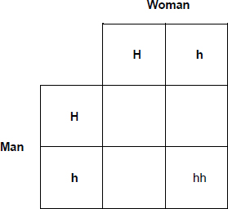
(3)
(h) What is the chance that a child of the man and the woman will have CF?
Tick (✓) one box.

25% |  | 50% |  | 75% |  | 100%
(1)
(i) The woman is pregnant.
The woman can have embryo screening to find out if the child will have CF.
Suggest one reason why the woman might not want to have embryo screening.
___________________________________________________________________
___________________________________________________________________
___________________________________________________________________
(1)
(Total 11 marks)
Q3.
Potatoes are a food crop.
(a) Potato plants are classified as eukaryota.
What type of classification group is eukaryota?
Tick (✓) one box.

Class
Domain
Kingdom
Phylum
(1)
(b) Potato plants can reproduce by asexual reproduction.
Which statement is true for asexual reproduction?
Tick (✓) one box.

Meiosis occurs.
Offspring are genetically identical.
Pollen and egg cells are produced.
(1)
(c) Flowers of potato plants contain gametes for sexual reproduction.
How is a gamete different from other cells in a potato plant?
Tick (✓) one box.

A gamete contains one-quarter of the number of chromosomes.
A gamete contains half of the number of chromosomes.
A gamete contains double the number of chromosomes.
(1)
(d) Plants in the same genus as potatoes have been studied by scientists.
Describe one way a new plant species could be identified as being in the same genus as potatoes.
___________________________________________________________________
___________________________________________________________________
(1)
(e) Scientists have collected and stored seeds from species in the same genus as potatoes.
In the future, these seeds may be used for genetic modification of potato plants.
Genetically modified potato plants could help supply food to the human population as the climate changes.
Explain why genetic modification of crop plants may be important for the human population to survive climate change.
___________________________________________________________________
___________________________________________________________________
___________________________________________________________________
___________________________________________________________________
___________________________________________________________________
___________________________________________________________________
___________________________________________________________________
___________________________________________________________________
___________________________________________________________________
___________________________________________________________________
___________________________________________________________________
___________________________________________________________________
___________________________________________________________________
___________________________________________________________________
___________________________________________________________________
___________________________________________________________________
___________________________________________________________________
(6)
(Total 10 marks)
Q4.
The figure below shows an evolutionary tree.
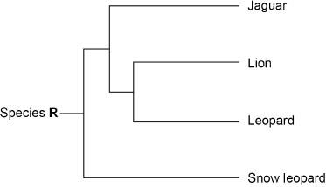

(a) Which species in the figure above is most closely related to lions?
Tick (✓) one box.

Jaguar
Leopard
Snow leopard
(1)
(b) Tigers are more closely related to snow leopards than to jaguars.
Draw a line on the figure above to show the evolution of tigers.
Label the line ‘Tiger’.
(1)
(c) What is represented by species R on the figure above?
Tick (✓) one box.

A species recently evolved from jaguars.
A species that may evolve in the future.
A species that the other species evolved from.
(1)
(d) Complete the sentence.
Choose the answer from the box.

classification | homeostasis | natural selection

Evolution occurs by the process of ______________________________ .
(1)
(e) Species can become extinct.
Give two possible causes of extinction.
1 _________________________________________________________________
___________________________________________________________________
2 _________________________________________________________________
___________________________________________________________________
(2)
(f) Fossils are used to study the evolution of some species.
Suggest one reason why fossils are used to study evolution.
___________________________________________________________________
___________________________________________________________________
(1)
Some bacteria have evolved to be resistant to penicillin.
Penicillin is an antibiotic.
(g) How has the process of evolution produced bacteria that are resistant to penicillin?
Write the stages, A, B, C, D and E in the correct order.
The first stage has been completed for you.
A The bacteria with mutations are more likely to survive.
B The population of bacteria is exposed to penicillin.
C The mutation for resistance to penicillin is passed on to offspring.
D Variation in the population of bacteria is caused by mutation.
E The surviving bacteria reproduce.
D → _______ → _______ → _______ → _______
(3)
(h) New antibiotics are not likely to control the spread of bacteria that are resistant to antibiotics.
What are two reasons why?
Tick (✓) two boxes.

Antibiotics kill all types of bacteria.
Antibiotic resistant bacteria will continue to evolve.
Bacteria reproduce very rapidly.
New antibiotics are cheap to produce.
Testing new antibiotics is quick.
(2)
(Total 12 marks)
Q5.
A catalyst is used to increase the rate of decomposition of hydrogen peroxide.
(a) Hydrogen peroxide decomposes to produce water and oxygen.
Write a word equation for the reaction.
____________________ → __________ + __________
(1)
A student investigated the rate of decomposition of hydrogen peroxide using three different catalysts:
• manganese dioxide
• copper oxide
• zinc oxide.
Figure 1 shows the apparatus.
Figure 1
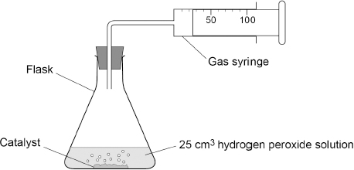
This is the method used.
1. Measure 25 cm³ of hydrogen peroxide solution into a flask.
2. Add 0.5 g of manganese dioxide catalyst to the flask.
3. Attach a gas syringe to the flask.
4. Measure the volume of oxygen produced every 20 seconds for 120 seconds.
5. Repeat steps 1 to 4 two more times.
6. Repeat steps 1 to 5 using copper oxide catalyst.
7. Repeat steps 1 to 5 using zinc oxide catalyst.
(b) Which two control variables are used in the investigation?
Tick (✓) two boxes.

Mass of catalyst
Shape of flask
Time of taking readings
Volume of hydrogen peroxide solution
Volume of oxygen produced
(2)
The table below shows the results with manganese dioxide catalyst.

Time in seconds | 0 | 20 | 40 | 60 | 80 | 100 | 120
Volume of oxygen in cm³ | 0 | 20 | 32 | 40 | 45 | 49 | 50
Figure 2 shows a graph of the results with copper oxide catalyst and with zinc oxide catalyst.
Figure 2
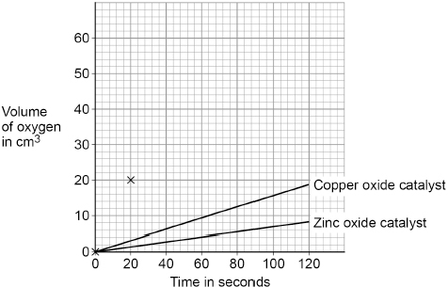
(c) Complete Figure 2.
You should:
• plot the data for the manganese dioxide catalyst from the table above
• draw a line of best fit.
The first two points have been plotted for you.
(3)
(d) Which is the best catalyst?
Give one reason for your answer.
Use the completed Figure 2.
Tick (✓) one box.

Copper oxide
Manganese dioxide
Zinc oxide
Reason ____________________________________________________________
___________________________________________________________________
(2)
(e) The student repeated the investigation with manganese dioxide catalyst.
The results were all close to the true value.
Complete the sentence.
Choose the answer from the box.

accurate | approximate | random
Results that are close to the true value are ____________________.
(1)
(f) The student repeated the investigation using manganese dioxide catalyst at a higher temperature.
Complete the sentence.
Choose the answer from the box.

decrease | stay the same | increase
At a higher temperature, the rate of reaction will ____________________.
(1)
(Total 10 marks)
Q6.
Alkanes and alkenes are hydrocarbons.
(a) Define the term ‘hydrocarbon’.
___________________________________________________________________
___________________________________________________________________
(1)
(b) The general formula for alkanes is C_{n}H_{2n+2}
Determine the formula of the alkane with 10 carbon atoms.
___________________________________________________________________
Formula = ____________________
(1)
(c) Crude oil is a mixture of hydrocarbons.
Figure 1 represents industrial equipment used to separate crude oil into fractions.
Figure 1
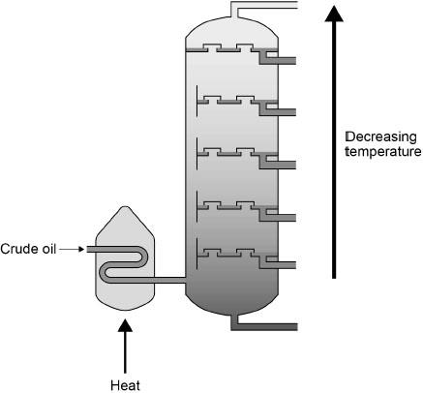
Explain how crude oil is separated into fractions.
Use Figure 1.
___________________________________________________________________
___________________________________________________________________
___________________________________________________________________
___________________________________________________________________
___________________________________________________________________
___________________________________________________________________
___________________________________________________________________
___________________________________________________________________
(4)
(d) The alkane molecule C₁₄H₃₀ can be cracked to produce smaller molecules.
Balance the equation for the reaction.
C₁₄H₃₀ → C₈H₁₈ + _____ C₃H₆
(1)
Propene (C₃H₆) is an alkene.
(e) Describe the test for alkenes.
Give the result.
Test ______________________________________________________________
___________________________________________________________________
Result _____________________________________________________________
___________________________________________________________________
(2)
(f) Poly(propene) is made from propene.
Figure 2 represents the repeating unit of poly(propene).
Figure 2
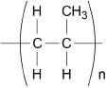
What type of substance is poly(propene)?
___________________________________________________________________
(1)
(Total 10 marks)
Q7.
The Earth’s atmosphere is always changing.
(a) Gases in the Earth’s early atmosphere caused changes on the Earth.
Draw one line from each change to the gas that caused the change.

Change |  | Gas that caused the change
 |  | Ammonia
Oceans formed |  | Carbon dioxide
 |  | Nitrogen
Sedimentary rocks formed |  | Oxygen
 |  | Water vapour
(2)
The table below shows the percentage of some gases in the atmospheres of Earth and Mars today.

Gas | Percentage of gas in atmosphere (%)
Gas | Earth | Mars
Argon | 0.90 | 1.9
Carbon dioxide | 0.04 | 95
Nitrogen | 78 | 2.6
Oxygen | 21 | 0.20
(b) Which gas has the highest percentage in the Earth’s atmosphere?
___________________________________________________________________
(1)
(c) Calculate how many times more carbon dioxide there is in the atmosphere of Mars than in the atmosphere of Earth.
Use the table above.
Give your answer in standard form.
___________________________________________________________________
___________________________________________________________________
___________________________________________________________________
___________________________________________________________________
___________________________________________________________________
Number of times more carbon dioxide (in standard form) = _______________
(3)
Carbon dioxide is a greenhouse gas.
(d) Figure 1 shows the concentration of carbon dioxide in the Earth’s atmosphere from 1960 to 2020.
Figure 1
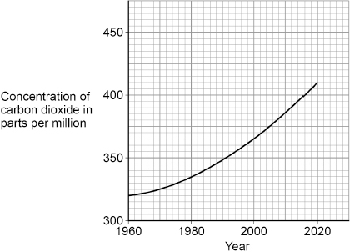
How has the concentration of carbon dioxide in the Earth’s atmosphere changed from 1960 to 2020?
Tick (✓) one box.

Decreased
Stayed the same
Increased
(1)
(e) Cars emit carbon dioxide.
A car emits 17.2 kg of carbon dioxide on a journey.
There are four people in the car.
Calculate the mass of carbon dioxide emitted per person.
___________________________________________________________________
___________________________________________________________________
___________________________________________________________________
Mass of carbon dioxide = __________ kg
(2)
(f) Planting trees helps to reduce climate change, because trees use carbon dioxide from the Earth’s atmosphere.
Name the process in trees which uses carbon dioxide.
___________________________________________________________________
(1)
(g) Figure 2 shows the annual change in forest area in four different parts of the world.
Figure 2
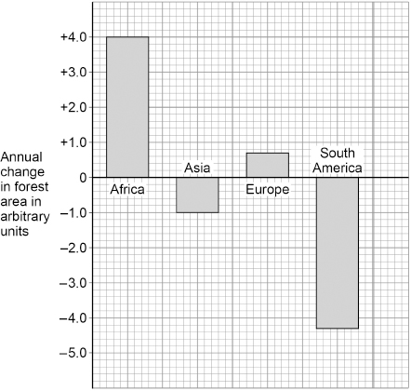
Give two conclusions about the annual change in forest area.
1 _________________________________________________________________
___________________________________________________________________
2 _________________________________________________________________
___________________________________________________________________
(2)
(h) Methane is a greenhouse gas.
Figure 3 shows sources of methane emissions.
Figure 3
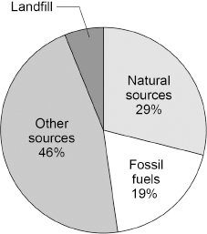
Determine the percentage (%) of methane emissions from landfill.
___________________________________________________________________
___________________________________________________________________
Percentage = __________ %
(1)
(i) Figure 4 shows two ways (A and B) of preventing used items going to landfill.
Figure 4
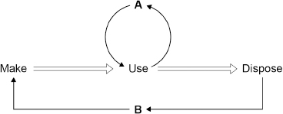
Name A and B.
Choose answers from the box.

recycle | reduce | release | reuse | reverse
A _________________________
B _________________________
(2)
(Total 15 marks)
Q8.
A teacher demonstrated how the frequency of a wave on a string affects the wavelength of the wave.
The figure below shows the equipment used.
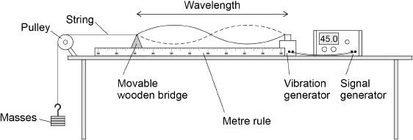
The frequency of the signal generator is adjusted so that the wave shown in the figure above is seen.
At this frequency the string vibrates between the two positions shown in the figure above.
(a) Describe a method the teacher could use to investigate how the frequency of the wave affects the wavelength.
___________________________________________________________________
___________________________________________________________________
___________________________________________________________________
___________________________________________________________________
___________________________________________________________________
___________________________________________________________________
___________________________________________________________________
___________________________________________________________________
___________________________________________________________________
___________________________________________________________________
(4)
Use the Physics Equations Sheet to answer parts (b) and (c).
(b) Which equation links frequency (f), wavelength (λ) and wave speed (v)?
Tick (✓) one box.

f = λ × v
λ = f × v
v = f × λ
(1)
(c) The wave on the string has a frequency of 45.0 Hz.
The wave speed is 35.1 m/s.
Calculate the wavelength of the wave.
___________________________________________________________________
___________________________________________________________________
___________________________________________________________________
___________________________________________________________________
___________________________________________________________________
Wavelength = ____________________ m
(3)
(Total 8 marks)
Q9.
Figure 1 shows a skydiver jumping from an aeroplane.
The skydiver is accelerating downwards.
Figure 1
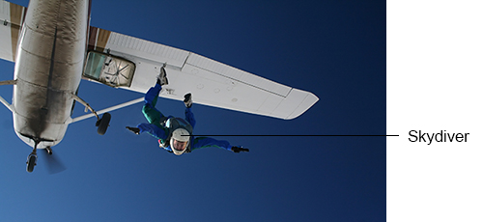
(a) Which force causes the skydiver to accelerate?
Tick (✓) one box.

Electromagnetic force
Gravitational force
Magnetic force
(1)
(b) Which force increases as the skydiver accelerates?
Tick (✓) one box.

Air resistance
Normal contact force
Tension
(1)
Figure 2 shows the two forces acting on the skydiver a few seconds after jumping from the aeroplane.
Figure 2
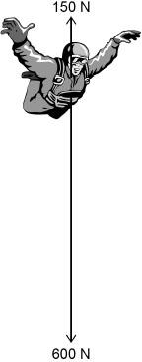
(c) Calculate the resultant force acting on the skydiver in Figure 2.
___________________________________________________________________
Resultant force = ____________________ N
(1)
(d) Eventually the skydiver stops accelerating and falls at a constant velocity.
What is the resultant force acting on the skydiver when falling at a constant velocity?
Tick (✓) one box.

0 N
150 N
600 N
(1)
(e) What name is given to the constant velocity of the skydiver?
Tick (✓) one box.

Average velocity
Initial velocity
Terminal velocity
(1)
Figure 3 shows a velocity–time graph for the skydiver.
Figure 3
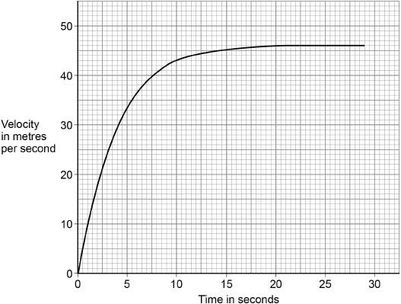
(f) How many seconds did the skydiver accelerate for?
Use Figure 3.
____________________ s
(1)
(g) What was the constant velocity of the skydiver?
Use Figure 3.
____________________ m/s
(1)
(h) After opening a parachute, the skydiver fell at a constant speed of 3.6 m/s for 25 seconds.
Calculate the distance travelled by the skydiver during this time.
Use the equation:
distance travelled = speed × time
___________________________________________________________________
___________________________________________________________________
___________________________________________________________________
Distance travelled = ____________________ m
(2)
(Total 9 marks)

Mark schemes
Q1.
(a) meiosis
allow phonetic spelling
1
(b) gametes / eggs / sperm are not (genetically) identical
allow gametes / eggs / sperm are (genetically) different
allow cells produced by meiosis are not (genetically) identical
1
(there is) mixing of genetic information / genes / DNA
or
genetic information / genes / DNA from two / both parents
allow genetic information / genes / DNA from each parent ignore gametes fuse unqualified
ignore two parents unqualified
1
if no other mark awarded allow 1 mark for mutations
(c) heterozygous
ignore dominant / recessive
1
(d) (parents gamete genotypes shown)
D d and d d
allow in either position in Punnett square
1
(possible offspring genotypes correctly derived)
Dd Dd dd dd
allow correct derivation of offspring genotypes from incorrect gametes
allow 3 correct offspring genotypes for 1 mark
2
correct identification of Dd offspring as having polydactyly
if derivation not correct and shows DD and Dd, both must be identified as having polydactyly
1
probability must match derived offspring genotypes
if no derivation shown allow 0.5 or 50% or 1 in 2 or
1:1 or ½
do not accept 1:2
allow correct probability from incorrectly derived offspring
1
(e) any two from:
• can find out if the embryo has an (inherited) disorder
allow can find out if the embryo has inherited disease
ignore can find out if the embryo has disease(s)
• can prepare for baby (with the disorder)
allow description of preparation for the baby eg access to early treatment
• can decide whether to continue with the pregnancy
allow choice of (in vitro) embryos (to be implanted)
• fewer people with (inherited) disorders over time
2
[11]
Q2.
(a) larger yields
1
(b) GM crops will harm wildlife
1
(c) gene(s)
allow allele(s)
1
(d) protein
1
(e) an allele is only expressed if two copies are present
1
(f) heterozygous
1
(g) Mark with (h)
offspring genotypes correctly derived
allow 1 mark for 1 or for 2 correct genotypes
2
hh circled Woman
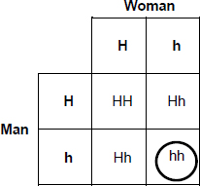
1
(h) Mark with (g)
25%
probability must match derivations (hh) in part (g)
1
(i) any one from:
• it might harm the embryo / baby / mother
ignore harmful / dangerous unqualified
• it might cause a miscarriage
• they do not want to make a choice about having an abortion
• it is against their religious beliefs
allow against their religion
1
ignore cost
[11]
Q3.
(a) domain
1
(b) offspring are genetically identical
1
(c) a gamete contains half of the number of chromosomes
1
(d) any one from:
• similar / same structure / characteristics / phenotype (as potatoes)
allow named similar structure / characteristics such as same shape / leaves / flowers / taste
allow studied with microscopes
ignore 'look the same / similar' unqualified
• similar DNA / genes
allow DNA analysis
allow analysis of genetic material
allow similar genetic material
ignore genetic information
do not accept same DNA / genes
• similar / same biochemistry
• same first part of binomial (name)
allow same first part of Latin / scientific name
1
(e) Level 3: Relevant points (reasons / causes) are identified, given in detail and logically linked to form a clear account.
5−6
Level 2: Relevant points (reasons / causes) are identified, and there are attempts at logical linking. The resulting account is not fully clear.
3−4
Level 1: Points are identified and stated simply, but their relevance is not clear and there is no attempt at logical linking.
1−2
No relevant content
0
Indicative content
allow reference to named crop throughout
effects of climate change
• climate change will change weather patterns / trends
• climate change causes flooding or drought or temperature change
• farming land decreased by sea level rise / flooding / desertification
• current crops cannot grow / survive (in changing conditions)
benefits of GM
◦ GM may allow crops to grow in wider range of conditions
◦ GM may allow crops to be resistant to wider range of pests / diseases
◦ GM may allow crops to be stored for longer
◦ GM may increase crop yield or increase growth rate
◦ to feed the increasing human population
◦ useful if less area available for farming
◦ larger human population needs more land for housing
other relevant content
▪ variation amongst current crops reduced by asexual reproduction or selective breeding
▪ rate of evolution (by natural selection) may be slower than rate of climate change
For Level 3, answers must explain effect(s) of climate change and benefit(s) of GM with logical link.
[10]
Q4.
(a) leopard
1
(b) a branch / line drawn at any point between 'X' marks, labelled 'tiger(s)'
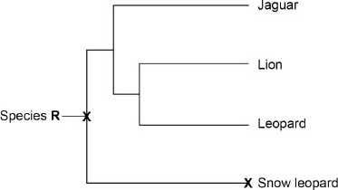
1
(c) a species that the other species evolved from
1
(d) natural selection
1
(e) any two from:
• drought
• ice age
• global warming
if none of these awarded
allow 1 mark for climate change
ignore weather
• volcanic activity
• asteroid collision
if neither of these awarded
allow 1 mark for catastrophic event or natural disaster
• (new) predators
allow named example
allow hunters
• (new) disease / pathogen
allow named example
• competition for food
allow lack of food
• competition for mates
allow lack of mates
ignore competition unqualified
• lack of habitat
or habitat change
ignore environment change
ignore isolation
ignore pollution
2
(f) any one from:
• if species is extinct
• if (fossil) species is unknown
• evolution is (usually) slow
• (fossils) show (evolutionary) change
ignore fossils are (usually) very old
1
(g) (D) → B → A → E → C
allow 1 mark for link B → A
allow 1 mark for link A → E
allow 1 mark for link E → C
3
(h) antibiotic resistant bacteria will continue to evolve
1
bacteria reproduce very rapidly
1
[12]
Q5.
(a) hydrogen peroxide → water + oxygen
allow H₂O₂ for hydrogen peroxide
allow H₂O for water
allow O₂ for oxygen
1
(b) mass of catalyst
1
volume of hydrogen peroxide solution
1
(c) all points plotted correctly
allow a tolerance of ± ½ a small square
allow at least 3 points plotted correctly for 1 mark
2
line of best fit
1
(d) manganese dioxide
allow ecf from part (c)
1
any one from:
• steepest curve
• reaction finishes first
• greatest volume of oxygen (in given time)
1
(e) accurate
1
(f) increase
1
[10]
Q6.
(a) (molecules) made up of carbon and hydrogen (atoms only)
1
(b) C₁₀H₂₂
1
(c) (crude oil) is heated
1
(so some of the hydrocarbons) vaporise
1
the column has a temperature gradient
allow the column gets cooler going up
1
(so) the hydrocarbons / fractions condense at different heights / temperatures in the column
or
(and) the hydrocarbons / fractions condense at their boiling points
1
(d) C₁₄H₃₀ → C₈H₁₈ + 2 C₃H₆
1
(e) add bromine (water)
1
(bromine water) changes (from orange) to colourless
allow (bromine water) decolourises
ignore clear
MP2 is dependent on MP1 being awarded
1
(d) polymer
allow plastic
allow hydrocarbon
1
[10]
Q7.
(a)
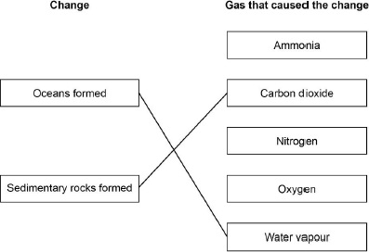
do not accept more than one line from a box on the left
2
(b) nitrogen
1
(c) (number of times more =)
1
= 2375
1
= 2.375 × 10³
allow a correctly calculated answer in standard form from an incorrect calculation which uses values given in the table
1
(d) increased
1
(e) (mass CO₂ =)
1
= 4.3 (kg)
1
(f) photosynthesis
1
(g) any two from:
(forest area)
• increases in Africa
• increases in Europe
• decreases in South America
• decreases in Asia
2
(h) 6 (%)
1
(i) (A) reuse
1
(B) recycle
1
[15]
Q8.
(a) Level 2: The method would lead to the production of a valid outcome. The key steps are identified and logically sequenced.
3−4
Level 1: The method would not lead to a valid outcome. Some relevant steps are identified, but links are not made clear.
1−2
No relevant content
0
Indicative content
• use the signal generator to adjust the frequency
• keep the number of masses the same
• move the wooden bridge
• observe a steady / stationary wave pattern
• use the metre rule to measure the wavelength
• repeat using different values of frequency
• repeat for different stationary wave patterns
(b) v = f × λ
1
(c) 35.1 = 45.0 × λ
1
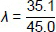
1
λ = 0.78
allow 0.780
1
[8]
Q9.
(a) gravitational force
1
(b) air resistance
1
(c) 450 (N)
1
(d) 0 N
1
(e) terminal velocity
1
(f) 20 (s)
allow an answer in the range 18 to 21 (s)
1
(g) 46 (m/s)
1
(h) s = 3.6 × 25
1
90 (m)
1
[9]

