Q1.
This question is about cells.
Figure 1 shows an animal cell.
Figure 1
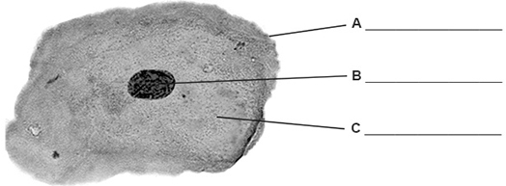
(a) Label parts A, B and C on Figure 1.
Choose answers from the box.

cell membrane |  | cell wall |  | chloroplast
 | cytoplasm |  | nucleus
(3)
(b) What is the function of the nucleus in a cell?
Tick (✓) one box.

To contain a solution called cell sap | 
To control the activities of the whole cell
To control the movement of substances into the cell
(1)
(c) What is the function of the mitochondria in a cell?
Tick (✓) one box.

To produce glucose during photosynthesis
To produce proteins for the cell
To release energy in respiration
(1)
(d) Figure 2 shows a light microscope.
Figure 2
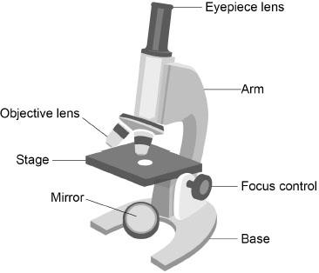
A student is given a prepared slide of animal cells to view using the microscope.
Complete the sentences.
Use labels from Figure 2.
Place the slide on the ____________________ .
Use the objective lens that has low power.
Look through the ____________________.
Direct the light by moving the ____________________ .
Make the image larger by using the high power ____________________.
(4)
(e) Figure 3 shows a different animal cell.
Figure 3
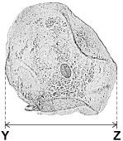
Calculate the magnification of the image in Figure 3.
Complete the following steps.
Measure the width of the image from Y to Z, in millimetres (mm).
Width of image = ____________ mm

Give the width of the image in micrometres (µm).
1 mm = 1000 μm
___________________________________________________________________
Width of image = ____________ μm
The cell in Figure 3 has a real width of 40 micrometres (μm).
Use the equation to calculate the magnification.
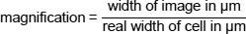
___________________________________________________________________
___________________________________________________________________
___________________________________________________________________
Magnification = × ____________
(4)
(Total 13 marks)
Q2.
A student investigated the loss of mass from leaves that were placed in winds of different speed.
The student used an electric fan to create different wind speeds.
The figure below shows the apparatus.
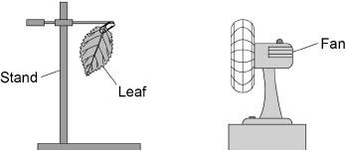
This is the method used.
1. Record the mass of one leaf taken from a plant.
2. Attach the leaf to a stand.
3. Leave for 1 hour with the fan off.
4. Record the final mass of the leaf.
5. Repeat steps 1 to 4 with the fan set at different speeds. Use leaves of a similar size each time.
6. Calculate the loss of mass for each leaf.
The table below shows the results.

Fan setting | Loss of mass in grams
Off | 0.06
Low speed | 0.15
Medium speed | 0.23
High speed | 0.31

(a) Why did the student do one experiment with the fan off?
___________________________________________________________________
___________________________________________________________________
(1)
(b) How does increasing fan speed affect the loss of mass from the leaves?
Use the table above.
___________________________________________________________________
___________________________________________________________________
(1)
(c) Explain why the mass of the leaves decreased at all fan speeds.
___________________________________________________________________
___________________________________________________________________
___________________________________________________________________
___________________________________________________________________
___________________________________________________________________
___________________________________________________________________
___________________________________________________________________
(3)
(d) The student repeated the investigation in a room at a higher temperature.
Complete the sentence.
Choose the answer from the box.

smaller | the same | greater
At a higher temperature the loss of mass from the leaves
would be ________________________________ .
(1)
(e) How could the student check the repeatability of the results?
Tick (✓) one box.

Do the investigation again using a different method.
Do the investigation again using a different type of plant.
Do the investigation again using the same method.
(1)
(Total 7 marks)
Q3.
A student investigated the concentration of salt in solution Z.
The student used a method involving osmosis.
The student used tubing made of partially permeable membrane.
This is the method used.
1. Cut six pieces of tubing to the same length.
2. Tie one end of each piece of tubing.
3. Put the same volume of solution Z into each piece of tubing.
4. Tie the other end of each piece of tubing to form a sealed tube.
5. Record the mass of each tube.
6. Place each tube into a different concentration of salt solution.
7. After 2 hours, remove each tube from the salt solutions.
8. Record the mass of each tube.
Figure 1 shows one of the sealed tubes in a salt solution.
Figure 1
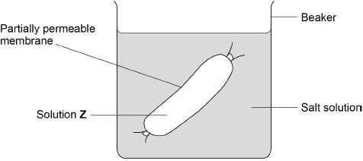
(a) What was the independent variable for the investigation?
Tick (✓) one box.

Change in mass of tube
Concentration of salt solution
Time in salt solution
Volume of solution Z
(1)
(b) The student dried the outside of each tube with a paper towel before recording the mass.
Why was it important to dry the tubes?
___________________________________________________________________
___________________________________________________________________
(1)
The table below shows the results.

Concentration of salt solution in mol/dm³ | Mass of tube in grams |  |  | Percentage (%) change in mass
Concentration of salt solution in mol/dm³ | At start | After 2 hours | Change | Percentage (%) change in mass
0.0 | 15.54 | 16.50 | 0.96 | X
0.2 | 15.16 | 15.78 | 0.62 | 4.1
0.4 | 15.00 | 15.35 | 0.35 | 2.3
0.6 | 15.29 | 15.37 | 0.08 | 0.5
0.8 | 14.95 | 14.75 | –0.20 | –1.3
1.0 | 14.77 | 14.40 | –0.37 | –2.5

(c) Calculate value X in the table above.
Give your answer to 1 decimal place.
___________________________________________________________________
___________________________________________________________________
___________________________________________________________________
___________________________________________________________________
___________________________________________________________________
Value X (1 decimal place) = ____________________ %
(3)
(d) Complete Figure 2.
You should:
• plot the percentage change in mass from the table above for salt concentrations of only 0.2 mol/dm³ to 1.0 mol/dm³
• draw a line of best fit.
One of the results has been plotted for you.
(3)
Figure 2
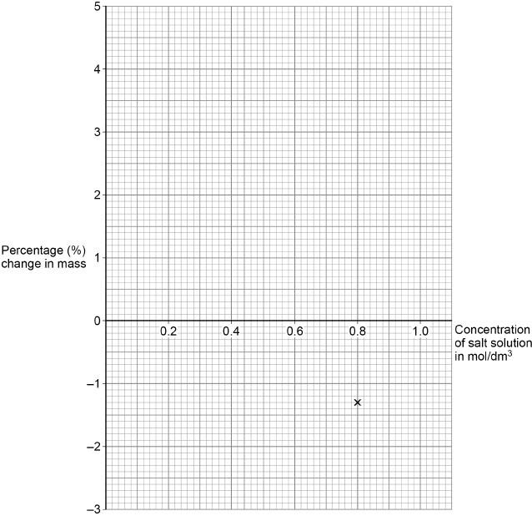
(e) Determine the concentration of salt in solution Z.
Use Figure 2.
Concentration = ____________________ mol/dm³
(1)
(Total 9 marks)
Q4.
A leaf is a plant organ.
Figure 1 shows tissues in a leaf.
Figure 1
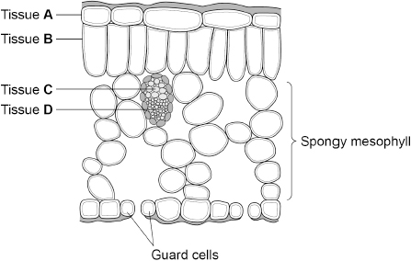
(a) Which tissue is the epidermis?
Tick (✓) one box.

A |  | B |  | C |  | D
(1)
(b) Explain how the spongy mesophyll is adapted for its function.
Use Figure 1.
___________________________________________________________________
___________________________________________________________________
___________________________________________________________________
___________________________________________________________________
___________________________________________________________________
___________________________________________________________________
(3)
(c) The xylem is adapted to transport water through a plant.
Explain one way that xylem is adapted for its function.
___________________________________________________________________
___________________________________________________________________
___________________________________________________________________
___________________________________________________________________
(2)
(d) Figure 2 shows a pair of guard cells around a stoma.
Figure 2
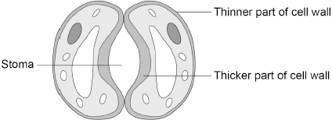
During the day, glucose is made in the guard cells.
Describe how an increase in glucose concentration in the guard cells causes the stoma to open.
___________________________________________________________________
___________________________________________________________________
___________________________________________________________________
___________________________________________________________________
(2)
(Total 8 marks)
Q5.
Communicable and non-communicable diseases are major causes of ill health.
(a) Which disease is a non-communicable disease?
Tick (✓) one box.

AIDS
Cancer
Gonorrhoea
Malaria
(1)
Obesity is a risk factor for many non-communicable diseases.
(b) Give one non-communicable disease that obesity is a risk factor for.
Do not refer to the diseases given in part (a) in your answer.
___________________________________________________________________
(1)
(c) National policies are used to help people who are obese to lose weight.
One national policy is to reduce the amount of sugar added to food and drinks.
Suggest one other national policy that could help people to lose weight.
___________________________________________________________________
___________________________________________________________________
(1)
(d) Body mass index (BMI) is one measure of obesity.
BMI is calculated using the equation:
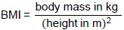
The table below shows how BMI is used to describe an adult’s BMI category.

BMI | BMI category
<18.5 | Underweight
18.5 to 24.9 | Healthy weight
25.0 to 29.9 | Overweight
>29.9 | Obese
A person is 1.64 m tall and has a mass of 69 kg.
Determine the BMI category for this person.
Use the BMI equation and the table above.
___________________________________________________________________
___________________________________________________________________
___________________________________________________________________
___________________________________________________________________
___________________________________________________________________
The person’s BMI category is ____________________
(3)
Scientists investigated the effect of smoking and of BMI on the birth mass of babies.
Women’s BMI categories were determined before the women became pregnant.
(e) Suggest why BMI categories were determined before the women became pregnant.
___________________________________________________________________
___________________________________________________________________
(1)
The figure below shows the results.
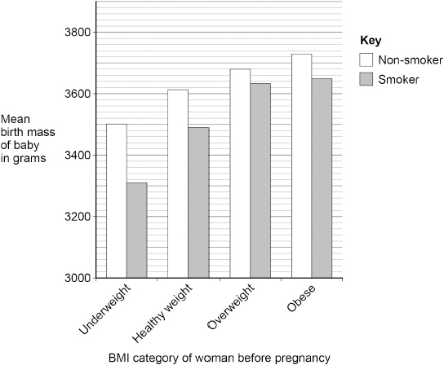
(f) Give two conclusions that can be made from the figure above.
1 _________________________________________________________________
___________________________________________________________________
2 _________________________________________________________________
___________________________________________________________________
(2)
(g) Measles is a communicable disease.
A virus causes measles.
Describe how the measles virus is transferred from person to person.
___________________________________________________________________
___________________________________________________________________
___________________________________________________________________
___________________________________________________________________
(2)
Athlete’s foot is a communicable disease.
A fungus causes athlete’s foot.
The athlete’s foot fungus infects the skin on feet.
(h) Scientists estimate that 17% of the UK population have athlete’s foot.
The estimated UK population is 67 961 900
Calculate how many people are estimated to have athlete’s foot.
___________________________________________________________________
___________________________________________________________________
___________________________________________________________________
Estimated number of people with athlete’s foot = ___________________________
(2)
(i) Athlete’s foot fungus grows in moist conditions.
Suggest one way a person could reduce their chance of catching athlete’s foot.
___________________________________________________________________
___________________________________________________________________
(1)
(Total 14 marks)
Q6.
This question is about photosynthesis.
(a) What is the symbol equation for photosynthesis?
Tick (✓) one box.

6 CO₂ + C₆H₁₂O₆ | → 6 H₂O + 6 O₂
C₆H₁₂O₆ + 6 O₂ | → 6 CO₂ + 6 H₂O
6 CO₂ + 6 H₂O | → C₆H₁₂O₆ + 6 O₂
6 O₂ + 6 H₂O | → 6 CO₂ + C₆H₁₂O₆
(1)
A student investigated the relationship between temperature and the rate of photosynthesis.
The student measured the volume of gas produced by an aquatic plant in 1 hour.
The student collected the gas in a measuring cylinder.
The table below shows the results.

Temperature in °C | Volume of gas produced in 1 hour in cm³
10 | 1
15 | 2
20 | 4
25 | 8
30 | 16
35 | 16
40 | 2
45 | 0
(b) Describe the effect of increasing temperature on the rate of photosynthesis.
Use data from the table above.
___________________________________________________________________
___________________________________________________________________
___________________________________________________________________
___________________________________________________________________
___________________________________________________________________
___________________________________________________________________
(3)
(c) Explain why no gas was produced by the plant at 45 °C.
___________________________________________________________________
___________________________________________________________________
___________________________________________________________________
___________________________________________________________________
(2)
(d) How could the student increase the accuracy of the results?
Tick (✓) one box.

Repeat the investigation, collecting the gas for 24 hours.
Repeat the investigation, measuring the volume of gas to 0.5 cm³.
Repeat the investigation using a different aquatic plant.
Repeat the investigation, using temperatures of 5 °C and 50 °C.
(1)
A person grows tomatoes in a greenhouse.
(e) The mean temperature of the greenhouse is 15 °C.
A heater would keep the temperature of the greenhouse at 25 °C.
Suggest two reasons against using a heater set at 25 °C in the greenhouse.
Do not refer to cost in your answer.
1 _________________________________________________________________
___________________________________________________________________
2 _________________________________________________________________
___________________________________________________________________
(2)
(f) The person cut a stem from one of the tomato plants.
The cut stem was placed in soil to grow new roots.
Which tissue in the cut stem will differentiate into new root cells?
Tick (✓) one box.

Epidermis
Meristem
Mesophyll
Phloem
(1)
(Total 10 marks)

Mark schemes
Q1.
(a) A - (cell) membrane
1
B - nucleus
1
C - cytoplasm
1
(b) to control the activities of the whole cell
1
(c) to release energy in respiration
1
(d) stage
must be in this order
1
eyepiece lens
allow eyepiece
ignore lens unqualified
1
mirror
1
objective lens
allow objective
ignore lens unqualified
1
(e) measurement
36 (mm)
allow in the range of 35 to 37 (mm)
1
conversion
36 000 (μm)
allow an answer using student's measurement × 1000
1
substitution
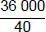
allow student's converted measurement divided by 40
1
magnification
900
do not accept if units given
1
[13]
Q2.
(a) (as a) control
allow to show the effect of fan / wind
do not accept control variable
or
(to) compare (the other results to)
1
(b) (loss of mass / water) increases
allow mass of leaves decreases more
allow more (mass / water) is lost
1
(c) loss of water
1
(because water) evaporated
allow by transpiration
allow diffusion
1
from stomata / stoma
ignore from guard cells
1
(d) greater
1
(e) do the investigation again using the same method
1
[7]
Q3.
(a) concentration of salt solution
1
(b) (water / solution on the tube / tubing) would affect / increase the mass
allow the results would not be valid
1
(c)
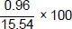
1
6.17 (760618...)(%)
1
6.2 (%)
allow answer written in Table 1
allow correct conversion to one decimal place from students' incorrect percentage change calculation using figures from 0.0 Concentration of salt solution in mol/dm³
1
(d) all 4 points plotted correctly
allow a tolerance of ± ½ a small square
allow 1 mark for 3 points plotted correctly
ignore attempt to plot a point for 0 mol/dm³
2
line of best fit
ignore extrapolation
1
(e) value from student's line of best fit
allow a tolerance of ± ½ a small square
if no line of best fit drawn allow 1 mark for an answer in the range
1
[9]
Q4.
(a) A
1
(b) has (large) air spaces (between cells)
allow has (large) gaps (between cells)
1
(so) gases can diffuse / move through the leaf
allow carbon dioxide or oxygen or water vapour for gases
1
to / from the photosynthetic / palisade / B layer
allow to / from the upper mesophyll
if named gas given for mp 2 direction of movement must be correct
1
if no other marks awarded allow 1 mark for cells have chloroplasts for photosynthesis
(c) composed of hollow tubes / cells
allow cells are empty
allow no cytoplasm / nucleus / sub-cellular structures
1
(so) no obstruction to water flow
allow (so) water flows easily if linked to hollow tubes
allow to maintain the transpiration stream
OR
has lignin (1)
ignore has thick walls
(to) hold tubes open (1)
or
(to) strengthen the tubes
allow (to) keep water inside xylem
allow (to) make tubes rigid
OR
no end walls (1)
(so) water flows easily (1)
or
(so) water flows continuously
must be linked to an adaptation
allow (so) maintains a constant water flow
allow to maintain the transpiration stream
1
reason must correctly match the structure
(d) water enters (guard) cells by osmosis
allow water enters (guard) cells because the concentration of water is higher outside the cell than inside the cell
1
cells swell and curve (to open the stoma)
allow cells become turgid and curve (to open the stoma)
allow inner wall of (guard) cell is thicker / stronger or less flexible than outer wall so cells curve (to open stoma)
1
[8]
Q5.
(a) cancer
1
(b) any one from:
ignore cancer
• (coronary) heart disease / CHD / cardiovascular disease
allow atherosclerosis
ignore heart attack
• diabetes
allow high blood pressure
allow stroke / asthma / depression / gallstones / (osteo)arthritis
allow sleep apnoea
1
(c) any one from:
• taxes on high energy / fat / sugar foods
allow increase the price on high energy / fat / sugar foods
• education (about diet and health)
• (government) advertising
• restrict media advertising of high energy / fat / sugar foods
• information on food labels
• help / advice / groups for obese people via the NHS
• calorie information on restaurant / takeaway menus
• regulation of supermarket offers on high sugar / fat / energy foods
• regulation of type of foods for sale near checkouts
• exercise campaigns
1
(d) 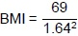
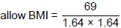
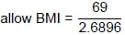
1
BMI = 25.6(5437....)
allow 26 or 25.7
1
(the person's BMI category is) overweight
must be consistent with their calculated BMI value
1
(e) any one from:
• women will gain mass / weight (during pregnancy)
allow BMI (of woman) will increase (during pregnancy)
• (developing) baby will increase mass / weight of woman
1
(f) any two from:
• smokers had babies with lower birth mass
• women / smokers / non-smokers with higher BMI had heavier babies
allow obese women have the heaviest / heavier babies
allow underweight women have the lightest / lighter babies
• smoking had the greatest effect on birth mass in underweight women
• smoking had the least effect on birth mass in overweight women
• smoking had less effect on birth mass in overweight and obese women (than in underweight and healthy weight women)
allow there is only a 365 g difference between the smallest and largest babies
2
statements must be comparative
allow converse statements
allow weight for mass
(g) coughs / sneezes (spread virus in droplets)
allow breathing out (spreads virus in droplets)
1
droplets / virus are inhaled
allow droplets / virus are breathed in
ignore contact with infected person unqualified
1
assume 'it' refers to the virus
allow touch a contaminated surface and then touch your mouth / nose / eyes for 1 mark
if no other marks awarded allow kissing for 1 mark only
(h) 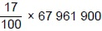
allow 0.17 x 67 961 900
1
= 11 553 523
allow 11 553 500
1
(i) any one from:
• dry feet thoroughly (after washing)
allow use foot powder
ignore keep feet dry
ignore wash feet regularly
• do not share socks / tights / shoes / towels
• use a fungicide
allow named fungicide
allow wear silver(-impregnated) socks
• do not walk around barefoot in public / contaminated areas
allow wear flip flops in public / contaminated areas
ignore avoid moist conditions
1
[14]
Q6.
(a) 6CO₂ + 6H₂O → C₆H₁₂O₆ + 6O₂
1
(b) (as temperature increases) the rate of photosynthesis increases then (the rate of photosynthesis) decreases
ignore references to volume unqualified
1
fastest rate between 30 °C and 35 °C
allow a fastest rate at a temperature above 30 °C and below 35 °C
allow reaches an optimum temperature between 30 °C and 35 °C
1
up to 30 °C the rate doubles every 5 °C increase
allow up to 30 °C the rate increases at an increasing rate
allow up to 30 °C the rate increases exponentially
1
(c) enzymes (in the plant / chloroplast) become destroyed
allow enzymes become denatured
do not accept enzymes are killed
do not accept cells / plants are denatured
1
(because) active site changes shape
OR
the active site changes shape (1)
(so) the substrate no longer fits / binds (1)
OR
enzymes (in the plant / chloroplast) become destroyed (1)
allow enzymes become denatured
do not accept enzymes are killed
do not accept cells / plants are denatured
(so) the substrate no longer fits / binds (1)
ignore the plant is killed / dead
1
(d) repeat the investigation, measuring the volume of gas to 0.5 cm³
1
(e) any two from:
• may have too many tomatoes to eat / sell
allow the idea of a glut or all ripen at the same time
• other factors could limit photosynthesis
allow other named limiting factor could limit photosynthesis
allow factors could limit tomato production
• the optimum temperature might be above / below 25 °C
• greenhouses are poorly insulated
• pollution from the heater
allow increase carbon dioxide emissions
allow increase global warming
• increase the rate of transpiration
allow increase the water loss from the plant
• increased spread of plant disease(s)
if no other mark awarded allow it is a fire hazard for 1 mark
2
(f) meristem
1
[10]

