Year 13 Film Studies Mock Exams Preparation:
Component 1 = 2 hrs 30min
Section A: Hollywood 1930-1990 (comparative study) – Vertigo & Do the Right Thing
One question from a choice of two, requiring reference to two Hollywood films, one from the Classical Hollywood period (1930-1960) and the other from the New Hollywood period (1961-1990).

Section B: American film since 2005 /2012 (two-film study) – Captain Fantastic & Joker
One question from a choice of two, requiring reference to two American films, one mainstream film and one contemporary independent film.

Section C: British film since 1995 (two-film study) – Shaun of the Dead & This is England
One question from a choice of two, requiring reference to two British films.

Component 2 = 2 hrs 30min
Section A: Global film (two-film study) – Mustang & City of God
One question from a choice of two, requiring reference to two global films: one European and one produced outside Europe.

Section B: Documentary film – will not be tested in the Mock - Amy
One question from a choice of two, requiring reference to one documentary film.

Section C: Film movements – Silent cinema – Buster Keaton Shorts
One question from a choice of two, requiring reference to one silent film or group of films.

Section D: Film movements – Experimental film (1960-2001) - Memento
One question from a choice of two, requiring reference to one film option.

The following revision material can be found on the students’ Film Studies Teams Tile:

- AL Film Studies Specification
- Knowledge Organisers
This table indicates which film is assessed for which specialist study area:
- Films
- Lesson Streams
- Independent Learning Documents
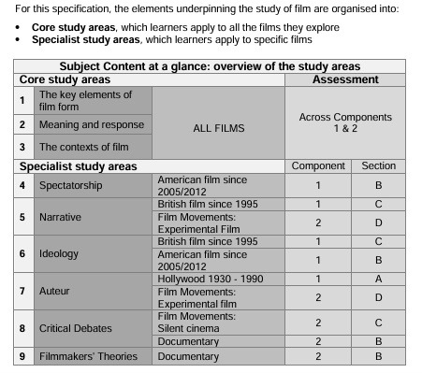
- Essay Structures & Sample Responses
- Example Past Papers & Questions

