
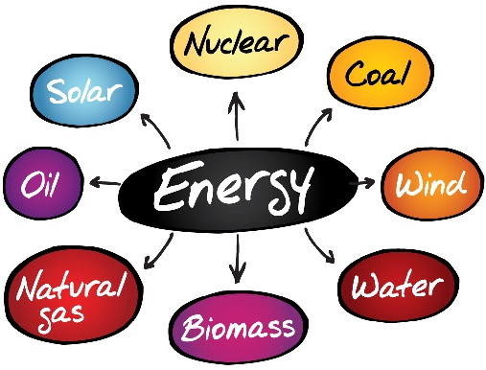
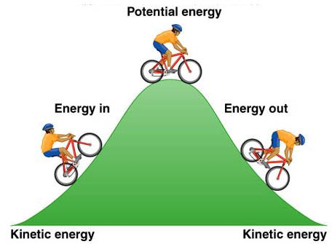
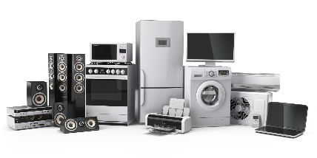
What is meant by power?

What is the equation for calculating power?

A motor transfers 10 000J of energy in 30s what is its power?

How do you calculate efficiency of power?

P1 – Conservation and dissipation of energy

Describe the difference between genetic and environmental variation

What happens to the GPE stores when an object moves up or down?

What is the equation to calculate change in GPE of an object when it moves up or down?
How is energy supplied to our homes?

Why are electrical appliances so useful?

Describe what is meant by useful and wasted energy:

What eventually happens to wasted energy?

Is energy still as useful after it is used? Explain

Write the equation for calculating KE:

Write the equation for calculating EPE:

What factors affect the energy in a KE store?

What is meant by efficiency?

How do you calculate efficiency?

How is energy wasted by machines?

HT Only How can we improve efficiency of machines?

Calculate the efficiency if:
- Total energy = 80J, useful energy = 35J
- Total energy = 125J, useful energy = 96J
- Total energy = 1050J, useful energy = 1012J

How is energy transferred? By what methods?

Describe what is meant by conservation of energy

Define work in science:

What is the equation needed to calculate work done?

What happens to work done to overcome friction?

Name and describe the different energy stores

