Childhood
Western notion of childhood | Has the position of children improved? | The future of childhood
Childhood is seen as a separate golden age of happiness and innocence. Children are seen as vulnerable and need protecting by being kept separate from the dangers of the adult world (child centredness). Laws - regulate what children are allowed or forbidden to do, e.g. excluded from paid work. Products and services especially for children – toys, food, books, entertainment, play areas. Dress – where different types of clothes form adults. | March of progress view - childhood has improved.  - Better educated - £64billion spent on education in the UK each year.  - Protected from abuse – child abuse laws.  - More child centred – no longer to be ‘seen and not heard’ – focal point of families and frequently consulted on decisions.  - Media and leisure activities – cater for the needs of children.  Evaluation  Idealised image of childhood – ignores the dark side of childhood (abuse, bullying, divorce etc.).  Conflict view – childhood has not improved for all children, variability.  1. Inequalities between children  - Gender differences – feminists argue that girl’s do more domestic labour than boys.  - Ethnic differences – Asian parents are more likely to be overly strict and restricting with their daughters than other parents.  - Class differences – Marxists argue that poorer working class children have higher infant and childhood mortality levels, suffer more long term illness, do less well at school and are more likely to be placed on the child protection register.  - International differences – childhood and life chances varies across the world e.g. higher infant mortality rates, poverty, child soldiers etc. in the Third world.  2. Inequalities between children and adults  Liberationists such as Firestone (1979) claim adults do not always use their power to protect children, but instead to dominate, oppress and control them - age patriarchy.  - Space and movement – restrictions on places children can play, cctv in schools, driven to school – in Sudan children free to ‘roam’.  - Time - adults control daily routines (e.g. bed time, tv time) and the speed children ‘grow up’ – in Samoa children never too young to do adult tasks.    - Bodies – adults control how children sit, dress, hairstyles, thumb sucking, piercings – In Trobiand Islands children have greater sexual freedom.  - Neglect and abuse (‘dark side’ of family life) – physical, sexual and emotional abuse.  Evaluation  Adult intervention and control is necessary - to safe guard children who are not mature enough to make rational decisions. | The disappearance of childhood  Postman (1994) suggests that the period of childhood is shortening – children are growing up too quickly and losing their innocence.  - Disappearance of children’s unsupervised games.  - Growing similarity of adult and children’s clothing.  - Children committing ‘adult’ crimes e.g. gun and knife crime.  - Underage sex, drinking and smoking.  Palmer (2006, Toxic childhood) Children’s physical, emotional and intellectual development is being damaged because of junk food, computer games, long working hours of parents, over-testing in schools etc.    The UK is low in surveys of children’s well being - concerns exist about obesity, self-harm, drug and alcohol abuse, violence, under age sex, teenage pregnancies, anorexia, self-harm.  Reasons for the disappearance of childhood  Postman suggests that technology and the media have eroded the boundary between childhood and adulthood - TV and the internet have allowed children to access adult knowledge and to grow up too quickly. Exposed to the real world of sex, disaster, death and suffering.  Evaluation  Not all children are equally affected by the above changes – mainly children from the lower social classes and poorer social groups.  Childhood is not disappearing  Opie (1993) suggests that childhood is not disappearing – children still have their own independent separate culture. She illustrates with the games, rhymes and songs children still grow up with, often unsupervised by adults.  Liberationists claim that far from disappearing, oppressive western patterns of childhood are spreading throughout the world (globalisation of western childhood). International agencies campaign for a separate childhood where children should be seen as innocent, vulnerable, need protection and have no economic role. E.g. campaigns against child labour and concerns about ‘street children’.
Childhood as a social construction
Childhood is socially constructed – something created and defined by society. Thus childhood is not natural, fixed and universal but is relative to time, place and culture.

Cross cultural differences
- Children take responsibility at an early age - in rural Bolivia children work in the home and community from 5 years of age.
- Less value placed on children being obedient – among the Tikopia (western Pacific) adults should not expect their children to be obedient (a concession granted by children).
- Children’s sexual behaviour varies – among Trobiand Islanders (western Pacific) – adults take the attitude of ‘amused interest and tolerance’ towards children’s sexual experiences.

Historical differences - Aries (1960) 10th to 13th Century – childhood did not exist.
- Same laws applied to children and adults – no distinction made between children and adults and children could receive the same punishments as adults.
- Dress - children would dress like adults.
- Toys and games specifically for children did not exist.

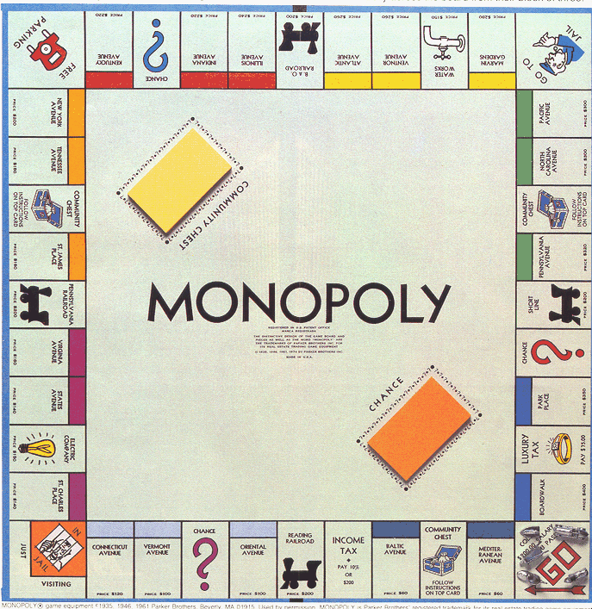
Reasons for changes in the position of children during the 19th and 20th Centuries (industrialisation)
Legal changes
- Child labour laws – restricting and excluding children from paid work has made children economically dependent on parents (in the past they were economic assets).
- Compulsory schooling and the raising of the school leaving age – created an extended period of economic dependency on adults.
- Child protection legislation – e.g. UN 1989 Rights Of The Child. Rights in terms of healthcare, education, protection from abuse, custody.
- Minimum age laws – e.g. sex and smoking laws reinforce the idea that children are separate form adults.

Other reasons
- Lower infant and child mortality rates and declining family size – as each child has greater chance of survival, parents are now more willing to make financial and emotional investments in their children.
- Impact of the mass media – children have access to the same information as adults because of tv and the internet.
Industrialisation – move from agriculture to factory production explains many of these changes. Eg modern industry needs educated workforce, hence compulsory schooling is crucial. Hence, industrialisation helped bring about changed status of children.
In conclusion the above views are an improvement on biological explanations of childhood. Many biological views assume that childhood is marked simply by the end of puberty. Sociological views recognise that childhood is fluid and varies according to time, place, social group etc.
Further reading
Pages 179-187 in Webb R et al. (2015) AQA AS level Sociology, Napier press.
Sample questions
a) Outline and explain two ways in which changing gender roles within the family may have affected children’s experience of childhood (10 marks)
b) Using one example, briefly explain how childhood may be a negative experience for some children in the United Kingdom today. (2 marks) [AS]
c) Outline and explain two ways in which government policies may affect the experience of childhood today. (10 marks)
d) Define the term ‘child-centred society’ (2 marks) [AS]
e) Outline three ways in which adults control children’s time, space and bodies (6 marks) [AS]

