Do now – Let’s get our imagination going! Thinking practice for Question 5 (the creative writing question)
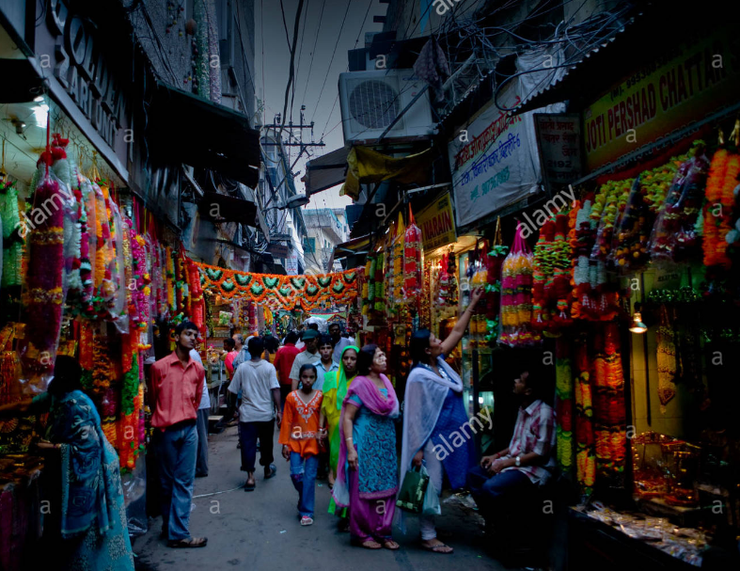 | I want to say the market stalls are: bright, nice, colourful.  List 5 more words/phrases I can use:  …………………………………………………………………..  ………………………………………………………………….  ………………………………………………………………….  ………………………………………………………………….  ………………………………………………………………….  ………………………………………………………………….
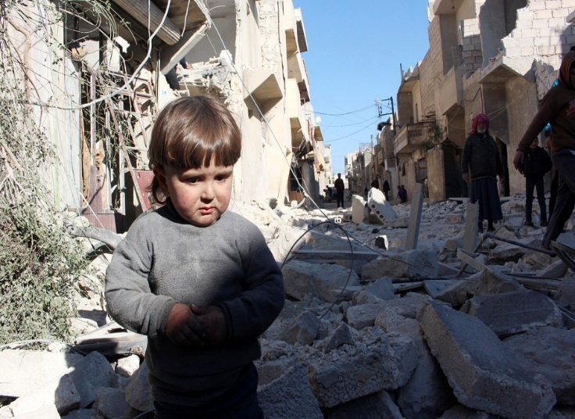 | I want to say the street was dusty, in a mess, broken.  List 5 more words/phrases I can use:  …………………………………………………………………..  ………………………………………………………………….  ………………………………………………………………….  ………………………………………………………………….  ………………………………………………………………….  ………………………………………………………………….
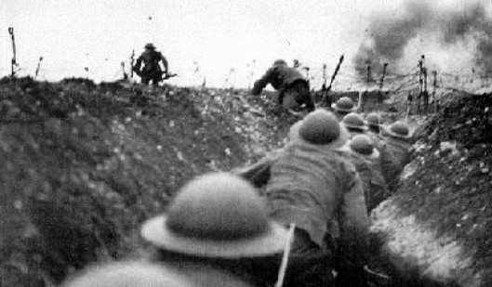 | I want to say the moment was scary because the noise was loud.  List 5 more words/phrases I can use:  …………………………………………………………………..  ………………………………………………………………….  ………………………………………………………………….  ………………………………………………………………….  ………………………………………………………………….  ………………………………………………………………….
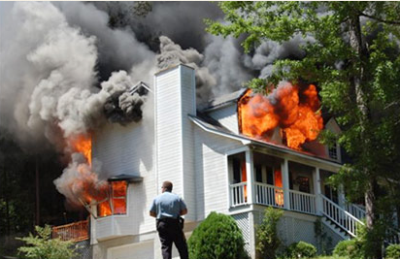 | I want to personify the fire, saying it was following me:  List 5 more words/phrases I can use:  …………………………………………………………………..  ………………………………………………………………….  ………………………………………………………………….  ………………………………………………………………….  ………………………………………………………………….  ………………………………………………………………….
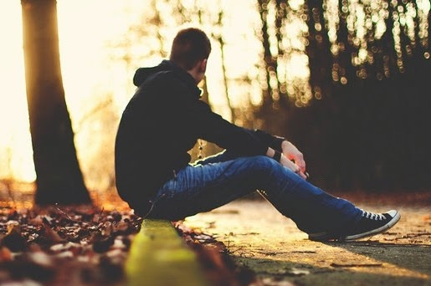
Task 1 – trouble shooting for creative writing!
Imagine you get this image in your exam:
Write your ideas in the speech bubbles, please be prepared to share with the class:
The image looks negative but I want to write a positive description!

The image is in daytime but I prefer writing about dark/night time

I can’t see any buildings but I want to say he’s waiting outside his house

I don’t know how to start!

So tomorrow in the exam – Question 5 first! For 45 minutes! Give it your all!
Then go back to the front of the paper and go through the reading questions:
Question 1 | Find 4 things about….. | Keep it simple! Just 4 true things from the lines it tells you to look at.
Question 2 | How does the writer use language to present (something/someone/somewhere) | Read the text and get an opinion of the something/someone/somewhere, then pick out words and explain how they give you that opinion:  The (something/someone/somewhere) is presented as ………………  The writer uses a ….. in this quote “………….”  This means that …………….and could suggest……………..  As a reader I imagine/wonder/feel interested in…/ am persuaded to like/dislike / ..
Question 3 | How does the writer structure the extract to interest you as a reader? | At the start the writer focuses my attention on…  This makes me wonder / hope / expect / feel curious about / feel surprised / uncomfortable for….  As the extract develops / in the second paragraph / in the third paragraph the writer changes my attention to….  This makes me wonder / hope / expect / feel curious about / feel surprised / uncomfortable for….  The writer also uses ……………………… (say where)  This makes me wonder / hope / expect / feel curious about / feel surprised / uncomfortable for….
Question 4 | Here’s an opinion about the extract you’ve read. XXXXXXXXXXXXXXXXX  To what extent do you agree? | AGREE WITH IT!  See the next page for more tips….

Question 4: They give you an opinion – agree with it and back up your opinion with some references to the extract.
Some common opinions they give you: | What this means in normal English? | So I just say some things about….
In the text the character of ……………. Is really brought to life. |  | What I learn about the character and how I can imagine them
In the text you can really imagine you’re in the room with the characters. |  | What I learn about the character and how I can imagine them
Readers can relate to the characters in this extract. |  | What I learn about the character and how I can imagine them because everyone knows a person like them or with their qualities
The character/place/etc really engages the reader’s interest. |  | What I learn about the character/place and why it’s interesting and makes me want to keep reading.

So to answer question 4 – agree and say why you do!

Now we’re going to read an extract and vote on which questions you’d like to practice together.

This extract is taken from Chapter 2 of The Kite Runner, a novel about growing up in Afghanistan. Amir, a young boy, is the narrator. In this extract Amir describes his house and his father – who he calls ‘Baba.’

Everyone agreed that my father, my Baba, had built the most beautiful house in the Wazir Akbar Khan district, a new and affluent neighbourhood in the northern part of Kabul. Some thought it was the prettiest house in all of Kabul. A broad entryway flanked by rosebushes led to the sprawling house of marble floors and wide windows. Intricate mosaic tiles, handpicked by Baba in Isfahan, covered the floors of the four bathrooms. Gold-stitched tapestries, which Baba had bought in Calcutta, lined the walls; a crystal chandelier hung from the vaulted ceiling.
Upstairs was my bedroom, Baba’s room, and his study, also known as “the smoking room,” which perpetually smelled of tobacco and cinnamon. Baba and his friends reclined on black leather chairs there after Ali had served dinner. They stuffed their pipes--except Baba always called it “fattening the pipe”--and discussed their favorite three topics: politics, business, soccer. Sometimes I asked Baba if I could sit with them, but Baba would stand in the doorway. “Go on, now,” he’d say. “This is grown-ups’ time. Why don’t you go read one of those books of yours?” He’d close the door, leave me to wonder why it was always grown-ups’ time with him. I’d sit by the door, knees drawn to my chest. Sometimes I sat there for an hour, sometimes two, listening to their laughter, their chatter.
The living room downstairs had a curved wall with custom-built cabinets. Inside sat framed family pictures: an old, grainy photo of my grandfather and King Nadir Shah taken in 1931, two years before the king’s assassination; they are standing over a dead deer, dressed in knee-high boots, rifles slung over their shoulders. There was a picture of my parents’ wedding night, Baba dashing in his black suit and my mother a smiling young princess in white. Here was Baba and his best friend and business partner, Rahim Khan, standing outside our house, neither one smiling--I am a baby in that photograph and Baba is holding me, looking tired and grim. I’m in his arms, but it’s Rahim Khan’s pinky my fingers are curled around.
Question 1: Look at the first paragraph and list 4 things about Amir’s house:
1. ……………………………………………………………………………………………………………….
2. ……………………………………………………………………………………………………………..
3. …………………………………………………………………………………………………………………..
4. ……………………………………………………………………………………………………………………..
Question 2: in the 2nd paragraph, how does the writer use language to present Amir’s father?
You could include the writer’s choice of:

• words and phrases
• language features and techniques
• sentence forms.

………………………………………………………………………………………………………………………………………………………………….
……………………………………………………………………………………………………………………………………………………………………
………………………………………………………………………………………………………………………………………………………………….
………………………………………………………………………………………………………………………………………………………………….
…………………………………………………………………………………………………………………………………………………………………..
………………………………………………………………………………………………………………………………………………………………….
………………………………………………………………………………………………………………………………………………………………..
……………………………………………………………………………………………………………………………………………………………….
………………………………………………………………………………………………………………………………………………………………
………………………………………………………………………………………………………………………………………………………………….
……………………………………………………………………………………………………………………………………………………………………
………………………………………………………………………………………………………………………………………………………………….
………………………………………………………………………………………………………………………………………………………………….
……………………………………………………………………………………………………………………………………………………………………
………………………………………………………………………………………………………………………………………………………………….
………………………………………………………………………………………………………………………………………………………………….
……………………………………………………………………………………………………………………………………………………………………
………………………………………………………………………………………………………………………………………………………………….
Question 3: How has the writer used structure to interest the reader?
You could write about:
• what the writer focuses your attention on at the beginning
• how and why the writer changes this focus as the extract develops
• any other structural features that interest you.
………………………………………………………………………………………………………………………………………………………………….
……………………………………………………………………………………………………………………………………………………………………
………………………………………………………………………………………………………………………………………………………………….
………………………………………………………………………………………………………………………………………………………………….
…………………………………………………………………………………………………………………………………………………………………..
………………………………………………………………………………………………………………………………………………………………….
………………………………………………………………………………………………………………………………………………………………..
……………………………………………………………………………………………………………………………………………………………….
………………………………………………………………………………………………………………………………………………………………
………………………………………………………………………………………………………………………………………………………………….
……………………………………………………………………………………………………………………………………………………………………
………………………………………………………………………………………………………………………………………………………………….
………………………………………………………………………………………………………………………………………………………………….
……………………………………………………………………………………………………………………………………………………………………
………………………………………………………………………………………………………………………………………………………………….
………………………………………………………………………………………………………………………………………………………………….
……………………………………………………………………………………………………………………………………………………………………
………………………………………………………………………………………………………………………………………………………………….
………………………………………………………………………………………………………………………………………………………………….
……………………………………………………………………………………………………………………………………………………………………
………………………………………………………………………………………………………………………………………………………………….
………………………………………………………………………………………………………………………………………………………………….
……………………………………………………………………………………………………………………………………………………………………
………………………………………………………………………………………………………………………………………………………………….
Question 4: One reader of the Kite Runner said ‘the description in this extract really brings to life the family and their relationships which is important in a novel.’
To what extent do you agree with this? Using quotes from the text, explain some reasons why you agree.
………………………………………………………………………………………………………………………………………………………………….
……………………………………………………………………………………………………………………………………………………………………
………………………………………………………………………………………………………………………………………………………………….
………………………………………………………………………………………………………………………………………………………………….
…………………………………………………………………………………………………………………………………………………………………..
………………………………………………………………………………………………………………………………………………………………….
………………………………………………………………………………………………………………………………………………………………..
……………………………………………………………………………………………………………………………………………………………….
………………………………………………………………………………………………………………………………………………………………
………………………………………………………………………………………………………………………………………………………………….
……………………………………………………………………………………………………………………………………………………………………
………………………………………………………………………………………………………………………………………………………………….
………………………………………………………………………………………………………………………………………………………………….
……………………………………………………………………………………………………………………………………………………………………
………………………………………………………………………………………………………………………………………………………………….
………………………………………………………………………………………………………………………………………………………………….
……………………………………………………………………………………………………………………………………………………………………
………………………………………………………………………………………………………………………………………………………………….
………………………………………………………………………………………………………………………………………………………………….
………………………………………………………………………………………………………………………………………………………………….
………………………………………………………………………………………………………………………………………………………………….
……………………………………………………………………………………………………………………………………………………………………
………………………………………………………………………………………………………………………………………………………………….
………………………………………………………………………………………………………………………………………………………………….

