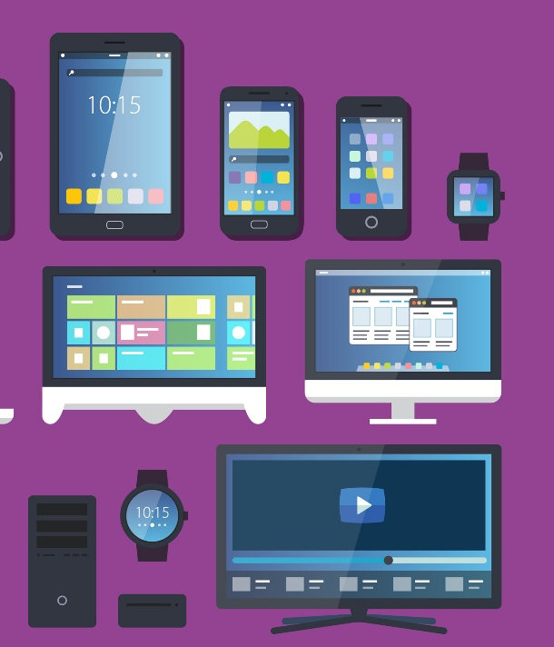
User Interfaces
- Allow the user to interact with the computer in a visual way.
- Graphs, text or audio are presented to the user.
GUI
- A type of interface that uses Windows Icons Menus and Pointers (WIMP) to represent the interaction between the user and a computer.
- Users use a mouse to interact with features displayed on the monitor.
- Powerful and easy to use but require a lot of processing power.
CLI
- User types a text command using the keyboard.
- The computer displays the results on the monitor.
- Requires little processing power and is extremely powerful.

Memory Management
- The management and organisation of memory at the system level.
- Memory is allocated between the different programs which are open.
- Programmers and users need not know where in memory data is held.
- Allocates free memory to programs that need it
- Frees up memory which is no longer needed.
- Controls the computer’s memory to optimise performance.
Encryption Software
- Scrambles the contents of files so they can only be understood by authorised users.
- A key or secret code is needed to descramble the content.
- Takes longer for messages to be sent and received.
- Increases security as data cannot be read if stolen.
- Can encrypt individual files or the whole hard disk.
Defragmentation Software
- Files on a disk are broken down into a series of segments.
- When files are deleted, the segments where they were stored are made available for new files.
- The new file may need more segments than the old, and so the segments allocated to it are not together on the disk. This is known as fragmentation.
- A fragmented disk takes longer to read from and write to, making the computer slower.
- Defragmentation software rearranges the segments so that they are stored next to each other.
- This decreases read/write time and improves performance.
Data Compression
- Reduces the size of a file.
- Uses algorithms.
- Smaller files are easier to transmit.
- Allows more files to be stored in the same space.
- Lossless - no data is lost and the original can be recreated.
- Lossy - some data is lost and the original file cannot be recreated.
Utility Software
Operating System Features
User Management | File Management
- Individual users can be created and deleted.  - Allows more than one person to use a computer with their own files and settings.  - Access levels control user access to systems for security.  - A log is kept of files a user creates, accesses, edits and deletes. | - All files are given a name.  - Files are stored in folders.  - Users can create, modify, move, and delete files and folders.  - Users can sort or search for files and folders.  - Users can restore deleted files.  - Users can set access rights to files.
Multitasking | Peripheral Management
- Many tasks can be executed on a computer simultaneously.  - An operating system has several processes running at the same time.  - Processor is given a small part of each task one after the other.  - All tasks appear to be executing at the same time.  - In reality, resources are shared between tasks. | - Allows devices to communicate with the computer.  - Data is transferred between devices and the processor.  - Controlled using Device Drivers:  - Contain instructions on how to control a device.  - Each device has its own driver.  - Any device can be used if a driver is available.  - Drivers can be updated to give better performance or fix bugs.

Operating Systems
- Tells the hardware what to do.
- Allows the computer to run other applications.
- Controls the operations of a computer.
- Provides an interface between the computer and a user.
- Hides the complexities of the hardware from the user.

Examples include:
- Microsoft Windows
- Apple OS X
- Linux
- Android
- Apple IOS
| Interface between the hardware and applications | Programs that run application software. | Software that helps the computer to run |

1.5 – Systems Software

