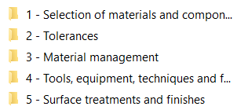
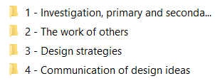
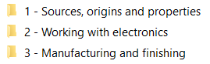
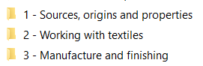
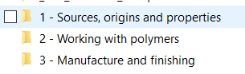
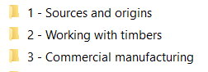
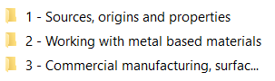
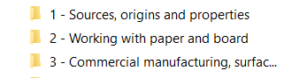
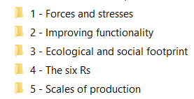
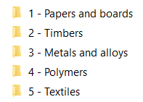
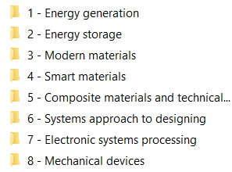
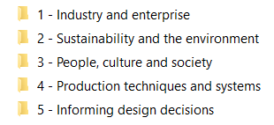
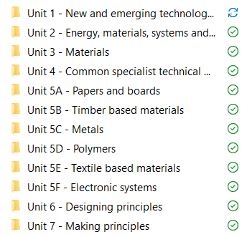
PG ONLINE RESOURCE FILES
Unit 7
Unit 6
Unit 5f
Unit 5e
Unit 5d
Unit 5c
Unit 5b
Unit 5a
Unit 1
Unit 2
Unit 3
Unit 4

Technology Student downloadable content free https://technologystudent.com/despro_flsh/new_revison1.html
Study Rocket https://studyrocket.co.uk/revision/gcse-design-and-technology-edexcel
BBC BITE SIZE https://www.bbc.co.uk/bitesize/examspecs/zb6h92p
Revision world.com https://revisionworld.com/gcse-revision/design-technology

