Christianity


Dictionary
Apocrypha: a collection of books that were not included in the Bible
Atheist: someone who does not believe in God or Gods
Authoritative: viewed as having power and being worthy of Trust and respect.
Agape: unconditional love
Baptism: a ritual in which people are immersed in water to symbolise turning away from sin and following God
Bishop: a Christian leader with authority over the priests and churches in an area
Cardinals: the most senior members of the Catholic church, after the pope
Catacombs: tunnels fill of tombs underneath Rome
Circumcision: the removal of a male’s foreskin
Conclave: the meeting at which a new Pope is elected
Confessional: a booth where Catholics ask a priest to grant them God’s forgiveness
Creed: a statement of belief
Congregation: people who attend a religious service
Denomination: a group within Christianity
Disciples: 12 men that Jesus chose to be his followers
Doctrine: a belief held and taught by a particular denomination
Early church: Christians in the first three centuries CE
Eucharist: the practicing of eating bread and drinking wine during a church service
Evangelism: spreading the Christian message in order to convert people
Excommunicated: expelled from the church
Free will: the ability to choose between right and wrong
Gentiles: a name given to non-Jews in the Bible
Gospels: the first four books of the New Testament about the life and teachings of Jesus, possibly named after their authors Matthew, Mark, Luke and John
Heresy: beliefs that are opposed to those of the church
Indulgences: certificates that people bought from the church so they would spend less time in purgatory when they died
Infallible: containing no faults or errors
Liberal: open to new ideas and less concerned with tradition
Martyred: when someone is killed for their beliefs
Missionaries: people who spread the Christian message
Monotheist: someone who believes in one God
Militants: individuals or groups who use violence to spread their ideas
New Testament: the last 27 books of the bible written shortly after Jesus’s lifetime
Ordained: made a priest or bishop in a special ceremony
Old testament: the first 39 books of the Bible written before the birth of Jesus
Penance: prayer or some other action to show that one is sorry for sinning
Persecution: discrimination against a group of people
Protestant: a form of Christianity that began in the 16th century as a protest against the Catholic church
Pilgrimage: a journey taken to a place of religious importance
Patriarchal: a way of describing a culture that is dominated and controlled by men
Reformation: a movement to reform the church resulting in the division of the western church into Catholicism and Protestantism
Resurrected: brought back to life after dying
Scriptures: religious texts such as the Bible
Spiritual gifts: supernatural abilities given by God for example the ability to prophesy or speak in tongues.
Sanctity of life: the belief that all life is God-given and sacred
Transubstantiation: the belief the bread and wine become the actual body and blood of Jesus during the Eucharist.
Trinity: the belief that God is three as well as one- Father, Son and Holy Spirit
Ten commandments: laws for how people should live, given to Moses by God in the old Testament
Worship: to show the highest respect of adoration for someone or something

- Beliefs and teachings
The nature of God
Christianity is a monotheistic religion and Christians believe in one God only. For Christians God shares many qualities such as being:
Omnipotent – all powerful
Omniscient - all knowing
Omnibenevolent – all loving/ good
Omnipresent- God is always present
Christians also see God as the creator of the world and that he is eternal which means that he has no beginning or end- God is everlasting. He is the giver and taker of life and there is only one God.
(Catholic)- Along the with qualities stated above Catholics also believe the nature of God to be holy as God is ‘other’, different from anything else he is sacred.
Creation, including the role of the Word and Spirit, with textual references to John 1 and Genesis 1-3.
As the creator of the world, Christians believe in the creation story in how God made the world in 6 days and rested on the 7th. There are two extractions of creation in the Bible that Christians refer to these are Genesis 1-3 and John 1.
Genesis 1-3: ‘Six Days of Creation and the Sabbath’
All Christians believe in the creation story and how God made the world, Genesis 1-3 is one of the stories that many Christians believe in.
“In the beginning God created the heavens and the earth, the earth was a formless void and darkness covered the face of the deep, while a wind from God swept over the faces of the waters and God said” …
Day 1 | “Let there be light” | God called the light day and the darkness night. And there was evening and there was morning the first day.
Day 2 | “God made the dome and separated the waters that were under the dome from the waters that were above the dome. And it was so. God called the dome Sky. Let the waters under the sky be gathered together into one place, and let the dry land appear”. | God created the sky, land the sea.
Day 3 | “Let the earth put forth vegetation: plants yielding seed, and fruit trees of every kind on earth that bear fruit with the seed in it”. | God created plants and trees.
Day 4 | “Let there be lights in the dome of the sky to separate the day from the night; and let them be for signs and for seasons and for days and years and let them be lights in the dome of the sky to give light upon the earth”. | God created the sun for the day and moon and stars for the night.
Day 5 | “Let the waters bring forth swarms of living creatures, and let birds fly above the earth across the dome of the sky. Be fruitful and multiply and fill the waters in the seas, and let birds multiply on the earth.” | God created creatures (fishes) and filled them in the water and filled the air with birds.
Day 6 | “Let the earth bring forth living creatures of every kind: cattle and creeping things and wild animals of the earth of every kind. “Let us make humankind in our image, according to our likeness; and let them have dominion over the fish of the sea, and over the birds of the air, and over the cattle, and over all the wild animals of the earth, and over every creeping thing that creeps upon the earth”. | God filled the land with creatures - animals and humans Adam and Eve.
Day 7 | “Thus the heavens and the earth were finished, and all their multitude. And on the seventh day God finished the work that he had done, and he rested on the seventh day from all the work that he had done. So God blessed the seventh day and hallowed it, because on it God rested from all the work that he had done in creation”. | God saw all that He had made, and it was very good. God blessed the 7th day and rested from all his work

Genesis 2: Another account of the Creation
“In the day that the Lord God made the earth and the heavens, when no plant of the field was yet in the earth and no herb of the field had yet sprung up—for the Lord God had not caused it to rain upon the earth, and there was no one to till the ground; but a stream would rise from the earth, and water the whole face of the ground— then the Lord God formed man from the dust of the ground, and breathed into his nostrils the breath of life; and the man became a living being. And the Lord God planted a garden in Eden, in the east; and there he put the man whom he had formed. Out of the ground the Lord God made to grow every tree that is pleasant to the sight and good for food, the tree of life also in the midst of the garden, and the tree of the knowledge of good and evil.
A river flows out of Eden to water the garden, and from there it divides and becomes four branches. The name of the first is Pishon; it is the one that flows around the whole land of Havilah, where there is gold; and the gold of that land is good; bdellium and onyx stone are there. The name of the second river is Gihon; it is the one that flows around the whole land of Cush. The name of the third river is Tigris, which flows east of Assyria. And the fourth river is the Euphrates.
The Lord God took the man and put him in the garden of Eden to till it and keep it. And the Lord God commanded the man, “You may freely eat of every tree of the garden; but of the tree of the knowledge of good and evil you shall not eat, for in the day that you eat of it you shall die.
Then the Lord God said, “It is not good that the man should be alone; I will make him a helper as his partner.” So out of the ground the Lord God formed every animal of the field and every bird of the air and brought them to the man to see what he would call them; and whatever the man called every living creature, that was its name. The man gave names to all cattle, and to the birds of the air, and to every animal of the field; but for the man there was not found a helper as his partner. So, the Lord God caused a deep sleep to fall upon the man, and he slept; then he took one of his ribs and closed up its place with flesh. And the rib that the Lord God had taken from the man he made into a woman and brought her to the man. Then the man said,
“This at last is bone of my bones
and flesh of my flesh;
this one shall be called Woman,
for out of Man this one was taken.”
Therefore, a man leaves his father and his mother and clings to his wife, and they become one flesh. And the man and his wife were both naked and were not ashamed”.

This narrative continues from the creation story and further talks about how God created humans (Adam and Eve) and talks about the Garden of Eden. The significance of Genesis 2 shows to Christians how Christians are made in the image from God. It also shows Gods knowledge by giving names to the animals, His righteousness, his holiness, principles and feelings. Some Christians believe Genesis 1 and 2 are two different accounts and some believe that they are 2 chapters of one continuous story.

Genesis 3: The First Sin and Its Punishment
“Now the serpent was more crafty than any other wild animal that the Lord God had made. He said to the woman, “Did God say, ‘You shall not eat from any tree in the garden’?” The woman said to the serpent, “We may eat of the fruit of the trees in the garden; but God said, ‘You shall not eat of the fruit of the tree that is in the middle of the garden, nor shall you touch it, or you shall die.’” But the serpent said to the woman, “You will not die; for God knows that when you eat of it your eyes will be opened, and you will be like God,^{[a]} knowing good and evil.” So when the woman saw that the tree was good for food, and that it was a delight to the eyes, and that the tree was to be desired to make one wise, she took of its fruit and ate; and she also gave some to her husband, who was with her, and he ate. Then the eyes of both were opened, and they knew that they were naked; and they sewed fig leaves together and made loincloths for themselves.
They heard the sound of the Lord God walking in the garden at the time of the evening breeze, and the man and his wife hid themselves from the presence of the Lord God among the trees of the garden. But the Lord God called to the man, and said to him, “Where are you?” He said, “I heard the sound of you in the garden, and I was afraid, because I was naked; and I hid myself.” He said, “Who told you that you were naked? Have you eaten from the tree of which I commanded you not to eat?” The man said, “The woman whom you gave to be with me, she gave me fruit from the tree, and I ate.” Then the Lord God said to the woman, “What is this that you have done?” The woman said, “The serpent tricked me, and I ate.” The Lord God said to the serpent,
“Because you have done this,
cursed are you among all animals
and among all wild creatures;
upon your belly you shall go,
and dust you shall eat
all the days of your life.
¹⁵ I will put enmity between you and the woman,
and between your offspring and hers;
he will strike your head,
and you will strike his heel.”
To the woman he said,
“I will greatly increase your pangs in childbearing;
in pain you shall bring forth children,
yet your desire shall be for your husband,
and he shall rule over you…”

(Catholic Christianity): Biblical accounts of creation (Genesis 1 and 2) and their significance for Catholic understanding of the natures of God, dignity of human beings and humanity’s relationship with creation.
Genesis 3 tells the narrative of how Eve was lured by a serpent to the tree of knowledge to eat fruit from it. Eve tells the serpent that God has told them to stay away from tree or that they will die. The serpent convinces Eve to eat the fruit and that when she does her eyes will be opened and she will be like God knowing good and evil.
Eve ate the fruit and gave some to Adam, from eating the fruit both of their eyes had open and they had seen each other naked and ran to cover themselves and sewed fig leaves and hid from the Lord. God called Adam but Adam did not come out and said to God I hid because you might see me naked God then said who told you that you were naked and had realised what Adam and Eve had done. From this God then punished them both and this is where the term original sin comes from.
These punishments consisted of making childbearing even more painful, men will rule over women, returning to dust etc.
… “And to the man he said,
“Because you have listened to the voice of your wife,
and have eaten of the tree
about which I commanded you,
‘You shall not eat of it,’
cursed is the ground because of you;
in toil you shall eat of it all the days of your life;
thorns and thistles it shall bring forth for you;
and you shall eat the plants of the field.
By the sweat of your face
you shall eat bread
until you return to the ground,
for out of it you were taken;
you are dust,
and to dust you shall return.”
The man named his wife Eve, because she was the mother of all living. And the Lord God made garments of skins for the man and for his wife and clothed them.
Then the Lord God said, “See, the man has become like one of us, knowing good and evil; and now, he might reach out his hand and take also from the tree of life, and eat, and live forever”— therefore the Lord God sent him forth from the garden of Eden, to till the ground from which he was taken. He drove out the man; and at the east of the garden of Eden he placed the cherubim, and a sword flaming and turning to guard the way to the tree of life.

Some Christians take the Genesis account literally and believe this is how the world was created without the help of any scientific discovery. However, for Catholic’s although they believe in the creation story and believe that God is the creator of all things, the accounts of Genesis 1 and 2 are received in a slightly different way.
For Catholic’s they believe that the stories from the Bible have to be understood within the time that they were written in. Catholics interpret science and reason along with the genesis account to understand creation and how God is responsible for it. Science may be able to explain how the universe was created but catholic Christians believe that the contribution of religion helps to explain this more and this is one of the differences between catholic Christians and other Christian groups.
To teach about creation, the catholic church uses both biblical accounts and the scientific theory of creation. The church teaches that the Genesis account is to be interpreted alongside science. Science may give answers, but Catholic’s ultimately believe God is entirely responsible for the whole of creation.
As all Christians, Catholics also believe that all human beings are created in the image of God and that humans are given a higher status. To describe the nature and their relationship with God may Catholics will use the Latin term ‘imago dei’ (made in the image of God) to describe this unique relationship that God and humans have. Different Christians have different understanding about being made in the image of God. For Catholics it shows and teaches that humans can be in a communion with God as he has given responsibilities to humans over his creation. God has given humans ‘dominion’ (to have rule or control over something’ over the world and made them ‘stewards’ (the duty of human beings care for the world) of the land.
Catholics do not see faith and science as conflicting, Catholics believe God created the universe with order, for Catholics all truth comes from God. They believe we learn more truths about God when we learn the truths about the universe through science. Science can bring us closer to god. God is the God of scientific truth and the God of scared truth.
Creation and Evolution- Catholic central https://www.youtube.com/watch?v=B_sE07heyy4
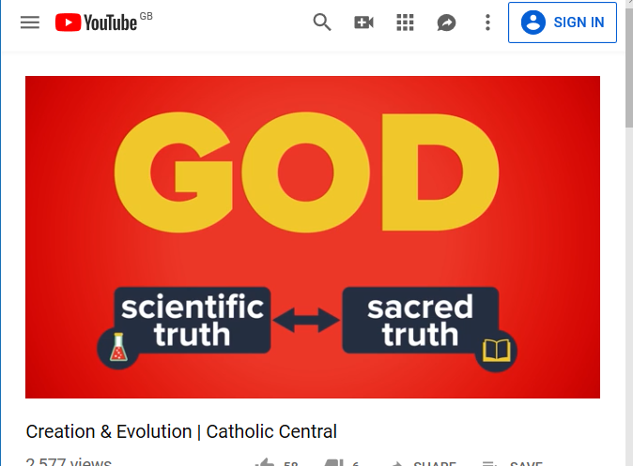
John 1: ‘The Word Became Flesh’
As many Christians believe in the creation story of Genesis 1-3, some Christians however believe in another adaptation of the creation story and this is John 1.
“In the beginning was the Word, and the Word was with God, and the Word was God. He was in the beginning with God. All things came into being through him, and without him not one thing came into being. What has come into being in him was life, and the life was the light of all people. The light shines in the darkness, and the darkness did not overcome it.”
There was a man sent from God, whose name was John. He came as a witness to testify to the light, so that all might believe through him. He himself was not the light, but he came to testify to the light. The true light, which enlightens everyone, was coming into the world.
He was in the world, and the world came into being through him; yet the world did not know him. He came to what was his own, and his own people did not accept him. But to all who received him, who believed in his name, he gave power to become children of God, who were born, not of blood or of the will of the flesh or of the will of man, but of God.
And the Word became flesh and lived among us, and we have seen his glory, the glory as of a father’s only son, full of grace and truth. (John testified to him and cried out, “This was he of whom I said, ‘He who comes after me ranks ahead of me because he was before me.”) From his fullness we have all received, grace upon grace. The law indeed was given through Moses; grace and truth came through Jesus Christ. No one has ever seen God. It is God the only Son, who is close to the Father’s heart, who has made him known”.

In John 1, this adaptation of the creation story includes the ‘Word’ (= Jesus) who is with God while earth is being created. The New Testament includes the story of creation of Jesus being with God. A key element of this verse from John 1 is the phrase of how the word ‘was’ is used. It is a timeless word – that is, it simply points to existence before the present time without reference to a point of origin. One can push back the “beginning” as far as you can imagine, and, according to John, the Word still is. Hence, the Word is eternal, timeless. The Word is not a creation that came into existence at “the beginning”.

The Trinity, including the oneness of God: Father, Son and Holy Spirit

(God in heaven)

Trinity

(God in the world)
(Jesus)

The Trinity was first formatted among early Christians and is linked together in the New Testament.
Christians are monotheists and believe in one God only. However, Christians also believe that God is three, this distinctive belief that God is both one and three is called the Trinity. The doctrine of the Trinity is an attempt to express how Christians understand God. The belief in the Trinity has caused many disagreements between Christians as some find it difficult to understand the concept in just how God can be expressed this way as each of the persons in the Trinity is fully God and these persons form a unity. Ultimately Christians accept that God is a mystery, he is unique and cannot be fully understood by humans.
In simpler terms in order to understand the concept of the Trinity the example of water can be used to explain this.
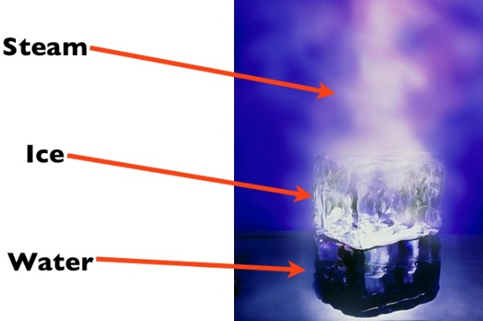
Water, ice and steam are all the same thing, the concept of using the model shows that the water, ice and steam have the same qualities and are made from the same thing but just in a different form. The Trinity shows that although there is one God he is experienced and understood in many ways.

God is also declared as one and the trinity shows that the Father, Son and Holy Spirit share the same one nature, but they are not the same thing, they are three distinct persons in one nature. To note: The Trinity is not mentioned in the Gospel.

(Catholic Christianity)- the Trinity and the Nicene Creed- Catholics also believe in the Holy Trinity and it is one of the greatest mysteries of the Catholic faith. The Nicene Creed is a statement of belief widely used in Christian liturgy. It is called Nicene because it was originally adopted in the city of Nicaea by the First Council of Nicaea in 325.
The Nicene Creed
We believe in one God,
the Father, the Almighty,
maker of heaven and earth,
of all that is, seen and unseen.
We believe in one Lord, Jesus Christ,
the only Son of God,
eternally begotten of the Father,
God from God, Light from Light,
true God from true God,
begotten, not made,
of one Being with the Father.
Through him all things were made.
For us and for our salvation
he came down from heaven:
by the power of the Holy Spirit
he became incarnate from the Virgin Mary,
and was made man.
For our sake he was crucified under Pontius Pilate;
he suffered death and was buried.
On the third day he rose again
in accordance with the Scriptures;
he ascended into heaven
and is seated at the right hand of the Father.
He will come again in glory to judge the living and the dead,
and his kingdom will have no end.
We believe in the Holy Spirit, the Lord, the giver of life,
who proceeds from the Father and the Son.
With the Father and the Son he is worshiped and glorified.
He has spoken through the Prophets.
We believe in one holy catholic and apostolic Church.
We acknowledge one baptism for the forgiveness of sins.
We look for the resurrection of the dead,
and the life of the world to come. Amen.

Catholics believe there are 3 distinct persons to this one God and that these 3 persons form a unity they believe in God the Father, the Son and Holy Spirit.

God the Father: like all Christians, Catholics also refer to God as the Father, and the Father is the creator of all things, he is loving and cares greatly for humanity.

God the son: God the son refers to Jesus Christ and for Catholics, Jesus is God in human form who was sent to save humanity. Catholics believe that the Son was present at the creation of the universe but was not in his human form at this stage. They believe God chose to reveal himself as a human being in order to spread his teaching on how life should be lived and to present to humanity salvation.

God the Holy spirit: Catholics believe the holy spirit is the power of God at work on earth. In scriptures the holy spirit is often depicted as wind, fire or in the form of a dove. It is through power and workings of the holy spirit that God is known today, and this shows Catholics what God wants them to do. It is also through the holy spirit that Catholics receive grace and gifts from God such as faithfulness and self-control. The Holy Spirit is connected with life and the soul. When Adam was created, God breathed life into him. Catholics also believe that it was through the Holy Spirit that Mary became pregnant with Jesus. Catholics believe that the Holy Spirit continues to act through people, producing characteristics which show a true Christian.

The main significance of the Nicene Creed was that it established much of what is now known as orthodox Christian teaching on the subject of God and the Trinity. It remains the only statement of faith that is accepted by all major parts of the Christian faith. The Nicene Creed expresses the truth of scripture concerning the doctrine of the Trinity.
The doctrine of the Trinity also has other functions:
- it brings humanity face to face with the mystery of God
- it helps understand God's complexity, otherness and mystery
- it helps humanity recognise the God they meet in the Bible, in history and in their own lives
- it helps humanity worship God
- steers humanity away from wrong ideas of God, such as: a patriarchal/hierarchical God and a God who can be logically understood
- it is the foundation of much Christian worship and liturgy
- helps humanity understand its own nature as made in the image of God
- it provides a model for human relationships, both as individuals and in community

The Nicene Creed is the declaration of the Christian faith for all Catholics and Orthodox as well as many Protestants. It is also called the Niceno-Constantinopolitan Creed, because it was defined at the Councils of Nicaea (325 A.D.) and Constantinople (381 A.D.).
The Nicene Creed explains the Church's teachings about the Trinity and affirms historical realities of Jesus' life. The creed does not directly quote Scripture, but it is based on biblical truths.

The Nicene Creed is the ultimate prayer for the Catholic Christian faith: "It is by believing with the heart that you are justified, and by making the declaration with your lips that you are saved. May the Year of Faith lead all believers to learn by heart the Creed and to say it every day as a prayer, so that the breathing agrees with the faith."

The problem of evil/suffering and a loving and righteousness God
Christians talk about the virtues of God and believe in how He is all good, powerful, loving, all knowing etc. and question why if there is a good all loving God why does evil exist? This here introduces the concept ‘the problem of evil’.
The problem of evil is a theory that has been around for a very long time since the time of ancient Greeks where people have studied and questioned evil. There are 4 main stages for this argument, the Greeks as well as some Christians believe:
- If God is omnibenevolent he would have the desire to get rid of evil and suffering because it causes so much unhappiness
- If God is omnipotent he would have the ability to get rid of evil because he can do everything, he is the creator of the world
- If God is omniscient, he would know how to get rid of evil because he knows everything
- There is evil in this world so either God does not exist, or he is not omnibenevolent, omnipotent or omniscient.
The problem of evil still remains a challenge to the Christian idea of God, as evil causes suffering. Many Christians still also question why is there suffering this world and think about the following 4:
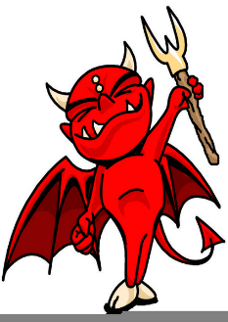
The Devil:
Evil and suffering together is something that Christians believe is caused by the devil. The Bible does not mention the devil but there is a story ‘Apocrypha’ that says he was an angel who was expelled from heaven as he refused to worship God. Some Christians believe that natural disasters are the work of the devil and other spiritual beings.
Key fact: in the Bible Jesus describes the devil as ‘the father or lies’. He also says ‘I saw Satan fall like lighting from heaven’- (this refers to the story of ‘Apocrypha’).

A test of faith:
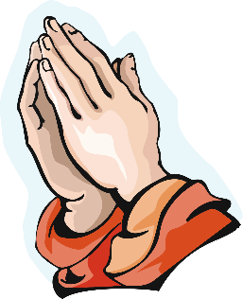
Some Christians say that suffering is a way of testing and strengthening people's faith. Through suffering people can also develop positive virtues such as patience courage empathy and love. Others disagree with this, arguing that suffering often has the opposite effect on people or that good achieved often does not outweigh the pain experienced. Furthermore, Christians might say that if God is omnibenevolent and omnipotent He would find a more loving way to develop people’s faith and virtues than making them suffer.
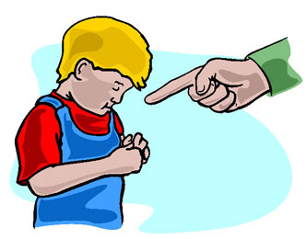
Punishment:
In the past many Christians viewed suffering as a punishment from God. During the 14th century, the Black Death killed approximately half of the population of Europe. At the time many people thought that God had sent this plague to punish people for their sins. A minority of Christians still believe that God chooses to punish people for sinning by sending natural disasters. However, most Christians do not believe that an omnibenevolent God wouldn’t want to punish people so severely.

Mystery: Many Christians believe that both life and God’s purposes are mysteries that cannot be fully understood by humans. They argue that we should accept that we do not know why suffering occurs but should trust that God knows what is best for us.

Though there is suffering and evil in this world for many Christians ‘Free will’ is the answer to evil and suffering.
Free will:
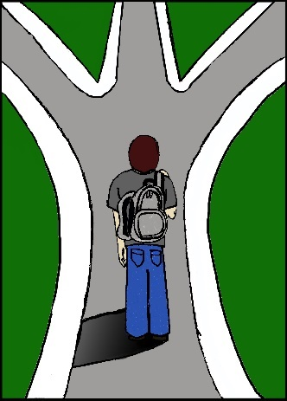
Throughout history Christians have tried to show that God can be omnibenevolent, omnipotent and omniscient even though there is evil and suffering in the world. One argument is that because God is omnibenevolent he did not want to create humans who would be like puppets, so he gave them a good gift of free will to choose their own path through life. With the gift of free will God has given humanity the power to make decisions of our own rather than having God or fate predetermine what we do.
Sometimes humans choose the path of evil which causes suffering and the only way that God could get rid of evil and suffering would be to get rid of free will.
Some people criticise the free will defence because it only explains evil and suffering caused by humans, not that caused by natural events such as earthquakes hurricanes and diseases. They also argue that if God knows people will choose evil then free will is not a loving gift for God to give.

The person of Jesus Christ
Born to Joseph and Mary sometime between 6 BC.
Fed 5000 people with 5 loaves of bread and 2 fish.
Stories of his life are written after his death
Engaged in healings, taught in parables and gathered followers
Ate bread which is a common food throughout history.
The Nicene Creed asserts that Jesus will judge the living and the dead either before or after their bodily resurrections.
The New Testment also says that Jesus is the only means of salvation.
If we didn’t have the virgin birth we couldn’t have a unique person.
Jesus had 4 brothers.
The son of God, healed the sick could forgive sins.
Jesus life is written in Mark
Jesus taught the Golden Rule: ‘In everything you do to others as you would have them done to you.
There is no record of his birth date. Many scholars say he was born in winter or early spring.
Regarded by most Christians as the incarnation of God

After his resurrection he met with his followers, preached for a short time and then ascended into Heaven.

Christians believe Jesus enables people to be reconciled to God.

The person of Jesus Christ, including beliefs and teachings relating to his incarnation, crucifixion, resurrection and ascension
Jesus is a key figure in Christianity and has a huge role and place. Jesus the Son of God is known for spreading the message of peace and love and is known to have performed miracles.
Incarnation: is the central Christian doctrine that God became flesh and assumed a human nature and became a man in the form of Jesus Christ the Son and God and the second person of the Trinity. In John 1 ‘the Word was God’- who was with God and was God who came down and took on flesh. In Romans 5 it says “the grace of that one-man Jesus Christ abounded for many”. It shows that God came down to be like us in everyway and in the book of Hebrews 2:17 “he had to be made like his brothers in every aspect” but that he was still nevertheless God. The New Testament makes a great deal that God had come down and save and the way that he was coming to save was in the person of Christ.
Crucifixion: The crucifixion is the cornerstone of Christian faith and this is a time where Jesus died for the sins that humanity had made but also that people could have an eternal life. At this point Jesus faced a huge suffering from the Romans where he was pushed, scratched, beaten and judged in front of his own people. Before the crucifixion took place, Jesus also had the last supper.
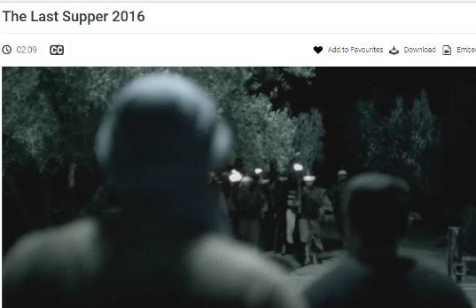

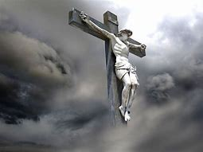
https://www.truetube.co.uk/film/last-supper-2016
Jesus came with a message of peace, forgiveness and love with the promise of eternal life for those who turned to him. He broke no law, committed no crime and sanctioned no rebellion. However, he was considered a threat by those religious leaders who wanted to maintain their position in society. He was obedient to the ways of God His Father to the point of death.
Jesus hands and feet were nailed to a cross and was placed in an upright position left in the scorching sun, hear his wounds bled even more, he had a difficulty in breathing and eventually died, with his body wrapped in a linen cloth and taken to a tomb. Jesus sacrifice shows that great love that he and God have for Christians and also shows that his death was not a sign of failure but the climax of his minister. Without the crucifixion of Jesus Christians believe that they would still be convicted as sinners at enmity with God without any hope for the future. Jesus sacrifice shows Christians should be thankful for what Jesus did and it should motivate one another to repent, change and live a committing life to God and Jesus.
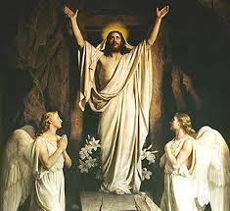
Resurrection: The resurrection of Jesus Christ is the Christian belief that after being put to death Jesus rose again from the dead. The resurrection is the foundation of the Christian faith. It is believed that 3 days after Jesus crucifixion he rose back from the dead. This is an important event in Christianity and commemorates Easter. The four Gospels narrate how several women including Mary Magdalene found the tomb of Jesus to be empty when they came to visit his tomb. Instead they met with an angel who told them that Jesus had been raised from the dead. With this news the women ran back and spread this news to the followers of Jesus.
The resurrection of Jesus symbolises how Christians are justified before God, because of our sins, humanity is separated from God and incapable of a relationship with him but also confirms that God accepted Jesus sacrifice for humanity that has given Christians the chance to access some right or a relationship with him. As well as this the resurrection shows:
- that Jesus defeated death, as death is seen as the enemy of mankind and the just punishment for each person’s individual sins
- The resurrection of Jesus Christ means that believers are united with Christ
- confirms the truth of Scripture.
- proves the gospel to be true
- proves that Jesus is the Son of God.
- The resurrection of Jesus Christ means that the Holy Spirit will be poured out into the hearts of those who believe.
- gives Christians a living hope.
- means that we will be raised like him
- The resurrection of Jesus Christ means that Christ will judge the world in righteousness.
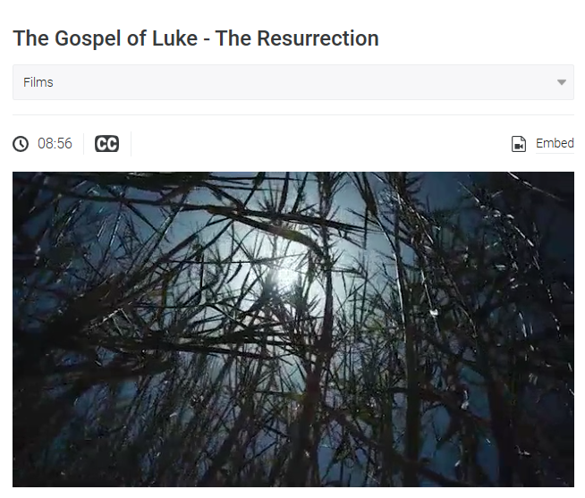
https://www.truetube.co.uk/film/gospel-luke-resurrection
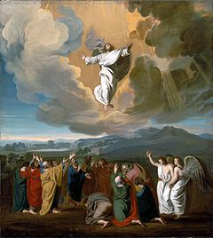
Ascension: The ascension is told in the first chapter of Acts and this is when Jesus ascended up to heaven. It is believed that it was 40 days after the resurrection that Jesus ascended into heaven and took his seat at the right hand of God.
Acts 1:9 tells us “He was taken up before their very eyes, and a cloud hid him from their sight,”
Jesus and His disciples went to Mount Olivet, near Jerusalem. There, Jesus promised His followers that they would soon receive the Holy Spirit, and He instructed them to remain in Jerusalem until the Spirit had come. Then Jesus blessed them, and as He gave the blessing, He began to ascend into heaven.
The ascension of Jesus is crucial for Christians as it benefits them in the following ways:
- It establishes Jesus as the reigning king over all powers in all ages
- Gives us access to God’s throne for mercy and grace
- Provides an advocate on earth whose presence is limitless
- Gives us the spoils of Christ’s victory- gifted leaders and spiritual gifts
- Keeps us longing for his return
- It is a special moment in religion because God had loving sent his son into the world and now he was returning back to him
- It signifies the success of Jesus and his work
- Marks the return to His heavenly glory and also shows the one who God is pleased will receive honour
The Catholic view:
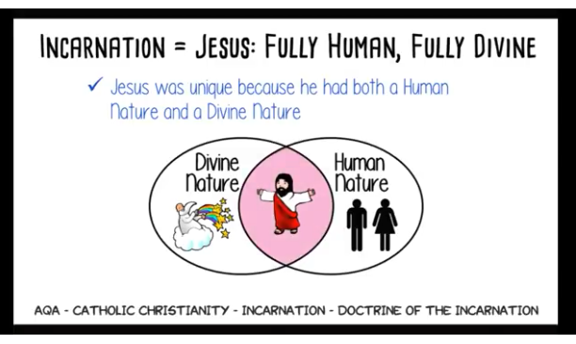
From the Christian belief that God came down in the form of a man, that is, Jesus Christ that is divine. This is a key belief in the doctrine of the incarnation. Catholics believe that Jesus is the ‘true God and true man’ that is both fully divine and fully human and that these are his two natures. Catholics believe in the incarnation, crucifixion and resurrection of Jesus and see it as a gift given from God to humanity. Jesus as the incarnate son shows a demonstration of God’s grace which creates an opportunity for salvation. The term ‘God’s grace’ is often used to remind Catholics that it is God who has allowed them to be saved. It fulfils God’s promise of salvation by showing that death can be defeated. Although some humans have strayed from God and do not necessarily deserve this, it is an expression of God’s love for humanity.
https://www.youtube.com/watch?v=I8zs81Omhsc

The church teaches the incarnation was a sign to show God’s love for humanity. God the Son, the second trinity entered humanity to teach humans how to live, bring salvation and offer eternity. The central belief of the doctrine for Catholics is that Jesus is both human and divine which makes him a unique being as Catholics believe Jesus experienced all human life except without sin. God took on human flesh in the person of Jesus. The significance of the incarnation of Jesus for Catholics is that Jesus is the meeting point. The incarnation means that Jesus is the meeting point between God and human beings.
Salvation- including law, sin, grace and spirt, the role of Christ in salvation and the nature of atonement
Salvation means to be saved from sin. Sin is the thing that separates us from God. Christians believe that all humans commit sins as nobody is perfect hence it is impossible to sin.
Christians believe that Christ is the only way to salvation, and that salvation will be for those who believe in God. In John’s Gospel it is stated that with God’s sacrifice of his only Son, there is salvation and redemption for humanity. As well as this Christians believe that salvation is achieved by having faith in God and obeying His laws.
Christians believe in order for salvation to happen, God set a process:
1. God saved his only son, Jesus so that all humans could be saved.
2. Jesus was a perfect human- he had no sin.
3. God placed the sins of the world upon him at his crucifixion.
4. Jesus actions meant that there was reconciliation between God and humanity- his death atoned or made up for human sin.
Christians believe this process shows a loving God as he gave his only son to save humanity and most importantly shows how God is able to forgive humans. With this process Christians also believe there are other several ways to achieve salvation.

Salvation through law | Some Christians believe salvation can be achieved by following God’s teachings and doing good deeds. For example, giving to charity, helping those in need etc.
Salvation through grace | Grace is God’s unconditional love that he has for everyone. This means that salvation is something that does not need be earned because we are made in the image of God and he has love for us already. Instead to achieve it through grace Christians should believe in God and his son Jesus.
Salvation through spirit | Before Jesus ascended to heaven he told his people that the holy spirit was to come. Believing in the holy spirit helps Christians to follow the teachings of God. God recognised that everyone will sin but that they will ‘turn to God in repentance’ (Acts 20:21) this means despite sinning humans will try to make amends and ask for forgiveness by believing and agreeing that God does exist.

Nature of atonement:
The term atonement refers to the belief that Jesus dying on the cross resolved the problems between humans and God. These problems began with Adam and Eve, who went against God's wishes by eating the fruit from the tree in the Garden of Eden. Christians believe that Jesus’s death on the cross was an atonement for the sins caused by humans. In John's Gospel, Jesus is described as: “The lamb of God, who takes away the sin of the world”. It shows Jesus gave his life to serve God and humanity and restored the relationship between God and Christians. Lastly, many Christians also believe that the crucifixion and resurrection of Jesus has made a way for them to be ‘at one with God’.

Eschatological beliefs and teachings, including the importance of resurrection and life after death, judgement, heaven and hell.
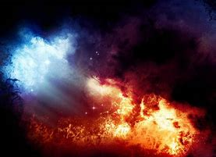
Christian beliefs about life after death are based on the resurrection of Jesus Christ. Christians believe that after people die they will be judged by God based on their faith and how they have lived their lives. Most Christians think that some people will be rewarded in heaven and others will go to hell. However, Christians disagree about whether heaven and hell are real places or whether they are metaphors or spiritual state of being that no one can fully understand.
Many Christians believe that the only way to get to heaven is by having faith in Jesus and following his teachings. One reason for this is that the Bible (John 3.16) says “God so loved the world that he gave his only son so that whoever believes in him will not perish but have eternal life”. Other Christians believe that an omnibenevolent God will not send somebody to hell for not believing in him.
Some Christians believe that partaking in evangelism (spreading the message of God) will help them and reward them to heaven, whereas some Christians place less emphasis on this as they believe God will not judge you if you have not spread the message of God.
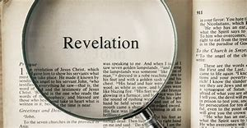
The book of Revelation talks about the end of time. For Christians life after death relates to the concept of the Messiah and the day of judgment. Many Christians believe there will be a time where everyone will rise, and Jesus will return with God where humans will be judged on their sins at the same time.
Since God has given human beings free will, there must be an opportunity for people to reject God. This is the basis of the idea of hell. Hell has traditionally been depicted as a place of eternal fire that symbolises pain and suffering. This is seen as the result of the refusal to accept the happiness that God wants people to share with him.
The main source of authority for Christians is the Bible.
Christians find many reasons in the Bible to believe in life after death. They include:
Eternal life - Jesus promised that his followers would have eternal life.
Jesus' life as an example - God sent Jesus to Earth in order that humans could overcome death and have eternal life.
Resurrection of the body - when Jesus rose from the dead he rose with a body. St Paul teaches in the Bible that people will have resurrection bodies like that of Jesus
Immortality of the soul - Jesus told the criminal crucified with him that he would go straight to paradise.
Christians interpret the teachings of the Bible on life after death to mean, that humans will have a spiritual existence after death, rather than a physical one.
Most Christians reject the idea of reincarnation. For Christians, God makes each individual unique and he loves them as they are. This unique individual is made up of body and soul. When this earthly life is over, this person will continue into an eternal life and not come back to this Earth in a different body.
Ultimately for Christians, life after death and heaven is seen as a reward and that people should do good in their life. However, Christians believe that you should not just do good for the sake of gaining a place in heaven, but you should always do good deeds as it is the right thing to do.
Although there are many views towards life after death, most Christians do believe in an afterlife and the core concept of heaven and hell is heavily emphasized.
(Catholic Christianity)- Eschatology
The Roman Catholic Church teaches that after death there is a state of purgatory (purgatory is a catholic belief only). This is a place where some people who have sinned are purified in a 'cleansing fire', after which they are accepted into Heaven. As Catholics believe a soul cannot go from purgatory to hell. Purgatory is not mentioned in the Bible. However, Catholics believe that praying for a dead person’s soul can speed the passage from purgatory into heaven. Most Christian churches do not accept the idea of purgatory, believing instead that once judgement happens, people will either be in Heaven or Hell for all eternity.
What does the Catholic Church say about heaven and hell?

The Catholic conception of the afterlife teaches that after the body dies, the soul is judged on how well they have followed Gods teachings, the righteous and free of sin enter Heaven.
The Catholic Church teaches that "heaven is the ultimate end and fulfilment of the deepest human longings, the state of supreme, definitive happiness". It holds that, "by his death and Resurrection, Jesus Christ has 'opened' heaven to us. For Catholics they believe that when a person dies they either go to heaven or to state of purgatory, depending on the life you have lived. When Catholics speak about the resurrection of the body they don’t actually mean that your current body and flesh will be the same. For Catholics, it is only the physical body that stops living.

Catholicism teaches you will face 2 two judgements:
- Individual which is sometimes called particular judgement
- Final where everyone is risen, and will all be judged by Christ.
These judgements are reflected in the Gospel, in the parable of the sheep (heaven) and the goats (hell).

Heaven is a state of pure bliss where one can return to God, Catholics believe when you die and go to heaven you are being invited to be one with the creator of the world. No one knows what heaven looks like, but it is described in the Bible. Catholics believe heaven is being in communion and at one with God. However, for hell- this is completely different. Hell is ‘a state of definitive self-exclusion from God and from those who love God’. This means that God does not send anyone help. The church teaches that hell exists, but God created heaven for everyone.
(Catholic Christianity)-The redemptive efficacy of life, crucifixion, resurrection and the ascension of Jesus Christ and their significance for catholic beliefs about salvation and grace
For Catholics, the ‘Paschal Mystery’ (one of the central concepts of Catholic faith relating to the history of salvation) is closely linked to ideas about redemption and salvation. The Paschal Mystery for Catholics relates to process that Jesus went through to save humanity from sin. These processes are the following 4 which are: his life, death, resurrection and finally his ascension.
For Catholics, the redemptive efficacy means being saved. Efficacy is to do with how effective something is in achieving a certain outcome. Therefore, redemptive efficacy is a Catholic idea that suggests the best and most effective way for humanity to be saved from sin was through Jesus’ suffering, crucifixion, resurrection and ascension. It is through this process that Catholics can be forgiven and reach Heaven. Jesus being born, then dying, being reborn again and going to heaven is an ‘effective way’.These events are remembered during the season of Lent and at Easter.
In the Gospel of Luke, “They were startled and frightened, thinking they saw a ghost. Jesus said to them why are you troubled, and why do doubts rise in your mind? Look at my hands and feet. It is I myself” (Luke 24: 36-38) the point is made that even Jesus’ disciples, who were his closest followers, doubted he could have risen from the dead. The act of resurrection defies human understanding of how the natural world works. This is where the idea of ‘mystery’ in the Paschal Mystery comes from.
The Paschal Mystery teaches Catholics that living, dying and rising are a part of their experience as Christians. It reminds Catholics that there may be times when they struggle and are in pain but that, if they follow Jesus’ teachings and have faith, they will reach heaven.
As well as this, Catholics believe salvation is only possible through Jesus but in order to achieve this Christians must follow and believe in Jesus.

The significance of grace and salvation for Catholics is that:
- Grace and salvation remind Catholics that God is all powerful and all loving and that he is prepared to sacrifice his only son for the good of humanity.
- These concepts create hope for Catholics as they believe they will be united with God in heaven and have an eternal afterlife.
- Grace and salvation are linked to ideas of reconciliation. Jesus’ presence on Earth and consequent death allowed God and humanity to be reconciled. Therefore, Christians believe humans have a duty to also try to reconcile with each other.
- Part of their experience as a Christian, if they follow Jesus path they will reach heaven

Catholic Christianity – 14
The number 14 is relevant and significant for Catholics. Referred to as ‘The Fourteen Stations’ these display the 14 stations (stages) that happened before Jesus crucifixion. Good Friday is one of the only two days in the year in which Catholics do not have mass and instead most Catholic churches say the stations of the cross and is normally found in pictures around the inside walls of all churches. In the 12th century St. Francis of Assisi devised the list and started the tradition of reciting it as a type of a devotional service.
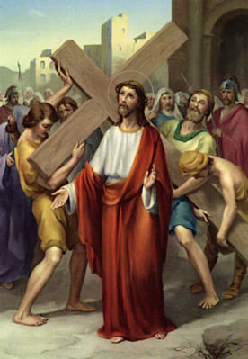
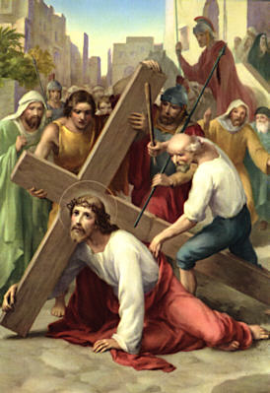
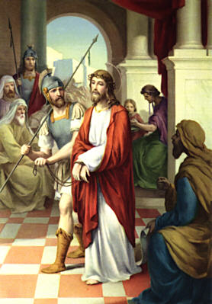

3rd station: Jesus falls for the first time.
2nd station: Jesus carries his cross.
1st station: Jesus is condemned to death.

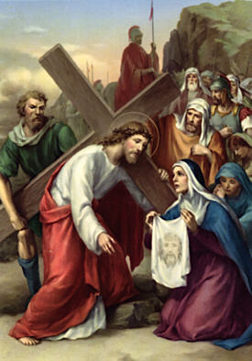
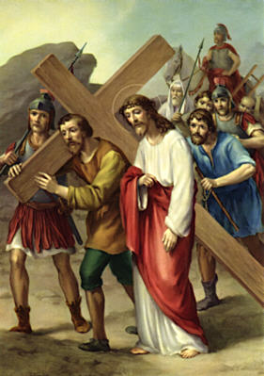
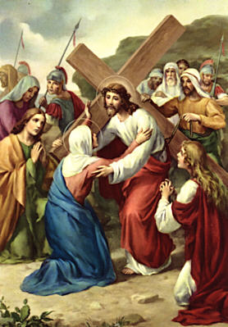

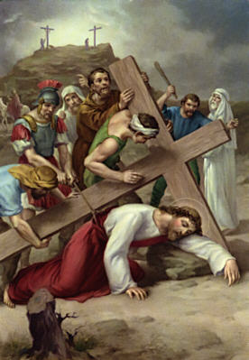
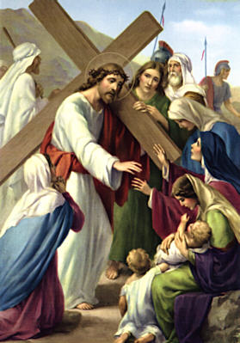
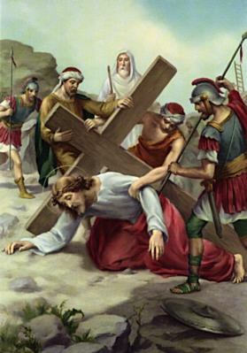
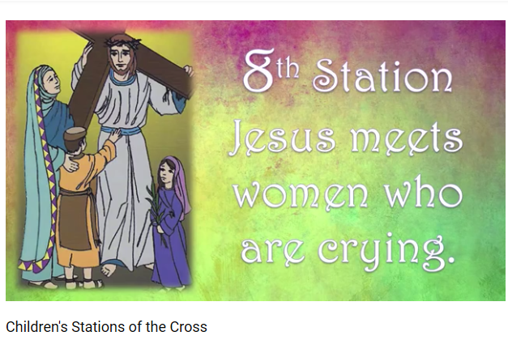
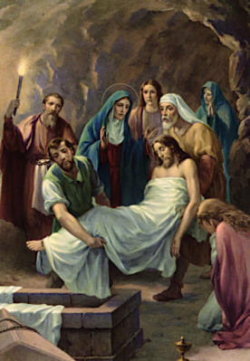
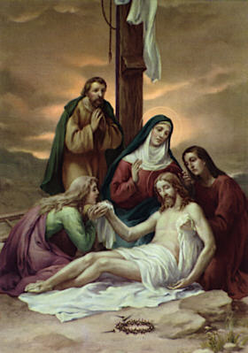
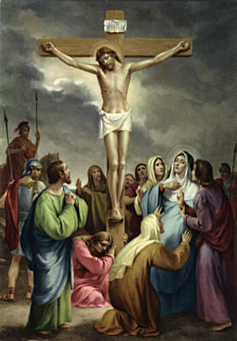
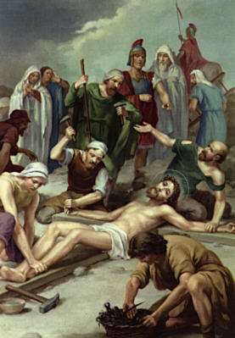
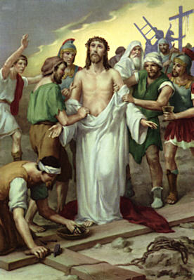
9th station: Jesus falls a third time.
8th station: Jesus meets the women of Jerusalem.
5th station: Simon of Cyrene helps Jesus to carry his cross.
7th station: Jesus falls for the second time.
6th station: Veronica wipes the face of Jesus.
4th station: Jesus meets his mother.
13th station: The body of Jesus is taken down from the cross.
14th station: Jesus is laid in the tomb.
https://www.youtube.com/watch?v=j0qv7c4PsrA
The 14 stations represent the stations that Jesus went through his crucifixion. Each station shows how much Jesus loved us even though he knows he is going be hurt and killed.
12th station: Jesus dies on the cross.
11th station: Jesus is nailed to the cross.
10th station: Jesus clothes are taken away.
- Practices
The significance of different forms of worship including liturgical, informal and individual
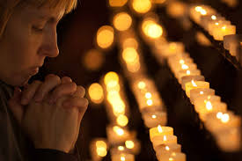
When Christians worship it involves praising God in music and speech, reading of holy scriptures- the Bible and attending holy ceremonies. When Christians pray they are showing their love and gratitude to God and thanking Him for all the blessings He has given and for everything that He does for humanity. Christians may also pray and ask God to forgive them for any sins that they may have committed.

It is essential to remember that Christian prayer is a conversation with God and should take place both in Church and in private. Prayer can be silent or said out loud. It can use set words, or a person's own words. In prayer, Christians lift their minds and hearts to God.

Worship can take place in several places, some Christians may pray in their own homes, pray in a church, chapel or in a Cathedral and each Christian denomination prays in different ways. Such as Anglicans, Roman Catholics and Orthodox Christians have a set form of worship. It is a formal ritual based around the sacraments, particularly Holy Communion. This type of worship is called liturgical worship.

Liturgical worship:

Liturgy is a Greek word which means ‘the work of the people’ and is characterized by the work of the people involved. The early Christians adopted the word to describe their principal act of worship. On one day a week- the Sunday service like holy Eucharist, holy communion or Mass is performed.
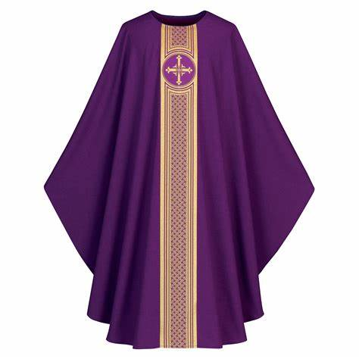
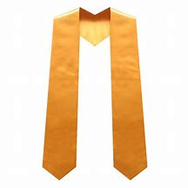
The leader of a liturgical worship, a priest or minister will wear special clothes and vestments such as a chasuble and stole.

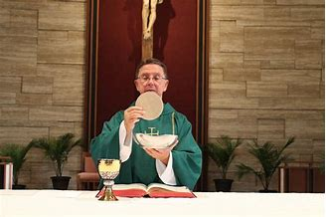
The priest will speak a set form of words and actions are laid out in a missal where the priest reads it from. When the priest reads out these words the readings are set and cannot be changed. The acts that the priest performs are important as whilst these actions are read and performed the priest is visualising Jesus when raising the host and the chalice at the consecration.

The actions and the words of the Mass change bread and wine into the body of Christ- this is called transubstantiation and is seen as a holy sacrament as it is a re-enactment of Christ’s sacrifice. Many Christians at this point believe that Christ and his spirit is in the bread and this becomes very holy. Christians will eat this bread after the ceremony which is blessed by the priest and then later given to the preachers. Preachers will eat the bread whole-heartedly and some are very religious that they will not even drop a crumb of the bread because it is so holy and divine. During liturgical worship there is a pattern of standing, sitting, kneeling for worshippers and the sign of the cross is used frequently.

Liturgical worship is the way a community worship as one and is best described as being ‘gathered by God’, ‘hearing the words of God’, ‘sharing in thanksgiving’ and then ‘being sent out back into the world’. Each four of these elements show a distinct pattern and order of service and worship.


- The gathering: the call of God’s grace, this element includes mutual greetings, prayer, processions and opening songs. For example, the procession shows Christians assembling to worship and shows a reminder that it is with Jesus death that Christians are able to offer pleasing, acceptable worship.

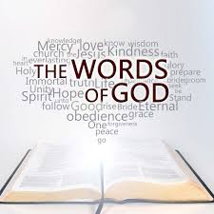
- Words of God: Being gathered from God, now offers up to three readings of scripture from the Old Testament, the New Testament and the Gospels. Hymns will also be added in; some Christians may stand while listening to the readings to show their respect. After hearing the word of God, Christians are then encouraged to respond in faith, and this can consist of reciting one of the historical creeds in the church and move into prayer by participating with the congregation. As well as this some Christians will also pray individually by thanking God, asking for compassion or forgiveness. From being gathered together and from praying Christians believe God has gathered them together to pass the peace.

- Thanksgiving: After prayers, Christians will offer gifts (donations). For Christians offering is worship as it symbolises God’s generosity and what he has given and hence Christians believe in giving back a portion of what God has given to them. During the offerings, the priests table is usually prepared with bread and wine and this commences ‘the great thanksgiving’. It symbolises the historical events of Jesus Christ and here prayers will be sung. The heart of the prayer is the story of Jesus and the last supper.


- Sent out to the world: The final movement in liturgical worship begins with a prayer of thanksgiving. The final prayer also signals a transmission from doing work in the worship of God to ‘doing’ of the work God has given us to do. The central element in this last element is a blessing to all. Here Christians believe by being blessed with God’s love they are now sent out into the world to do good, spread peace and do his work.

Non-Liturgical Worship
Other Christian churches practise non-liturgical worship, e.g. Baptists and Quakers. This kind of worship has no set form and often does not involve Holy Communion (Eucharist) as you would find in liturgical worship. It is usually centred on Bible readings, a sermon, music and prayers. It can be structured or unstructured and spontaneous and there will be times where no special vestments are worn. A typical non-liturgical service is a non-conformist Sunday service where worship consists of hymns, extempore prayers (prayers without text) rather than set prayers. The minister or person leading the worships will choose Bible readings that will be based on the theme of the sermon. Prayer is usually in the person’s own words and personal style.

Informal Worship:
Charismatic worship is a form of individual worship. The service has the characteristics of other forms of worship (hymns, sermon, prayer, readings), but it is very free flowing as many will use everyday language while praying.
On charismatic (spirit-inspired) worship, worshippers will often speak in tongues (outbursts of praise in words that are not intelligible, but which express the person’s devotion to God.) This is seen as the gift of the Holy Spirit. Singing, often accompanied by music, is lively. This has much more of a relaxed feel to it. Some Christians believe it comes more from the heart.
Evangelical churches are often charismatic in style. These have become more popular in recent church history in Britain.
Communal Prayer:
Communal prayer means to pray with others. This can take place during church services, or it could be a structured meeting of Christians who have arranged to pray together. This type of prayer can help Christians connect with each other as well as God and help to strengthen the Christian community.

Extemporaneous prayers:
Extemporaneous prayers are prayers that are said without prepared words. An example of this might be after someone has heard some bad news, they will say a prayer for those who are involved. Some Christians believe this type of prayer to be more heartfelt as they are not ‘arranged’.
Individual Worship:
Worship is very important for Christians and just as publicly worshipping with the community many Christians also believe that private individual worship is just as important. Individual worship can take place anywhere. Worshipping alone allows worship to be done exactly how the person wants it and enables them to feel close to God as they are alone with God in prayer and in their thoughts. For some Christians, for example, Anglicans may say morning prayers and evening prayers everyday and these can consist of thanking God, praying for love, happiness etc. Another example is some Christians who are travelling such as on the train or on long journeys may use the time for silent worship. Apart from having set prayers in the morning and evening many Christians will pray in their own time, some will pray once or pray several times during the day.
Along with quiet, silent prayers Christians may also individually worship by:

Informal Worship:

In public worship, this takes the form of extemporary prayer. Most Christians use their own words at least some of the time in their private prayers. Many prefer informal prayer to set prayers as they seem to come more directly from the heart, meeting their particular concerts. One type of informal prayer is known as the arrow prayer. These are very short prayers addressed to God spontaneously at a time of urgent need or in response to a particular situation. In a time of personal crisis, a Christian might pray, ‘Help me God,’ or respond to getting through a crisis with, ‘Thank you God’.
The significance of worship:
- Brings a community together
- Helps one feel closer to God
- Worship is peaceful and allows for meditation
- In worship Christians praise God as the eternal being and a source of everything that exists- ‘Hallelujah’ means praise the lord
- Allows one to express their faith
- “This is the confidence we have in approaching guard that if we ask anything according to his will he hears us and if we know that he hears us whatever we ask we know that we have what we asked of him” (John 5, 14:15) worship reminds and shows us that God is always here, he is constantly present which allows one to build their relationship with God.
- Many Christians also believe that praying will as a family encourages children to grow up as praying Christians
- The point of prayer is to communicate with God and hear what he is saying
- Although many Christians pray in different ways that still put their attention and focus on God.
The place of prayer, including the Lord’s prayer, set prayers and informal prayer
Most Christians believe prayer deepens a person's faith. Praying can help the believer come to a greater understanding of God's purpose for their lives. Christians interpret the response they might get to their prayers in the following ways:
Sometimes Christians think that God has answered their prayers in quite spectacular ways, e.g. the recovery of a sick person. They may see this as a miracle.

God answers prayers but not always in the way the person wants. When a prayer is not answered, it may be that the person asked for something God thinks would not be good for them, or that their prayer will be answered later.

Others, especially Orthodox Christians, use the 'Jesus Prayer', Lord Jesus Christ, Son of God, have mercy on me, a sinner. They may chant this prayer over and over to clear their minds and achieve inner peace.

For some Christians, meditation or contemplation is a way of trying to reach a higher spiritual level.

Candles, a crucifix or a cross can all help Christians to focus on meditation and allow the Holy Spirit to enter their hearts. For other Christians, especially Roman Catholics, will use a rosary to meditate on the life of Jesus.
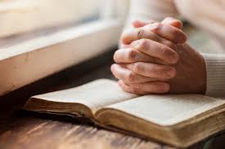
Prayer has a vital place in the life of a Christian and is both a privilege and a duty. It is the secret of holiness that shows a continual state of communion with God that is central and crucial in the life of the Christian. Jesus Christ spent much of his time in prayer and prayer is important because it helps one to search of their faith, seek guidance, provide some comfort, shows their commitment to God and the Christian faith, it acknowledges God's goodness and also helps one when they are in need of peace.

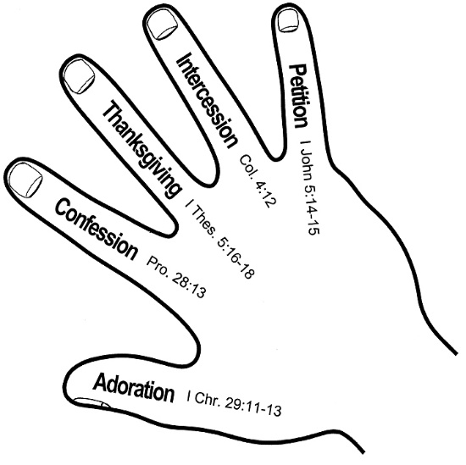
There are several types of prayer. A way of remembering them is to think in terms of ‘the hand of prayer’. Praise/adoration is the basis of all prayer. It has been said that the whole of life should be an act of thanksgiving. The forefinger is used to point in accusation – so it represents the opposite. Christians believe that balanced prayer includes many or all of these aspects.
Jesus spoke about prayer on a number of occasions. In parables, he made the point that persistence can make even the most corrupt and self-centred people sometimes give in. Jesus’ point was that if humans could be persuaded, then an all-loving God would definitely respond to the needs of those praying. Jesus also stated that humility and honesty in prayer were very important.

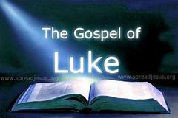
In the Gospel of Luke on one occasion Jesus was asked by his disciples how to pray with this Jesus taught them ‘The Lord’s Prayer’ (also known as the ‘Perfect Prayer’) Is a set prayer in Christianity and is ever so holy and important within Christianity. It can be seen as the foundation and setting stone of how Jesus encouraged, taught and introduced to his people how to pray. Praying deepens a person’s faith and can help one to gain a greater understanding of God’s purpose in their lives but it also gives one the opportunity to spend time with God and develop a relationship with Him.
The Lord’s Prayer is significant in Christianity and the most important prayer of all prayers as it shows the following:

The beginning of the prayer shows a statement of faith. Showing that God is up in heaven and that he is very involved in our lives.
“Our Father who art in heaven,
hallowed by the name,
thy kingdom come, thy will be done on earth as it is in heaven.
Give us this day as our daily bread,
and forgive us our trespasses as we
forgive those who trespass against us.
And lead us not into temptation but deliver us from evil.
For thine is the kingdom, the power and the glory, for ever and ever”.
Amen

This line shows worship and praise. From this line Christians pray that God be accepted as holy.

This shows adoration and involves a change of heart in those who do not yet perfectly follow Gods law.
Is a prayer of intercession in where Christians ask for the bread of Eucharist which will help up Christians spiritually as normal bread will not do this. Also asks for the needs of all people.

A prayer of confession or contrition. This is when Christians show how sorry they are for any wrong doings they have done and promise to share their forgiveness with others.

This line is a prayer of petition in which we ask God to remove temptations from our lives.

The end of the prayer that reminds Christians that God has all the power and authority, and may all praises be given to Him.
A Hebrew word that means ‘so be it’. Christians end their prayers with this word to show they mean and assent to what they say.

As well as this, ‘The Lord’s Prayer’ is accepted and believed by all Christian denominations which combines all Christian’s as all members of one community. The prayer also stresses what unites us and what divides us by showing a statement of faith.
The Archbishop of Canterbury Rev. Dr Rowan Williams also shows that ‘The Lord’s Prayer’:
- sets us free
- it is not an easy prayer
- helps with the human condition
- seen as a radical prayer because the prayer challenges our assumptions,
- it is a prayer to be shared
- It is a prayer template from Jesus that tells us how to address God
As well as believing in set prayers, when Catholics pray they also use ‘The Rosary’.
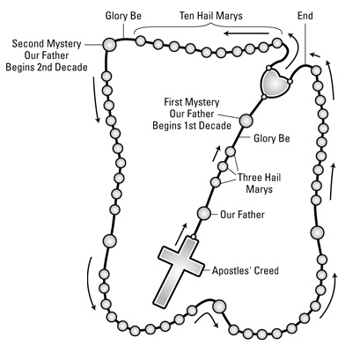
The Rosary is a string of beads with a crucifix attached. Saying the Rosary involves running one’s hands through the set of beads and saying certain set prayers (the Lord’s Prayer, the Hail Mary and the ‘Glory be to the Father…’) while touching each bead. The Rosary is used more in private individual worship and helps one to keep on track while praying. The purpose of the Rosary is to help keep memory in certain principal events in the history of salvation. There are 20 mysteries reflected upon in the Rosary and these are divided into the five ‘Joyful mysteries’ (said on Monday and Saturday), the five ‘Luminous Mysteries (are said on Thursday), the five ‘Sorrowful Mysteries’ (are said on Wednesday and Sunday). As an exception the joyful mysteries are said on Sundays during Christmas while the sorrowful mysteries are said on the Sundays of Lent.
Summary of prayers:
Private Prayer | Praying alone
Set Prayer | Well known prayers such as the Lord’s Prayer
Informal Prayer | Praying to God using more simple everyday language
Extemporaneous Prayer | Spontaneous Prayer
Communal Prayer | Praying with others
Adoration | Praising God for his greatness and admitting dependence on him
Confession | owning up to sin and asking for God's mercy and forgiveness
Thanksgiving | thanking God for his many blessings, e.g. health or children
Petition | asking God for something, e.g. healing, courage or wisdom
Intercession | asking God to help others who need it, e.g. the sick, poor, those suffering in war
The role and meaning of the sacraments in Christian life, including baptism and eucharist
Sacraments are the vehicles of a visible sign of God’s inward grace and the Protestant traditions generally acknowledge only the two sacraments of baptism and the Eucharist. They are known as Gospel sacraments because they were authorised by Jesus and there are many references to their use in the books of the New Testament. Roman Catholics, Orthodox Christians and some Anglicans recognise seven sacraments.
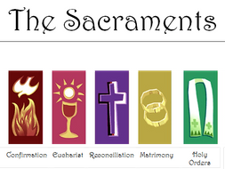
What do sacraments consist of?
Sacraments are seen as a means by which Christians participant in the ‘mystery of Christ’. In Christianity the term sacrament is used to describe symbolic actions in which central elements of the Christian faith are enacted.
Protestant Traditions
Baptism:
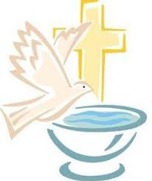
A baptism is a ritual bathing to symbolise purification or conversion. The word ‘baptism’ comes from the Greek word ‘baptizo’ which means ‘dip in water’. A baptism is a very important sacrament in Christianity as it signifies and symbolises the washing away of sins. In the Gospels John the Baptist instructed people to ‘repent and be baptised’. Jesus was baptised by John (Mark 1:9-11) but John objected to this saying Jesus instead should baptize him. After Jesus resurrection he told his followers to “Go and make disciples of all nations, baptising them in the name of the Father, Son and Holy Spirit” (Matthew 28:19)
Baptism symbolises a new life and washing away of the sin and someone who takes part in a baptism is considered to be ‘born again’. Christians are baptised in nearly all denominations except the Salvation Army and Quakers.

Who can get baptised?
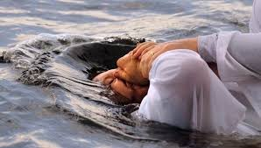

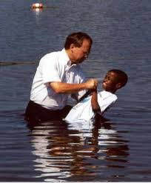

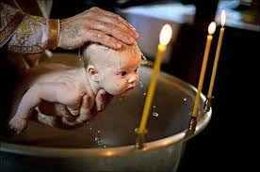
Any Christian believer or infant can be baptised at any stage in their life. Adults can be baptised in any denomination, if they haven’t been baptised as babies.
Those who regard baptism as a sacrament see no problem with baptising infants, as they believe that this cleanses the baby from original sin giving it a fresh start in life and making it a member of God’s family. Traditionally infant baptism was especially important if the baby was sick and likely to die- unbaptised babies were though to be unable to enter heaven.
Baptist, Pentecostal, and House Church Christians and those from independent fellowships tend to receive dedication as babies and baptism only as believers. They believe you shouldn’t be baptised until you are old enough to accept Christianity yourself.
What happens during a baptism service for infants?
-Confirmation is considered as a sacrament or rite which signifies faith and commitment of a person who wishes to publicize their convictions to their friends, family and the church.
-for an adult they will make their own promises as they are able to do so, because the infant is small and unable to make the promises- this is why the parents and godparents make the promises.
-A baptism begins a baby’s faith in their religion.
-Christians believe that God is present at the baptism and is working in it. Christians believe as the baby grows, God will be with them and in their lives.
-Some churches do not allow infant baptism at all and wait for the child to be old enough to make their own decisions and this is called a believer’s baptism.
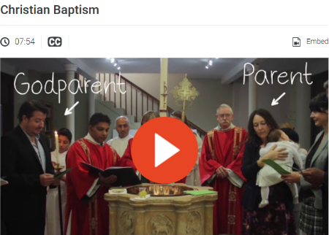

https://www.truetube.co.uk/film/christian-baptism

Believers Baptism:
A believer’s baptism is when a person consciously commits themselves to be a disciple of Jesus Christ. Many Christians believe in a believer’s baptism as they believe that a person should only be baptised when they are old enough to choose for themselves. Here some Christians may disagree with an infant’s baptism as the child has not had the opportunity to make their own choice.
So what happens in a believers baptism?
A believer’s baptism can take place in a church, a lake, a swimming pool and several people are usually baptised at one special service.
In a believer’s baptism, the baptism ritual is same as the infants but the build up to the baptism is carried out differently. Whoever wishes to be baptised will go through the following process:
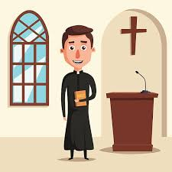
- A believer will firstly go to a Baptist church and meet with a priest.

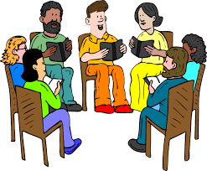
2. They will then go to a baptism class that will take them through precessions and explain what baptism is and speak about what it means for them and their commitment to the church.

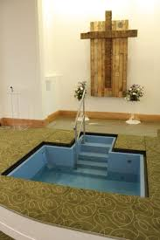
3. A date and time is then scheduled for the baptism to take place and will take place in the baptistry which is large bath/pool. Some Christians may choose to have the baptism elsewhere instead of a baptistry i.e. a lake

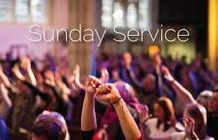
4. On a Sunday morning, a service will then take place and after the service the believer will stand before the congregation and give a testimony and explain how they became Christian, why they want to be baptised and what it means for them.


5. After the believer gives their testimony, they will then walk into the pool and there will be a priest and another leader or member of the church standing in the pool.


6. The priest will then ask the following: "Do you repent of your sin and acknowledge your need of a savior? And Have you put your faith in Jesus as your world and saviour?

Once the believer answers these questions the priest will then say:
"because of your repentance of sin and faith in Jesus, today we acknowledge your old self is buried with Christ and you have been raised to new life in Jesus! Therefore, I baptise you in the name of the Father, the Son and of the Holy spirit"
A believer is then immersed into the water.

The baptism marks a celebration and shows how one identifies with Jesus, his death and resurrection. It is a powerful movement symbolising purification, regeneration and admission to the Christian church. A baptism also shows an act of obedience, the burial and ending of a person’s old life and becoming reborn again and at one with Jesus Christ and strengthening the Christian faith.
Key elements of baptism:
- White clothes are worn as a sign of the new life that is about to begin
- The testimony, which is a statement by the person (candidate) about to be baptised, explaining how he or she came to believe and their reasons for seeking baptism
- Declaration of penitence, of being truly sorry for sin, of faith in Christ as his or her personal Saviour and of the intension to show lifelong dedication to the service of Christ
- The candidate goes down one set of steps into the water, symbolising the end of the old life of sin and separation from God
- At least one person, often but not necessarily the minister, is in the water and tips the person back, right under the water, stating ‘I baptise you in the name of the Father, the Son and the Holy Spirit. Amen.’ This baptism is a powerful symbol of death and resurrection. The newly baptised person comes out of the water by another set of steps, symbolising the start of his or her new life as a Christian. The candidate may go off to get dried
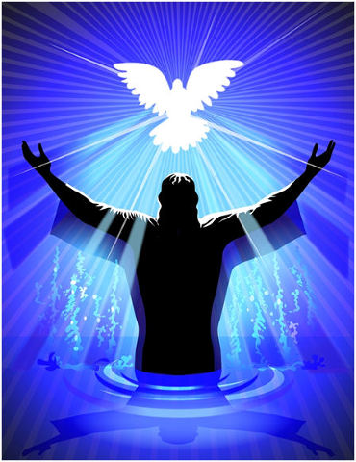
He or she may be given ‘the right hand of fellowship’ by the minister on behalf of the whole Christian community. This is a handshake done to welcome them.
- The person received the gifts of the Holy Spirit and these are:
- Understanding
- Courage
- Knowledge
- Awe and wonder in God’s presence
- Reverence
- Wisdom
- Right Judgement

Eucharist:
Eucharist is also seen as a sacrament in Christianity and is the practice of eating bread and drinking wine during a church service that commemorates the Last Supper. During the church service of holy communion bread and wine is eaten to remember Jesus’s death and the events that took place before it. Christians believe that the bread and wine symbolises Jesus’s body and the wine represents his blood.
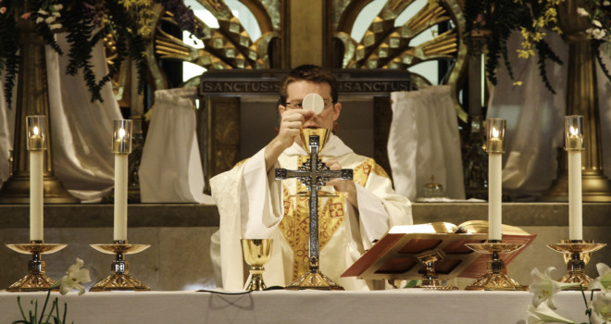

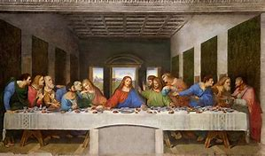
Luke Gospel’s tells the story of the last supper and is the run up to the death of Jesus and the celebration of Easter. In the last supper Jesus and his apostles have a meal this meal was a Passover meal and it is the final meal in the Gospel accounts that Jesus shared with his apostles in Jerusalem before his crucifixion.
During Passover when the hour came Jesus said to his apostles “I have eagerly desire to eat this Passover with you before I suffer. As for I tell you I will not eat it again until it finds fulfilment in the Kingdom of God”.
After taking the cup and giving thanks he said to his disciples “take this and divide it among you for I tell you I will not drink again from the fruit of the wine until the Kingdom of God comes”.
Jesus then took out some bread, gave thanks, broke it and distributed it among his apostles saying, “this is my body and for you, do this in remembrance of me in the same way”. After the supper he took the cup and said, “this cup is the new covenant in my blood which is poured out for you”. The last supper shows how Jesus knows he is going to suffer and that one of his disciples will betray him.
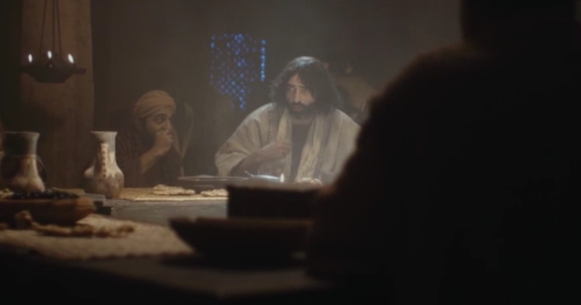

https://www.truetube.co.uk/film/gospel-luke-last-supper
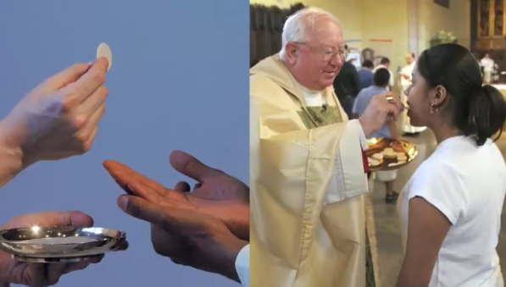
Many Christians believe that this was not the last supper and instead there were several. However, the story of the last supper encourages eucharist. Eucharist is received during communion and is the central act of gathered worship, the appointed means by which Christ can become present to his church. Christians receive the bread and wine from the consecrated host where the bread is given on the tongue of in the hand at the discretion of each communicant- they do not just take the eucharist.
They will also have some wine and all Christians will drink it from the same cup. Once a person has had some wine the priest will clean the edge of the cup with a cloth ready for the next person to drink from it.
Christians believe that they receive Jesus in holy communion and in the eucharist Jesus’s body, blood, soul and divinity is present. It is a blessed sacrament as Christians believe they receive Jesus into their lives. All Christians eat the bread and if there is any left over the priest shall eat the remaining- nothing should stay left.
Whereas for Catholics, eucharist has the same significance as all other Christian denominations however for Catholics it slightly differs. Catholics believe in the bread and wine symbolising Jesus’s body and blood and believe when the priest repeat Jesus’s words from the Last Supper the bread and wine actually turn into the body and blood of Christ and this is called transubstation. Although the outward appearance of the bread and wine stays the same, transubstantiation is the belief that the bread and wine become the actual body and blood of Jesus Christ during the Eucharist. Christians believe that the spirit of Jesus is present in the bread. Eucharist is performed and experienced during mass for Roman Catholics. The Eucharist is one of the seven sacraments in Catholicism.
Remember: Only Catholics believe in transubstantiation. Oher Christians believe that the bread and wine represents Jesus, but it is not transformed.
The Seven Sacraments
The sacraments are rituals that teach, strengthen and express faith. They are relevant to all areas and stages of life, and Catholics believe that the love and gifts of God are given through seven sacraments. Roman Catholics, Orthodox Christians and some Anglican believe in 7 sacraments, these are:
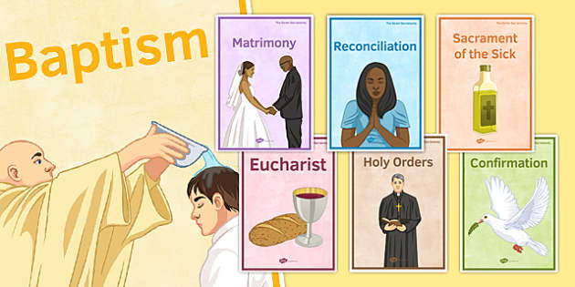

- Baptism: baptism or christening marks a personal officially being accepted as a Christian
- Confirmation (chrismation in the Orthodox Church) – In this ceremony a Christian renews the vows made on his or her behalf at baptism
- Reconciliation – this involves confession of the sin, followed by contrition, penance and absolution
- Eucharist – In taking holy communion, the believer receives Christ into him or herself afresh.
- Anointing of the sick - This may be for healing, or to prepare a dying person for his or her journey into the next life- also called extreme unction or viaticum
- Marriage – when a couple are joined in holy matrimony, the receive a special blessing
- Ordination (becoming a priest) – this is the rite in which people are made deacons, priests or bishops
God is thought to communicate his grace directly through sacraments, whether or not the recipient understands what it all means.
Non-conformists generally regard baptism as a symbol not a sacrament.
Most Protestants accept only baptism and eucharist as sacraments.

These Christians believe that through the sacraments God imparts particular gifts and powers. For many Christians, they are of central importance to the practice of their religion. Some of the seven sacraments are intended for all Christians, notably baptism, confirmation, the Eucharist, healing and reconciliation. Roman Catholics refer to the sacraments of baptism, confirmation and the Eucharist as the three rites of initiation. Marriage is for those who get married. Ordination is for those who believe that God has called them to the priesthood.
The Symbolism of the Seven Sacraments
Sacrament | Outward and Visible Sign | Inward and Spiritual Grace
Baptism | Water and Trinitarian formula | Receiving the Holy Spirit  The removal of original sin  Entry into the kingdom of God/the Church
Confirmation | The laying on of hands by the bishop | Strengthening/sealing the gifts of the Holy Spirit in the person  Becoming an ‘adult’ member of the Church
Eucharist | Bread and wine | Spiritual ‘feeding’ with the body and blood of Christ
Reconciliation | Words of absolution (forgiveness) | The forgiveness of sins
Healing | Anointing and the laying on of hands | Spiritual and sometimes physical healing  Preparation for death
Marriage | Ring(s) | The endless love between the couple
Ordination | The laying on of hands by the bishop. | The special gifts of the Holy Spirit needed by a deacon or a priest

The importance of sacraments for Catholic Christians
For many, the sacraments are God’s fists of grace offered to them at appropriate points in their Christian lives. Some can be seen as rites of passage, as they move from one stage of life into another.
Baptism marks the start of the Christian life, giving the strength needed for the journey ahead. Confirmation reinforces baptism, as now those being confirmed make the commitment for themselves. The Eucharist is unique in that it is the only sacrament intended to be received frequently. Christians believe that it unites them with the risen Christ. Reconciliation enables Christians to think about how they have fallen short of God’s will for them. They show their penitence through confession their sins and performing a special task set for them by the priest and they are assured of forgiveness through the priest’s words of absolution. The sacrament of marriage is believed to unite the couple with each other and with God in what is to be a lifelong loving relationship. Healing is given at times of serious or prolonged illness, not necessarily just when a person is dying. It is believed to give strength and peace of mind. However, when given to those who are dying it is intended to prepare them for death by enabling them to accept peacefully and trustingly what will come. The Eucharist which is given at this point is known as the viaticum, that is, the food for the journey. Ordination sets apart those who believe God has called them to the priesthood, giving them the gifts needed to carry out their ministry.
For some Christians, the seven sacraments are the means by which they can grow closer in love to God and are as essential to their spiritual lives as oxygen is to physical life.
Why some Christians do not believe in the Sacraments?
Quakers and members of the Salvation Army reject all sacraments. They claim that there is no reference to most of the seven in the Bible. They also think that Jesus did not intend either baptism or his words and actions over the bread and wine at the Last Supper to become rituals for his followers to follow. Above all, they believe that God speaks directly to the believer’s heart and that there is no need of any form of ‘go-between’. Symbols and ritual are a distraction from the true religion.
The role and importance of pilgrimage and celebrations including at least two contrasting examples of Christian pilgrimage (such as Walsingham, Taize, Iona) and celebrations.
As in any other religion pilgrimage is an important act that many perform where they go on a spiritual journey to become close with God and for Christians pilgrimage is just as important. Pilgrimage has always played an important role in the history of Christianity, though it is not a compulsory duty and many today see no need to go on a pilgrimage. Places of pilgrimage have special meanings, often making people feel closer to God.
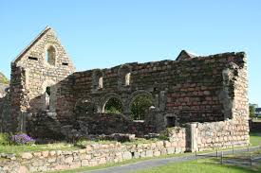
Place of pilgrimage: Iona Abbey Pilgrimage
Iona Abbey was the home of St. Columba, whose missionary work in the 6th century brought Celtic Christianity to Scotland. Known as the Celtic pilgrimage it is now home to the ecumenical Iona Community and remains a place of Christian pilgrimage, dedicated to the Virgin Mary.
The roots of this pilgrimage come from St. Columba who had to part with his family because of feud that killed 3000 people. Uprooting to the small island of the west coast in Scotland the Gaelic rulers gave Iona to Columba so he could build a monastery. Here St. Columba taught monks and blessed them but unfortunately died in 597 CE. In the early Middle Ages, Iona again became a centre of pilgrimage when Benedictine monks built a monastery with a beautiful abbey church. Pilgrims did a circuit of all the sites, culminating in arriving at St Columba’s shrine, and from there they went into a crypt beneath the abbey church to see relics of the saint.
In 1938, George McLeod, a minister in Glasgow, brought to Iona a group of unemployed skilled craftsmen and men training to become ministers. His plan was that they should rebuild the actual monastic buildings which had fallen into ruin and disrepair. At the same time, they would rebuild the community life which Columba had first set up by living together and sharing everything. That led to the foundation of the ecumenical Iona Community. Ecumenical means on which includes all Christian denominations. This group of men and women are committed to a way of life that reflects the Gospel and is relevant to the modern world. It has a global membership who are committed to a Rule that required daily prayer and Bible reading, stewardship of time and money, regular meetings with other members and an active concern for justice, peace and the environment
Pilgrims travel to Iona to rest, reflect and walk in the steps of St. Columba. This is a pilgrimage which focuses on peace and justice. On the island, guests will go around the island and stop around holy places. It is a spiritual exercise drawn into God’s light. Some Christians believe there is an energy in Iona which is loving. The pilgrimage to Iona reminds Christians that God wants us to be whole and many Christians also believe that Iona is a place where an inner connection can be found within themselves.
During this pilgrimage, pilgrims will collect two stones and each stone has a different purpose.

The 1st stone, a pilgrim will make a wish on what they want to achieve in their lives and will keep this stone for a while.

The 2nd stone, represents what a pilgrim wants to get rid of. Again, a pilgrim will make the wish and then throw the stone away.

Peace and tranquillity can be found everywhere on Iona and many Christians believe that doing this pilgrimage forms a community for pilgrims, new beginnings and creates opportunities for one.
Place of pilgrimage: Walsingham
The Shrine of our Lady of Walsingham is a special religious place in Norfolk England which is a pilgrimage for healing and recovery. It is an ancient shrine of the mother of God- Mary and is a unique place for every catholic.
Before going on pilgrimage to Walsingham, a Christian must look and answer on what their intention is, why they are coming to pray for and why? During this pilgrimage, pilgrims will go many church services, read the bible, worship, pray and learn about faith and religion. The pilgrimage of Walsingham reflects the life of Mary and is dedicated to her. There is no set period or time when one must go, Christians can go whenever they want to. Some Christians will go with their local church as group and this is important as is symbolises community and faith. Although it is a place of worship for Catholics, all denominations are welcome to attend and this is important as it helps Christians to feel united in their beliefs.
Walsingham was founded in 1061 by Lady Richeldis but it was later destroyed by Henry the 8th in 1538 and restored in 1922 by Father Hope Patten the Anglican Vicar of Walsingham.
The shrine has an eventful history and this eventful history is very important for Christian pilgrims because an important vision about Mary, the mother of Jesus Christ took place here. Many Christians believe that Richeldis de Faverches, a Saxon noblewoman, lived here and had a vision in the year 1061. In this vision, Richeldis believed that she was taken by Mary, the mother of Jesus, to her home in Nazareth. In this house in Nazareth, it is believed that the Angel Gabriel promised Mary that she would give birth to a son, Jesus. Richeldis was then asked in this vision by Mary to build an exact copy of this house in Walsingham. This is why Walsingham is often called the Nazareth of England. Today, this copy of Mary's home in Nazareth is called the Holy House and is found in the Anglican Shrine or the Parish Church of Saint Mary. A statue of Our Lady of Walsingham is also positioned above the altar in this church.
At the heart of the Shrine of Our Lady lies the Holy House that contains images of the Lady of Walsingham. The holy house is contained within the highly decorated shrine church.
There are three major pilgrimages each year and these are:
-The National
-The Youth
-Healing and Renewal
These three pilgrimages bring thousands of people to Walsingham that allows them to take time out and build their relationship with God.
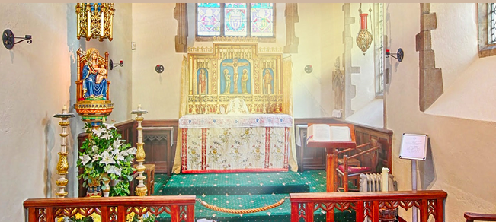
Walsingham is a very holy and sacred place for Christians and all that is left of the church is the arch. Christians come to Walsingham to remember the vision of Mary given to Richeldis. Pilgrims feel that worshipping in this place of spiritual importance can help them to develop spiritually but also bless them.
The last mile- the Slipper Chapel
A part of the pilgrimage for some Roman Catholics consists of walking barefoot for the last mile from the Slipper Chapel to the Holy House as an act of penance. The slipper Chapel is the last and most important part of the pilgrimage and is a place where one goes to Mass to confesses their sins. The Slipper Chapel served pilgrims on their way to England’s Nazareth. When a pilgrim gets to the slipper chapel and confesses their sins, the person will then slip off their shoes and walk the holy mile to the holy house in Walsingham. The Chapel is dedicated to St. Catherine, the patron of saint pilgrims as her knights kept open the road to Nazareth during the Crusades. Her tomb lies in the Monastery on Mount Sinai, within the Basilica of the Annunciation. Just as on Mount Sinai, Moses took off his shoes because he was on holy ground, so the pilgrims to England’s Holy Land used to remove their shoes and walk the Holy Mile into Walsingham.
In summary Walsingham is a place of worship, that recognises the

The place of mission, evangelism and church growth
Church growth: The effort to expand the numbers of people in the Church.
Mission: A vocation or calling to go out and spread the Christian faith.
Evangelism: Spreading faith to others. Jesus said to ‘make disciples of all nations’ (Matthew 28:19).

Christians follow Jesus who said, "As the Father has sent me, so I send you"(John 20.21). They are called to serve God's mission by living and proclaiming the good news (the ‘Gospel’). For Christians, God's mission is about transformation - transforming individual lives, transforming communities and transforming the world. By following Jesus Christ, they believe that God's mission is revealed to them by the Holy Spirit in three ways:
- through the Bible
- through the tradition and life of the Church
- through listening, praying, thinking and sharing
All practicing Christians seek to obey the instructions of the Great Commission (spread the Gospel) but they do this in different ways, depending on their denomination, culture, background, personal taste, or talents.
‘Witnessing for Christ’- is the duty of every Christian. Evangelicals (who can belong to any denomination or to specifically evangelical church) particularly stress the importance of conversion. Others put more emphasis on praying for the souls of the unbelievers. But all true Christian’s acknowledge the need to witness for Christ in their speech and lives, so that those people may come into contact at any time and given the opportunity to respond to Jesus.
Through Speech=
Christians often welcome opportunities to talk to non-Christians about their beliefs. Churches from all denominations have in recent years been running 'Alpha courses' which are designed to explain Christianity to those as yet outside the faith. Many Christian’s find this sort of evangelism difficult as non-Christian’s aren’t always keen to listen.

Through Lifestyle=
Christians should try to live their lives based on love for God and for their neighbours. Jesus said, “if you have love for one another, everyone will know you are my disciples” (John 13:35). Christians also seek to live by the bible moral code with integrity, witnessing to Christ though their marriages, family life, work, how they spend their free time and so on.

Through Vocation=
Some Christians feel that God is calling them to full-time Christian work. This may be as a deacon, priest or bishop, through charity or missionary work, or in a Christian community e.g. as a monk or nun in a religious order.

Role of the church in the local community and living practices
The importance of the worldwide church including work for reconciliation, the persecuted church and the work of one of Christian Aid/ Tearfund/Cafod

Catholic Christianity
The significance of prayer as “the raising of the mind and heart to God” both in formulaic prayers and extempore prayer, including the Lord’s prayer
The importance of the sacramental nature of reality. The names, meanings and effects of the seven sacraments with a particular emphasis on the Eucharist as the “source and summit of Christian life”
The Catholic church and the old Catholic church recognise seven sacraments: Baptism, Reconciliation, Eucharist, confirmation, marriage, holy orders and anointing of the sick
The role and importance of forms of popular piety such as the Rosary, Eucharistic adoration, stations of the cross and pilgrimage to such as Walsingham, Taize, Lourdes, Assisi, Rome. The funeral rite
Catholic beliefs about the essential requirement to love out neighbour in concrete ways locally, nationally and globally. How these beliefs are reflected in Catholic Social Teaching in catholic teaching on justice, peace and reconciliation; in the work of catholic agencies such as Cafod, Caritas and Mission
The meaning and significance of mission and evangelism for Catholics locally, nationally and globally.

- Sources of wisdom and authority

- Forms of expression and ways of life

