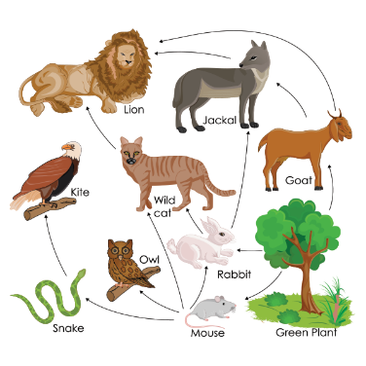
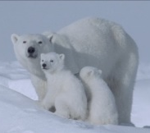
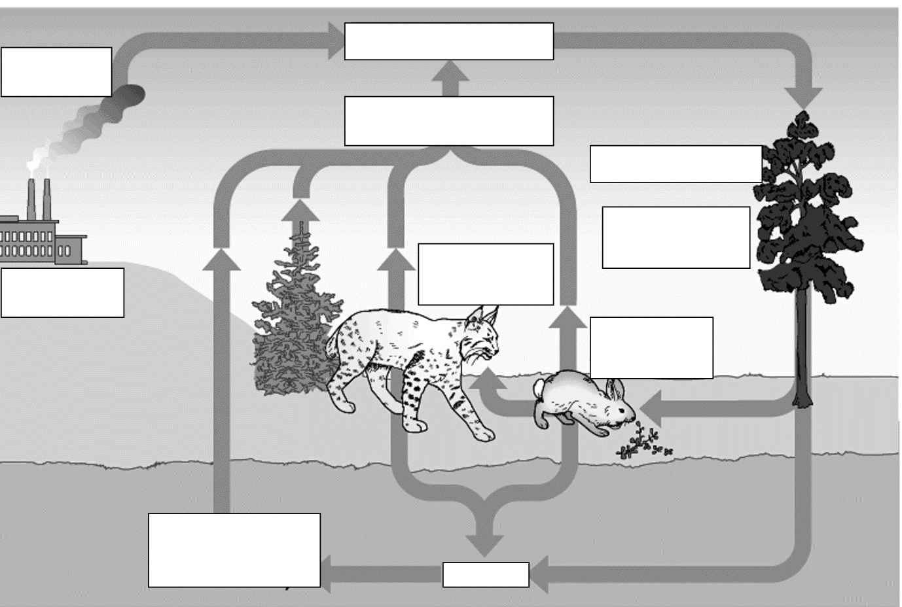
Carbon cycle
What is a producer? Give an example

Create a food chain and label the producer, primary, secondary and tertiary consumers

How are the numbers of predators and prey linked?

Identify a range of biotic and abiotic factors that can affect communities of organisms:

Describe the role of microorganisms in recycling materials:

Outline the main stages of the water cycle and explain why it is important:

Give an example of a situation where you could use a quadrat to take a sample and a situation where a transect would be suitable:

Describe how you can measure the distribution of living organisms using a quadrat:

Describe how you would use a transect to measure distribution of living things:

Describe a range of adaptations that different
animals and plants have to help them survive in
cold and hot climates.

Define:
- Communities –
- Interdependence –
- Median –
- Mode –
- Range –
- Transect –
- Competition –
- Adaptation –
- Extremophiles –

Describe what is meant by a stable community and give an example:

B15 – Communities
B16 – Feeding relationships

Describe the difference between genetic and environmental variation

What things do plants compete for?

How do plants compete with each other?

What things do animals compete for?

What makes a successful competitor?

Carbon cycle

