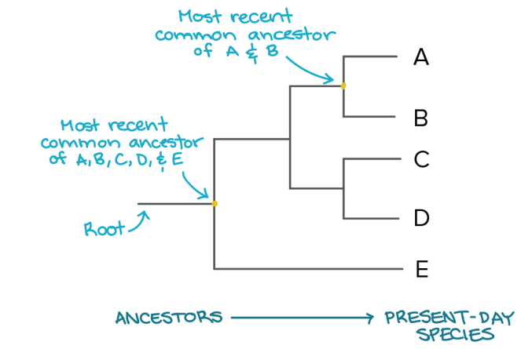
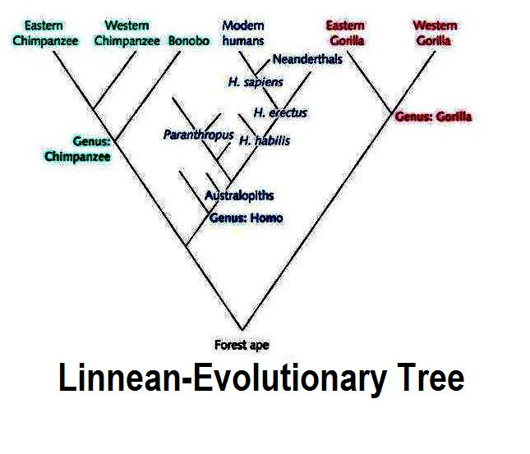
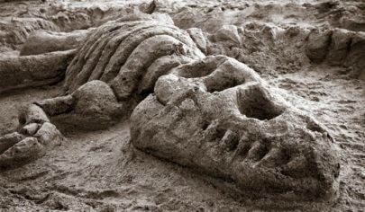
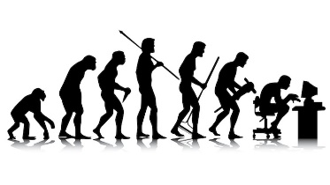
Evolutionary trees
Carl Woese introduced a new higher classification than kingdoms called a domain. What are the domains?

Name the parts of Linnaeus’ classification system
K………………………………
P……………………………...
C……………………………..
O……………………………..
F……………………………….
G……………………………...
S……………………………...
How are organisms named by the binomial system?
Describe the different factors that cause extinction, including mass extinction:

What is genetic engineering?

What are the reasons for genetically engineering organisms?

What are the benefits and problems with GE?

HT only – Describe the process of genetic engineering?

What is antibiotic resistance?

What causes it?

How can we prevent antibiotic resistance in the future?

State what a fossil is:

Describe how fossils are formed:

How are fossils useful?

What are the problems with the fossil record?

B13 – Variation and evolution
B14 - Genetics and evolution

Describe the difference between genetic and environmental variation

What is selective breeding?

Why is it done?

What are the problems with it?

Which scientist came up with the theory of natural selection?

Describe the 4 key stages in the process of natural selection

State what is meant by variation

Describe the difference between genetic and environmental variation

