American West: The story so far – Part 2

1. Increase in migrants along the Oregon Trail due to the discovery of gold in California in 1848 increased pressures on food supplies for Plains Indians, because migrants disturbed the buffalo herds. Less food meant more conflict between the tribes. | 2. White migrants assumed that Indian war parties they saw were a threat to them. Mostly, though they were just witnessing conflict between tribes. They also put pressure on the food supply by killing buffalo for meat. | 3. Both white migrants and Plains Indians demanded the US government to provide protection. This resulted in the Fort Laramie Treaty of 1851. | 4. Give 4 consequences of the Fort Laramie Treaty.  Territories for Indians  White settlers allowed into Indian territories.  Railroad surveyors and military posts in Indian territories.  Tribes receive resources. | 5. Two consequences of the Treaty was Plains Indians start to depend on the government for food resulting in a loss of Indian independence. The US government. White settlement increased as safe passage allowed. | 6. Give 4 causes of lawlessness:  Racism tensions  Mining camps  Not enough law enforcement  Mass settlement  New crime – claim jumping  Social factors eg alcohol | 7. San Francisco’s population grew with the Gold Rush: by 1849 it had grown from 1000 to 25,000. Few people found god and the town filled with unemployed. As more Chinese immigrants came so racial tension increased. Murder and theft were common.
8.. Citizens of San Francisco set up a vigilance committee to control gang violence of 1851. Vigilance committees spread to mining camps.  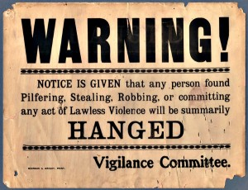 | 9. The federal government tried to tackle lawlessness. US marshals were appointed by the President for a state or territory. Town marshals were appointed by towns people on a yearly basis. | 10. Marshals dealt with saloon brawls and drunken shootings. They could appoint deputies. There were fewer marshals than deputies but they did the same work. Sheriffs were appointed for a 2 year period. | 11. When a territory reached a population of 60,000 it could become a state with its own legal system. Until it became a state the federal government was in charge. | 12. Give 2 problems for federal law and order:  Geography  Lack of funding  Sheriffs were poorly paid  Settlers often disliked federal government and wanted nothing to do with their laws. | 13. Civil War led to new settlement in the West. The Homestead Act of 1862 provided incentives for people to take up unclaimed land in the West. | 14. Under the Homestead Act 160 acres of land was available cheaply.  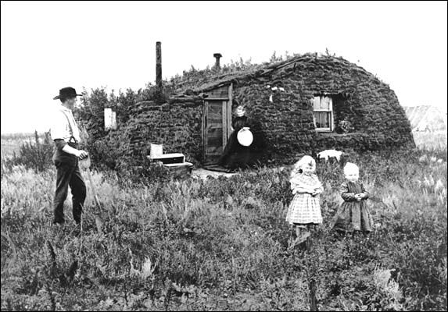
15. Give 3 consequences of the Homestead Act:  6 million acres homesteaded by 1876  Free land was an important pull factor  80 million acres homesteaded by 1930s. | 16. The Pacific Railroad Act (1862) provided incentives for private companies to build transcontinental railroad (1869).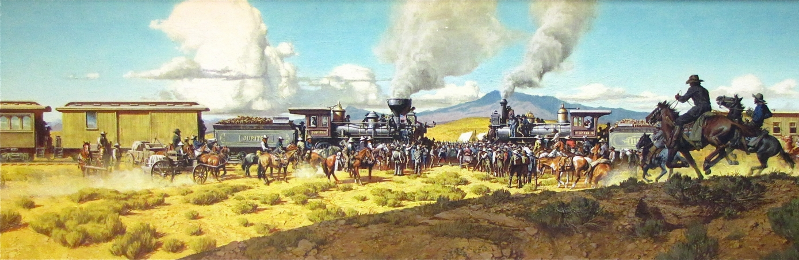 | 17. The government needed railroads to:  control Indian uprising  Fulfil Manifest Destiny  Help with law and order  Promote settlement  Transport goods  Promote unity. | 18. . The federal government face financial support for the railroad. $61 million in loans.  45 million acres of free land for the railroad company to sell to settlers. | 19. The railroad promoted settlement by:  selling plots of land along their routes.  Setting up towns at railheads.  Selling the idea of settlement. | 20. 1862-76 saw technological solutions to problems of farming and different farming methods. Give two:  Sod houses  Barbed wire  Wind pumps | 21. 160 acres allocated under the Homestead Act could not support the average family. Give 2 Acts that helped.  The Timber Culture Act 1873  The Desert Land Act 1877
22. Civil War had a significant impact on law and order. War devastated the South’s economy creating unemployment. Young men had been traumatised by war. | 23. Railroads created new towns known as Hell on Wheels. They often grew quickly with no law enforcement. Some were ‘cow towns’. | 24. Hell on wheels’ towns were notorious for gambling, drinking and prostitution.  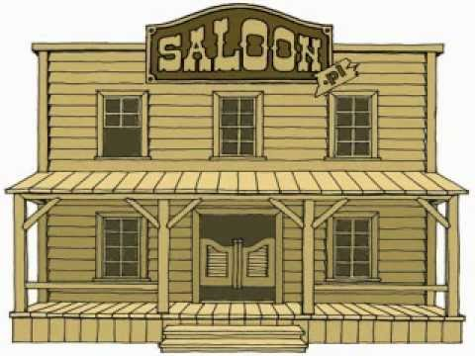 | 25. ‘Lawlessness was tackled by electric telegraph improving communication, banning firearms. The Pinkertons were a private detective agency who tracked down robbers and thieves. | 26. Before the Civil War cowboys herded the cows on long drives. A quarantine law was put in place because of Texas fever to prevent infected cattle entering Missouri and Kansas. | 27. After the Civil War the railroads provided a new way to move cattle. Abilene was the first cow town. Joseph McCoy saw the potential of Abilene. Stockyards and hotels were built. | 28. The Goodnight-Loving Trail opened another market for cattle to new settlements in the West. In 1868, Goodnight’s trail extended to Colorado and Wyoming.
29. In 1866 the government had failed to get enough food to the Navajo Indian reservations. 800 cattle sold for $12000 for the Navajo. | 30. Goodnight’s success encouraged other cattlemen to drive cattle to Wyoming, and Wyoming’s cattle ranches began to grow. | 31. John Illif saw opportunities to sell meat to mining towns in Colorado. It was difficult to get supplies there. | 32. llif saw the opportunity to raise cattle on the Plains and began ranching near Denver in 1866. | 33. Illif became Denver’s first millionaire by selling his beef to miners, Indian reservations and railroad worker gangs. | 34. Cowboys were mostly young single men. They were tough, hard-working, often hard-drinking. They worked long hours in all weathers. Life could be lonely as they often worked miles apart. | 35. Life changed for cowboys on ranches. Fewer were needed. Fewer dangers. They slept in bunkhouses and used cookhouses. Drinking, gambling, guns and knives were banned. Many struggled to adapt to this lifestyle.

American West: The story so far – Part 2
1.Iincrease in migrants along the _______ Trail due to the discovery of ____ in California in ____ increased pressures on food supplies for Plains Indians, because migrants disturbed the buffalo herds. Less food meant more conflict between the tribes. | 2. White migrants assumed that Indian war parties they saw were a threat to them. Mostly, though they were just witnessing conflict between tribes. They also put pressure on the food ______ by killing ________ for meat. | 3. Both white migrants and Plains Indians demanded the US ____________ to provide protection. This resulted in the ________ _______________ Treaty of _______. | 4. Give 4 consequences of the Fort Laramie Treaty.  1.  2.  3.  4. | 5. Two consequences of the Treaty was Plains Indians start to depend on the __________ for ____ resulting in a loss of Indian ______________. The US government. White settlement increased as safe passage allowed. | 6. Give 4 causes of lawlessness:  1.  2.  3.  4. | 7. San Francisco’s population grew with the Gold Rush: by ____ it had grown from _____ to ______. Few people found god and the town filled with unemployed. As more ________ immigrants came so racial tension increased.  Murder and theft were common.
8.. Citizens of San Francisco set up a ___________ committee to control gang violence of 1851. _________ committees spread to mining camps. | 9. The federal government tried to tackle lawlessness. US ________ were appointed by the President for a state or territory. Town marshals were appointed by towns people on a yearly basis. | 10. Marshals dealt with saloon brawls and drunken shootings. They could appoint deputies. There were fewer marshals than deputies but they did the same work. Sheriffs were appointed for a _______ period. | 11. When a territory reached a population of _______ it could become a state with its own legal system. Until it became a state the federal government was in charge. | 12. Give 2 problems for federal law and order:  1.  2. | 13. Civil War led to new settlement in the West. The ___________ Act of _____ provided incentives for people to take up unclaimed land in the West. | 14. Under the Homestead Act ____ acres of land was available cheaply.
15. Give 3 consequences of the Homestead Act:  __________ acres homesteaded by 1876  Free land was an important ____ factor  _________ acres homesteaded by 1930s. | 16. The ____________ Act (1862) provided incentives for private companies to build transcontinental railroad (1869). | 17. The government needed railroads to:  control _________ uprising  Fulfil ___________ Destiny  Help with law and order  Promote settlement  Transport goods  Promote unity. | 18. . The federal government face financial support for the railroad. _______________ in loans.  _____ million acres of free land for the railroad company to sell to settlers. | 19. The railroad promoted settlement by:  selling plots of land along their routes.  Setting up towns at railheads.  Selling the idea of settlement. | 20. 1862-76 saw technological solutions to problems of farming and different farming methods. Give two: | 21. 160 acres allocated under the Homestead Act could not support the average family. Give 2 Acts that helped.
22. Civil War had a significant impact on law and order. War devastated the South’s economy creating ___________. Young men had been _____________ by war. | 23. Railroads created new towns known _______________s. They often grew quickly with no law enforcement. Some were ‘cow towns’. | 24. Hell on wheels’ towns were notorious for gambling, drinking and prostitution. | 25. ‘Lawlessness was tackled by electric telegraph improving communication, banning firearms. The __________ were a private detective agency who tracked down robbers and thieves. | 26. Before the Civil War cowboys herded the cows on long drives. A quarantine law was put in place because of ______ fever to prevent ________ cattle entering Missouri and Kansas. | 27. After the Civil War the ____________ provided a new way to move _______. ________ was the first cow town. Joseph ______ saw the potential of Abilene. Stockyards and hotels were built. | 28. The _____________________ Trail opened another market for cattle to new settlements in the West. In 1868, Goodnight’s trail extended to Colorado and Wyoming.
29. In 1866 the government had failed to get enough food to the Navajo Indian reservations. 800 cattle sold for ____________ for the Navajo. | 30. Goodnight’s success encouraged other cattlemen to drive cattle to __________, and _____________ cattle ranches began to grow. | 31. John __________ saw opportunities to sell meat to mining towns in _____________. It was difficult to get supplies there. | 32. ___________ saw the opportunity to raise cattle on the Plains and began ranching near _________ in 1866. | 33. Illif became Denver’s first _____________ by selling his beef to miners, Indian reservations and railroad worker gangs. | 34. Cowboys were mostly young single men. They were tough, hard-working, often hard-drinking. They worked long hours in all weathers. Life could be __________ as they often worked miles apart. | 35. Life changed for cowboys on ranches. Fewer were needed. Fewer dangers. They slept in ______________ and used _______________. Drinking, gambling, guns and knives were banned. Many struggled to adapt to this lifestyle.

