American West: The story so far
1. Many different social and tribal structures made up the peoples known as the Plains Indians. Most tribes were divided into bands, each with a chief and a council. Examples of tribes include:  - Sioux  - Cheyenne | 2. Chiefs and elders formed the tribal councils that advised tribal chiefs. Some tribes were part of larger groups called nations. The best warriors from each band formed it’s warrior society. | 3. Plains Indians did not view leadership in the same way as white Americans. Everyone at the council had to agree to a decision. The rest of the tribe or band did not have to obey the decision. | 4. The Great Plains was a tough environment. It was dry with hot summers and extremely cold winters.  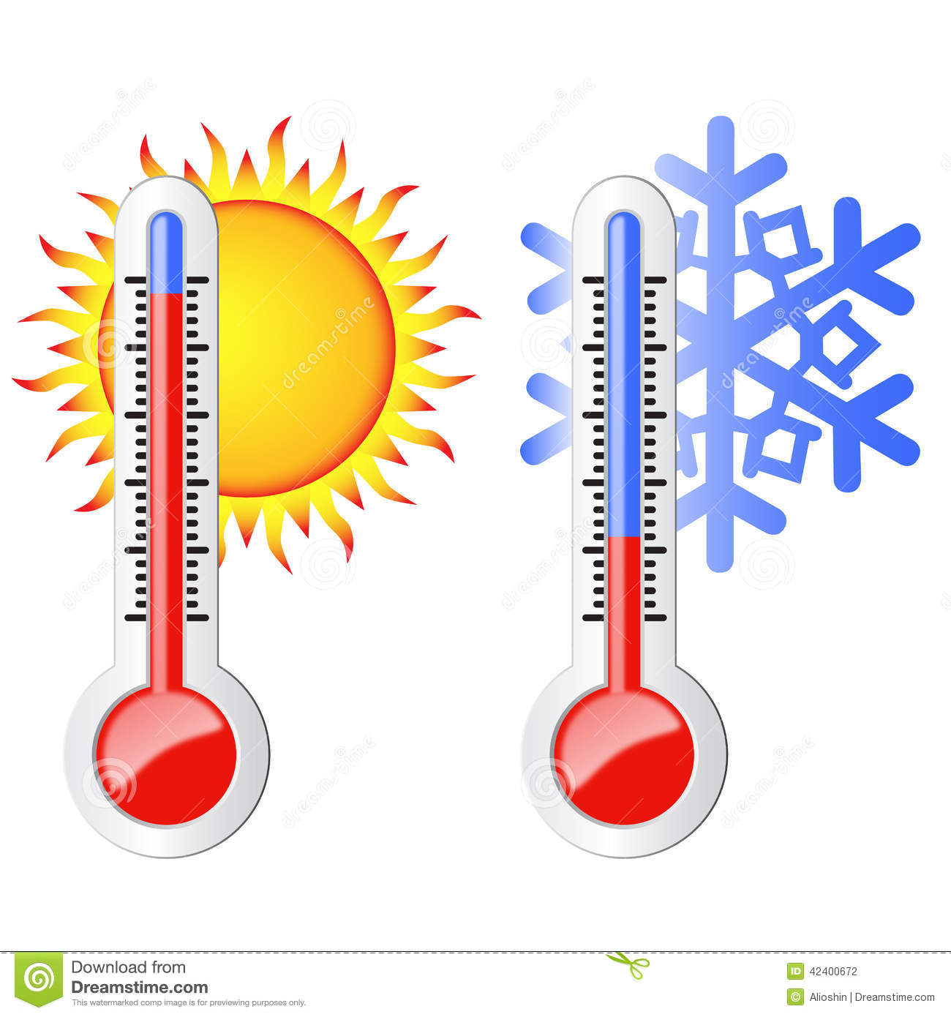 | 5. Indians needed buffalo and horses to survive. Catching buffalo was easier and quicker on horseback. Every part of the buffalo was used except its heart which the Indians believed gave new life to the herd. | 6. Most Plains Indians followed the buffalo migration. This meant they had a nomadic lifestyle. Tipis made of wood and covered with buffalo hide could be taken down quickly. | 7. A consequence of a nomadic lifestyle was that Indians found it difficult to live on reservations because they were used to travelling and hunting freely.  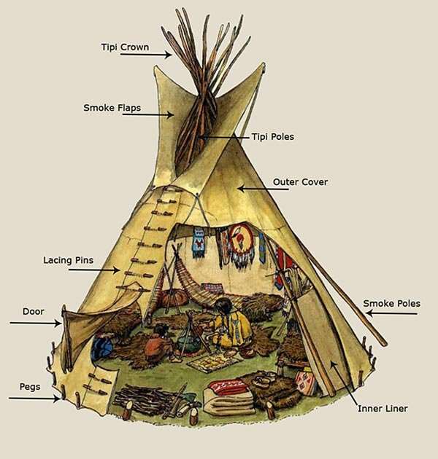
8. Plains Indians believed everything in nature had a spirit and that these could help or harm them. Humans were a part of nature and should work with it rather than try to tame and control nature. | 9. Plains Indians had sacred areas for example the Black Hills. Generally, no one owned land. For Indians land was not anyone’s property and not something someone could keep for themselves. | 10. A consequence was white settlers had very different views from Plains Indians about land and this lead to tension and conflict. | 11. Indians had developed ways to avoid too much killing. Give two ways:  Counting coup  Running away if a fight turned against them. | 12. 1830 Indian Removal Act forced 46,000 Indians to give up their lands in return for new lands west of the Mississippi River. White’s thought this land was worthless. | 13. 1834 A permanent Indian Frontier divided Indian territory in the eastern states. Forts guarded the frontier to stop whites crossing over to settle in Indian territory. | 14. 1848 US victory in the Mexican-American War meant US gained new territories in the west. Indian Territory was now sandwiched in the middle of the USA.
15. The government needed US citizens to live in its new territories in the west. This meant people needed to travel across Indian lands. The US army forced Indians away from the trails in case they attacked Americans travelling on it. | 16. 1850s white Americans want to use parts of land in the West that had been given to Indians. They paid Indians to give up that land and move to smaller areas. They hoped they would learn to farm. | 17. Give 5 pull factors for migration to the west:  - freedom and independence  - fertile land  - Oregon Trail  - Space  - Gold | 18. Give 4 push factors for migration to the west:  - collapse of wheat prices  - overpopulation  - persecution  - unemployment | 19. In 1836 the first migrants travel the Oregon Trail by wagon and reach their destination.  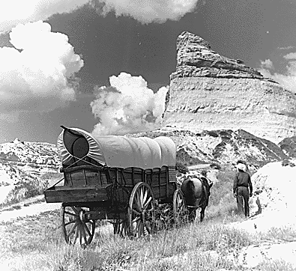 | 20. Manifest Destiny was God’s will that white Americans should settle over all of America and civilise it. | 21. The discovery of gold in California in 1848 led to an increase in migration. Most migrants did not find gold.  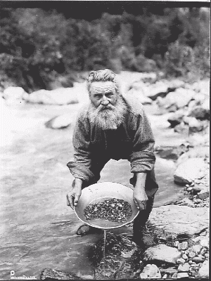
22. Consequences of the gold rush were:  - Farming boom  - Genocide of Indians  - Tension with Plains Indians  - Gold boosts US economy  - Racial tension due to immigration | 23. The Oregon Trail was 3200km long or 3800km if going to California. Migrants needed to complete it before Winter or risk getting stuck in the mountains. | 24. Crossing the Great Plains was dangerous because of:  - cholera  - quicksand  - extreme heat  - stampeding buffalo  - Indian attack | 25. The Donner Party lead by Jacob and George Donner left for California in May 1846 with 60 wagons and 300 people. At Fort Bridger about 80 of them tried to take a short cut. | 26. They arrived late in the Sierra Nevada and were trapped by heavy snow. To survive they had to eat their dead. | 27. Mormons migration of 1846-47 was successful. Mormons were persecuted for their success, practice of polygamy, their desire to free slaves and be friends with Plains Indians. | 28. Joseph Smith founded the Church of the Latter-Day Saints whose followers were known as Mormons. When he died Brigham Young became leader.
29. Persecution in Illinois forced Brigham Young and 1500 others to find land near Great Salt Lake that no one else wanted. | 30. To make the journey Young researched the route in advance, planned well with enough food to last a year. | 31. Young’s advance group of 150 people were specially chosen with the skills to pick out the best route. | 32. Between 1847 and 1869 70,000 Mormons followed the ‘Mormon Trail’. | 33. Settlers on the plains had many problems. Give 2 for farming:  Climate  Lack of trees | 34. Settler’s dealt with the lack of wood by building their homes out of sod. These were fireproof but impossible to keep clean. | 35. Crops that did well in the East died in the West from lack of water or insect infestations such as grasshopper swarms.

American West: The story so far
1. Many different social and tribal structures made up the peoples known as the ______ ________ Most tribes were divided into ______, each with a chief and a council. Examples of tribes include: | 2. Chiefs and elders formed the tribal councils that advised tribal chiefs. Some tribes were part of larger groups called _______. The best warriors from each band formed it’s ___________. | 3. Plains Indians did not view leadership in the same way as white Americans. Everyone at the council had to agree to a decision. The rest of the tribe or band _____________________. | 4. The Great Plains was a tough environment. It was dry with ___ summers and extremely ______ winters. | 5. Indians needed _______ and __________ to survive. Catching _______ was easier and quicker on _________. Every part of the ______ was used except its _____ which the Indians believed gave new life to the ____. | 6. Most Plains Indians followed the buffalo migration. This meant they had a ______ lifestyle. Tipis made of wood and covered with buffalo hide could be taken down quickly. | 7. A consequence of a nomadic lifestyle was that Indians found it difficult to live on ____________ because they were used to travelling and hunting freely.
8. Plains Indians believed everything in ______ had a spirit and that these could help or harm them. Humans were a part of nature and should work with it rather than try to tame and control nature. | 9. Plains Indians had sacred areas for example the ___________. Generally, no one owned land. For Indians land was not anyone’s property and not something someone could keep for themselves. | 10. A consequence was white settlers had very different views from Plains Indians about ____ and this lead to __________  ___________________ | 11. Indians had developed ways to avoid too much killing. Give two ways: | 12. 1830 Indian Removal Act forced _______ Indians to give up their lands in return for new lands west of the __________ River. White’s thought this land was worthless. | 13. 1834 A ____________  _____________________ divided Indian territory in the eastern states. Forts guarded the frontier to stop whites crossing over to settle in Indian territory. | 14. 1848 US victory in the ________-American War meant US gained new territories in the west. Indian Territory was now sandwiched in the middle of the USA.
15. The government needed US citizens to live in its new territories in the west. This meant people needed to travel across Indian lands. The US army forced Indians away from the ______ in case they attacked Americans travelling on it. | 16. 1850s white Americans want to use parts of land in the West that had been given to Indians. They paid Indians to give up that land and move to smaller areas. They hoped they would learn to _______. | 17. Give 5 pull factors for migration to the west: | 18. Give 4 push factors for migration to the west: | 19. In 1836 the first migrants travel the ______  ________ by ______ and reach their destination. | 20. Manifest Destiny was God’s will that white Americans should settle over all of America and ___________ it. | 21. The discovery of ____ in California in 1848 led to an increase in migration. Most migrants did not find gold.
22. Consequences of the gold rush were: | 23. The Oregon Trail was 3200km long or 3800km if going to _____________. Migrants needed to complete it before _______ or risk getting stuck in the mountains. | 24. Crossing the Great Plains was dangerous because of: | 25. The Donner Party lead by Jacob and George Donner left for California in May 1846 with 60 wagons and ____ people. At Fort Bridger about __ of them tried to take a short cut. | 26. They arrived late in the Sierra Nevada and were trapped by ______  ________. To survive they had to | 27. Mormons migration of 1846-47 was successful. Mormons were persecuted for: | 28. Joseph Smith founded the Church of the Latter-Day Saints whose followers were known as Mormons. When he died ________  _________________ became leader.
29. Persecution in Illinois forced Brigham Young and ____ others to find land near ______________ that no one else wanted. | 30. To make the journey Young | 31. Young’s advance group of ___ people were specially chosen with the skills to pick out the best route. | 32. Between 1847 and 1869 ________________ Mormons followed the ‘Mormon Trail’. | 33. Settlers on the plains had many problems. Give 2 for farming: | 34. Settler’s dealt with the lack of ______ by building their homes out of ___. These were fireproof but impossible to keep clean. | 35. Crops that did well in the East died in the West from

