- LEVEL BIOLOGY at GEORGE SALTER ACADEMY

AQA A LEVEL BIOLOGY TRANSITION SUMMER READING PACK
Year 11 ➝ Year 12.


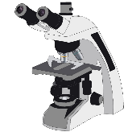
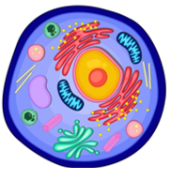

Introduction:

Welcome to A-Level Biology at George Salter Academy
Congratulations on choosing to study A Level Biology at George Salter Academy, an exciting step towards exploring the science of life and unlocking a wide range of future opportunities in science, health, and the environment.
Biology is one of the most dynamic and rapidly advancing sciences, helping us understand everything from microscopic cells to global ecosystems. Whether you're interested in medicine, genetics, conservation, or biochemistry, A Level Biology provides a strong foundation in both theoretical knowledge and practical skills.
At George Salter Academy, we pride ourselves on high-quality teaching, personalised support, and an ambitious curriculum that challenges and inspires our students. You will engage in hands-on experiments, develop scientific thinking, and learn how biology applies to real-world issues; from tackling diseases to solving climate change.
This summer reading pack is designed to help you bridge the gap between GCSE and A Level study. It introduces key ideas from your first four topics and gives you a head start for a successful transition into Year 12.
We look forward to welcoming you in September!

Course Overview
Exam Board: AQA
Specification Code: 7401 (AS), 7402 (A Level)
Biology is the science of life. Studying A-Level Biology with AQA will help students develop a deeper understanding of biological principles and build strong practical and analytical skills.

Core Skills You will develop:
- Scientific method and critical thinking
- Practical lab work and data interpretation
- Application of biology in real-world contexts (medicine, genetics, ecology)

Knowledge Organiser: Topics 1–4
Topic | Title | Key Concepts
1 | Biological Molecules | Carbohydrates, lipids, proteins, enzymes, water, ATP
2 | Cells | Prokaryotic vs eukaryotic cells, cell structure, microscopes, cell division
3 | Exchange of Substances | Gas exchange, transport in animals and plants, surface area to volume ratio
4 | Genetic Information, Variation & Relationships | DNA/RNA structure, protein synthesis, mutations, meiosis, biodiversity


Suggested Reading + Web Links (with QR Codes)
- Biological Molecules

https://www.physicsandmathstutor.com/biology-revision/a-level-aqa/biological-molecules/
- Cell Structure and Microscopes
  - Cells and Microscopes – Khan Academy
- Exchange Systems

  - S-cool Biology: Exchange and Transport


- DNA and Genetics
  - Your Genome – DNA Basics

Follow-up Questions

Topic 1: Biological Molecules
- Define a monomer and a polymer. Give two examples relevant to biology.
- Describe the role of enzymes in biological reactions.
- Explain how the structure of starch relates to its function.

Topic 2: Cells
- Compare prokaryotic and eukaryotic cells.
- What is the function of the mitochondrion?
- Describe the process and importance of mitosis.

Topic 3: Exchange of Substances
- Why is surface area to volume ratio important in biology?
- Describe how gas exchange occurs in the lungs.
- Compare transport systems in plants and animals.

Topic 4: Genetic Information
- Describe the structure of DNA.
- What is the role of RNA in protein synthesis?
- Explain how genetic variation arises during meiosis.

Optional Preparation Tasks
- Create a glossary of key terms from Topics 1–4.
- Watch YouTube channel "A Level Biology - SnapRevise" for visual summaries.
- Prepare a mind map for each topic based on the knowledge organiser.

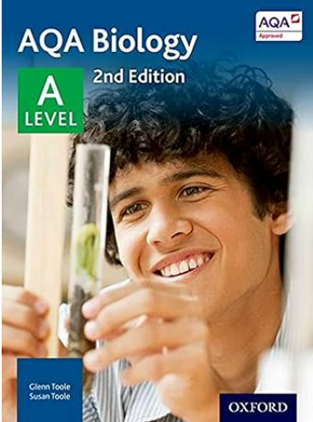
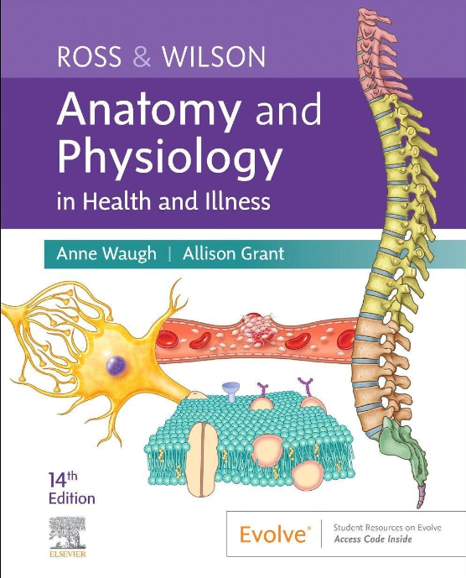
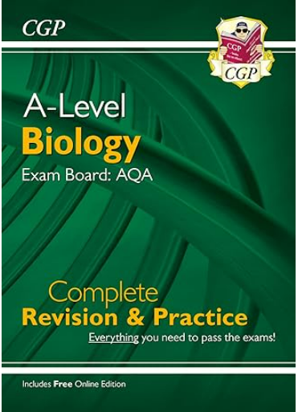
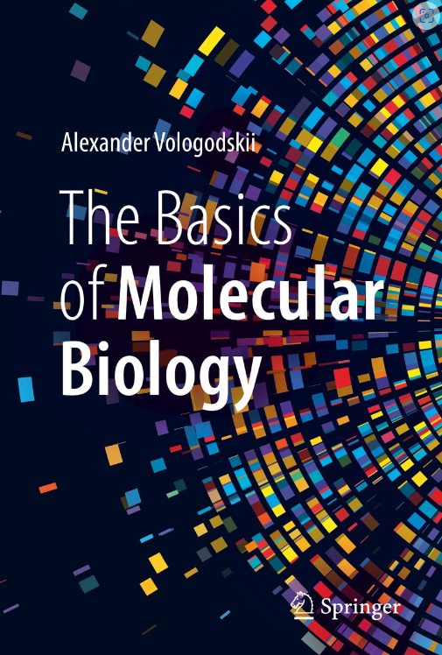
CGP A-Level Biology
The perfect companion for A-Level AQA Biology, this new and improved CGP Complete Revision & Practice Guide is ideal for reference throughout both years and preparing for those final exams! It has straightforward study notes, helpful examples and full-colour diagrams.
Anatomy and Physiology
This textbook is widely recommended for students looking to pursue a career in nursing, allied health, or biomedical and paramedical science. For A-level students, it can be a helpful introduction to what lies beyond and give you a head start while you look at your university options.
AQA A level Biology
This book draws on straightforward explanations to complex subject topics to bring ideas together. As it is written by both curriculum and subject experts, you will benefit from the scientific aspects of what is taught on an A-level Biology course and what is likely to be covered in an exam paper.
Book Recommendations
The Basics of Molecular Biology
This book is ideal for visual learners, as it boasts over 100 rich illustrations. Chapters are dedicated to molecular biology, including nucleic acids and proteins, the genetic code, and protein synthesis. This book is ideal for critical thinkers. Whether you're studying A-level Maths, Biology, or any other subject, it is important to be able to program your mind to solve problems.

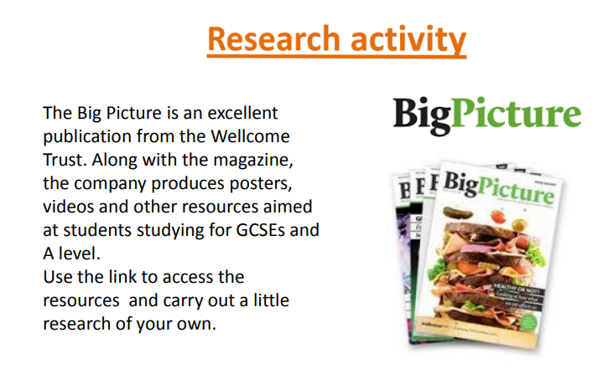
The Immune System Available at: https://www.stem.org.uk/resources/elibrary/resource/35694/immune-system
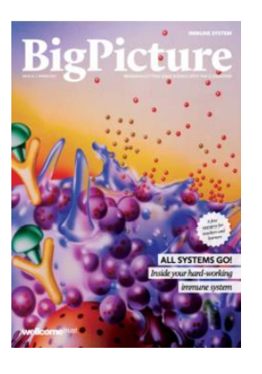
The immune system is what keeps us healthy in spite of the many organisms and substances that can do us harm not least of all corona virus. In this issue, explore how our bodies are designed to prevent potentially harmful objects from getting inside, and what happens when bacteria, viruses, fungi or other foreign organisms or substances breach these barriers.



Recommended videos to watch
Take a moment to appreciate biology in context. Explore these outstanding presentations by world-leading scientists and researchers, covering a wide range of fascinating topics. They offer insightful answers and raise thought-provoking questions.
Click the link or scan the QR code to watch:


Svante Pääbo – Father of paleogenetics
Svante Pääbo is widely recognized as the father of paleogenetics, a field he pioneered by developing methods to extract and analyze DNA from ancient human remains, particularly Neanderthals. https://www.youtube.com/watch?v=kU0ei9ApmsY

Bonnie L. Bassler – Molecular biologist & pioneer of quorum sensing
Bonnie L. Bassler is a molecular biologist renowned for her pioneering work in quorum sensing, the process by which bacteria communicate with each other using chemical signals.

https://www.hhmi.org/news/tapping-bacterial-conversations

