

**George Salter Academy Geography Department**

**Geography A Level Preparation**

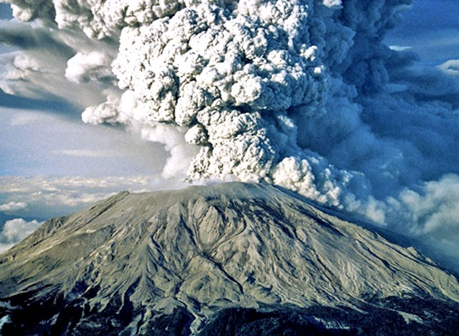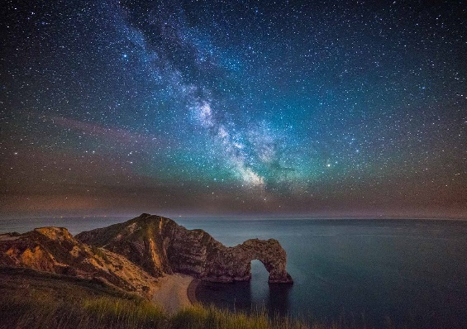

***“Geography explain the past, illuminates the present and prepares us for the future. What could be more important than that?”***

**Michael Palin**

**Welcome to A-level Geography!**

With the start of your A levels many months away, it is important that we do not let slip all the skills and understanding that you have worked so hard for over the last few years. Whether or not you are continuing geography to A level, the skills of researching, analysing and evaluating material are important across all subjects and so the aim for the following weeks is to build on what you have already learnt during your GCSE course.

If you are (very wisely!) intending to continue geography at A level, this work will also provide some excellent resources to use throughout your course, as well as helping to develop further some of the most important skills and enable you to more readily “Think like a geographer.”

Our current intention is to set a variety of tasks that will give you a greater understanding of the world we live in, as well as investigating some aspects of the A level course. (If you are considering A level geography, a summary of the content can be found at <https://filestore.aqa.org.uk/resources/geography/specifications/AQA-7037-SP-2016.PDF> under Specification at a Glance



**AQA A Level Geography Course**

**Assessment**

|  |  |
| --- | --- |
| **Unit** | **Weighting and contents** |
| **Component 1 – Physical Geography** | * 40% of the A level. * Written exam 2hrs 30minutes * 120 marks |
| * Water and carbon cycles. * Coastal systems and landscapes * Hazards |
| **Component 2- Human Geography** | * 40% of the A level. * Written exam 2hrs 30 minutes * 120 marks |
| * Global systems and global governance. * Changing place. * Population and the environment. |
| **Component 3 – Geography fieldwork investigation** | * 20% of the A level. * 3,000 to 4,000 word written investigation. * 60 marks. * Marked by teachers – moderated by AQA. |
| Students complete an individual investigation, which must include data collected in the field. The individual investigation must be based on a question or issue defined and developed by the student relating to any part of the specification content |

**Order of teaching**

**Year 12**

* Coastal systems and landscapes
* Hazards
* Changing Place
* NEA (Non-Examined Assessment) Coursework research project

**Year 13**

* Population and the environment
* Water and carbon cycles
* Global systems and global governance
* NEA (Non-Examined Assessment) Coursework research project – submitted April/May

**So you want to be an A level geographer? ….**

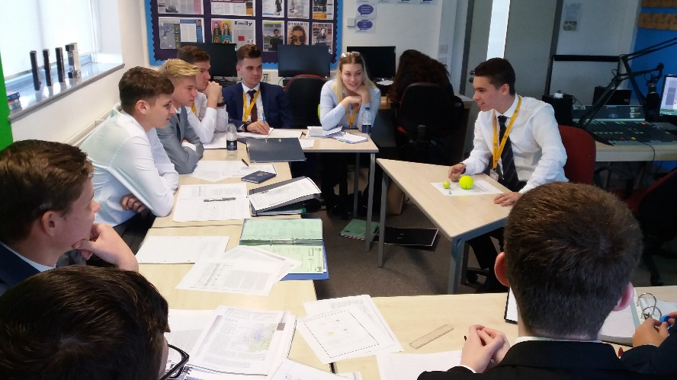

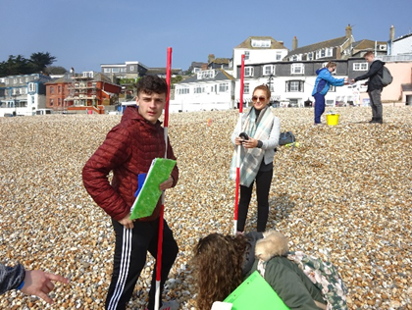

To be a great geographer you need to develop the ability to think **synoptically**, being able to see the greater overview and how everything begins to link together. Geography is not just about studying people and landscapes; it is also the relationships that exist between people and their environment.

At GCSE, you have covered many of the foundations of the underpinning concepts; **physical processes** and how they have shaped the landscape and the key **human processes** that shape our society. GCSE has provided a breadth of study, whereas A Level will now enable you to gain greater depth by exploring topics in **detail** but also encouraging you to see and explore the links between topics.

**The best geographers at A Level** keep reading the news and generally seek to improve their geographical understanding by engaging with geographical discussions regarding key issues.

This guide has been designed for you to be able to dip in and out of, from looking at general geographical issues and developing your ability to think like a geographer, through to starting to explore some of the topics we will be looking at in Year 12 and 13 so you can do some valuable background reading.

**Task 1 – Key words A level geography**

Below is a key word list for coastal systems and landscapes along with hazards. You will need to research what these key words mean – and be aware of them before we start the A level course. This will enable you to access A level reading material a lot more easily and understand the content in lessons and exam questions.

|  |  |
| --- | --- |
| Coasts specialist terms | Definition |
| abrasion |  |
| accretion |  |
| arch |  |
| attrition |  |
| barrier beach (or bar) |  |
| barrier island |  |
| berm |  |
| biological weathering |  |
| cave |  |
| cavitation |  |
| climatic climax community |  |
| coastal morphology |  |
| compound spit |  |
| constructive wave |  |
| corrasion |  |
| cost-benefit analysis (CBA) |  |
| cusp |  |
| Dalmatian coast |  |
| destructive wave |  |
| double spit |  |
| drift-aligned beach |  |
| emergent coastline |  |
| environmental refugee |  |
| eustatic change |  |
| fjord |  |
| halophyte |  |
| hard-engineering |  |
| high-energy environments |  |
| hydraulic action |  |
| Integrated Coastal Zone Management (ICZM) |  |
| isostatic change |  |
| isostatic recovery |  |
| isostatic subsidence |  |
| landform |  |
| landscape |  |
| landslide |  |
| landslip (or slump) |  |
| lithology |  |
| longshore (littoral) drift |  |
| low-energy environments |  |
| mass movement |  |
| mudflat |  |
| mudflow |  |
| offshore bars |  |
| pioneer species |  |
| raised beach |  |
| recurved tip |  |
| ria |  |
| rip currents |  |
| rockfall |  |
| runnels |  |
| saltation |  |
| saltmarsh |  |
| sand dune |  |
| scree |  |
| sediment budget |  |
| sediment cell |  |
| Shoreline Management Plan (SMP) |  |
| slump (or landslip) |  |
| soft-engineering |  |
| soil creep |  |
| solifluction |  |
| solution (dissolved load) |  |
| solution (corrosion) |  |
| spit |  |
| stack |  |
| stump |  |
| submergent coastline |  |
| suspension |  |
| swash-aligned beach |  |
| tidal range |  |
| tides |  |
| tombolo |  |
| traction |  |
| vegetation succession |  |
| wave quarrying |  |
| wave refraction |  |
| wave-cut notch |  |
| wave-cut platform |  |

|  |  |
| --- | --- |
| Hazards specialist terms | Definition |
| acid dome volcanoes |  |
| adaptation |  |
| asthenosphere |  |
| atmospheric hazards |  |
| caldera |  |
| composite cones  (strato-volcanoes) |  |
| conservative plate margins |  |
| constructive (divergent) plate margins |  |
| core |  |
| crown fire |  |
| crust |  |
| destructive (convergent) plate margins |  |
| El Niño |  |
| extrusive |  |
| eye wall |  |
| fatalism |  |
| fissure eruptions |  |
| geophysical hazards |  |
| gravitational sliding |  |
| ground fire |  |
| hazard |  |
| hazard management cycle |  |
| hot spot |  |
| hydrological hazards |  |
| igneous rocks |  |
| Indian Ocean Dipole (IOD) |  |
| intrusive |  |
| ladder effect |  |
| lahar |  |
| liquefaction |  |
| lithosphere |  |
| Love (L) waves |  |
| magma |  |
| magma plume |  |
| mantle |  |
| mid-ocean ridges |  |
| mitigation |  |
| nuée ardente |  |
| palaeomagnetism |  |
| prediction |  |
| preparedness |  |
| prevention |  |
| primary or pressure (P) waves |  |
| pyroclastic flows |  |
| Rayleigh (R) waves |  |
| ridge push |  |
| rift valleys |  |
| Saffir-Simpson scale |  |
| sea-floor spreading |  |
| secondary or shear (S) waves |  |
| seismicity |  |
| shield volcanoes |  |
| sial |  |
| sima |  |
| slab pull |  |
| storm surge |  |
| subduction |  |
| submarine volcanoes |  |
| supervolcano |  |
| surface fire |  |
| tephra |  |
| transform fault |  |
| tropical storm |  |
| tsunami |  |
| vulcanicity |  |
| wildfire |  |

**Task 2- Contemporary geographical issues**

Task 2 will be aimed at delving into what you enjoy about geography. This will enable you to investigate independently a geographical issue that you find interesting in the form of a 500-word report. For example, you could research one of the following:

* ***The causes, impacts and responses of the Australian bushfires in 2020.***
* ***Opportunities and challenges of deforestation in the Amazon rainforest.***
* ***Issues of crime in the favelas in Rio.***
* ***The geography of Corona-virus – global distribution and disparities.***
* ***Climate change human vs natural causes – future projections.***

It does not have to be one of the titles above it could be your own title – but it needs to be specific, not generic and obviously related to a geographical context. In your report, you need to be able to include some of the key words that you have researched in task 1 if it is coasts or hazards related, also the following key themes into your writing to demonstrate you can write at an A level standard:

|  |  |
| --- | --- |
| **Sustainability** | Sustainability is about meeting the needs of today without compromising the needs of future generations – what elements of sustainability do you need to discuss about your geographical issue. |
| **Scale** | Scale refers to the size of an event or its distribution. Is this geographical issue global, national or local? How far does it extend or have impact? What is the level of response or root cause? |
| **Temporal/change** | Temporal refers to spatial and time – so for example how might the impacts of climate change have changed over time and how might they differ in different parts of the world. |
| **Process/theory** | Processes could be physical or human processes. For example, you could be looking at the Australian bush fires in 2020 - looking at the process of how wildfires begin and how they are spread. |
| **Impact and management** | Impact and management often link. As geographers we may initially look at the causes, what impact does this have (socially, economically, environmentally, and politically) and how is this managed? Who is it managed by? How effective is that management? Is it **sustainable?** |
| **Synopticity** | Synopticity is about how aspects of the geographical issue link to other issues or contexts. So for example, the Australian bushfires can be linked to climate change and change in weather patterns**. This can be challenging – do not worry if you are struggling with this theme.** |

**Task 2- Contemporary geographical issues**

**Suggested reading and research**

**Websites:**

1. BBC NEWS <https://www.bbc.co.uk/news> - an excellent source of up-to-date articles – explore the key headings such as Science, as well as the UK, World and other stories.
2. THE GUARDIAN <https://www.theguardian.com/uk> - again many useful articles and logically ordered – keep an eye on the Environment, Science, Society, Global Development stories in particular!
3. THE CONVERSATION.COM <http://theconversation.com/uk> We can highly recommend you use this! This you will find is useful to support many of your A Levels. It provides up-to-date articles from academics and specialists in the field written in a way that is accessible to all, summarising key points in short but insightful articles.
4. GEOGRAPHICAL <https://geographical.co.uk/places> - brilliant range of articles based around contemporary issues around the world.
5. PLACES JOURNAL <https://placesjournal.org/explore-places/geography/?gclid=EAIaIQobChMI0PX1pa2a6QIV0u3tCh0LlQgGEAAYASAAEgLF2vD_BwE&cn-reloaded=1>

**Podcasts:**

**Costing the Earth –** There are some great podcasts here to pick from on a wide variety of geographical issues <https://www.bbc.co.uk/programmes/b006r4wn/episodes/player> (many topics, including amongst others.. climate change, carbon, urban greening, deforestation, alternative power, plastics etc.)

**Royal Geographical Society –** “Ask the Geographer” podcasts - <https://www.rgs.org/schools/teaching-resources/ask-the-expert-podcasts/> - a fantastic set of podcasts to keep A Level studies up-to-date with the latest geographical research – pick out some that interest you and give them a go**!**

**Task 3 – Hazards case study: Indian Ocean Tsunami 2004**

For the hazards section of the course you will need to know many case studies. One of the case studies will be of a seismic event (earthquake related). In your case study, you will need to complete the following:

**HAZARDS KNOWLEDGE BOOSTER- First watch the video clips and make notes to further enhance your tectonics knowledge.** [**https://timeforgeography.co.uk/videos_list/plate-tectonics/**](https://timeforgeography.co.uk/videos_list/plate-tectonics/)

1. An annotated map to show the location of the tsunami epicenter and affected areas within the Indian Ocean.
2. Explain what caused the Boxing Day tsunami in 2004 – use an annotated diagram.
3. Categorise the impacts into the following (you may not be able to fill all boxes):
4. Click on the links below to read the Geofiles on the Boxing Day Tsunami.



|  |  |  |  |
| --- | --- | --- | --- |
| Type of impact | Primary (immediate) | Secondary (impacts resulting as a direct consequence. | Long term impacts |
| Social |  |  |  |
| Economic |  |  |  |
| Environmental |  |  |  |
| Political |  |  |  |

1. What were the long term and immediate responses to these hazards?
2. Question: ***‘An earthquake is much a human disaster as a natural disaster’. Discuss this statement.***

Research starting point:

1. Watch Netflix: ‘The impossible’
2. <https://www.telegraph.co.uk/news/worldnews/asia/11303114/2004-Boxing-Day-tsunami-facts.html>
3. <https://earthquake.usgs.gov/earthquakes/eventpage/official20041226005853450_30/executive>
4. <https://www.bbc.co.uk/news/world-asia-30034501>
5. <https://www.newscientist.com/article/dn9931-facts-and-figures-asian-tsunami-disaster/>
6. <https://time.com/3636613/what-caused-the-boxing-day-tsunami/>
7. <http://www.coolgeography.co.uk/GCSE/AQA/Restless%20Earth/Tsunamis/Tsunamis.htm>
8. <https://www.ngdc.noaa.gov/hazard/26dec2004.html>

**Task 4 – Coastal systems and landscapes case study: Dorset Coastline**

For the coasts section of the course you will need to know many case studies. You will need to know about coastal landforms, processes and management. Our residential trip will be to the Dorset coastline. In your case study, you will need to complete the following:

**COASTS KNOWLEDGE BOOSTER – First watch the video clips and make notes to further enhance your coasts knowledge.** [**https://timeforgeography.co.uk/videos_list/coasts/**](https://timeforgeography.co.uk/videos_list/coasts/)

1. Find a UK map and locate where Dorset is on the UK map – describe its location.
2. Find a geology map of the Dorset coastline and label on the following:

* Where is Swanage?
* The types of rock.
* Concordant and discordant coastlines.
* Names of coastal features and landforms (e.g Old Harry) including picture and explanation of how these landform were created.
* Colour code these landforms into erosion and deposition features.

1. Locate Lyme Regis using a map.
2. Explain why Lyme Regis needs coastal protection.
3. Research the four phases of coastal management at Lyme Regis.
4. Click on the link below to read the Geofile on Lyme Regis coastal management 

|  |  |  |
| --- | --- | --- |
| Phase | Description of management strategies. Hard or soft? Cost? Location? | Problems and benefits |
| 1 |  |  |
| 2 |  |  |
| 3 |  |  |
| 4 |  |  |

1. Question: ***To what extent is the coastal management at Lyme Regis successful?***

Research starting point:

1. <https://geographyjog.files.wordpress.com/2018/05/case-study-lyme-regis.pdf>
2. <https://www.dorsetcouncil.gov.uk/countryside-coast-parks/beaches-and-coast/coastal-protection-and-management/coast-protection-in-west-dorset.aspx>
3. <https://www.internetgeography.net/topics/coasts/dorset-coast/>
4. <https://getoutside.ordnancesurvey.co.uk/guides/the-10-best-geological-features-along-the-jurassic-coast/>