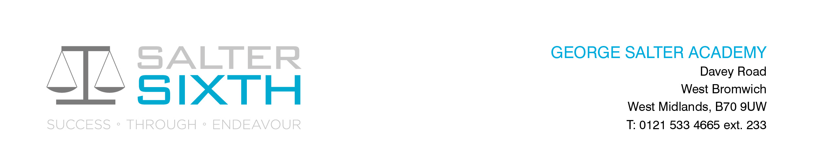

Year 11-12 Transition Pack:

Art & Design

**OCR A Level GCE Art and Design**

H601- A Level Fine Art

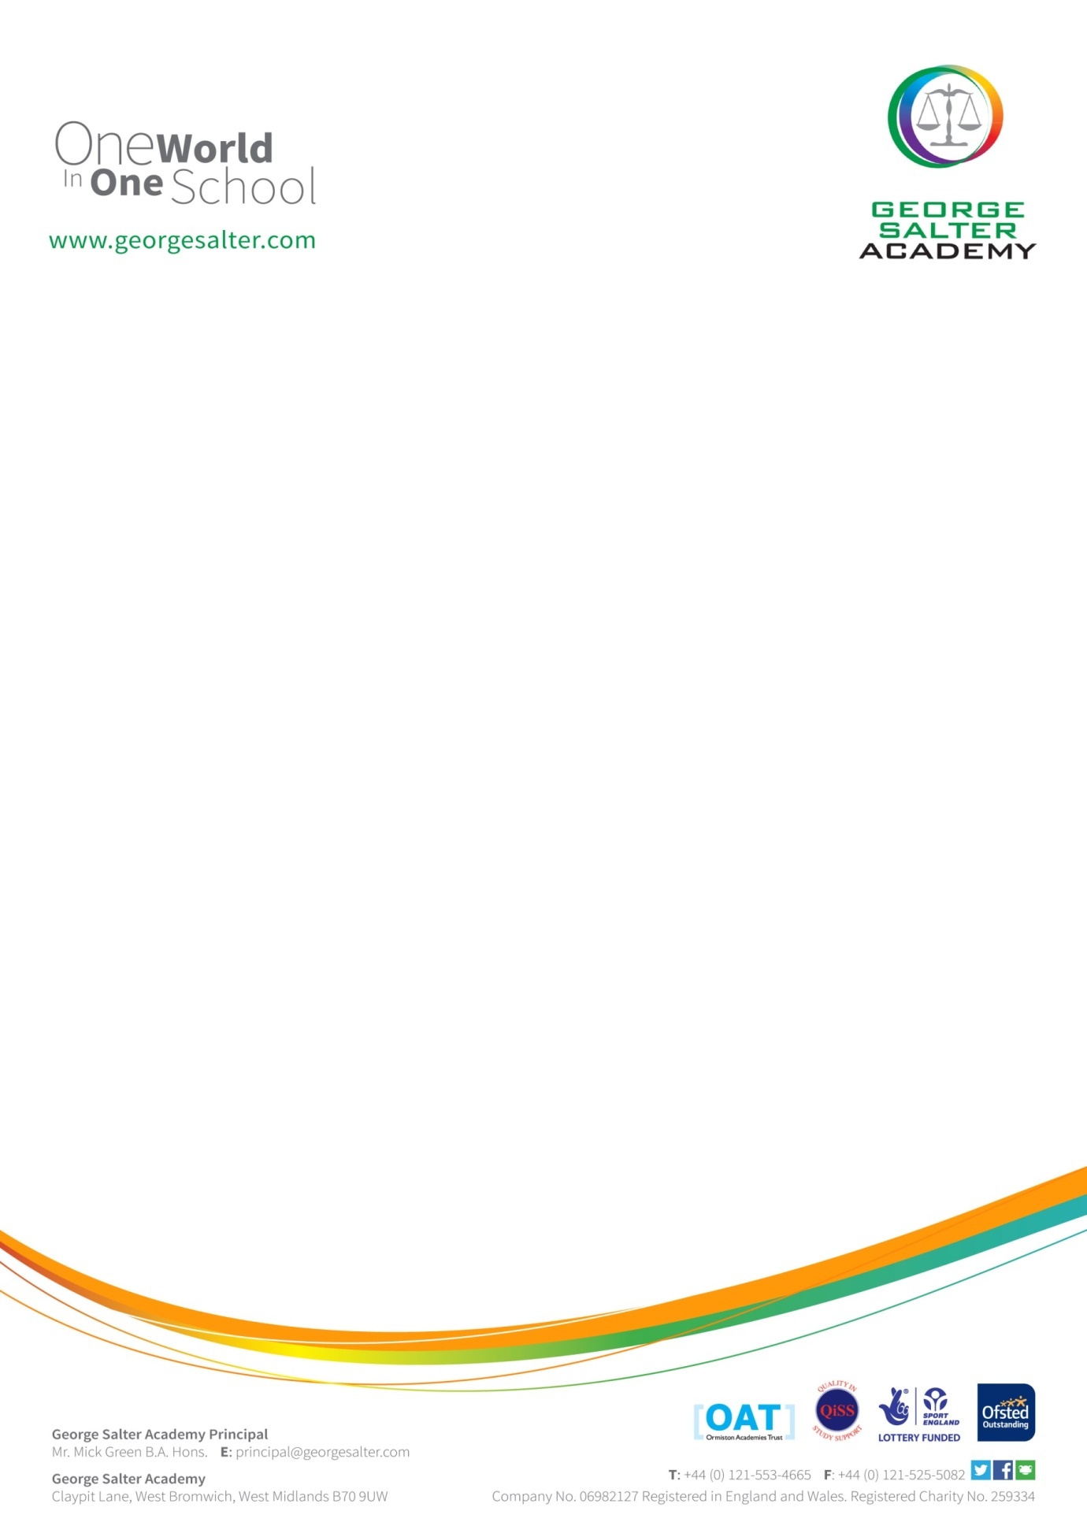

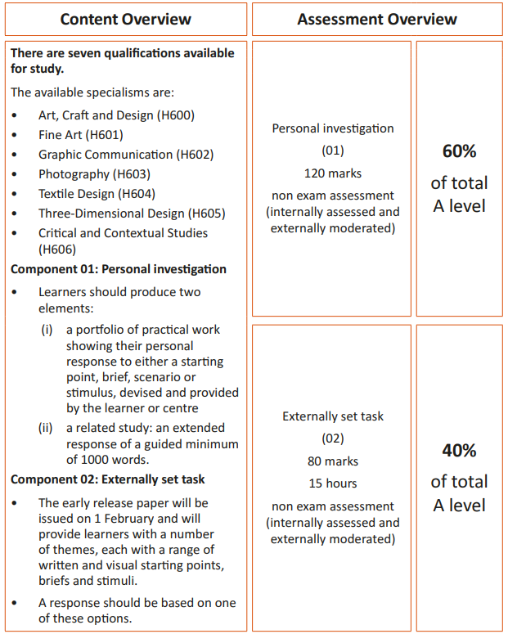**Course Overview:**

**Introduction**

The year 12 is all about building and refining practical skills. The emphasis is about demonstrating advanced skills, so a solid grade of 6/7 or above is required for starting the course.

The externally set task which will be a starting point set by the exam board- OCR will be released on February 1st of the 2nd year of teaching. Up until this, each course will carrying out subject specific workshops to help prepare and develop advanced skills and techniques within the particular area of study.

The endorsement that we will be delivering are **Fine Art.**

**Assessment and Content: Overview**

**Component 1- Marks- Weighting- Personal investigation (01)** 120marks -60%

Non-exam assessment (internally assessed and externally moderated).

Students should produce a portfolio of practical work in response to a brief, scenario or stimulus provided by the student or centre, and a related written study of at least 1000 words.

A practical portfolio with supporting contextual research in response to a set theme. The portfolio may be presented in a format appropriate to the specialism and area of study chosen.

A related study using words and illustrations demonstrating the context in which their portfolio exists, exploring the relevant genre, subject matter, movement or historical framework of the selected theme.

**Externally set task (02) 80-40%**

**15 hours non-exam assessment (internally assessed and externally moderated).**

Students produce a response to one of a number of provided themes, each of which will have a range of written and visual starting points, briefs and stimuli.

Students can choose a starting point from any of the seven given themes for which they will generate an appropriate personal response for assessment. They will carry out preparatory work to research, plan and develop their ideas, before engaging in 15 hours of supervised time to complete their work.

Year 12 will be all about workshops and practical work- all exploring the formal elements and how these can be represented visually- experimenting, exploring and trying out new techniques and process…all in different combinations and ways that you may not have even thought of before.

***If you have any questions about the courses, feel free to email Mrs Shaw- Leanne.shaw@georgesalter.com***

Summer Activities 1 – **Explore the Arts!**

Exposure yourself to art, photography, Textiles. Have a look at these websites and begin to form opinions of artworks and the artist associated with them. Here are some links that take you to a series of well-established galleries within the UK.

Take a look at these……….

<http://www.tate.org.uk> / <http://www.nationalgallery.org.uk/>

<http://www.saatchigallery.com/> <http://courtauld.ac.uk/>

<http://www.thebricklanegallery.com/>

<http://www.halcyongallery.com/> <https://ikon-gallery.org/>

<http://www.birminghammuseums.org.uk/bmag>

Go one step further and visit two fantastic galleries in Birmingham, the ‘IKON gallery’ and ‘Birmingham Museum of art’. Get out of the house this summer and see some art, photography and textiles. Both venues are free entry.

WATCH AND INVESTIGATE the Arts too– look at television documentaries on NETFLIX and BBC I Player...even look at Sky Arts as they cover a wealth of different genres of art.

Please see the list that was given out via Microsoft teams for specific documentaries…..

Summer activity 2 -**Mini portfolio and presentation.**

The purpose of this mini portfolio task is to encourage you to begin to develop your thinking and interpretation skills with both art and photography. Choose one of the following themes, from this theme we would like you to put together a mini portfolio made up of 5 images. You can use any material you want, for example, in art; pencil, watercolour, chalk, charcoal, mixed media, biro and in photography; cameras, scanner, Photoshop, even a camera phone with editing apps from an app store.

You can present this portfolio however you want; in a sketchbook, PowerPoint, presentation boards, home made sketchbook, website, Instagram page…… it’s up to you. We want to see what you can do! BE imaginative, BE Creative

When you return in September we will share these with each other in a mini presentation and begin to identify each other’s strengths and styles within the subject, it’s a great opportunity to show your teacher and peers your style and thinking process within the subject. It’s a chance for your to experiment with ideas and media with no pressure.

The themes are; Personality Structure Postcards Stay Still HOLIDAY!

 What will you create? Use the GSA Visual arts ‘PINTEREST’ boards for inspiration.

These can be found on [www.pinterest.com](http://www.pinterest.com) search for ‘GSA visual arts’or GSA Mrs Shaw