

Year 11-12 Transition Pack:

Level 3 BTEC

National Diploma

Performing Arts



**Introduction**

***Want to develop your skills in Dance and Drama? Passionate about the arts?***

***Want to gain a breadth of knowledge and understanding into different performance styles?***

Then this qualification is the ideal course for you.

This two year course will enable you to become a diverse performer through a variety of performance opportunities.

BTEC Nationals use a combination of assessment styles to give you confidence to succeed in the workplace and develop the study skills to continue learning on higher education courses and throughout your career. All assessments are undertaken within a vocational setting to give you first-hand experience of the performing arts industry.

If you have any additional questions on the syllabus, then please contact Miss Clark on the following email address:

[jose.clark@georgesalter.com](mailto:jose.clark@georgesalter.com)

**Course Overview**

As you can see below. Within this qualification, there are choices that can be made in terms of the units you can participate within. The six mandatory units are as follows:

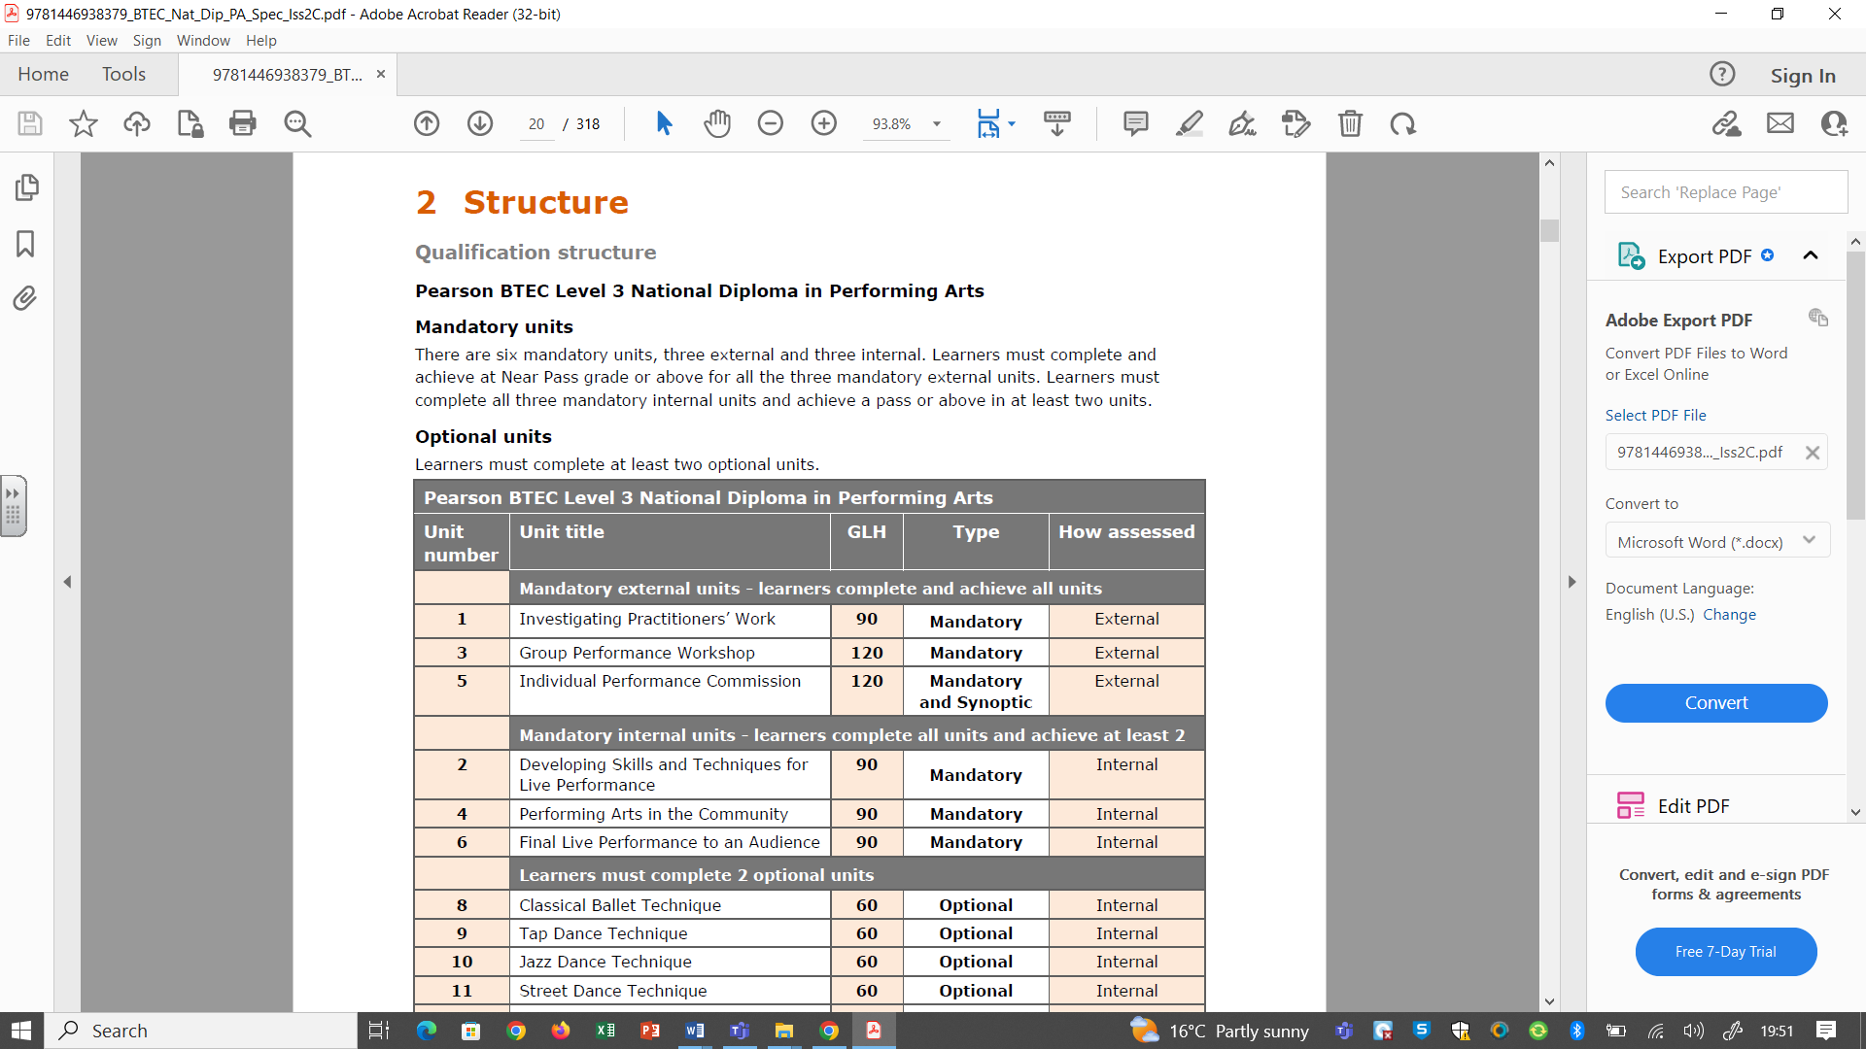

Below are the examples of option choices for the remainder of the course. These will be selected by staff once the cohort is finalised.

* Jazz Dance Technique
* Street Dance Technique
* Theatre Directing
* Acting Styles
* Improvisation
* Children’s Theatre Performance
* Musical Theatre Performance
* Stand-up Comedy
* Community Theatre
* Storytelling

**Articles to Read**

**Textbooks**

**(Please do not buy any of these. Many pages of these can be read on Google Books for free or within your library).**

Ashley, L., *Essential Guide to Dance* (3rd Edition), Hodder Education, 2008, ISBN 978-0-340-96838-3 Useful guide for both learners and tutors; this is highly useful to this induction unit, including choreography, anatomy, staging and performance.

Berry, C. *Voice and the Actor,* Jossey Bass; New Ed edition, 1991, ISBN 978-0-0204-1555-8 Comprehensive and accessible guide to voice training containing exercises and techniques covering relaxation, breathing and voice control.

Callery, D., *Through the Body: A Practical Guide to Physical Theatre*, Nick Hern Books, 2001, ISBN 978-1-8545-9630-7 Contains information and workshop ideas based on the work of key physical theatre practitioners, with exercises to develop performance skills.

Fredman, R., Reade, I., *Essential Guide to Making Theatre (Essential Guides for GNVQ Performing Arts)*, Hodder Education, 1996, ISBN 978-0-340-655140-6 Useful guide for both learner and tutors including practical information and practical activities covering a range of acting styles and contexts.

Ostwald, D.F., *Acting for Singers: Creating Believable Singing Characters*, 1st Edition OUP USA, 2005, ISBN 978-0-195-14540-3 Contains guidance on professional development as well as exercises and techniques to interpret script/libretto and rehearse to develop characters in musical performance.

**Journals**

*Actors and Performers Yearbook* (Bloomsbury Publishing) Yearly publication listing agencies and career opportunities with advice on finding work, establishing contacts and networking.

*The Stage* (The Stage Media Company Ltd) Weekly publication featuring news, reviews, interviews, also contains job advertisements, career and professional development advice.

**Websites**

www.dance.about.com Information and useful guidance and definitions covering all dance styles.

www.digitaltheatreplus.com Subscription-based resource include teaching materials, interviews with performers and production personnel detailing the making of theatre, study guides and recordings of a range of productions.

www.nationaltheatre.org.uk/discover-more (Royal National Theatre) Information regarding current and past productions at the National Theatre and includes a video library resource covering a range of topics on the making of theatre with interviews, extracts from rehearsals, performing and staging techniques, etc.

www.prospects.ac.uk Careers website containing job descriptions for performing arts roles, with information on salaries, training, etc.

www.rsc.org.uk (The Royal Shakespeare Company) Resources and content linked to RSC productions of all Shakespeare’s plays and includes tutor and learner resource packs, video clips of key scenes and tutor notes.

www.thestage.co.uk (The Stage) Online version of the printed journal, features news, reviews, interviews. This also contains job advertisements, career and professional development advice.

www.ukperformingarts.co.uk (The Prince Partnership) Directory of places to train and work in the performing arts industry and contains articles and advice related to specific performing arts job roles.

**Summer Activity- Due in your first lesson in September**

Create a portfolio of **1000 words** or a **detailed PowerPoint** about the roles and skills of a performer.

Within this you should demonstrate your knowledge and understanding of the roles and skills of a performer with reference to examples of disciplines, such as acting, dance and singing. You should ensure that your work is analytical and evaluative throughout.

You should include:

Performance roles, such as:

o actor

o dancer

o musical theatre performer

o performance artist.

Interrelationship with other roles in performance practice, e.g. other performers,

directors, choreographers. (Who do each of these roles work alongside?)

Formal training qualifications and progression routes.

Employment opportunities and trends.

Working conditions.

Lifestyle factors.

Performance skills needed by each, such as:

o technical

o physical

o vocal

o interpretative.

Training, such as:

o strategies for professional development

o exercises and techniques to develop and improve performance skills

o methods of monitoring progress.

Practical skills, such as:

o planning

o responding to direction/choreography

o collaboration

o team working.