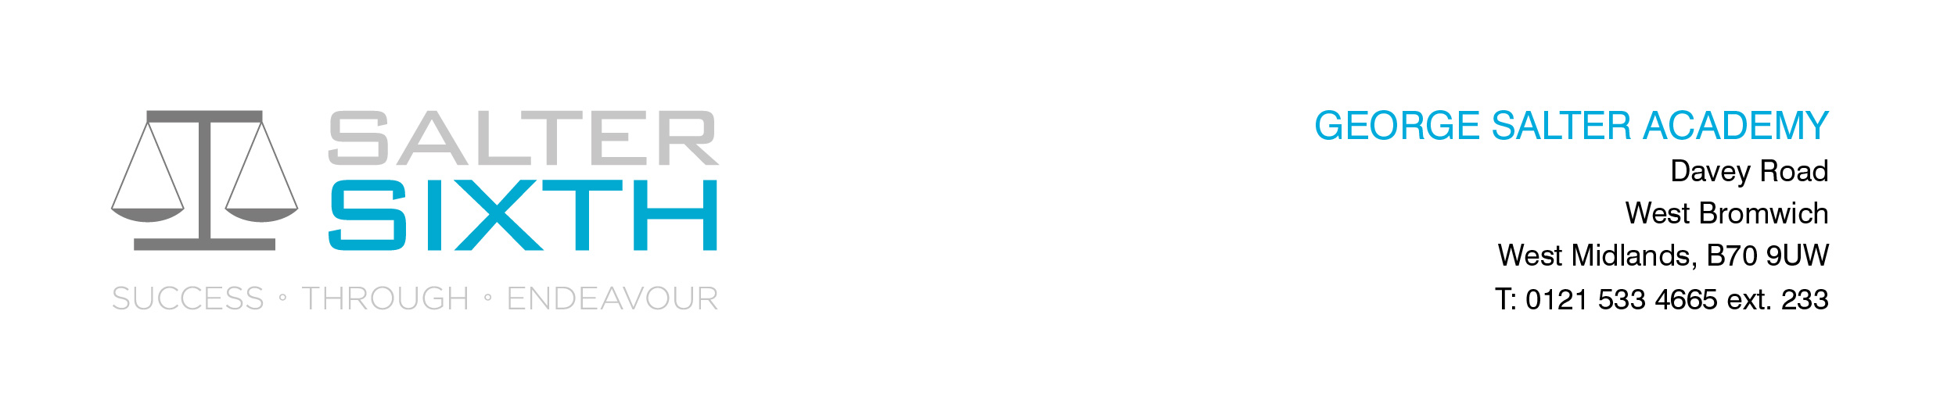

Year 11-12 Transition Pack:

**A Level**

**Religious Studies**

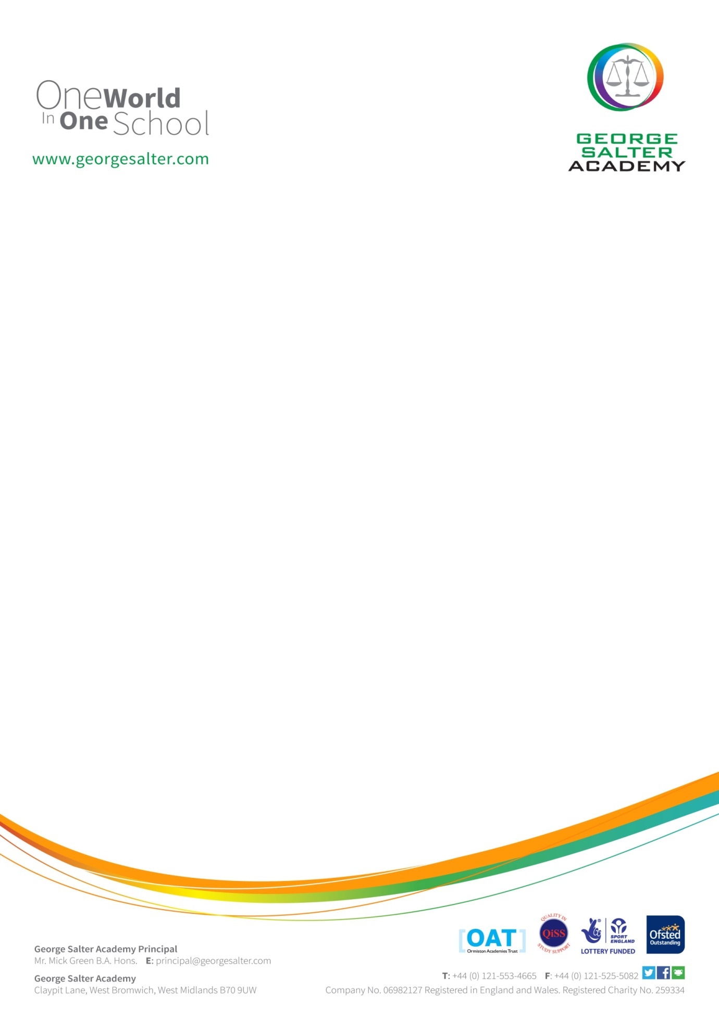

**Introduction**

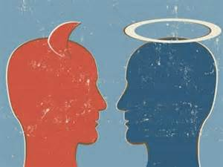It is great that you have chosen to study Religious Studies at A Level.

This pack contains a programme of activities and resources to prepare you to start an A Level in Religious Studies in September. It is aimed to be used after you complete your GCSE throughout the remainder of the summer term and over the summer holidays to ensure you are ready to start your course in September.

The pack is divided into some of the key topics you will study in A level Religious Studies: Sources of wisdom and authority: Self, death and the afterlife: God: Religion v’s Science

Discovering more about what billions of people live their lives by is fascinating and will really open your mind to the place of religion in our society and world.

**Course Overview**

Your GCE (A Level) Religious Studies course gives you a strong foundation for understanding three key components to Religion. Religious belief and practice, Philosophy and Ethics.

|  |  |  |
| --- | --- | --- |
| **Component 1: Philosophy of Religion and Ethics** | | |
| **What is assessed?** | **How is it assessed?** | **The exam** |
| **Section A: Philosophy of religion**  • Arguments for the existence of God.  • Evil and suffering.  • Religious experience.  • Religious language.  • Miracles.  • Self and life after death.  **Section B: Ethics and religion**  • Ethical theories.  • Issues of human life and death.  • Issues of animal life and death.  • Introduction to meta ethics.  • Free will and moral responsibility.  • Conscience.  • Bentham and Kant. | Written exam: -3 hours  -100 marks  - 50% of A-level | **Questions**  • **Section A: Philosophy of religion** – two compulsory two-part questions, each worth 10 marks and 15 marks  • **Section B: Ethics and religion** – two compulsory two-part questions, each worth 10 marks and 15 marks  In both sections, questions may span more than one topic. In each two-part question, the first part tests AO1 and the second part tests AO2. |

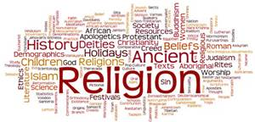

|  |  |  |
| --- | --- | --- |
| **Component 1: Philosophy of Religion and Ethics** | | |
| **What is assessed?** | **How is it assessed?** | **The exam** |
| **Section A: Study of religion – Christianity**  The following topics are covered:  • Sources of wisdom and authority.  • God/gods/ultimate reality.  • Self, death and the afterlife.  • Good conduct and key moral principles.  • Expression of religious identity.  • Religion, gender and sexuality.  • Religion and science.  • Religion and secularisation.  • Religion and religious pluralism.  **Section B:** The dialogue between philosophy of religion and religion.  How religion is influenced by, and has an influence on philosophy of religion in relation to the  issues studied.  **Section C:** The dialogue between ethical studies and religion.  How religion is influenced by, and has an influence on ethical studies in relation to the issues studied. | Written exam:  -3 hours  -100 marks  -50% of A-level | **Questions**  **Section A: Study of religion** – two compulsory two-part questions, each worth 10 marks and 15 marks relating to the religion chosen. Questions may be set that span more than one topic. In  each two-part question, the first part tests AO1 and the second part tests AO2.  **Section B:** The dialogue between philosophy of religion and religion – one unstructured synoptic question from a choice of two (25 marks).  **Section C**: The dialogue between ethical studies and religion – one unstructured synoptic question from a choice of two (25 marks). |

**Interesting Reading**

Journals are a good way of keeping up to date with what’s happening in the world and how religion impacts this. You can subscribe for a year or buy individual past publications.

Some good RE magazines are:

[**http://www.onreligion.co.uk/**](http://www.onreligion.co.uk/)

[**http://www.reform-magazine.co.uk/**](http://www.reform-magazine.co.uk/)

**Useful Websites**

You need to be aware of current events that are related to the units you will be studying; so look out for things in the news to do with the topics we are studying. You can use Google Alerts to make this easier

<https://www.google.co.uk/alerts>

There are also many good websites you can use. News website are partially good at keeping you informed and up-to-date.

News websites include –

[www.bbc.co.uk](http://www.bbc.co.uk)

<http://www.telegraph.co.uk>

<https://www.theguardian.com/world/religion>

You can also use websites like –

<https://www.futurelearn.com/courses> -

These are free online courses that anyone can join with some having relevance for topics you will study at A level. They are run by university's and are great background preparation for the students. Most of the courses have approximately 3 hrs study time a week. Check with staff in the RE department for the suitability of the course.

**What else can I do?**

Download news apps onto your phone and read on the go – World Religion News

When visiting somewhere new – eg: on holiday- keep An eye open for all of the ways religion impacts the world and how it differs within different cultures.

When watching the TV, Films or listening to music consider how ethics and moral decision making is

Use YouTube to watch documentaries on Philosophical debates and Ethical dilemmas.

**Summer Activities**

Over the Summer you will need to complete the following activities to help you ‘hit the ground running’ when you start in September. Please bring the completed activities to your first RE lesson. Remember that this will be the first piece of work we mark and will be how you make your first impression upon us.

1. **Ethics**

Natural Law is often associated with St. Thomas Aquinas (1225-1274) in his work Summa Theologica. Aquinas had been very influenced by the Christian tradition – he was a priest. Answer the following questions;

* Is there a universal moral code within all people?
* What makes a thing wrong, the nature of the act or the consequence of the action?
* Are human being essentially good or bad?
* Do all humans have a common purpose, and if so, what is it?
* Research and explain the origins of Natural Moral Law in approx. 500 words.

1. **Philosophy**

* Research the meaning of moral and natural evil.
* Choose between either **moral** or **natural** evil.
* Research an example of this (preferably not one that we might already know a lot about).
* Research the factors affecting this evil, such as: environment, personality, economic issues.
* Assess whether this proves or disproves the existence of a God.
* List the possible reasons people may give for how God could still exist and allow this to happen.
* Compile all your answers, ready for a brief presentation to the rest of the class.