

Year 11-12 Transition Pack:
AS/ A Level
Film Studies
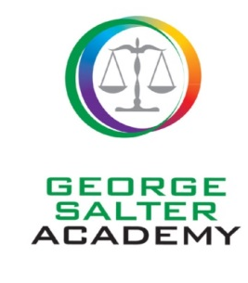

Introduction

We are really pleased that you are considering the AS/ A Level Film Studies course. This WJEC specification offers a breadth of film experience that we are sure that you will enjoy.
This pack is designed to help you to prepare for your study of Film at AS and A Level. We would like you to use it following the completion of your GCSEs and to refer to it over the summer holidays. Also included are some tasks that we would like you to complete in preparation for your studies.
A qualification in Film Studies will help you develop a number of key transferrable skills valuable for both further study and future employment. Your ability to gather, assess and interpret ideas and opinions will develop, as will your analytical skills, your cultural awareness, your ability to write clearly and concisely and to communicate complex ideas. You will be introduced to aspects of the film industry; researching how films progress from production through to audience consumption. You will also learn some new practical skills, creating media products.

Course Overview
Eduqas AS Film Studies:
The AS/A specification in Film Studies is designed to deepen students' understanding, appreciation and enjoyment of film, the major art form of the twentieth century, and one developing new modes of expression and exhibition in the first decades of the twenty-first century. By its nature, a study of Film also requires candidates to consider individual, moral, ethical, social, cultural and contemporary issues.
External Examination – Component 1 – American Film (35% of AS)
Component 1 assesses knowledge and understanding of three American films. 1½ hours written paper. Three questions, one from each section:
Section A (60min): Hollywood 1930-1990 (comparative study) - One two-part question, requiring reference to two Hollywood films, one produced between 1930 and 1960 (Alfred Hitchcock’s ‘Vertigo’ 1958) and the other between 1961 and 1990 (Spike Lee’s ‘Do the Right Thing’ 1989). There is a choice of question in the second part.
Section B (30min): Contemporary American independent film - One two-part question, requiring reference to one contemporary American independent film (produced after 2010 – Matt Ross’ ‘Captain Fantastic’ 2016). There is a choice of questions in the second part.



External Examination – Component 2 – European Film (35% of AS)
Component 2 assesses knowledge and understanding of two British films and one non English language European film.
Section A (60min): British film (two-film study). One two-part question, requiring reference to two recent British films (Edgar Wright’s ‘Shaun of the Dead’ 2004 and Meadows’ ‘This is England’ (2006). There is a choice of question in the second part.
Section B (30min): Non-English language European film. One two-part question, requiring reference to one non-English language European film (Erguven’s ‘Mustang’ 2015). There is a choice of questions in the second part.

Non-Exam Assessment – Component 3 – Production (30% of AS)
Component 3 assesses one original student production and its accompanying evaluative analysis.
Production (20%) – students produce:
- Either an extract from a film highlighting narrative construction (2½ to 3½ minutes)
- Or a screenplay for an extract from a film highlighting narrative construction of between 1200 and 1400 words plus a digitally photographed storyboard of a key section from the screenplay (approximately 1½ minutes' screen time, corresponding to approximately 15 storyboard shots).
Evaluative analysis (10%) – students produce:
- An evaluative analysis (1000-1250 words) of the production in comparison with other professionally produced films or screenplays.

Eduqas A Level Film Studies
If a student decides to continue with Film Studies at A Level, it is a smooth transition.
External Examination – Component 1 (2hrs 30min) – Varieties of film and filmmaking (35% of AL)
Component 1 assesses knowledge and understanding of six feature-length films.
Section A (50min): Hollywood 1930-1990 (comparative study). One question from a choice of two, requiring reference to two Hollywood films, one from the Classical Hollywood period (1930-1960) and the other from the New Hollywood period (1961-1990) - Alfred Hitchcock’s ‘Vertigo’ 1958 and Spike Lee’s ‘Do the Right Thing’ 1989.
Section B (50min): American film since 2005 (two-film study). One question from a choice of two, requiring reference to two American films, one mainstream film and one contemporary independent film - Matt Ross’ ‘Captain Fantastic’ 2016 and Joel and Phillips’ ‘Joker’ 2019.
Section C (50min): British film since 1995 (two-film study). One question from a choice of two, requiring reference to two British films - Edgar Wright’s ‘Shaun of the Dead’ 2004 and Shane Meadows’ ‘This is England’ 2006..
External Examination – Component 2 (2hrs 30min) – Global filmmaking perspectives (35% of AL).
Component 2 assesses knowledge and understanding of five feature-length films (or their equivalent).
Section A (60min): Global film (two-film study). One question from a choice of two, requiring reference to two global films: one European (Mustang (Deniz Gamze Ergüven’s Turkish film ‘Mustang’ 2015) and one produced outside Europe (Fernando Meirelles’ Brazilian crime drama ‘City of God’ 2002).
Section B (30min): Documentary film. One question from a choice of two, requiring reference to one documentary film (Asif Kapadia’s ‘Amy’ 2015).
Section C (30min): Film movements – Silent cinema. One question from a choice of two, requiring reference to one silent film or group of films - Buster Keaton’s Shorts - One Week (1920), The Scarecrow (1920), The 'High Sign' (1921) and Cops (1922).
Section D (30min): Film movements – Experimental film (1960-2000). One question from a choice of two, requiring reference to one film option (Nolan’s film, ‘Memento’ 2000).

Non-Exam Assessment – Component 3 – Production (30% of AL)
This component assesses one original student production and its evaluative analysis.
Production (20%) – students produce:
- Either a short film (4-5 minutes)
- or a screenplay for a short film (1600-1800 words) plus a digitally photographed storyboard of a key section from the screenplay
Evaluative analysis (10%) – students produce:
- an evaluative analysis (1600 - 1800 words).

Helpful Reading
The following texts are available to purchase through Amazon or could be ordered to borrow through your local library. We also have a limited number in the department that can be borrowed.
WJEC Eduqas Film Studies for A Level & AS Revision Guide - by Jenny Stewart | 18 Mar 2020. Amazon - £16.99 Introduction to Film Studies, ed. Jill Nelmes Film Theory: The Basics Paperback – 22 Feb. 2016 by Kevin McDonald. Amazon - £16.51
Useful Websites
http://www.bfi.org.uk/
http://www.boxofficemojo.com/weekend/chart/
http://www.imdb.com/
http://www.empireonline.com/
https://www.futurelearn.com/courses - These are free online courses that anyone can join with many being based on topics you will study at A level. They are run by universities and are great background preparation for the students. Most of the courses have approximately 3 hrs study time a week.

What else can I do to prepare?
Use YouTube to watch documentaries on actors and their films. Watch as many different films as you can from different genres (British film, Hollywood, Independent, National Encourage your parents to join you in watching some of these films! You can then have discussions regarding your response and meanings created.

Compulsory Summer Preparation for September:
Over the summer you will need to complete the following activities to help you with your understanding of film when you start in September. Please bring the completed activities to your first Film Studies lesson.
- Watch at least one British and one Hollywood film and use the internet to research their production.
Task: For each film, research the production company, the marketing and distribution used, how each film was exhibited and how it was received by audiences.
- Research the ways in which micro-elements (cinematography, mise-en-scene, sound, editing and performance) create meaning in film.
Task: Referring to one of your chosen focus films, write one side of A4 explaining how one micro-element (Cinematography, Editing, Mise-en-scene, Sound or Performance) is used to create meaning in a 5 min clip of your film.
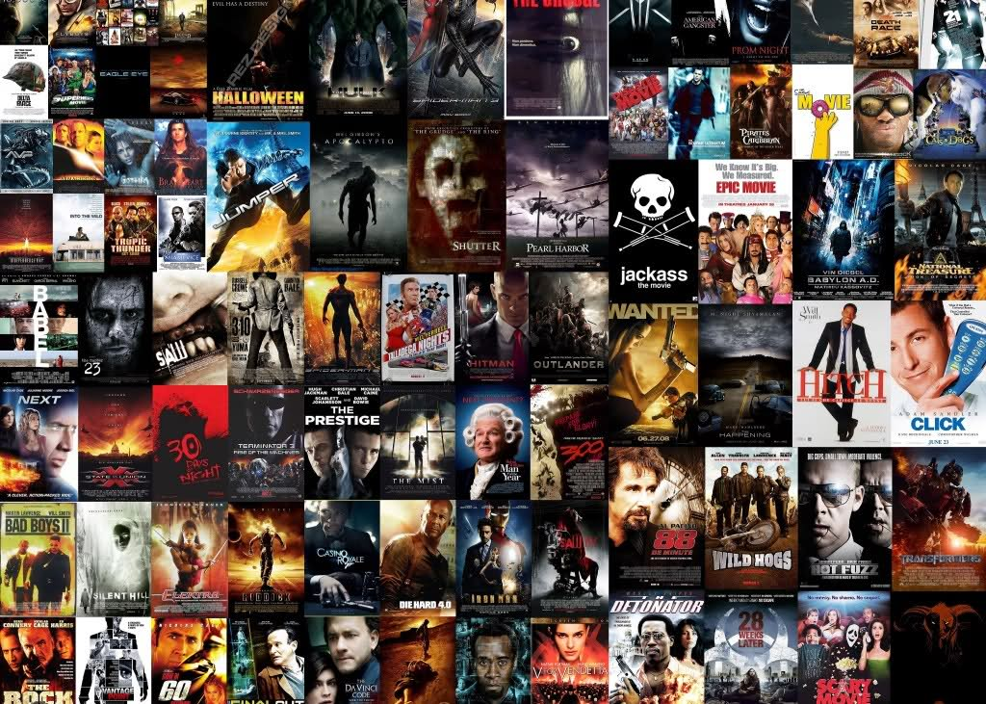
Enjoy! ☺

