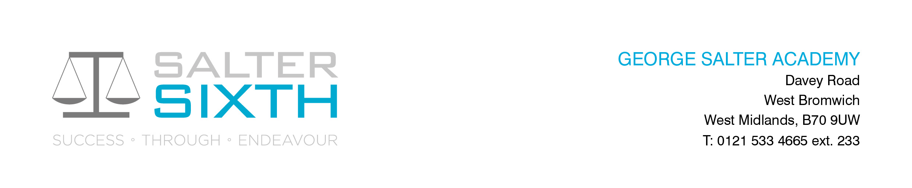

Year 11-12 Transition Pack:
A Level English Literature

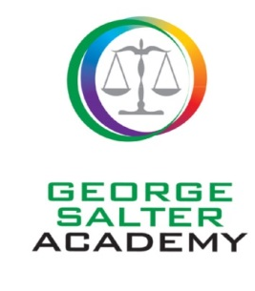

Introduction

We are really pleased that you are considering the AQA A Level English Literature Specification A course. This specification offers a breadth of literary experience that we are sure you will enjoy.
This pack is designed to help you to prepare for your study of English Literature at A Level. We would like you to use it following the completion of your GCSEs and to refer to it over the summer holidays. Also included are some tasks that we would like you to complete in preparation for your studies.
A qualification in English Literature will help you develop a number of key transferrable skills valuable for both further study and future employment. Your ability to gather, assess and interpret ideas and opinions will develop, as will your analytical skills, your cultural awareness, your ability to write clearly and concisely and to communicate complex ideas. In addition, your capacity to listen to, and take on board, other people's ideas will mature and develop.
Course Overview
The AQA English Literature A course is split into two areas of study: ‘Love Through the Ages’ and ‘World War 1 and its Aftermath’.
Paper 1: Love Through the Ages (3 hours – 40%. Examined at the end of the two year course)
Section A: Shakespeare: Othello: one passage-based question with linked essay (25 marks) (Closed Book) Section B: Unseen poetry: compulsory essay question on two unseen poems (25 marks) Section C: Comparing texts: one essay question linking The Great Gatsby and poetry from a pre-1900 poetry anthology (25 marks) (Open Book)

Paper 2: WW1 and its aftermath (2hours 30min – 40%. Examined at the end of the two year course)
Section A: Set texts. One essay question on set text – Journey’s End (Drama) (25 marks) (Open Book) Section B: Contextual linking - one compulsory question on an unseen extract (25 marks) One essay question linking two texts: Life Class (Post-2000 Novel) & WWI Poetry (25 marks) (Open Book)

Non-Exam Assessment (Coursework - 20% - Marked by the teacher and moderated by examiners)
You will have to write a comparative, critical essay on two texts, at least one of which must have been written pre-1900 (2,500 words). This will also have to include a bibliography.
The NEA is 20% of your English Literature A-Level and is submitted in the second year of your course.
The English Literature A specification develops a historicist approach to literary study which means that students are required to read widely across a range of texts and connect them across time and topic. You will need to look at ways in which authors shape meanings within their texts through their use of language, form, structure and context. Finally, because texts and their meanings are not fixed, interpretation is not fixed, and you must therefore consider different interpretations.

Compulsory Summer Reading Task: Primary Texts
The following primary texts examined on this course must be read over the summer:
Primary Reading:
Life Class, Pat Barker (Penguin 7 Aug. 2008)) - £7.99 on Amazon.co.uk Journey’s End, R. C. Sherriff (Penguin Modern Classics) - £5.80 on Amazon.co.uk

Compulsory Summer Wider Reading and Writing Task:
You will need to bring the following completed activities to your first English lesson:
- Sign up and complete the following Open University online course - The First World War: trauma and memory - https://www.open.edu/openlearn/history-the-arts/the-first-world-war-trauma-and-memory/content-section-overview?active-tab=description-tab Bring in your certificate of completion to lesson (evidence for English and super-curricular for UCAS).
- Read the GradeSaver critical analysis on the drama Journey’s End, keeping your own notes on key aspects of plot, theme, character and context https://www.gradesaver.com/journeys-end/study-guide/summary
In summary:
You should arrive at your first English lesson in September with:
- An A4 folder and dividers for your notes
- A Journey’s End text
- A Life Class text
- Written evidence of wider critical reading on Journey’s End (minimum of 2 sides of A4)
- The statement of participation certificate for the Open University course: The First World War: trauma and memory

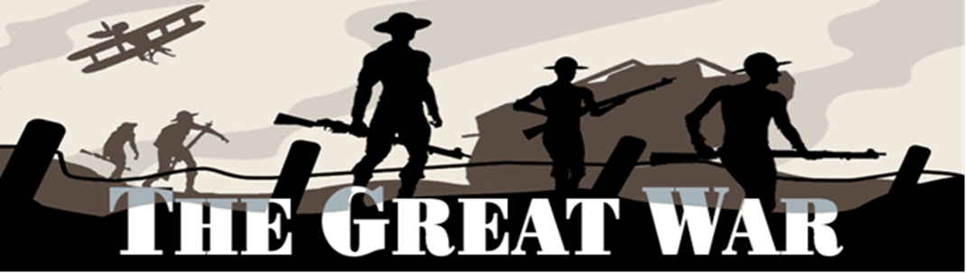

Non-compulsory (but valuable!) extension/ secondary tasks to improve reading skills and knowledge:
WW1 Poetry Resources:
- "British" World War One Poetry: An Introduction – Oxford University Podcasts - https://podcasts.ox.ac.uk/series/british-world-war-one-poetry-introduction
- YouTube documentaries: https://www.youtube.com/watch?v=wU6jmbVPDKM https://www.youtube.com/watch?v=GWKjZJS6WMA https://www.youtube.com/watch?v=zsPdEgC0wdk https://www.youtube.com/watch?v=1eMYKpnbLq4

Secondary Reading:
Persuasion, Jane Austen Jane Eyre, Charlotte Bronte Wuthering Heights, Emily Bronte The Awakening, Kate Chopin Tess of the D’Ubervilles, Thomas Hardy A Room with a View, E.M.Forster The Go-between, L.P.Hartley Rebecca, Daphne Du Maurier Atonement, Ian McEwan Birdsong, Sebastian Faulks Regeneration, Pat Barker All Quiet on the Western Front, Erich Maria Remarque A Farewell to Arms, Ernest Hemingway
Useful Websites
You need to be aware of different interpretations of the primary texts that you will be studying; look out for critical writing on the internet, but be conscious of plagiarism!
Websites to consider:
http://www.bl.uk/
http://www.sparknotes.com/
http://www.gradesaver.com/study-guides
https://www.futurelearn.com/courses -

These are free online courses that anyone can join with many being based on topics you will study at A level. They are run by universities and are great background preparation for the students. Most of the courses have approximately 3 hrs study time a week.

What else can I do?
- Use YouTube to watch documentaries on writers and their texts.
- Watch film adaptations of different literary texts (be aware that some adaptations differ from the original text!).
- Encourage your parents to join you in reading some of these texts! You can then have discussions regarding your reading experiences and develop your experience of different interpretations!

