

Year 11-12 Transition Pack:

1. Level

Mathematics



**Introduction**

Thank you for choosing to study A-level mathematics at George Salter Academy. A-level mathematics is an exciting and challenging course where you will be extending your mathematical skills and techniques learnt at GCSE to understand coherence and progression in mathematics and how different areas of mathematics are connected. You will also learn new mathematical concepts which you would not have encountered before.

This course is suitable for those who achieved a grade 6 or higher in GCSE mathematics. An interest/enjoyment in mathematics is desirable as you will be spending a good amount of time doing maths independently throughout the two years.

A-level mathematics can lead you to many careers including engineering, economics, accountancy, architecture, computer science and the healthcare sector.

**Course Overview**

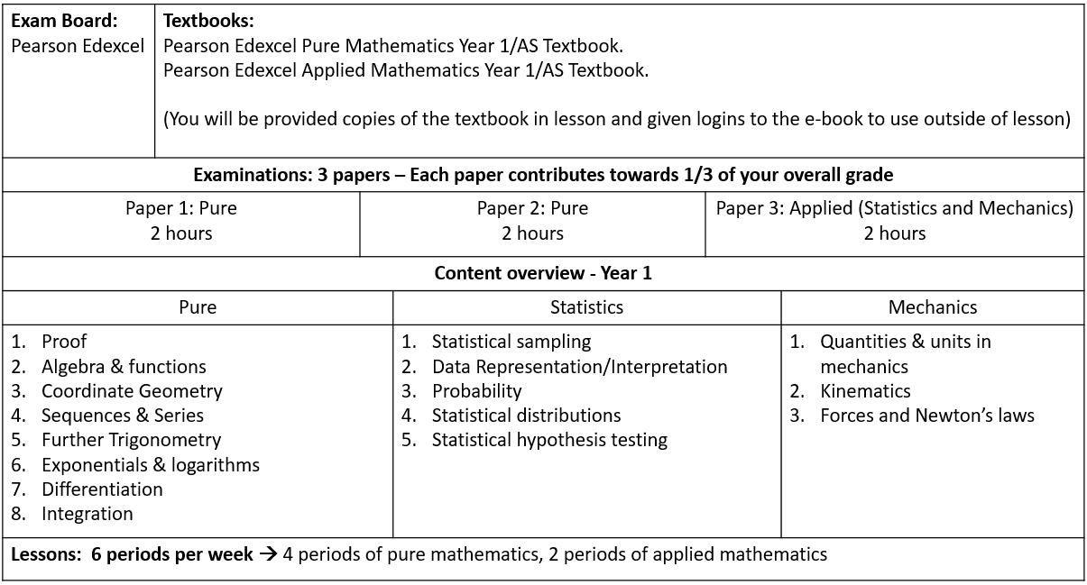

**Articles to Read**

**Websites**

If you want to have a taste of what A-level maths involve, here are links to some Bicen Maths video playlists:

[A-level Pure 1 Ch.1](https://www.youtube.com/watch?v=iMIGYz9YD8M&list=PL0SSkmc4r_BaIA6sumiqE6re-oeyZ5X3z)

[A-level Pure 1 Ch.6](https://www.youtube.com/watch?v=zYcXzpdmmMk&list=PL0SSkmc4r_BY4u87JNP-F_2VSS8nECDyR)

[A-level Pure 1 Ch.8](https://www.youtube.com/watch?v=5NWWKRuANMk&list=PL0SSkmc4r_BbTZrAk_0faFsx4v1EP3Fg6&index=6)

If you are unable to access the links, you can find them on YouTube by searching ‘Bicen Maths’.

**Books**

If you are interested in learning some intriguing things about maths that you may not have learnt before, here are a few choices.

(Please do not buy any of these. Many pages of these can be read on Google Books for free or within your library).

* Alex’s Adventures in Numberland *by Alex Bellos*
* Cabinet of Mathematical Curiosity *by Ian Stewart*
* The num8er My5teries *by Marcus De Sautoy*
* How Many Socks Make a Pair? Surprisingly Interesting Maths *by Rob Eastaway*
* The Curious Incident of The Dog in the Night-time *by Mark Haddon*
* The Penguin Dictionary of Curious and Interesting Numbers *by David Wells*
* The Calculus Wars *by Jason Socrates Bardi*
* The Code Book *by Simon Singh*

**Summer Activity- Due second week in September**

It is ***vitally important***that you spend some time working through the questions in this booklet over the summer - you will need to have a good knowledge of these topics *before* you commence the course in September.

A-Level mathematics is a demanding course and good skills in the areas covered within this booklet will be paramount to your success.

The exercises in this booklet will ensure that you are ready for the exciting challenges of becoming an A-level student in September.

**Instructions:**

**Complete all ‘Introduce’ and ‘Strengthen’ questions in the booklet. This is the minimum requirement.**

**It is recommended to also try as many ‘Deepen’ questions so you are best prepared for A-level mathematics.**

Use the videos on these websites to help with answering the questions in this booklet:

<https://www.mathsgenie.co.uk/gcse.html>

<https://corbettmaths.com/contents/>

You must bring all your work with you in your first maths lesson in the second week of September.

You will be tested in September to see how well you understand these topics.

Have a great summer, we are looking forward to seeing you in September!!

|  |  |
| --- | --- |
| **Transition booklet topics** | |
| **Simplifying expressions** | **Linear Simultaneous equations** |
| **Operations with algebraic fractions** | **Straight-line graphs** |
| **Solving quadratic equations** | **Right-angled trigonometry** |
| **Quadratic graphs** | **Further trigonometry** |

**Key facts and formulae:**

**The Quadratic formula:**

The solution of ***ax*** 2 + ***bx*** + ***c*** = 0 where ***a*** ≠ 0

-***b*** ± ***b***2 - 4***ac***

***x*** = 2***a***

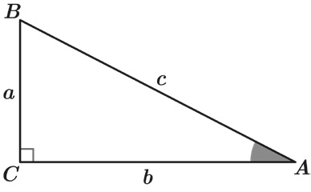**Trigonometry:**

In any right-angled triangle ***ABC*** where ***a***, ***b*** and ***c*** are the length of the sides and ***c*** is the hypotenuse:

***c***

sin***A*** = ***a***

***c***

cos***A*** = ***b***

tan***A*** = ***a***

## b

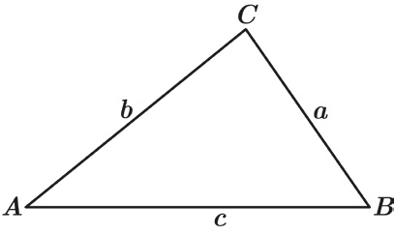In any triangle ***ABC*** where ***a***, ***b*** and ***c*** are the length of the sides:

sine rule:

***a***

sin***A***

## b

sin***B***

=

## c

sin***C***

=

© Sparx limited

Page 3

cosine rule: ***a***2 = ***b***2 + ***c***2 - 2***bc*** cos***A***

**Simplifying expressions** **Introduce**

**Q1** Fully simplify the expression 4***y*** 5 x 3***y*** 2

Answer:

**Q2** Simplify (***h***-5)3

Give your answer without any negative indices.

Answer:

**Q3** Write

2***t*** 6***u***

8***t*** 3

as a fraction in its simplest form.

Answer:

# Simplifying expressions Introduce

**Q4** Fully simplify ***t*** 3 2

( )

***u***5

Answer:

**Q5** Write

33***xy*** + 9***x*** 18***x***

as a fraction in its simplest form.

Answer:

**Q6** Fully simplify

6***a*** + 42

***a***2 + 11***a*** + 28

Answer:

# Simplifying expressions Strengthen

(3***a***)2

**Q1** Write

54***ak***

as a fraction in its simplest form.

Answer:

**Q2** Fully simplify (64***g***

1

8***h***4) 2

Answer:

**Q3** Fully simplify

***x*** + 2 2***x***2 - 31***x*** - 70

Answer:

# Simplifying expressions Deepen

**Q1** Work out the values of ***a***, ***b*** and ***c*** in the equality below.

2***x***20***y***4 x 12***x***4***y***26

(2***xy***2)3

= ***axbyc***

Answer:

***a*** =

***b*** =

***c*** =

**Q2** Work out what expression should replace the ? in the equivalent fractions below.

? 2***n*** 12***r***4(***t*** + 6) = 3***r***

Answer: ? =

**Q3 *ax***2 + ***bx*** + ***c dx***2 - 25

simplifies to give

***x*** - 4 2***x*** - 5

Work out the values of ***a***, ***b***, ***c*** and ***d*** in the original fraction.

Answer:

***a*** =

***b*** =

***c*** =

***d*** =

# Operations with algebraic fractions Introduce

**Q1** Fully simplify

14***a*** x ***b b*** 2

Answer:

**Q2** Fully simplify

6***a v***

÷ 2***a*** 5

Give your answer as a fraction.

Answer:

**Q3** Fully simplify the expression below to give a single fraction.

***n*** + 2

5

+ 6***n*** 7

Answer:

# Operations with algebraic fractions Strengthen

**Q1** Fully simplify

2 x

5***a*** + 4

45***a*** + 36

## a

Give your answer as a fraction.

Answer:

**Q2** Fully simplify

6***x*** - (5***x*** - 7)(***x*** + 1)

1

5***x*** - 7

Give your answer fully factorised.

Answer:

# Operations with algebraic fractions Strengthen

**Q3** Write the following as a single fraction in its simplest form:

2***x*** 2 - 11***x*** + 12

***x*** + 5

÷ (4***x*** 2 - 6***x*** )

Give your answer fully factorised.

Answer:

**Q4** Fully simplify

4***ab***2 x

## k

3***ak*** 12***k***

x 7 5***ab***

Give your answer as a fraction.

Answer:

# Operations with algebraic fractions Deepen

**Q1** Fully simplify

7

36 - ***x*** 2

-

3

6 + ***x***

Give your answer fully factorised.

Answer:

**Q2** Write the following as a single fraction in its simplest form:

6 - (***x*** + 4) ÷

***x*** 2 + 11***x*** + 28

***x*** - 7

Give your answer fully factorised.

Answer:

# Solving quadratic equations Introduce

**Q1** Find the two solutions to the equation (***x*** - 9)(***x*** + 5) = 0

Answer:

**Q2** Solve this equation by factorising:

***y*** 2 + 3***y*** - 10 = 0

Answer:

**Q3** Solve this equation by factorising: 12 - 8***w*** + ***w*** 2 = 0

Answer:

# Solving quadratic equations Introduce

**Q4** Using the quadratic formula, solve 4***x*** 2 + 16***x*** + 15 = 0

Answer:

**Q5** Solve this equation by factorising: 2***m*** 2 - 11***m*** + 5 = 0

Answer:

# Solving quadratic equations Strengthen

**Q1** Using the quadratic formula, solve ***y*** 2 - 6***y*** + 7 = 0 Give your answer in the form ***a*** ± ***b***

Answer:

**Q2** Solve the equation below using factorising.

6***y*** 2 - 11***y*** - 10 = 0

Answer:

# Solving quadratic equations Strengthen

**Q3** Using the quadratic formula, solve 6***x*** 2 - 35 = -11***x***

Answer:

**Q4** Solve 3***r*** ( 3***r*** - 4 ) = 2

Give your answers to 2 d.p.

Answer:

# Solving quadratic equations Deepen

**Q1** Solve ***x*** (***x*** + 4) - 4(5***x*** + 9) = 0

Answer:

**Q2** Jessica thinks of a positive number, ***n***, which is less than 1 She adds this number to its reciprocal and gets 2.9

Work out the value of ***n*** .

Give your answer as a fraction in its simplest form.

Answer:

# Solving quadratic equations Deepen

**Q3** Solve

4

***y*** - 1

-

5

***y*** + 2

= 3

## y

Answer:

**Q4 *x*** =

-3 ± 29

2

There is only one equation of the form ***x*** 2 + ***bx*** + ***c*** = 0 that gives these values of ***x***

as solutions.

Work out the values of ***b*** and ***c***.

Answer: ***b*** = ***c*** =

# Quadratic graphs Introduce

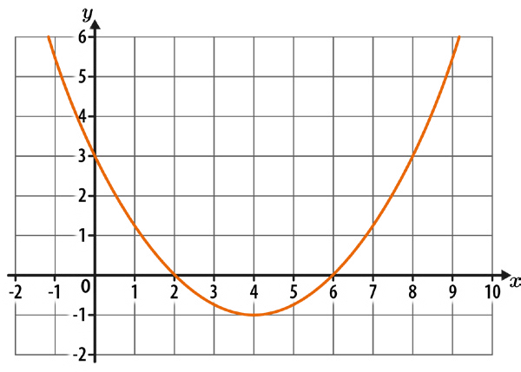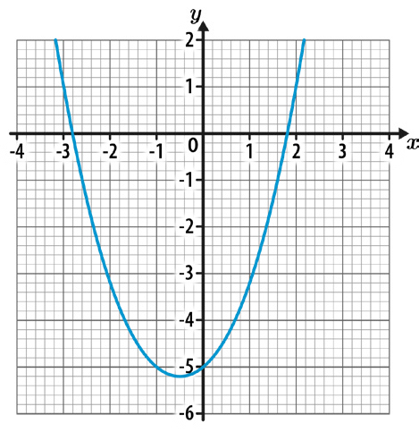

**Q1** Write down the coordinates of the roots of the quadratic curve shown below.

Answer: ( , ) and ( , )

**Q2** Here is the graph of the function ***y*** = ***x*** 2 + ***x*** - 5

Estimate the solutions to ***x*** 2 + ***x*** - 5 = 0 Give your answers to 1 d.p.

Answer:

# Quadratic graphs Introduce

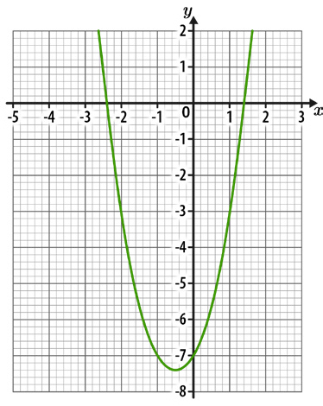

**Q3** The diagram below shows the graph of the function ***y*** = 2***x*** 2 + 2***x*** - 7 Work out the solutions to 2***x*** 2 + 2***x*** - 7 = -3

Answer:

**Q4** a) Write ***x*** 2 + 6***x*** + 11 in the form (***x*** + ***c***)2 + ***d***, where ***c*** and ***d*** are numbers.

Answer: a)

b) Hence, write down the coordinates of the turning point on the curve

***y*** = ***x*** 2 + 6***x*** + 11

Answer: b) ( , )

# Quadratic graphs Strengthen

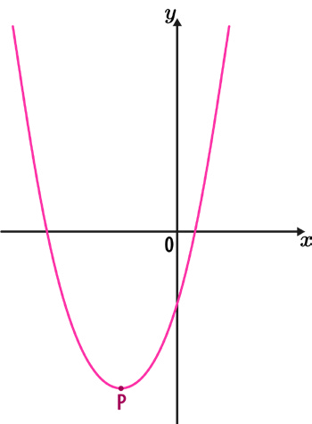

**Q1** The diagram below shows a sketch of the curve ***y*** = ***x*** 2 + 8***x*** - 10 P is the turning point of the curve.

Work out the coordinates of P.

Answer: ( , )

**Q2** Work out the coordinates of the turning point of the curve ***y*** = ***x*** 2 - 5***x*** + 1

Answer: ( , )

# Quadratic graphs Strengthen

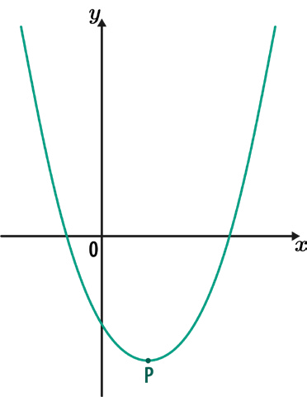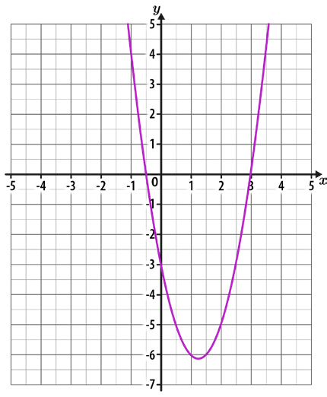

**Q3** The diagram below shows a sketch of the curve ***y*** = 3***x***2 - 6***x*** - 10 P is the turning point of the curve.

Work out the coordinates of P.

Answer: ( , )

**Q4** The diagram below shows the graph of ***y*** = 2***x*** 2 - 5***x*** - 3

Use the diagram to estimate the solutions to 2***x*** 2 - 5***x*** - 3 = -2***x*** + 2 Give any decimal answers to 1 d.p.

Answer:

# Quadratic graphs Deepen

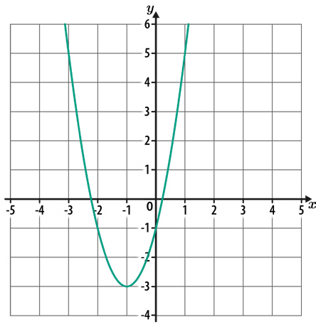

**Q1** The diagram below shows the graph of ***y*** = 2***x***2 + 4***x*** - 1

The equation 2***x*** 2 + 4***x*** - 1 = ***k*** has solutions at ***x*** = -3 and ***x*** = 1

What is the value of ***k***?

Answer: ***k*** =

**Q2** A curve has the equation ***y*** = ***x*** 2 + ***ax*** + ***b***, where ***a*** and ***b*** are numbers.

The turning point of the curve is (5, 4) Work out the values of ***a*** and ***b***.

Answer: ***a*** = ***b*** =

# Quadratic graphs Deepen

**Q3** A curve has the equation ***y*** = -***x*** 2 + 16***x*** - 65

1. Work out the turning point of the curve.

Answer: a) ( , )

1. By considering the position of the turning point and the shape of the curve, work out how many real roots ***y*** = -***x*** 2 + 16***x*** - 65 has.

Answer: b)

# Linear simultaneous equations Introduce

**Q1** Solve the following simultaneous equations: 6***x*** + ***y*** = 22

2***x*** + ***y*** = 10

Answer:

***x*** =

***y*** =

**Q2** Solve the following simultaneous equations: 7***x*** - 4***y*** = 20

2***x*** + 4***y*** = 16

Answer:

***x*** =

***y*** =

# Linear simultaneous equations Introduce

**Q3** Solve the following simultaneous equations: 15***a*** - 4***b*** = 25

5***a*** + 2***b*** = 25

Answer:

***a*** =

***b*** =

**Q4** Solve the following simultaneous equations: 2***x*** + 3***y*** = 8

3***x*** + 4***y*** = 11

Answer:

***x*** =

***y*** =

# Linear simultaneous equations Strengthen

**Q1** Solve the following simultaneous equations: 7***x*** + 5***y*** = 8

3***x*** - 2***y*** = -9

Answer:

***x*** =

***y*** =

**Q2** Solve the following simultaneous equations: 6***x*** + 7***y*** = 5

9***x*** + 13***y*** = -10

Answer:

***x*** =

***y*** =

# Linear simultaneous equations Strengthen

**Q3** Solve the following simultaneous equations:

7***y*** + 2***x*** = 23

2

5***y*** + 3***x*** = 9

Answer:

***x*** =

***y*** =

**Q4** Solve the following simultaneous equations:

4.6***t*** + 8.1***u*** = 104

3.8***t*** - 2.7***u*** = -8

Answer:

***t*** =

***u*** =

# Linear simultaneous equations Deepen

**Q1** Solve the following simultaneous equations: 3***x*** = 3 - 4***y***

12***y*** + 11 = -5***x***

Answer:

***x*** =

***y*** =

**Q2** Find the values of ***x***, ***y*** and ***a*** by solving the following simultaneous equations: 6***x*** - 7***y*** = -10

12***x*** - 5***y*** = 16

2***x*** + ***ay*** = 10

Answer:

***x*** =

***y*** =

***a*** =

# Linear simultaneous equations Deepen

**Q3** Solve the following simultaneous equations:

4 1

=

7***x*** - 4 6***y***

5***x*** = 4 3***y*** + 2

Answer:

***x*** =

***y*** =

**Q4** Solve the following simultaneous equations:

2***x*** = 4(7 - 2***y***)

3(5***x*** - 13***y***) = 81

Answer:

***x*** =

***y*** =

# Straight-line graphs Introduce

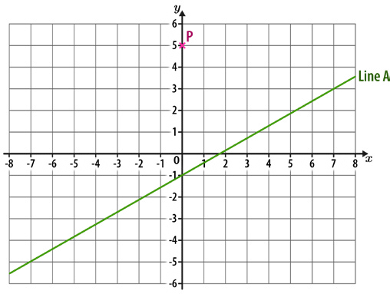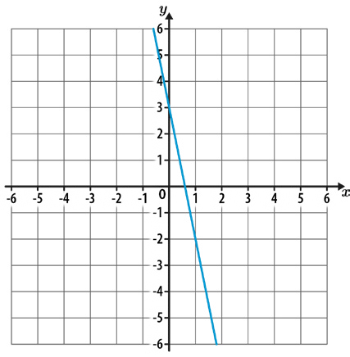

**Q1** Work out the equation of the straight line shown below.

Answer:

**Q2** Work out the equation of the straight line that is parallel to line A and passes through point P.

Answer:

**Q3** Line A has the equation 2***y*** - 10 = 16***x*** Line B is perpendicular to Line A.

What is the gradient of Line B?

Answer:

# Straight-line graphs Introduce

**Q4** A straight line has a gradient of 3 and passes through the point (2, 10) Work out the equation of the line.

Answer:

**Q5** Work out the equation of the straight line that passes through (2, 3) and (5, 18)

Answer:

# Straight-line graphs Strengthen

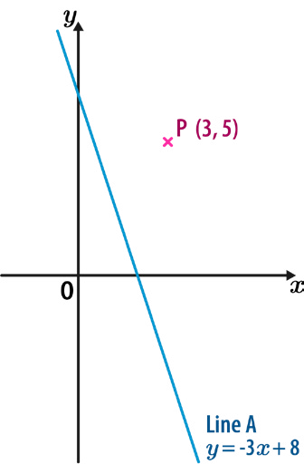

**Q1** A straight line has a gradient of - 3 , and passes through the point (32, 12) Work out the equation of the line.

4

Answer:

**Q2** The diagram below shows point P and Line A.

Line B is **perpendicular** to line A and passes through point P. What is the equation of line B?

Answer:

# Straight-line graphs Strengthen

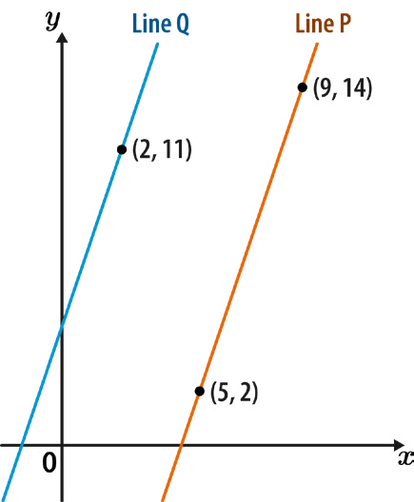

**Q3** Work out the equation of the straight line that passes through (1, -7) and (6, 8)

Answer:

**Q4** The graph below shows line P and line Q. Line Q is **parallel** to line P.

What is the equation of line Q?

Answer:

# Straight-line graphs Deepen

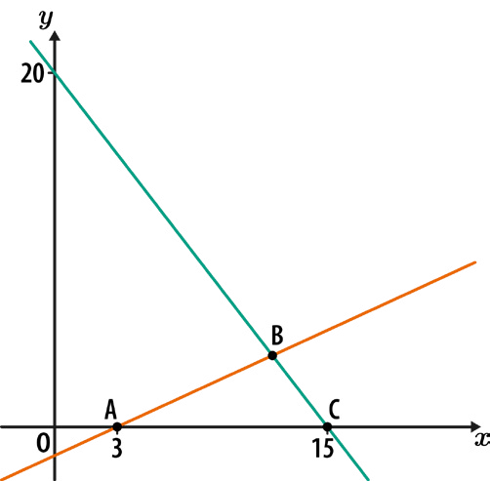

**Q1** Write an expression, in terms of ***h***, for the gradient of a line **perpendicular** to the line segment joining (3***h***, 20) to (6***h***, 8)

Give your answer as a fully simplified fraction.

Answer:

**Q2** The triangle ABC has an area of 24 square units.

What are the coordinates of point B?

Answer: ( , )

# Straight-line graphs Deepen

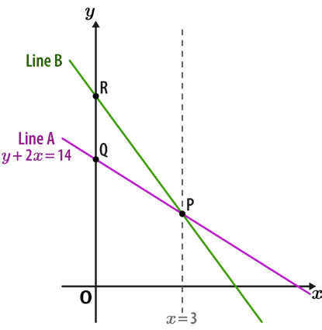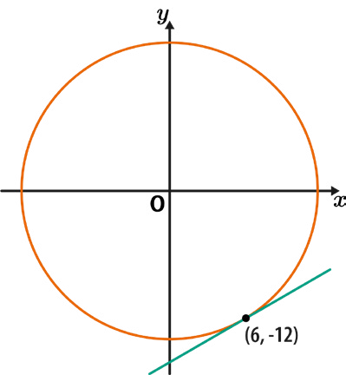

**Q3** Line A has the equation ***y*** + 2***x*** = 14

The gradient of line B is twice the gradient of line A.

Work out the ratio of the length of OQ to the length of OR. Give your answer in its simplest form.

Answer:

**Q4** A circle, centre O, passes through the point (6, -12), as shown.

Work out the equation of the tangent to the circle at this point.

Give your answer in the form ***y*** = ***mx*** + ***c***, where ***m*** and ***c*** are integers or fractions in their simplest form.

Answer:

# Right-angled trigonometry Introduce

**Q1** Work out the length ***g***.

Give your answer to 1 d.p.

Not drawn accurately

Answer: mm

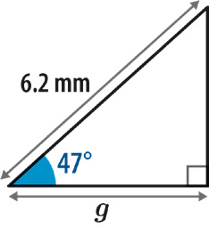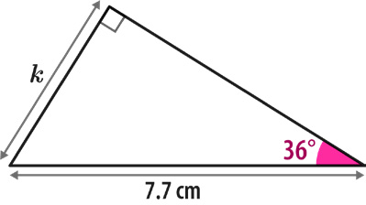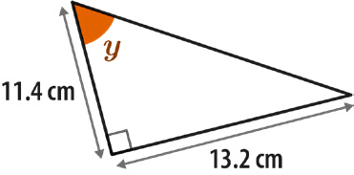

**Q2** Work out the length ***k***.

Give your answer to 1 d.p.

Not drawn accurately

Answer: cm

**Q3** Calculate the size of angle ***y***.

Give your answer to the nearest integer.

Not drawn accurately

Answer: °

# Right-angled trigonometry Strengthen

**Q1** Calculate the length ***y***.

Give your answer to 2 d.p.

Not drawn accurately

Answer: m

**Q2** Calculate the size of angle BAC. Give your answer to 1 d.p.

Not drawn accurately

Answer: °

**Q3** What is the size of angle ***x***? Give your answer to 1 d.p.

Not drawn accurately

Answer: °

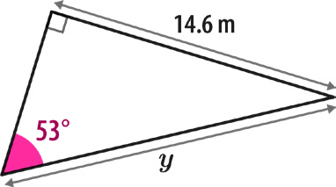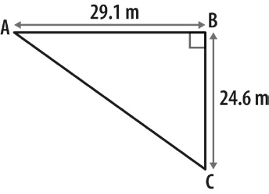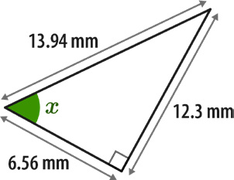

# Right-angled trigonometry Deepen

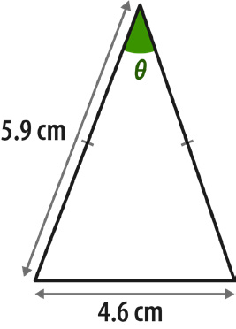

**Q1** Calculate the size of angle *0-*.

Give your answer to 1 d.p.

Not drawn accurately

Answer: °

**Q2** Work out the length ***y***.

Give your answer to 2 d.p.

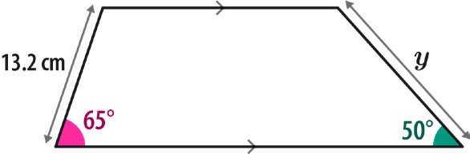

Not drawn accurately

Answer: cm

# Right-angled trigonometry Deepen

**Q3** The graph below shows the line with equation ***y*** = 5***x*** + 2 The axes both have the same scale.

Calculate the size of angle *0-*.

Give your answer in degrees to the nearest integer.

Not drawn accurately

Answer: °

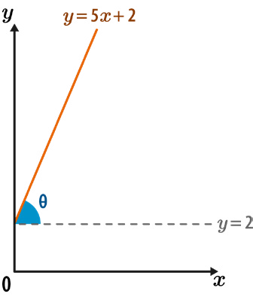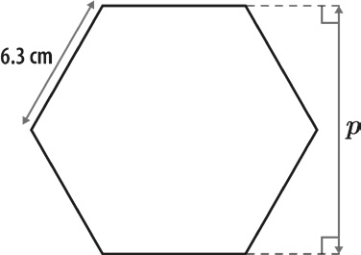

**Q4** The shape below is a regular hexagon.

Use trigonometry to calculate the distance ***p***. Give your answer in centimetres to 2 d.p.

Not drawn accurately

Answer: cm

# Further trigonometry Introduce

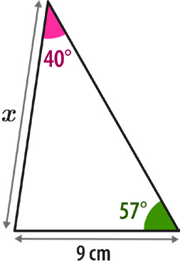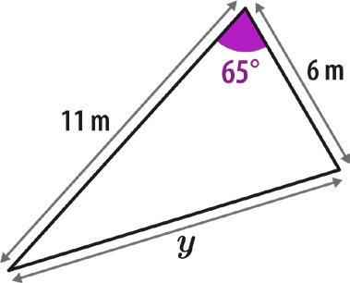

**Q1** Using the sine rule, calculate the length ***x***.

Give your answer to 1 d.p.

Not drawn accurately

Answer: cm

**Q2** Using the cosine rule, work out the length ***y***.

Give your answer to 1 d.p.

Not drawn accurately

Answer: m

# Further trigonometry Introduce

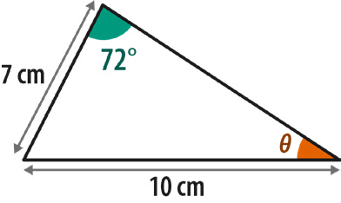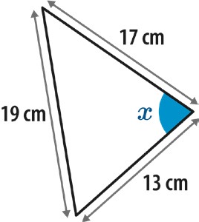

**Q3** Use the sine rule to calculate angle *0-*.

Give your answer to 1 d.p.

Not drawn accurately

Answer: °

**Q4** Use the cosine rule to calculate the size of angle ***x***.

Give your answer to the nearest degree.

Not drawn accurately

Answer: °

# Further trigonometry Strengthen

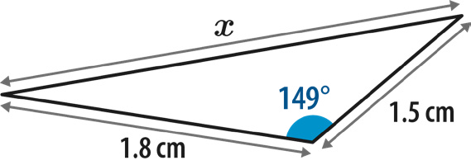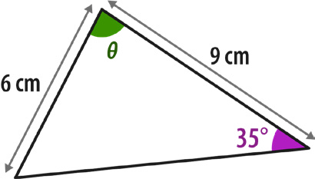

**Q1** Work out length ***x***.

Give your answer to 1 d.p.

Not drawn accurately

Answer: cm

**Q2** All the angles in the triangle below are acute.

Calculate the angle *0-* to 1 d.p.

Not drawn accurately

Answer: °

# Further trigonometry Deepen

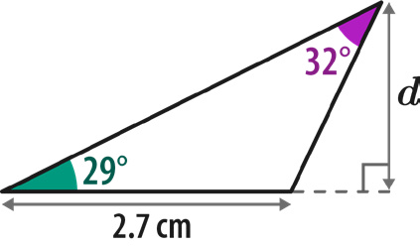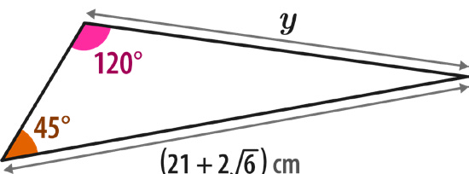

**Q1** Calculate the length ***d***.

Give your answer to 2 s.f.

Not drawn accurately

Answer: cm

**Q2** Work out the length ***y*** in the triangle below.

Give your answer in its simplest form, rationalising the denominator if necessary.

Not drawn accurately

Answer: cm

# Further trigonometry Deepen

**Q3** Using the information below, work out the value of ***x***.

sin***A*** = 4

5

sin***B*** = 3

4

Not drawn accurately

Answer:

**Q4** Given that cos*0-* = 1 in the triangle below, show that ***y***2 = ***ax*** 2 + ***bx*** + ***c*** where ***a***, ***b***

8

and ***c*** are numbers.

What are the values of ***a***, ***b*** and ***c***?

Not drawn accurately

Answer:

***a*** =

***b*** =

***c*** =



