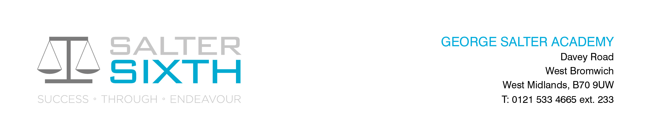

Year 11-12 Transition Pack:
BTEC
Applied Science

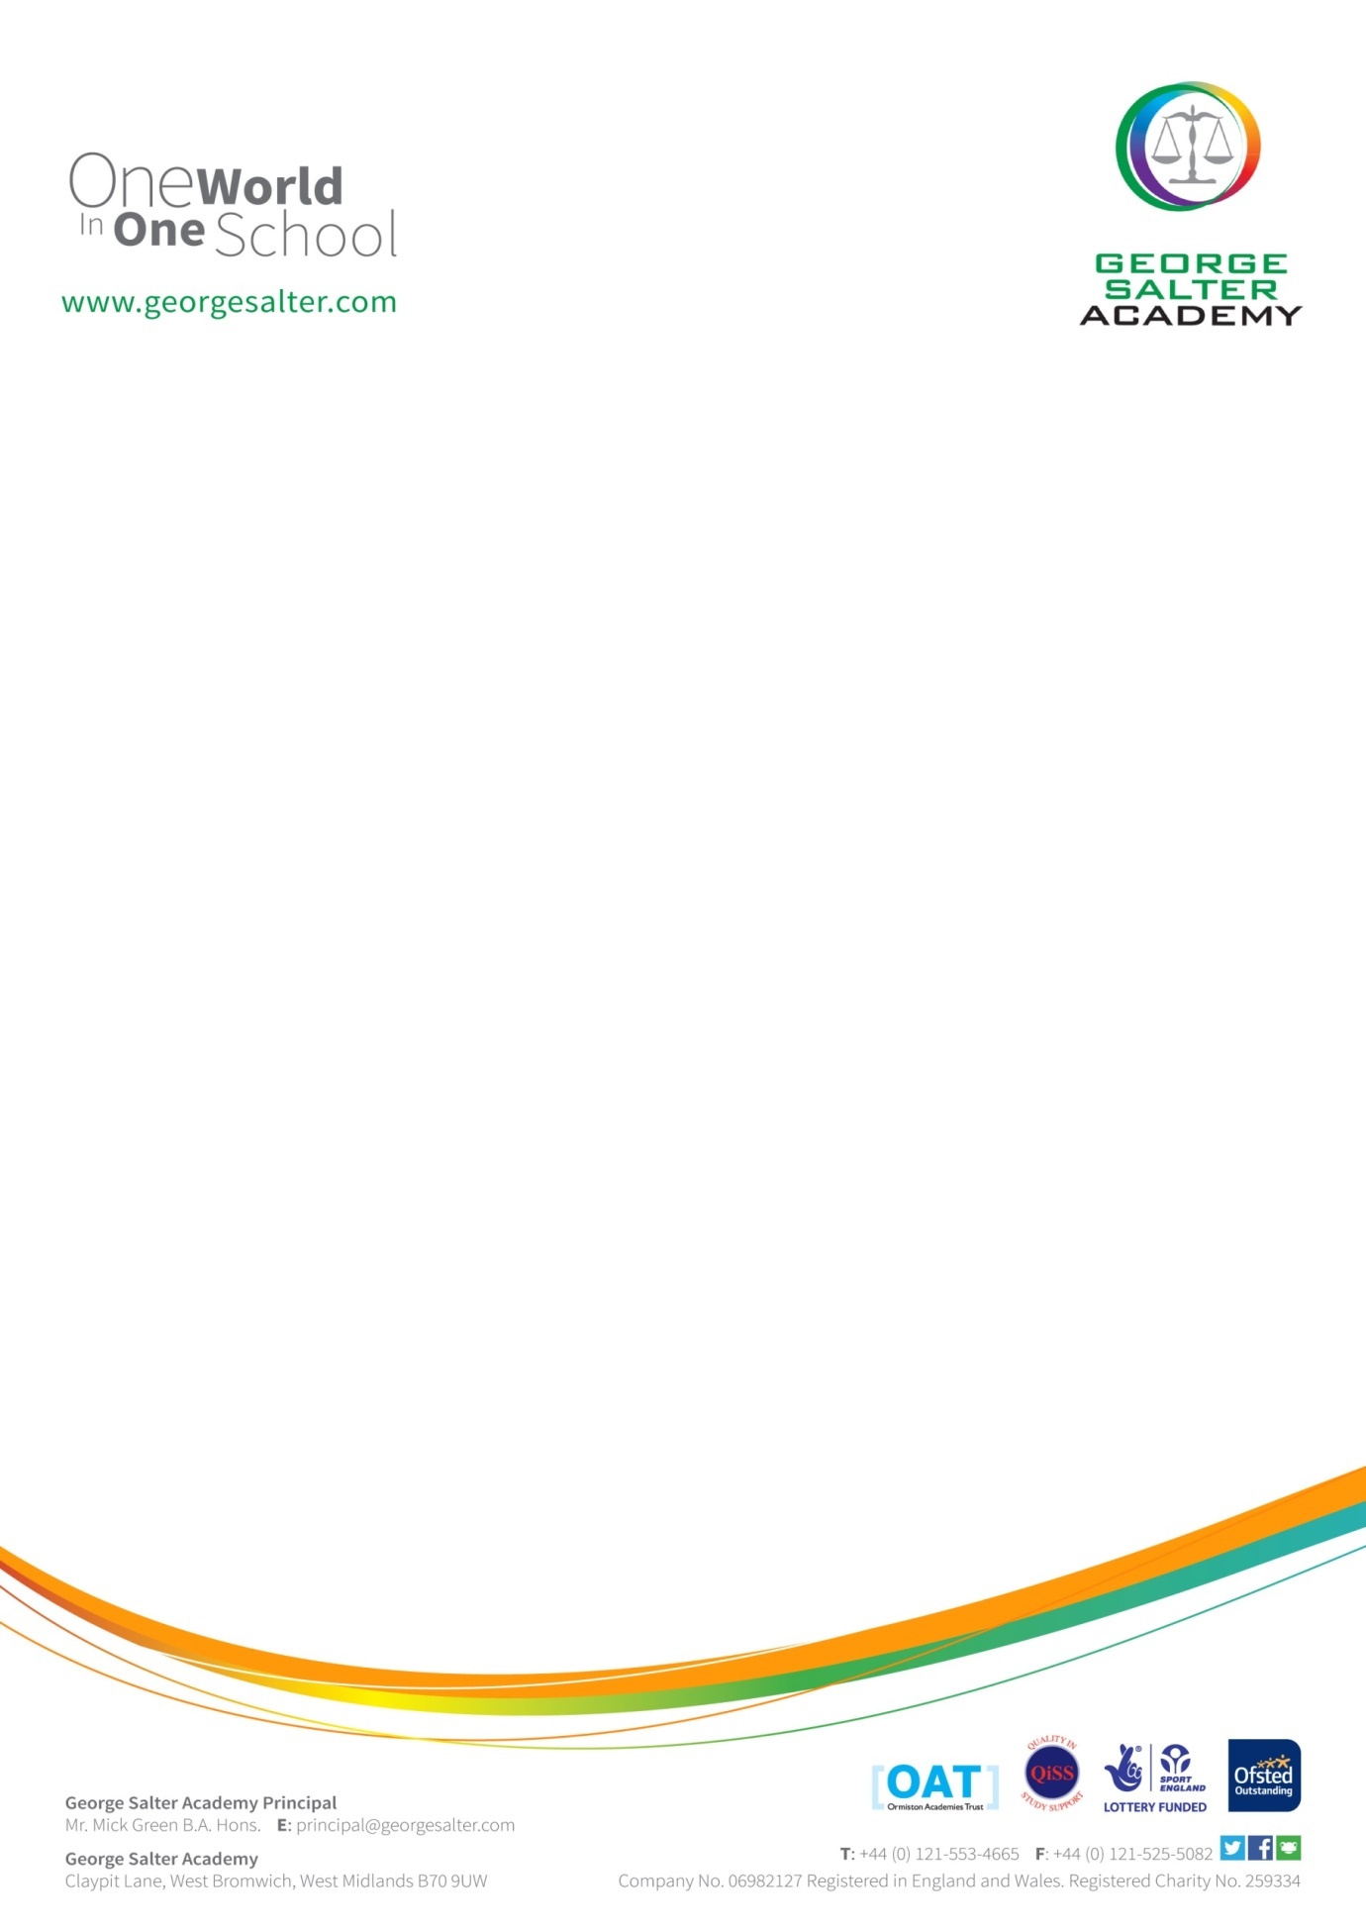

Applied Science
Course Information
BTEC Applied Science is a mixture of coursework units as well as exam units. It requires students to be organised to manage their assignments set for their course work units while revising for the examined units. It will test your ability to recall ideas and apply it to unknown contexts. It also requires a good understanding of maths which comes through repeated practice. The gap between GCSE and BTEC Applied Science is a significant one and private study is essential if you want to be successful. Private study does not mean extra work, it means that you are consolidating and applying what you have already been taught. Private study also means reading ahead, in order to prepare for lessons. Examples of tasks that you could carry out during private study include:
- Adding to your class notes by using the specification as a guideline.
- Annotating class notes or diagrams using your revision guides.
- Summarising your notes or creating mind maps or flashcards.
- Completing past exam questions.
- Creating a glossary of key definitions.
At
Specification
At Salter Sixth, you are studying Pearson BTEC Level 3 National Extended Certificate in Applied Science. Below is a link to the specification for the course:
QR Code to specification:
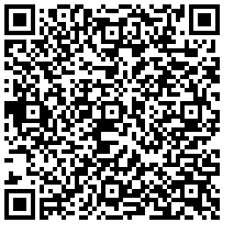
https://qualifications.pearson.com/content/dam/pdf/BTEC-Nationals/Applied-Science/2016/specification-and-sample-assessments/BTEC-L3-Nat-ExtCert-in-Applied-Science-Spec.pdf

Applied Science students must familiarise themselves with the specification and should download and save it on their personal electronic study device so that they can refer to it
Topic check list
On the specification, the areas you will be studying are:
Year 12:
Unit 1: Principles and Applications of Applied Science 1 (examined unit. Exams are at the end of year 12)
Unit 2: Practical Scientific Procedures and Techniques (coursework unit)

Year 13:
Unit 3: Science Investigation skills (examined unit. Exams are at the end of year 13)
Unit 8: Physiology of Human Body Systems (coursework unit)

Extend your learning and knowledge of each topic detailed on the check list by:
- Reading the subject content once over and produce a revision tool on your second reading (you can use YouTube videos, revision books etc)
- Completing exam questions set for you
- Completing extended practice questions set for you

Reading lists – useful websites

QR Codes and direct links to useful websites to help you prepare for Applied Science
Revision notes on Chemistry:  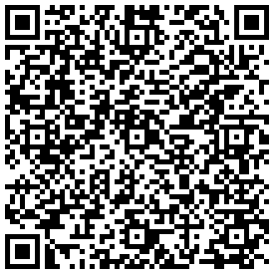  https://www.physicsandmathstutor.com/pdf-pages/?pdf=https%3A%2F%2Fpmt.physicsandmathstutor.com%2Fdownload%2FChemistry%2FA-level%2FNotes%2FAQA%2FPhysical-I%2FDetailed%2F1.1.%20Atomic%20Structure.pdf | Revision notes on Biology  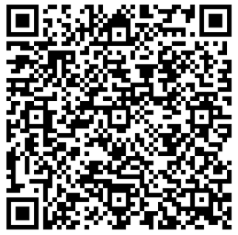  https://www.physicsandmathstutor.com/pdf-pages/?pdf=https%3A%2F%2Fpmt.physicsandmathstutor.com%2Fdownload%2FBiology%2FA-level%2FNotes%2FAQA%2F2-Cells%2FSummary%20Notes.pdf | Revision notes on Physics  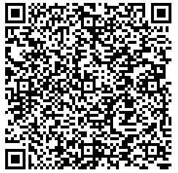  https://www.physicsandmathstutor.com/pdf-pages/?pdf=https%3A%2F%2Fpmt.physicsandmathstutor.com%2Fdownload%2FPhysics%2FA-level%2FNotes%2FAQA%2F03-Waves%2FDetailed%20Notes%20-%20Section%2003%20Waves%20-%20AQA%20Physics%20A-level.pdf

Reading list – Text books

Revise BTEC National Applied Science Revision Guide (ISBN 978 1 292 15004 8)
BTEC National Applied Science Student Book 1 (ISBN 978-1292134093)
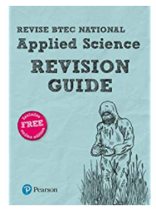 | 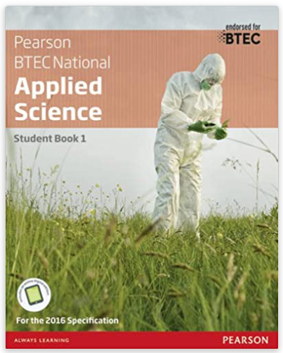

Videos to watch:

The most AMAZING chemical Reactions Good demonstration reactions  https://www.youtube.com/watch?v=0Bt6RPP2ANI | 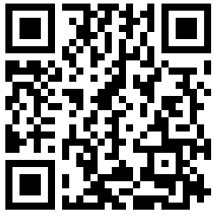
Amoeba Sisters Biology Learning Playlist  Explore how to use a light microscope and some information about cells  https://www.youtube.com/watch?v=tVcEEw6qbBQ&list=PLwL0Myd7Dk1HR9u5jw19E1_Q5u25PKg8v&index=2 | 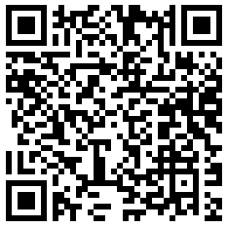
Insider Tech  Find out how noise cancelling headphones work  https://www.youtube.com/watch?v=zj33WAODsJg | 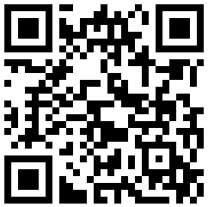
A thread of quicksilver – The Open University  A brilliant history of the most mysterious of elements – mercury. This program shows you how a single substance led to empires and war, as well as showing you come of the cooler properties of mercury.  https://www.youtube.com/watch?v=t46lvTxHHTA | 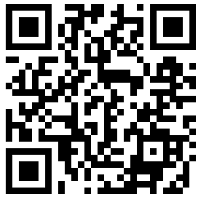
How to smash glass with your voice  Learn how soundwaves can be used to break objects such as a wine glass and kidney stones  https://www.youtube.com/watch?v=TP1-dHszNjE&t=8s | 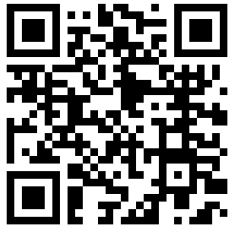

Summer Tasks to complete for Applied Science (Starting September 2024)

Task 1: Wider Reading Literacy Task: Is vaping better than smoking?
Read the article from Medical News Today on vaping and Smoking. Access this article by scanning QR code or click on Website link below:
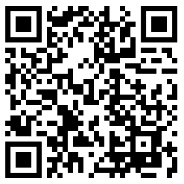
https://www.medicalnewstoday.com/articles/vaping-vs-smoking
Produce a summary on the risks and long-term effects of vaping and smoking. Include your own conclusion on if vaping or smoking is more harmful and justify your conclusion.

-------------------------------------------------------------------------------------------------------------------------------------------------------

Task 2: Research task: Pick a Question:
Choose a question below and prepare a detailed poster or essay to explain the answer to the question you’ve selected. Make sure you discuss the Science in your explanations. Include a reference list (i.e. list websites and books you used to help you complete this task)
