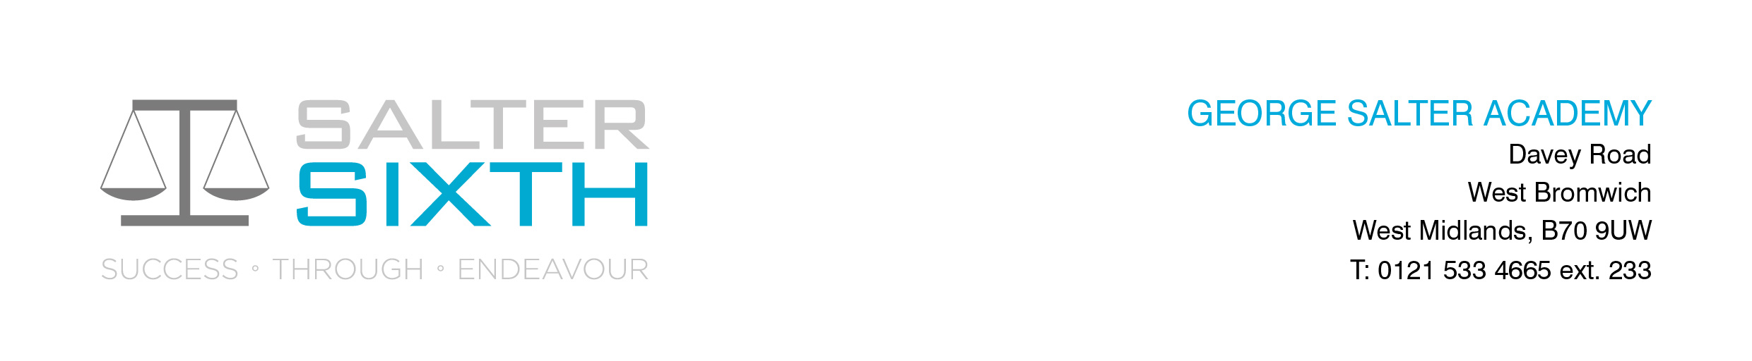

Year 11-12 Transition Pack:
A Level
Film Studies
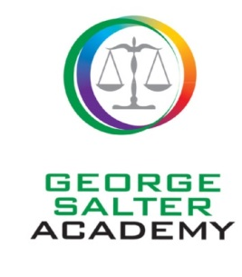

Introduction

We are really pleased that you are considering the A Level Film Studies course. This WJEC specification offers a breadth of film experience that we are sure that you will enjoy.
This pack is designed to help you to prepare for your study of Film at A Level. We would like you to use it following the completion of your GCSEs and to refer to it over the summer holidays. Also included are some tasks that we would like you to complete in preparation for your studies.
A qualification in Film Studies will help you develop a number of key transferrable skills valuable for both further study and future employment. Your ability to gather, assess and interpret ideas and opinions will develop, as will your analytical skills, your cultural awareness, your ability to write clearly and concisely and to communicate complex ideas. You will be introduced to aspects of the film industry; researching how films progress from production through to audience consumption. You will also learn some new practical skills, creating media products.

Course Overview
Eduqas A Film Studies:
The A Level specification in Film Studies is designed to deepen students' understanding, appreciation and enjoyment of film, the major art form of the twentieth century, and one developing new modes of expression and exhibition in the first decades of the twenty-first century. By its nature, a study of Film also requires candidates to consider individual, moral, ethical, social, cultural and contemporary issues.
External Examination – Component 1 (2hrs 30min) – Varieties of film and filmmaking (35% of AL)
Component 1 assesses knowledge and understanding of six feature-length films.
Section A (50min): Hollywood 1930-1990 (comparative two film study). One question from a choice of two, requiring reference to two Hollywood films, one from the Classical Hollywood period (1930-1960) and the other from the New Hollywood period (1961-1990) - Alfred Hitchcock’s ‘Vertigo’ 1958 and Spike Lee’s ‘Do the Right Thing’ 1989.
Section B (50min): American film since 2005 (two-film study). One question from a choice of two, requiring reference to two American films, one mainstream film and one contemporary independent film - Matt Ross’ ‘Captain Fantastic’ 2016 and Todd Phillips’ ‘Joker’ 2019.
Section C (50min): British film since 1995 (two-film study). One question from a choice of two, requiring reference to two British films - Edgar Wright’s ‘Shaun of the Dead’ 2004 and Shane Meadow’s ‘This is England’ 2006.

External Examination – Component 2 (2hrs 30min) – Global filmmaking perspectives (35% of AL).
Component 2 assesses knowledge and understanding of five feature-length films (or their equivalent).
Section A (60min): Global film (two-film study). One question from a choice of two, requiring reference to two global films: one European (TBC) and one produced outside Europe (Fernando Meirelles’ Brazilian crime drama ‘City of God’ 2002).
Section B (30min): Documentary film. One question from a choice of two, requiring reference to one documentary film (Asif Kapadia’s ‘Amy’ 2015).
Section C (30min): Film movements – Silent cinema. One question from a choice of two, requiring reference to one silent film or group of films - Buster Keaton’s Shorts - One Week (1920), The Scarecrow (1920), The 'High Sign' (1921) and Cops (1922).
Section D (30min): Film movements – Experimental film (1960-2000). One question from a choice of two, requiring reference to one film option – Christopher Nolan’s ‘Memento’ 2000.

Non-Exam Assessment – Component 3 – Production (30% of AL)
This component assesses one original student production and its evaluative analysis.
Production (20%) – students produce:
- Either a short film (4-5 minutes)
- or a screenplay for a short film (1600-1800 words) plus a digitally photographed storyboard of a key section from the screenplay
Evaluative analysis (10%) – students produce:
- An evaluative analysis (1600 - 1800 words).

Helpful Reading
The following texts are available to purchase through Amazon or could be ordered to borrow through your local library. We also have a limited number in the department that can be borrowed.
WJEC Eduqas Film Studies for A Level & AS Revision Guide - by Jenny Stewart | 18 Mar 2020. Amazon - £16.99 Introduction to Film Studies, ed. Jill Nelmes Film Theory: The Basics Paperback – 22 Feb. 2016 by Kevin McDonald. Amazon - £16.51
Useful Websites
http://www.bfi.org.uk/
http://www.boxofficemojo.com/weekend/chart/
http://www.imdb.com/
http://www.empireonline.com/
https://www.futurelearn.com/courses - These are free online courses that anyone can join with many being based on topics you will study at A level. They are run by universities and are great background preparation for the students. Most of the courses have approximately 3 hrs study time a week.
What else can I do to prepare?
Use YouTube to watch documentaries on actors and their films. Watch as many different films as you can from different genres (British film, Hollywood, Independent, National Encourage your parents to join you in watching some of these films! You can then have discussions regarding your response and meanings created.
Summer Activities- Due second week in September
- Read the chapter on Film Language: Film Form and Meaning available at https://www.researchgate.net/publication/326403858_Film_Language_Film_Form_and_Meaning
- Make your own brief notes on the microelements of film: Editing, Performance, Cinematography, Mise-en-scene, Sound. (These could be presented as mind-maps, a reflective journal…)
- Watch Alfred Hitchcock’s film ‘Vertigo’.
- Read the critical analysis of Hitchcock’s ‘Vertigo’ at https://www.sparknotes.com/film/vertigo/
- Read the BFI’s Sight and Sound article: https://www.bfi.org.uk/sight-and-sound/features/vertigo-1958-alfred-hitchcock-greatest-films-poll
- Make your own brief notes on Hitchcock’s film ‘Vertigo’. (Again, these could be presented as a mind-map, handwritten notes, a journal…)
These notes/ mind-maps should be brought in to lesson by the second week back.
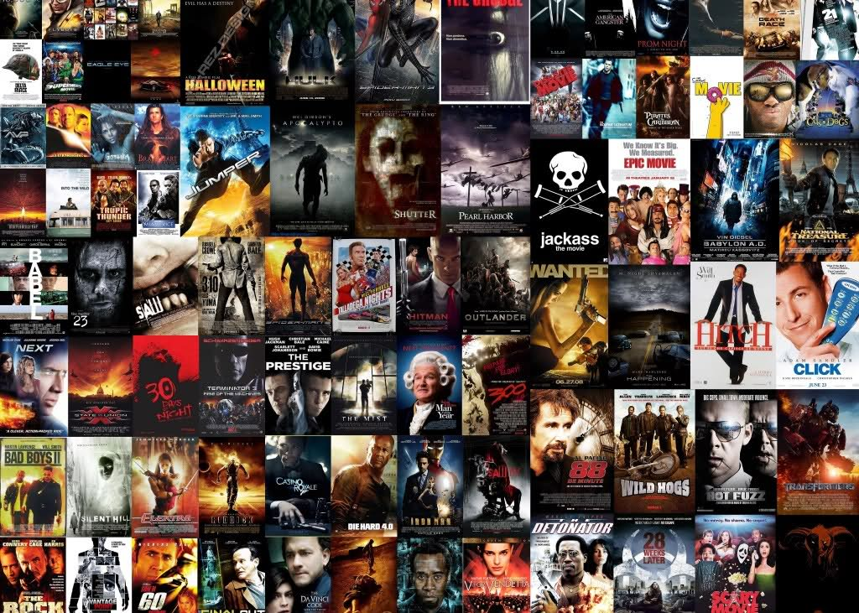
Enjoy! ☺

