Year 11-12 Transition Pack:
SOCIOLOGY
A-LEVEL

Introduction
Ever wondered how we developed into the society we are today? How the way you see yourself determines the way people identify you? What inequalities are there within the education system? Why purpose does family and religion serve? Whether men or women are more likely to commit a crime? A-level Sociology will help you to make sense of the society we live in and understand the cultural and identity issues which are relevant to everyday life and affect us all.

So, before you have even opened a sociology textbook you will already have acquired some knowledge of society. Sociology invites us to challenge and question our common sense assumptions about society and develop a sociological imagination. You will learn a number of skills including the use of evidence to support your arguments, how to investigate facts, and critical thinking.

This pack contains a programme of activities and resources to prepare you to start an A Level in Sociology in September. It is aimed to be used after you complete your GCSEs throughout the remainder of the summer term and over the summer holidays to ensure you are ready to start your course in September. We hope you enjoy discovering about the world we live in as we do!
Course Overview
What will I study?
In the first year of study you’ll study:

• Education and methods in context: You’ll
consider the role of education in society. For
example as part of your studies you’ll look
into gender and ethnicity differences in school
achievement. You’ll also learn how to apply
your own sociology research methods to the
study of education.

• Research methods: You’ll learn how to
conduct your own sociological research, from
interviews to reviewing documents and official
statistics.
•You’ll also the topic: families and households

In the second year of the A-level you’ll broaden your understanding of society. You’ll study:

• Crime and deviance with theory and
methods: You’ll learn about criminal and
deviant behaviour, including factors that might lead a person to follow this path in life and how the media portrays them

• Theory and methods: you’ll expand on your knowledge of research methods and study theory and methods.

You’ll also the topic: beliefs in society

What will I study?
In the first year of study you’ll study:

• Education and methods in context: You’ll
consider the role of education in society. For
example as part of your studies you’ll look
into gender and ethnicity differences in school
achievement. You’ll also learn how to apply
your own sociology research methods to the
study of education.

• Research methods: You’ll learn how to
conduct your own sociological research, from
interviews to reviewing documents and official
statistics.
•You’ll also the topic: families and households
How will I be assessed?

At A-level there are three exams, each account for one third of your A-level grade. The three exams last 2 hours and are worth 80 marks each. The exams consist of a mixture of short answer and extended writing questions.

What do I need for this course?
The entry requirements for this course are a B grade in English. This course is designed for those with an inquisitive mind and a thirst of knowledge surrounding social issues. Good essay writing and discussion skills are vital for the course as well as plenty of commitment!

Sociology is…
- The study of society, large groups of people and individuals.
- It studies how and why people behave the way they do in society
- Looks at how structures such as family and Government influence human behaviour
- A social science which uses research to investigate and predict human behaviour to help governments improve the lives of its citizens
- A critical and radical subject; it is about questioning why society is as it is. It is about digging under the surface, looking at what is really going on.

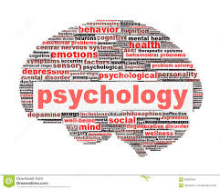
- An easy subject
- Just common sense
- Wishy-washy and unscientific
- Psychology
Why are some of the hardest jobs poorly paid?
Why are some people rich and some people poor?
Is sociology for me?
Yes, if you’re interested in questions like these…
Sociology is NOT...

Would the world be happier if there was just one religion?
Why are a large proportion of MPs white, male and from private schools?
Are people successful because of their background or how hard they work?
Are children and young people treated unfairly in society?
QUIZ
What kind of Sociologist will you be?
1. The defining characteristic of human behaviour is:
A) Their gender/ sex
B) Their social class
C)Their Race
D) Their integration into society
E) Their culture

2. We have the freedom to choose our own behaviour
A) Yes
B) No
C) Depends
D) Doesn’t matter
E) What is freedom?

3. What are your views on the family….
A) Family is oppressive to women and teaches us to conform to gender roles
B) Family is a tool of the ruling class teaching us to obey authority
C) Family is a vital part of socialisation that teaches us norms and values
D) Family is what you make it, everyone has a different view on it
E) Family – what is a family? You can’t define it

4. When it comes to inequality
- Gender is the most serious issue!
- Money and power the rich exploit the poor!
- Inequality is normal part of society
- Inequality is a label that has different meanings to people
- You make your own reality up

5. When it comes to Crime
- The justice system is more lenient on women
- Criminal laws protect the rich and powerful
- Crime is good for society as it reminds us of the rules
- Crimes are actions labelled as wrong to influence our behaviour
- Crime – what is a crime? Can we really define what a crime is?

6. When it comes to religion
- Religion oppresses and controls women – telling us to cover up and be obedient
- Religion is a tool used by those with power to control us
- Religion is a useful institution which unites people who share a common set of beliefs
- Religion means different things to different people
- Religion is just another meta-narrative (big story) people use to explain reality
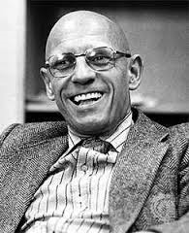
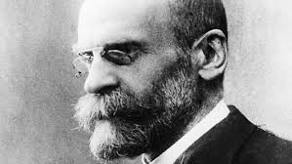
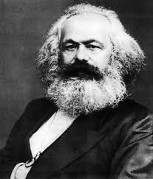
Mostly A – Our Feminist
You are most likely to turn into our Feminist Sue Sharpe. Feminism looks at how society is structured in a way that benefits men while oppressing women – this is known as patriarchy (male domination.). The theory is often a misunderstood as stereotypes and misconceptions about it exists. Many people do not realise that there are several types of feminism such as black, radical feminism and liberal.

Mostly B – Our Marxist
You are most likely to turn into Karl Marx. Marxism looks at how society is constructed is a way that produces class conflict with the rich having all the power and control whilst the poor are oppressed. Marx argues that the root cause of class inequality is down to capitalism as it encourages people to be greedy and materialistic. Just as capitalism replaced feudalism, Marx argues that capitalism will one day be replaced with communism

Mostly C- Our Functionalist
You are most likely to turn into Emile Durkheim. Functionalism is theory which argues that members of society are united together by a shared set of idea and beliefs called ‘norms’ (normal behaviour.) These norms are accepted by all members in society and are enforced by structures such as family and education. They see society like a human body – with all parts needed in order for it to ‘function’ and work effectively.

Mostly D- Our interactionist
You are most likely to turn into Becker/ Mead. Interactionism looks at how people create meaning during social interactions, how they present and construct the self (or identity) as well as how they define situations. One of the perspectives key ideas is that people act the way they do because of how they define situations. Becker uses the example of nudity to illustrate how timing, place and audience can influence how people see an action or idea.

Mostly E – Our post-modernist
You are most likely to turn into Foucault. Post-modernism is a more recent Sociological theory which seeks to question and de-construct existing structures and understandings of reality. Post modernism rejects the idea that one theory such as functionalism, Utilitarianism, religion or even science can explain reality!
What kind of Sociologist will you be?
Interesting Reading
Journals are a good way of keeping up to date with what’s happening Sociology. You can subscribe for a year or buy individual past publications.
Some good Sociology magazines are:
Sociology Review, Go to: http://www.philipallan.co.uk/geographyreview/index.htm
BSA Sociology journal, Go to: http://www.britsoc.co.uk/publications/sociology-journal.aspx

Useful Websites
You need to be aware of current social and global events that are related to the units you will be studying; so look out for things in the news to do with the topics we are studying. You can use Google Alerts to make this easier
http://www.google.co.uk/alerts?hl=en
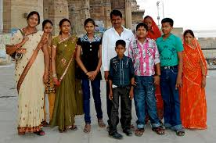
There are also many good websites you can use. News website are partially good at keeping you informed and up-to-date.
News websites include –
www.bbc.co.uk
http://www.independent.co.uk/news/uk
You can also use websites for information like –
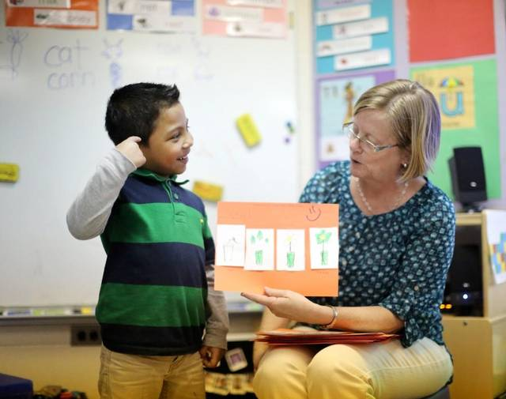
https://www.ons.gov.uk/
http://www.britsoc.co.uk/
http://esociology.co.uk/
https://www.sociologystuff.com/
www.tutor2u.net/blog/index.php/sociology
What else can I do?
Download news apps onto your phone and social media pages and read on the go – e.g. the Independent
When visiting somewhere new – eg: on holiday- keep a journal of cultural features and issues you see and try to find out as much as you can about where you are visiting.
Use YouTube/Netflix to watch documentaries on social issues, e.g. explained- the series.
Sociology- Summer homework
Over the Summer you will need to complete the following activities to help you ‘hit the ground running’ when you start in September. Please bring the completed activities to your first Sociology lesson.
- Education
In Sociology, we will examine some of the trends and issues surrounding the education system during the course of study. In any topic you would be expected to present real-life examples and accounts in your work.
Task: You are to create a collage of articles, which demonstrate the most significant currents trends and issues in education in 2019 based on your findings.
A good starting point is inspecting the education section of news sites, but also making use of printed newspapers or magazines to ensure you have a variety of information and enabling you to select the most relevant and useful articles and headlines. The collage should be well presented and be a creative revision tool that you can add concepts/articles to and refer to at a later point. Adding subtitles and highlighting key words would be a good idea. You are expected to include at least 10 articles/headlines and be prepared to explain them
- Families and Households
You will study some aspects relating to family and households in depth during the first year of the course, e.g. the domestic division of labour. You need to be prepared in Sociology to always consider different points of view and be critical in your line of thinking.
Task: You must select one of the following statements below and present a discussion on this as a written response:-
- ‘Family life is always a positive experience for people.’
- ‘Men should be out working and women should be at home in a proper family’
- ‘The typical family today is made up of two parents and two children.’

You should write a side of A4, presenting a two-sided argument, with a final conclusion for your statement. You are expected to provide evidence to justify your arguments, rather than simply providing your opinions, e.g. statistical evidence and real-life stories. Use the recommended websites to help you collate additional evidence to use as well as your existing knowledge. We will be looking at the structure and quality of your written response. Any sources that you use should be referenced at the bottom of the page.

