

Year 11-12 Transition Pack:

Level 3 BTEC Extended Certificate  
Health and Social Care



**Introduction**

This course allows you an insight in the many roles available within health and social care from nurses to social workers to childcare assistants and beyond they have many key features that we shall explore and apply. You will be studying a range of units which will help you to gain skills that will be valuable in your chosen profession or future study. You will learn about the human body and mind alongside the changes across time. You will learn what it means to work in the sector and what skills and behaviours you will need to develop.

You can contact the following staff for further information:

Ms Kaur- [b.kaur@georgesalter.com](mailto:b.kaur@georgesalter.com)

Mrs [Wall-s.wall@georgesalter.com](mailto:Wall-s.wall@georgesalter.com)

**Course Overview**

During unit one, Human Lifespan Development, you will focus on:

* Understand the different influences on an individual’s development and how this relates to their care needs.
* You will be introduced to the biological, psychological and sociological theories associated with human

lifespan development.

* You will explore the physical effects of ageing and the theories that help to explain psychological changes.
* How you will be assessed: this is a paper based exam, that lasts for 1 hour 30 minutes, that is worth 90

marks. There is a variety of short- and long- answers. The questions are designed to test your knowledge on

individual’s development, the factors that affect this and the theories that explain this.

* During unit two, Working in Health and Social Care, you will focus on:
* You will be introduced to the roles and responsibilities of health and social care practitioners and the

organisations they work for.

* You will see how a wide range of roles, including doctors, nurses, physiotherapists, occupational therapists,

social workers, youth workers, care workers and other professionals, work together to ensure that the individual needs of vulnerable people are met.

* How you will be assessed: this is a paper-based exam, that lasts for 1 hour 30 minutes and worth 80 marks.

There will be four sections and include short- and long- answers. The questions are intended to assess your understanding of how health and care services can provide professional support to a service user. Each section will relate to a different service user group, for example the frail elderly, people with learning disabilities, people with mental health problems or people with long-term illnesses.

* During unit five, Meeting Individual Care and Support Needs, you will focus on:
* You apply knowledge in order to provide the care and support that meets the needs of an individual in a

health and social care environment, for this you need to understand the principles and practicalities that are the foundation of all the care disciplines.

* You will need to consider ethical issues that may arise and challenges the individual may face in order to

provide personalised care.

* You will reflect on the different methods used by professionals working together in a multi-agency team to

provide a package of care and support that meets individual needs.

* How you will be assessed: by a series of assignments set at school. You will provide practice assignments to

help you prepare for the final assessment. You will need to check that your work first meets all the pass criteria before moving on to merit and then finally distinction criteria.

The final unit will also be a series of assignments based on in class work exploring a specific aspect of health e.g. physiological or psychological care. You will need to look at case studies as you did in unit five and use your knowledge to explain their behaviour or condition leading to treatment plans

**Articles to Read**

**Textbooks: Pearson BTEC National Health and Social Care Specification 2016**

**Journals** <https://journals.rcni.com/nursing-standard>

**Websites** <https://www.jobs.nhs.uk/>

<https://www.skillsforcare.org.uk/Careers-in-care/Think-Care-Careers.aspx>

**Summer Activity- Due in your first lesson in September**



**Health and Social Care in the Media**



It is important to make the public realise about the issues which are prevailing in society relating to health and social care. One way in which public awareness is raised about health and social care in general and issues that exist within the health and social care sector is through the media.

Your task is to pick…

➢ x2 Films

➢ x1 Book

➢ x2 Documentaries

You will then be asked to write an essay with the following title: **‘Discuss the portrayal of Health and Social Care within the media’**

You must watch/read some of the examples on the previous slides you have picked and create notes to help with your essay. Consider the following:

• What issues, if any, are being raised in the stimulus?

• How does the stimulus present H&SC?

* Is the stimulus informative/helpful and why?

• Are there any quotes/scenes etc that stand out to you and why?

• How effective is the stimulus in raising public awareness about H&SC/Issues?

This list is NOT exhaustive there may be other questions/ideas you wish to consider as you watch or read.

 Documentary Suggestions:

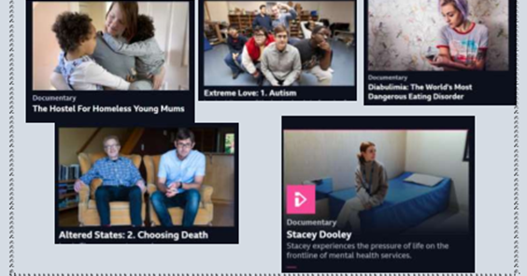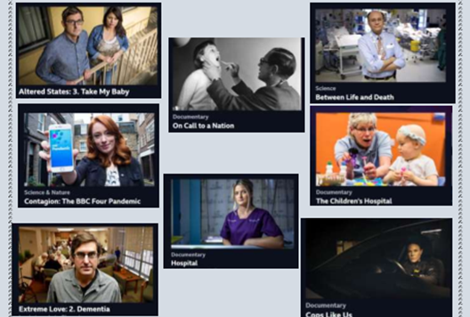

Learning Log

Record here any additional reading/viewing you are undertaking in order to show what you have been completing in order to prepare you for the course. Use the reading list on the previous slides you have been given for guidance on what you could you watch/read/

|  |  |  |  |
| --- | --- | --- | --- |
| **Date** | **Title** | **Summary of content** | **My thoughts** |
|  |  |  |  |
|  |  |  |  |
|  |  |  |  |
|  |  |  |  |
|  |  |  |  |
|  |  |  |  |
|  |  |  |  |



**Task:** Research and define the following words which are central to the Modern Britain unit. Then, draw a symbol to summarise the term and help you remember it.

|  |  |  |
| --- | --- | --- |
| **Term** | **Definition** | **Symbol** |
| Adolescence | An important status change following the onset of puberty during which a young person develops from a child into a adult. |  |
| Advocate |  |  |
| Attachment |  |  |
| Care package |  |  |
| Clinical Commissioning Groups (CCGs) |  |  |
| Development |  |  |
| Discrimination |  |  |
| Diversity |  |  |
| Empathy |  |  |
| Ethical |  |  |



|  |  |  |
| --- | --- | --- |
| **Term** | **Definition** | **Symbol** |
| Fine Motor Skills |  |  |
| Growth |  |  |
| Holistic Approach |  |  |
| Milestone |  |  |
| Nature |  |  |
| Nurture |  |  |
| Risk Assessment |  |  |
| Safeguarding |  |  |
| Self-Concept |  |  |
| Self-Esteem |  |  |







What does it mean when people talk about being ‘on the front line’?

Government declares a ‘pandemic’…….

What does it mean when people talk about the situation as a pandemic?

|  |  |  |  |
| --- | --- | --- | --- |
| Job Role | Definition | Roles and Responsibilities | How to they respond in a pandemic? |
| District Nurse |  |  |  |
| Auxiliary Nurse |  |  |  |
| Palliative Care |  |  |  |
| Phlebotomist |  |  |  |
| Domiciliary Carer |  |  |  |
| Adult Social Worker |  |  |  |

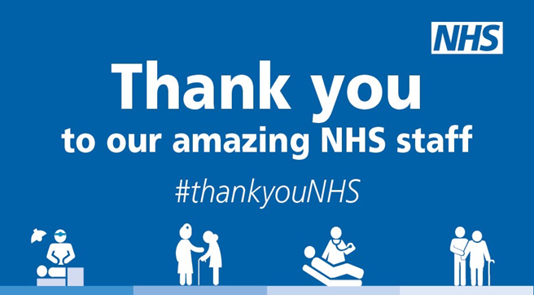

True or False?

