Year 11-12 Transition Pack:
Level 3 BTEC Extended Certificate
Children’s Play, Learning and Development.

Introduction
Within this course you be able to study key units that will enable you to enhance your knowledge and understanding of how children learn and play including how they develop. The qualification will support you to develop specialist knowledge and skills that will be needed for you to either progress to university, move on to an apprenticeship or work in a childcare setting. Pearson BTEC Level 3 National Extended Certificate in Children’s Play, Learning and Development is equivalent to one A Level.
You can contact the following staff for further information:
Ms Kaur- b.kaur@georgesalter.com
Mrs Wall-s.wall@georgesalter.com
Course Overview
During unit one, you will focus on: Children’s Development
- In this unit, you will learn about theories and models of development that explain how and why children develop and how this relates to the Early Years Foundation Stage (EYFS). You will develop an understanding of a range of factors that may influence children’s development, and consider the short- and long-term effects on their development.
- The knowledge you will gain in this unit will prepare you for a variety of careers as a childminder, family support worker or early years educator in the private, voluntary or state sector and/or allow progression to higher education studies in early years education or management.
- How you will be assessed: this is a paper based exam, that lasts for 1 hour 45minutes, that is worth 90 marks. There is a variety of short- and long- answers. The questions are designed to test your knowledge on children's development, the factors that affect this and the theories that explain this.

During unit two, you will focus on: Development of Children’s Communication, Literacy and Numeracy Skills
- In this unit, you will learn the sequence of children’s speech, communication, language, literacy and numeracy skills development. You will plan stage appropriate activities that encourage children’s development and understanding by stimulating their enthusiasm, and using exciting and interesting ways to enable them to find out more.
- This unit will prepare you for a variety of careers as an early years educator in the private, voluntary or state sector, or help you to progress to higher education studies in early years education or management.
- How you will be assessed: this is a paper-based exam, Task set and marked by Pearson and completed under supervise conditions. In part A, learners will be provided with a case study of a centre two days before the supervised assessment period in order to carry out research . In part B, the supervised assessment period is three hours in a period timetabled by Pearson This a exam out of 68 marks

- In the second year you will be assessed through course work. These two units are specialised units that will link into the two external units that you will have completed in the first year.
Unit 3: Play and Learning
Unit 5: Keeping Children Safe

Articles to Read
Textbooks: Pearson BTEC Children’s Play, Learning and Development.

Journals https://bmjpaedsopen.bmj.com/

Websites https://www.cache.org.uk/for-learners/choosing-early-years-as-a-career
https://www.stepintothenhs.nhs.uk/careers

Summer Activity- Due in your first lesson in September
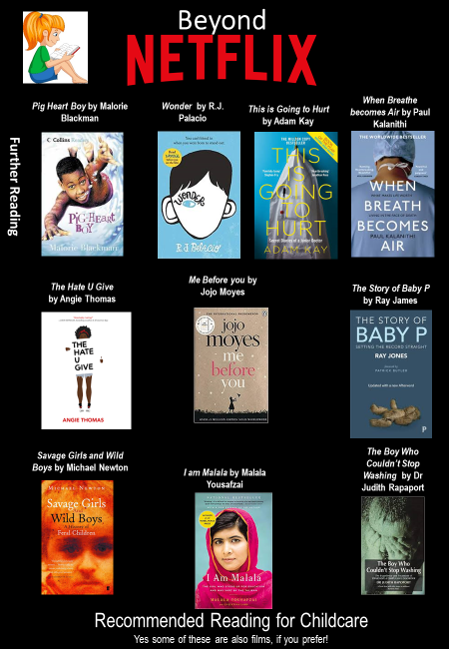

Children’s play, learning and development in the Media.
It is important to make the public realise about the issues which are prevailing in society relating to safeguarding and how children develop at different rates. One way in which public awareness is raised about concerns and issues with children's services and in the world of a professional working with children, is through the media.
Your task is to pick…
➢ x2 Films
➢ x1 Book
➢ x2 Documentaries
You will then be asked to write an essay with the following title: You must watch/read some of the examples on the previous slides.
Discuss how the films/ book/ documentaries portray children's play learning and development and evaluate this against the normal rate of growth and development.’ You will benefit from researching into the EYFS standards
You must watch/read some of the examples on the previous slides you have picked and create notes to help with your essay. Consider the following:
• What issues, if any, are being raised in the stimulus?
• How does the stimulus present the changes of how we grow and develop?
Is the stimulus informative/helpful and why?
• Are there any quotes/scenes etc that stand out to you and why?
• How effective is the stimulus in raising public awareness about issues / concerns of how children develop and the expectations from parents and wider society?
This list is NOT exhaustive there may be other questions/ideas you wish to consider as you watch or read.
Documentary Suggestions

Task: Research and define the following words which are central to the Modern Britain unit. Then, draw a symbol to summarise the term and help you remember it.
Term | Definition | Symbol
Adolescence | An important status change following the onset of puberty during which a young person develops from a child into a adult. | 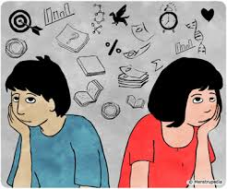
Advocate
Attachment
Fine Motor Skills
Clinical Commissioning Groups (CCGs)
Development
Discrimination
Diversity
Empathy
Ethical

Research a list of childcare careers / medical or appropriate terms for each letter of the alphabet.
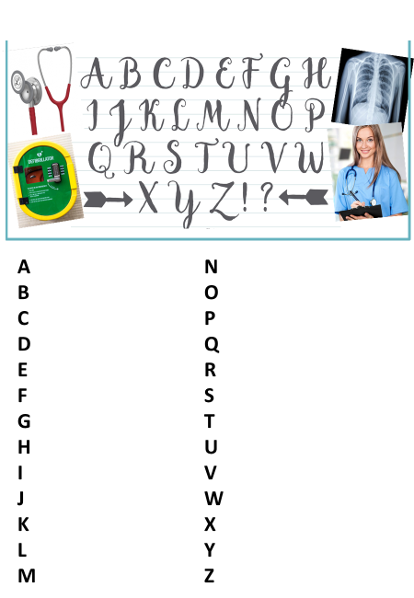

Research task

Chose a professional from the following:
- Midwife
- Paramedic
- Paediatric nurse
- Nutritionist
- Physiotherapist
You could choose your own idea from childcare care roles if you prefer.
Create a fact file for your chosen job role
You could include:
- A day in the life of……
- General roles and responsibilities
- Routes into the role/ qualifications required
- Skills & qualities
- Average pay
- Where they work
- Who they work with
And anything else you think may be suitable

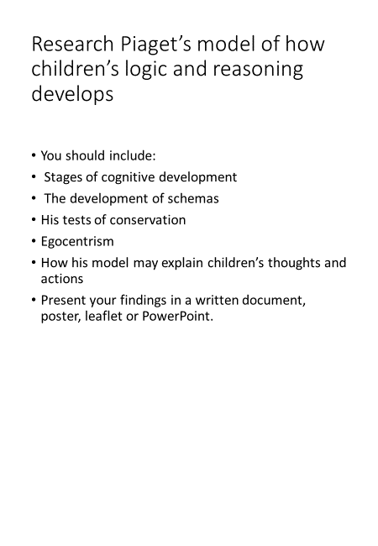

True or False
There are residential care settings for children
A palliative care nurse will get involved with everyone who gets coronavirus.
Everyone who works in childcare is responsible for promoting good mental health.
A nurse will only work with children

