Year 11-12 Transition Pack:
Art & Design
OCR A Level GCE Art and Design – H600-604
Fine Art- H601
Photography- H603
Textiles- H604

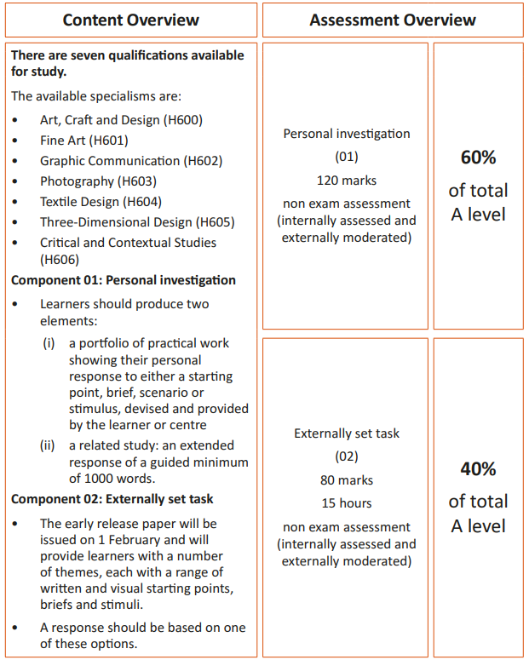
Course Overview:
The year, Art, Craft and Design will be offered as an A Level course only.
If you take it in year 12 and leave, you will not get an AS.
Introduction
The year 12 is all about building and refining practical skills. The emphasis is about demonstrating advanced skills, so a solid grade of 6/7 or above is required for starting the course.
The externally set task which will be a starting point set by the exam board- OCR will be released on February 1st of the 2nd year of teaching. Up until this, each course will carrying out subject specific workshops to help prepare and develop advanced skills and techniques within the particular area of study.

The endorsement that we will be delivering is called- Art, Craft and Design. With this endorsement, you will have to demonstrate 2 or more specialist areas of study from the list below, in any combination. 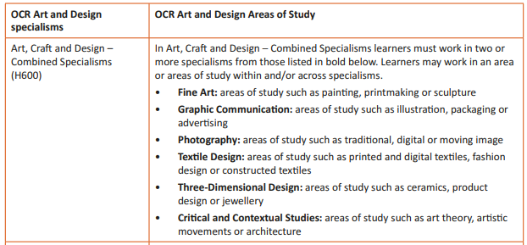
Year 12 will be all about workshops and practical work- all exploring the formal elements and how these can be represented visually- experimenting, exploring and trying out new techniques and process…all in different combinations and ways that you may not have even thought of before.
If you have any questions about the courses, feel free to email Mrs Shaw- Leanne.shaw@georgesalter.com

Summer Activities 1 – Explore the Arts!

Exposure yourself to art, photography, Textiles. Have a look at these websites and begin to form opinions of artworks and the artist associated with them. Here are some links that take you to a series of well-established galleries within the UK.
Take a look at these……….
http://www.tate.org.uk / http://www.nationalgallery.org.uk/
http://www.saatchigallery.com/ http://courtauld.ac.uk/
http://www.thebricklanegallery.com/
http://www.halcyongallery.com/ https://ikon-gallery.org/
http://www.birminghammuseums.org.uk/bmag

Go one step further and visit two fantastic galleries in Birmingham, the ‘IKON gallery’ and ‘Birmingham Museum of art’. Get out of the house this summer and see some art, photography and textiles. Both venues are free entry.
WATCH AND INVESTIGATE the Arts too– look at television documentaries on NETFLIX and BBC I Player...even look at Sky Arts as they cover a wealth of different genres of art.
Please see the list that was given out via Microsoft teams for specific documentaries…..

Summer activity 2 -Mini portfolio and presentation.
The purpose of this mini portfolio task is to encourage you to begin to develop your thinking and interpretation skills with both art and photography. Choose one of the following themes, from this theme we would like you to put together a mini portfolio made up of 5 images. You can use any material you want, for example, in art; pencil, watercolour, chalk, charcoal, mixed media, biro and in photography; cameras, scanner, Photoshop, even a camera phone with editing apps from an app store.
You can present this portfolio however you want; in a sketchbook, PowerPoint, presentation boards, website, Instagram page…… it’s up to you. We want to see what you can do!
When you return in September we will share these with each other in a mini presentation and begin to identify each other’s strengths and styles within the subject, it’s a great opportunity to show your teacher and peers your style and thinking process within the subject.
The themes are; Personality Structure Postcards Stay Still
What will you create? Use the GSA Visual arts ‘PINTEREST’ boards for inspiration.
These can be found on www.pinterest.com search for ‘GSA visual arts’.

