Year 11-12 Transition Pack:
Level 3 BTEC
Applied Science

Introduction
Applied Science is an exciting opportunity for students to study all three sciences through a more vocational approach. Topics covered include applied experimental techniques and science in the modern world, undertaking a scientific investigation and optional units in Biology, Chemistry and Physics. This course is designed for students who enjoy the study of science but struggle to communicate their knowledge and understanding in examinations. Students on this course will study all three specialisms of science (Biology, Chemistry and Physics) in a variety of different contexts whilst also developing their communication of scientific information and their practical skills.
Students on this course are able to progress into careers within the science industry and become Lab Technicians, Radiographers, Nurses and Environmental Scientists. Students also have the option to go on to university to study a science based course.
Entry requirements:
Grade 5 or above in GCSE Science

If you have any additional questions, please email Mrs Mandair – d.mandair@georgesalter.com

Course Overview
The fundamental philosophy of Applied Science is that, in order to understand the nature of science, students must actively experience the science environment. The units that are examined will combine traditional whole class teaching, individual and whole group research activities as well as practical investigations. Units that are assessed by portfolio work will be delivered primarily through developing investigative skills and students are expected to complete a full written investigation of the work carried out. A draft portfolio is marked by the teacher and returned with guidelines on how to improve to achieve a students’ target grade.

Good subject combinations
Applied Science combines well with Health and Social care, Psychology, PE and Food Science & Nutrition

Assessment:

Year 1 Units
- Unit 1: Principles and applications of science
- Unit 2: Practical scientific procedures and techniques

Year 1 Assessment
- Unit 1 is assessed through a 90-minute examination
- Unit 2 is assessed through coursework
- Each Unit is worth 50% of the AS year or 25% of the whole A-level (AS+A2)

Year 2 Units
- Unit 3: Science investigation skills
- One optional unit from a range of different topics across all three sciences

Year 2 Assessment
- Unit 3 is assessed through an external assessment (ISA)
- Optional unit is assessed through coursework
- Unit 3 is worth 66.6% of the A2 year or 33.3% of the whole A-level (AS+A2)
- Optional unit is worth 33.3% of the A2 year or 16.7% of the whole A-level (AS+A2)

Books & videos of interest
Books
• A short History of Nearly Everything-Bill Bryson
• On the Origin of Species-Charles Darwin
- The Periodic Table – Primo Levi
- Surely You're Joking Mr Feynman: Adventures of a Curious Character
- Thing Explainer: Complicated Stuff in Simple Words – Randall Munroe

Videos
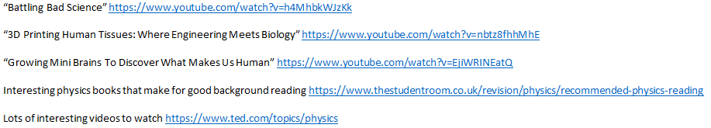

Textbooks
(Please do not buy any of these. Many pages of these can be read on Google Books for free or within your library).

Summer Activity- Due in your first lesson in September
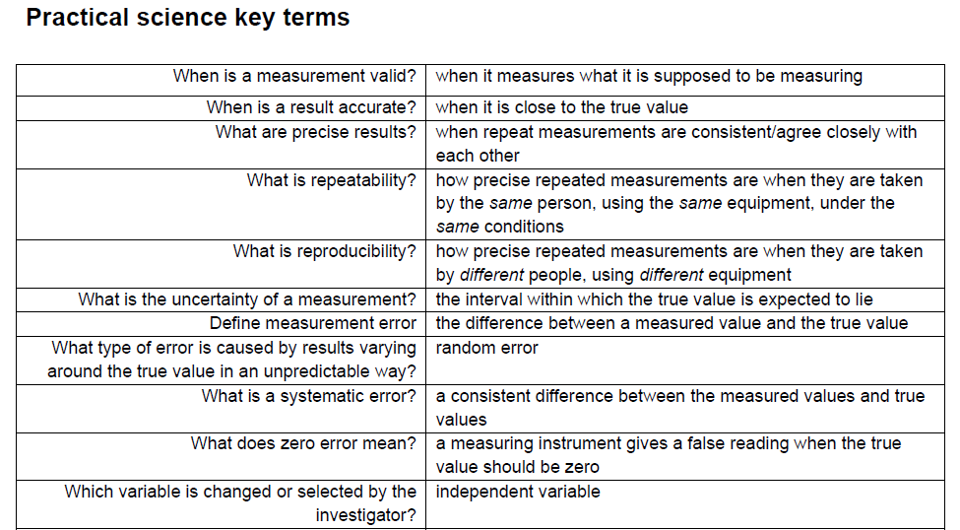
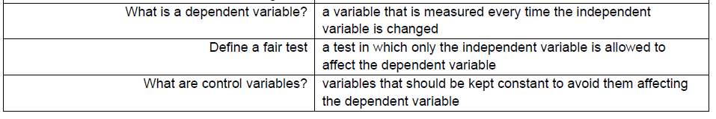
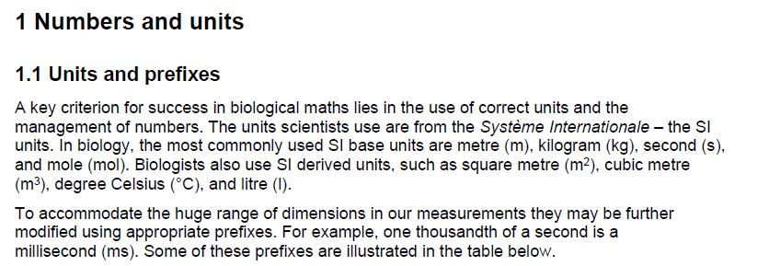
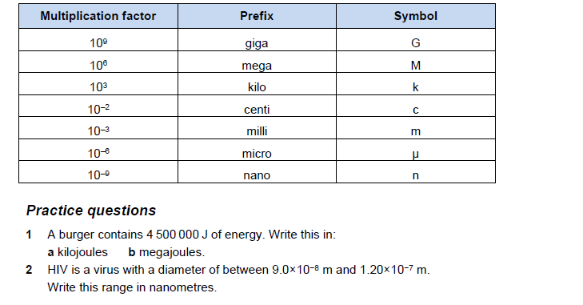
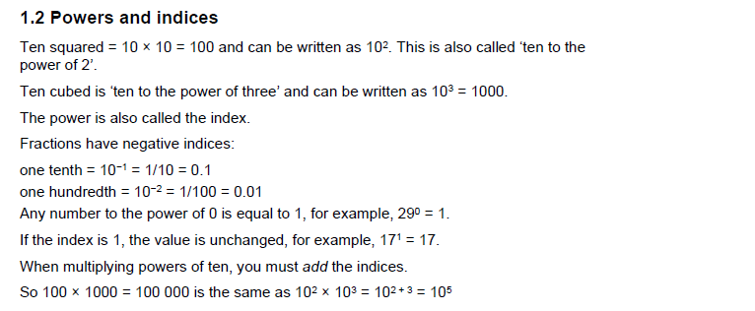
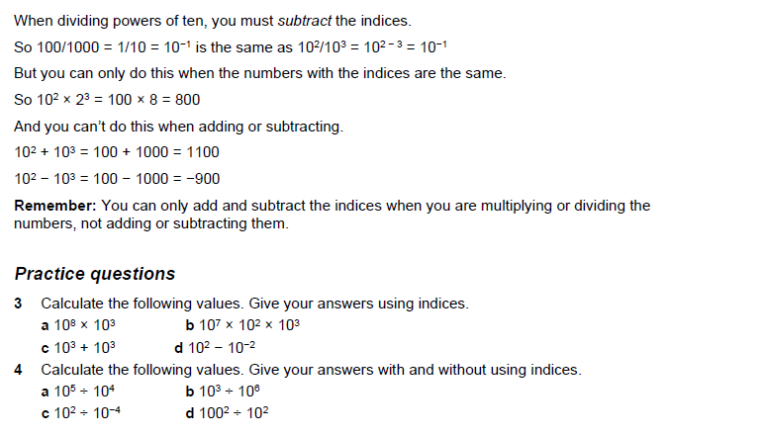
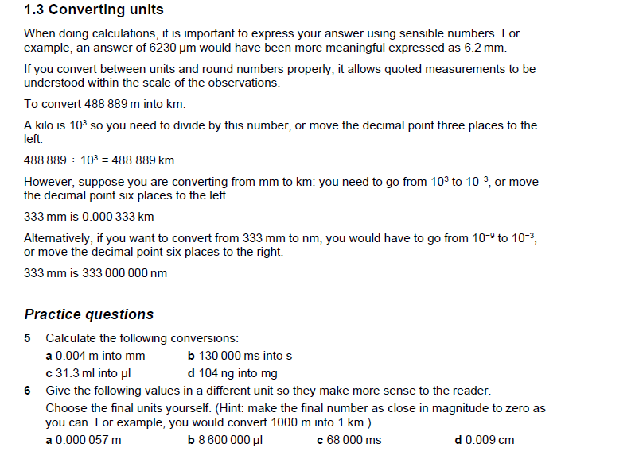
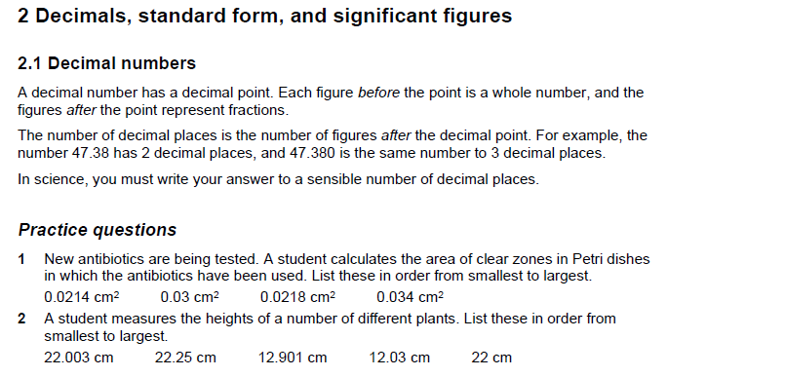
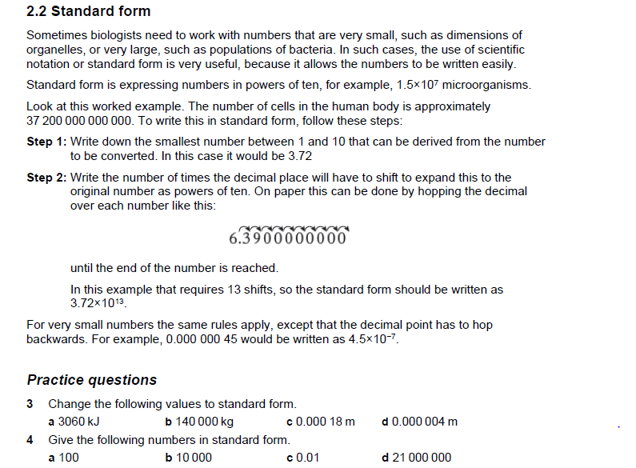
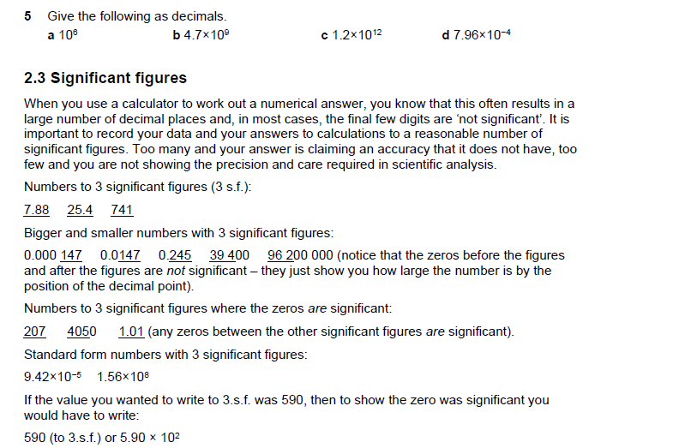
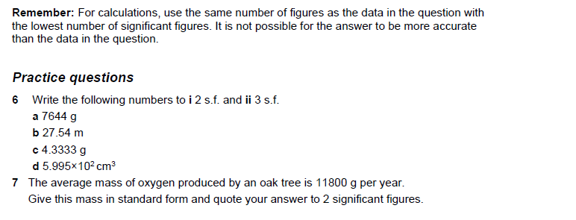
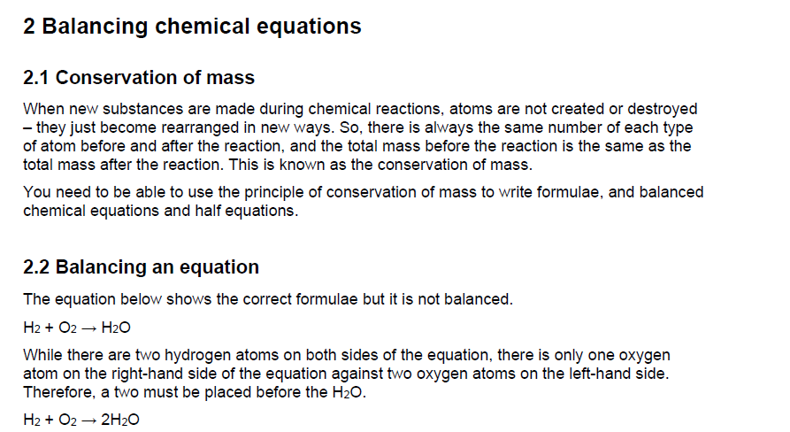
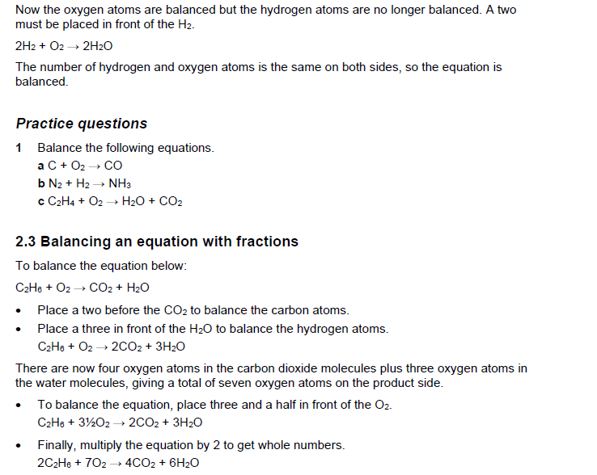
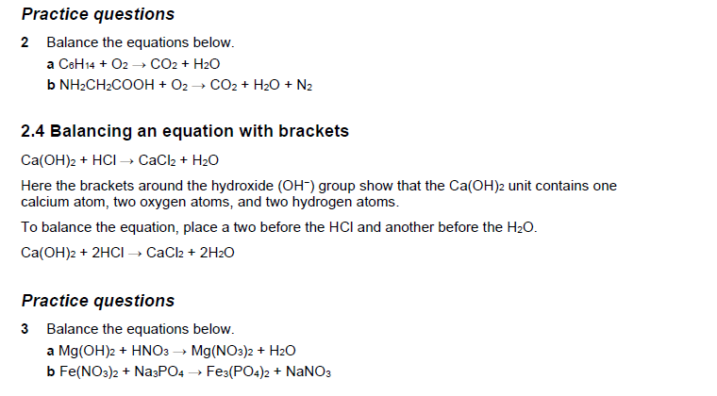
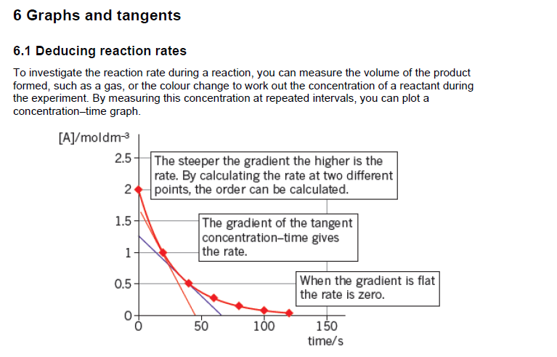
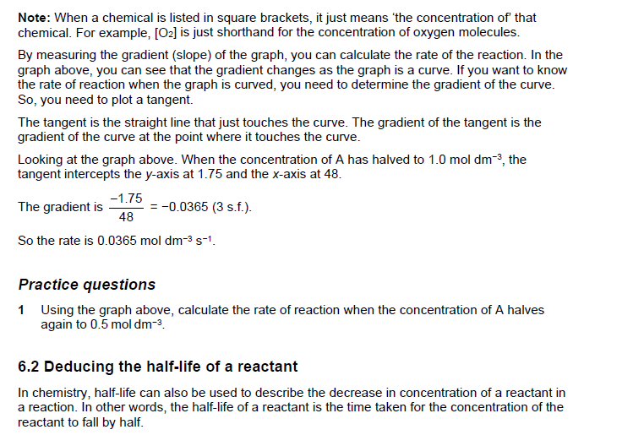
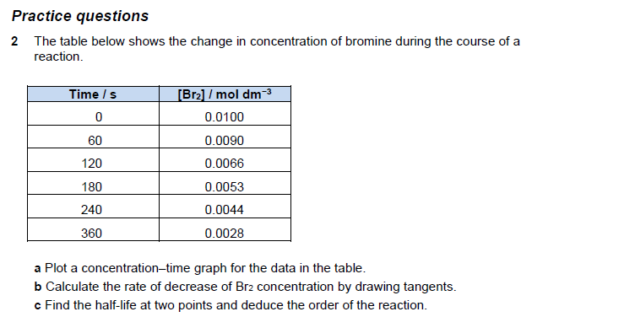
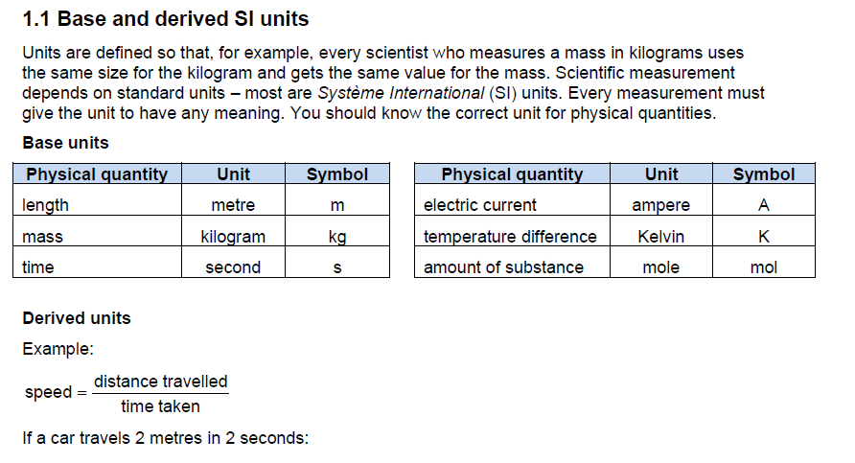
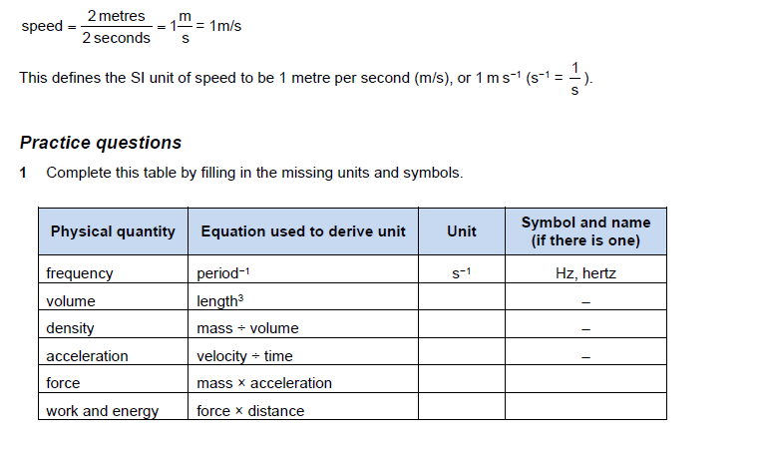
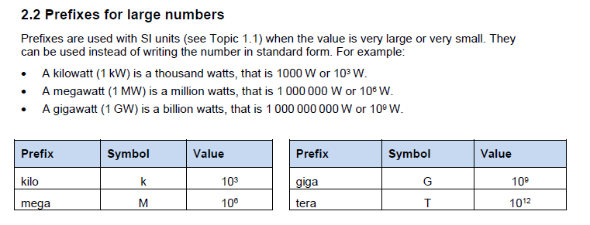
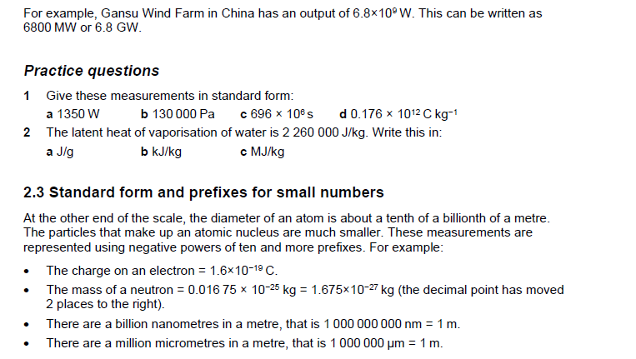
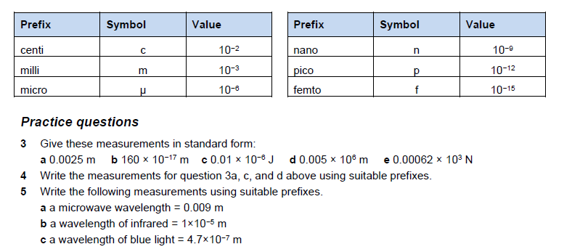

Comprehension Applied Science task

Read the information from this article and then prepare written responses in full sentences to the questions on the next page.

Cancer: Out of Control Cells
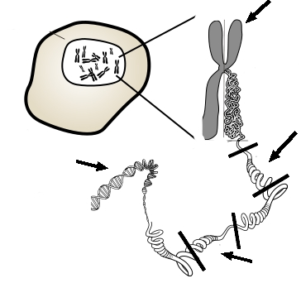
Cells do not live forever, and they will reach a point where they will divide through mitosis, or die through a process called apoptosis. Cancer cells are the exception, these cells do not die and divide uncontrollably as they crowd out healthy, productive cells. Cancer can have many causes, but most are thought to be related to carcinogens in the environment. Carcinogens are chemicals that can damage DNA and interfere with a cell's normal cycle, thus disrupting the cells ability to control when and how often it divides.
While most cells do not live forever, cancer cells do continue to divide as long as they are provided with nutrients. Research has been conducted for many years on an immortal line of cells called HeLa cells, named after Henrietta Lacks, who was a female with cervical cancer. All HeLa cells are derived from the original sample taken from her when she was a patient in 1951; Henrietta Lacks died that same year.

How Cancer Works
Cancerous transformation results from changes of the DNA and the genes that control the cell cycle. Two types of genes normally control the cell cycle: proto-oncogenes, which start cell division and tumour-suppressor genes which turn off cell division. These two genes work together, one turning on cell division when the body needs to repair or replace tissue, and the other turning off cell division when the repairs have been made. If the proto-oncogenes become mutated, they can become oncogenes, genes that lead to uncontrolled cell division. Mutations in the tumour-suppressor genes result in the cell not having the ability to turn off cell division. Oncology is a branch of medicine that deals specifically with cancer.

Cancer Cells
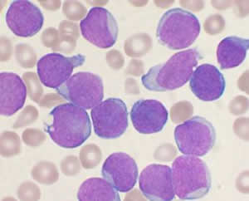
When a cell becomes cancerous, it develops traits that normal cells do not have. For instance, a cancer cell can have unusual number of chromosomes due to incomplete mitosis or cytokinesis. Cancer cells may be abnormally shaped or larger than normal cells. Cancer cells also can lose their attachment to nearby tissue and travel to other parts of the body, where they continue dividing and causing problems at other locations. Secondary growths of cancer at a distance from the primary site are referred to as metastasis. Once a cancer has metastasized, aggressive therapies may be needed to treat the disease. Cancer cells take essential nutrients from the blood to grow and divide and crowd out other cells that have important jobs. In the case of leukaemia, white blood cells grow uncontrollably and crowd out the red blood cells, thus reducing an individual's ability to deliver nutrients to the body and affecting the blood's ability to clot and repair wounds.

Questions for Applied Science comprehension task:
1. Compare the role of tumour suppressor genes to proto-oncogenes.
2. What are HeLa cells and why are they important?
3. What is the relationship between carcinogens and mutations? How does this in turn affect the development of cancer?
4. Identify the parts on the picture at the top of the article. [ DNA, Chromosome, Tumour Suppressor, Proto-Oncogene, Cell ]
5. In 1951, cells were taken from Henrietta Lacks and used for many years in research. Henrietta did not give permission for her cells to be used, the law did not require that. These cells have been used in over 60,000 research projects, but Henrietta's family has not received any compensation for contribution to the research. Do you think the law should be changed? Should people be compensated for donating their cells to science?

