Year 11-12 Transition Pack:
A Level
Physics

Introduction
A Level Physics is the study of how the universe works. You learn about matter, radiation, forces and mechanics and see how the laws of Physics work to produce the world around us. You will look at theories about the origin and fate of the universe and delve into the interactions of subatomic particles. Physics is both a challenging and rewarding subject. No other subject explores our universe at a more fundamental level or considers such a breadth of scale from the parts of the atom to the structure of the galaxies. It is an extremely well-respected A-Level qualification, which allows progression into a very diverse range of career paths.
A qualification in A-level Physics provides excellent preparation not only for a wide range of scientific, medical and engineering careers, but anywhere in which a logical and thorough approach is valued, such as the financial sector.

Entry requirements:
Grade 6/6 in Trilogy or Grade 6 in GCSE Physics
Grade 6 in GCSE Maths
You must study Maths at A-Level

If you have any additional questions, please email Mrs Mandair – d.mandair@georgesalter.com
Course Overview
Over the two years, you will cover all areas of the Physics AQA specification:
Units studied in year 12 | Units studied in year 13
Measurements & their errors | Further mechanics & thermal physics
Particles & radiation | Fields & their consequences
Waves | Nuclear physics
Mechanics & materials | Astrophysics
Electricity

Throughout the A-Level, there will be a large emphasis on gaining practical skills, to link theory with practice and to deepen students’ knowledge and understanding. Over the two years, you will have to complete a minimum of 12 required practicals in order to pass the course. These practical skills will also be assessed in the written papers, they will make up at least 15% of the marks. The A-Level is assessed through three exam papers. Overall, at least 40% of the marks in assessments for physics will require the use of mathematical skills. These skills will be applied in the context of physics.

Good subject combinations:
A-level Physics combines well with Maths, Chemistry and Accounting

Assessment:
You will be examined at the end of the 2 years:
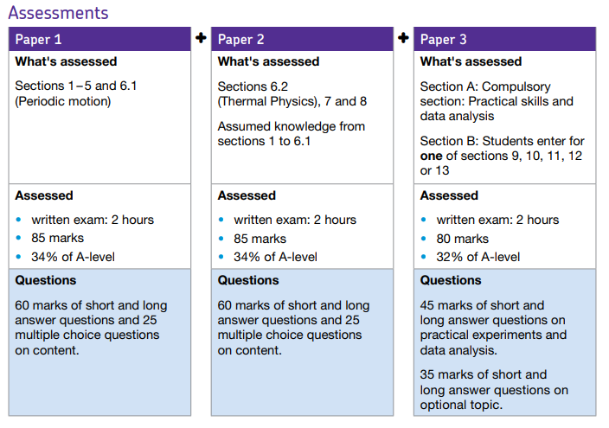
Reading & websites that may interest you:
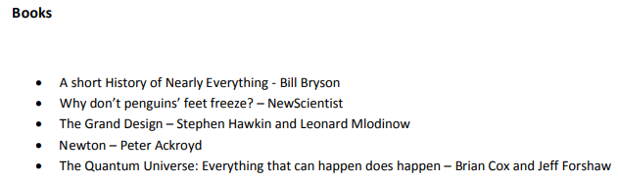
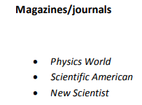
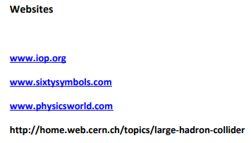

Textbooks
(Please do not buy any of these. Many pages of these can be read on Google Books for free or within your library).

Summer Activity- Due in your first lesson in September
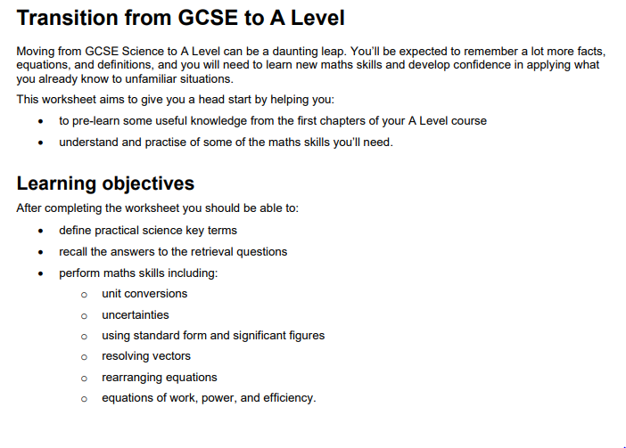
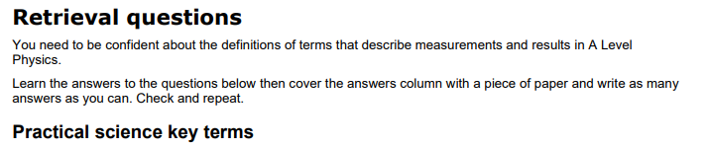
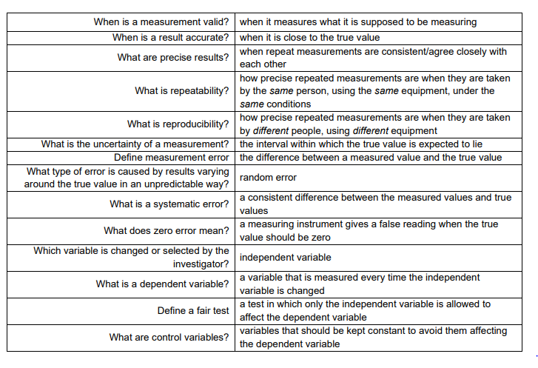
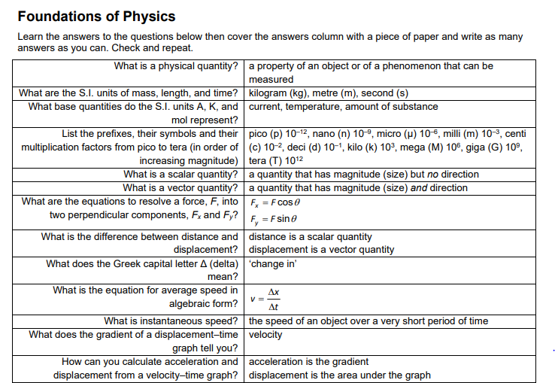
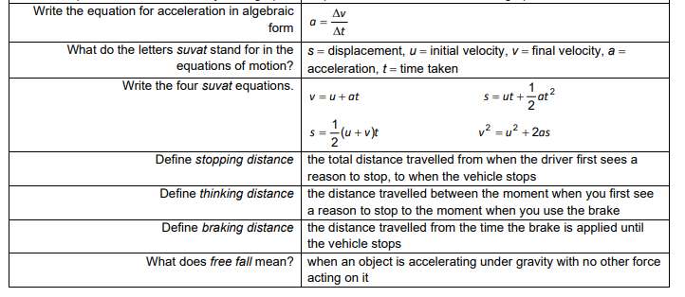
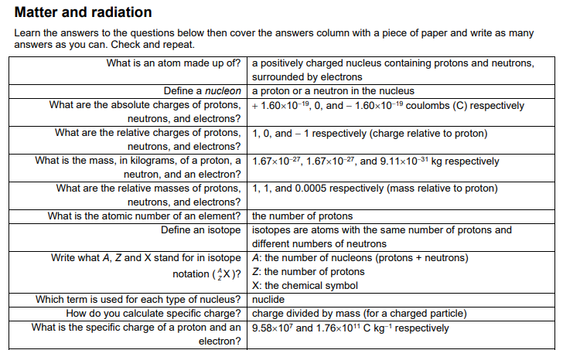
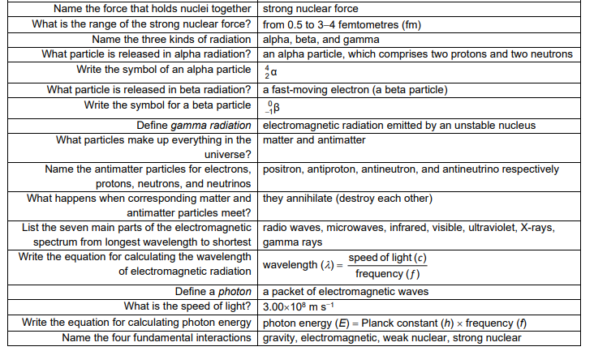
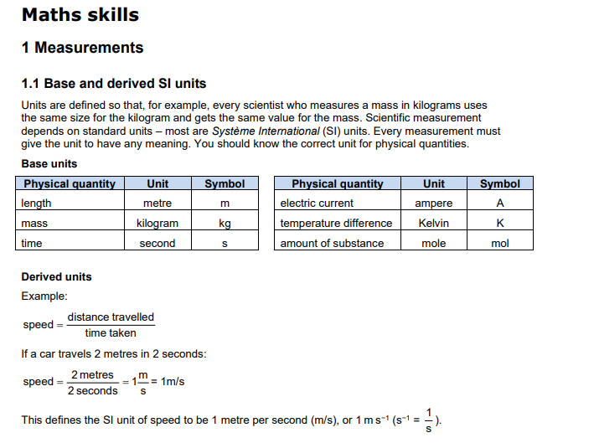
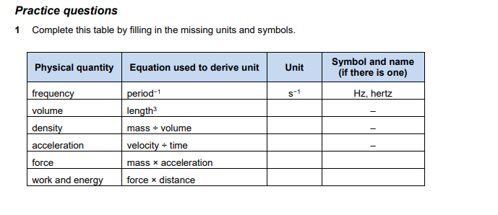
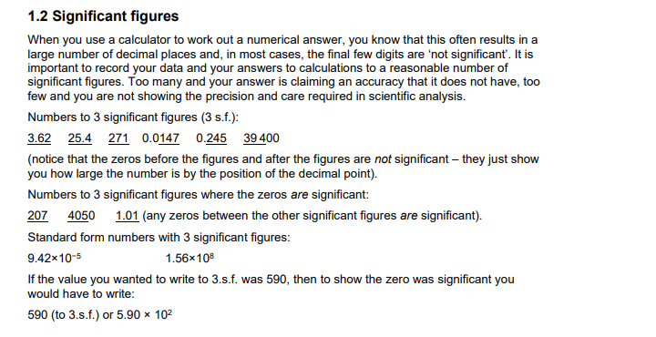
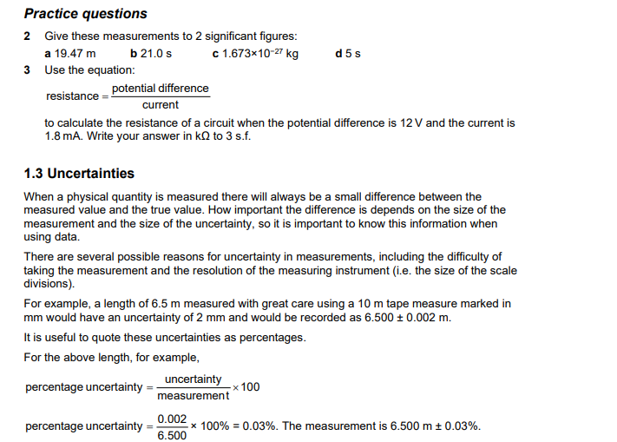
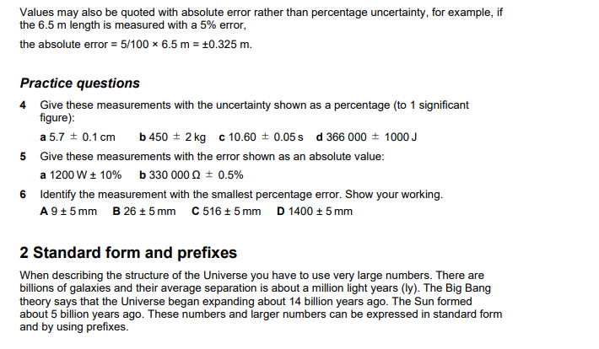
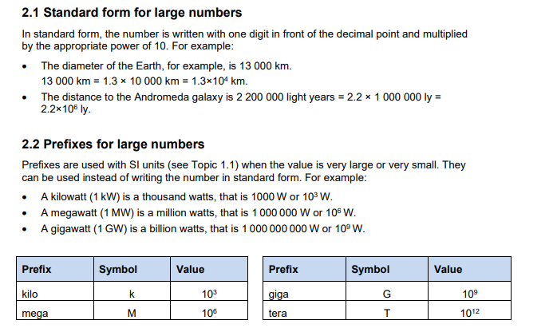
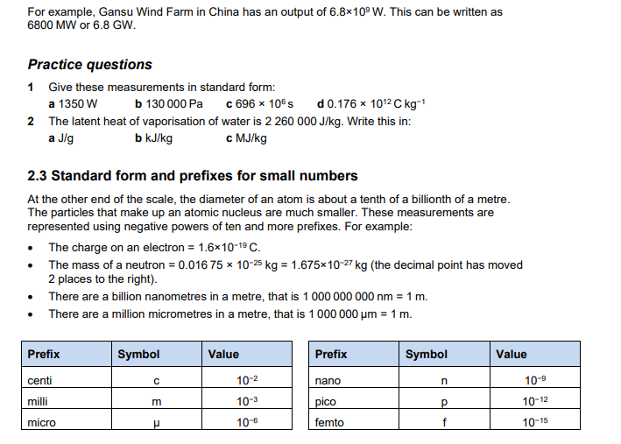
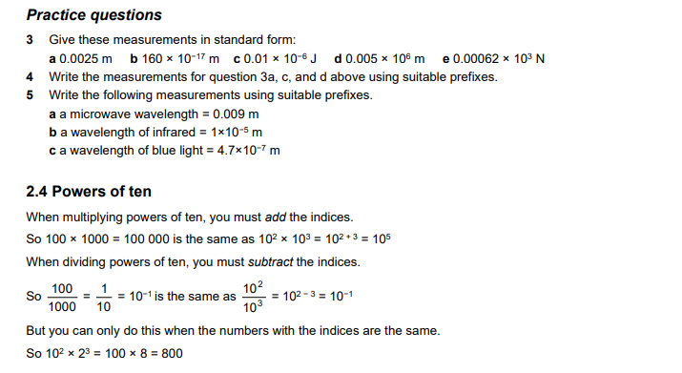
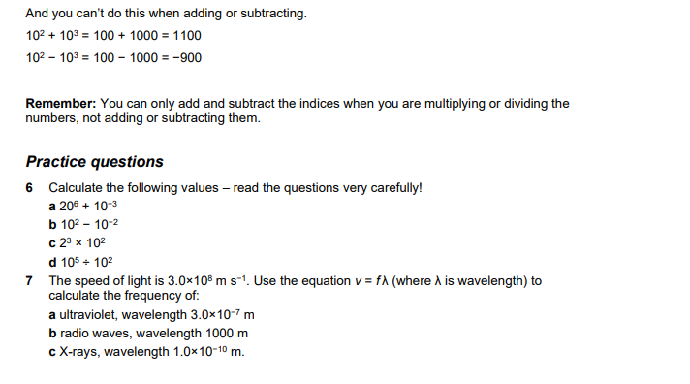
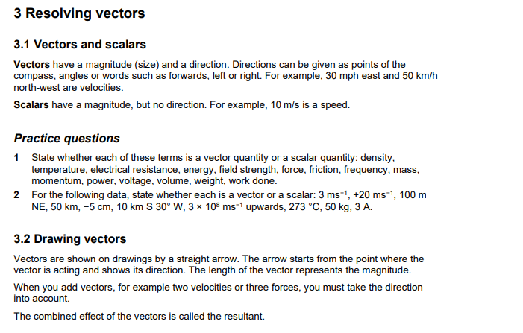
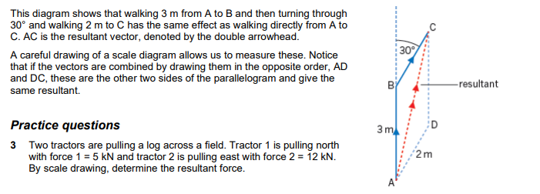
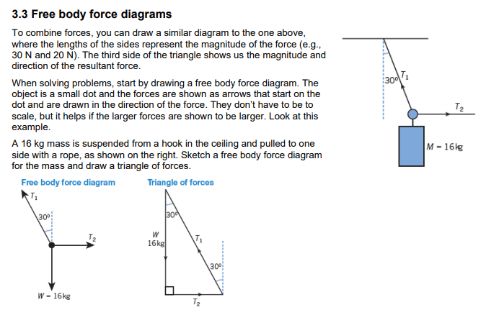
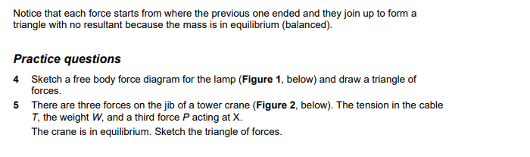
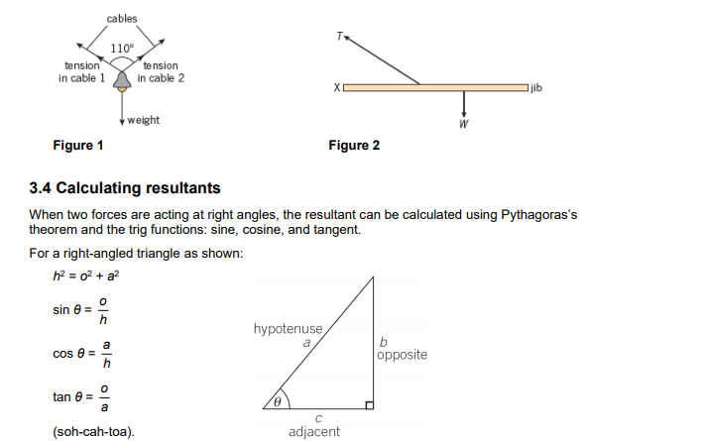
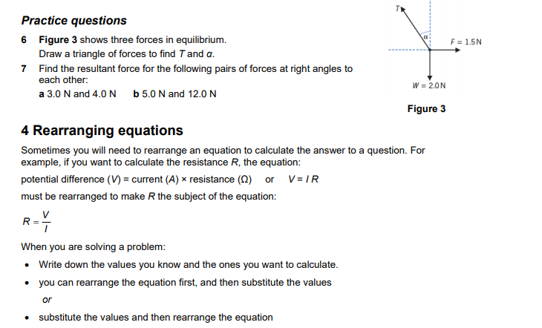
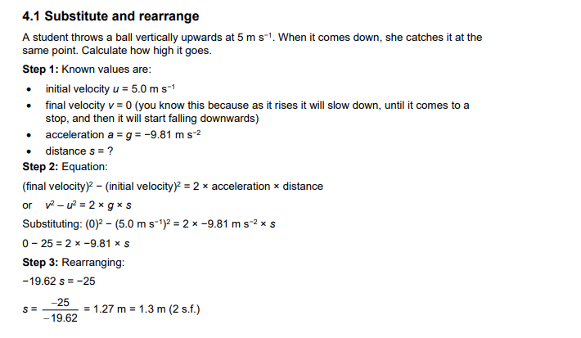
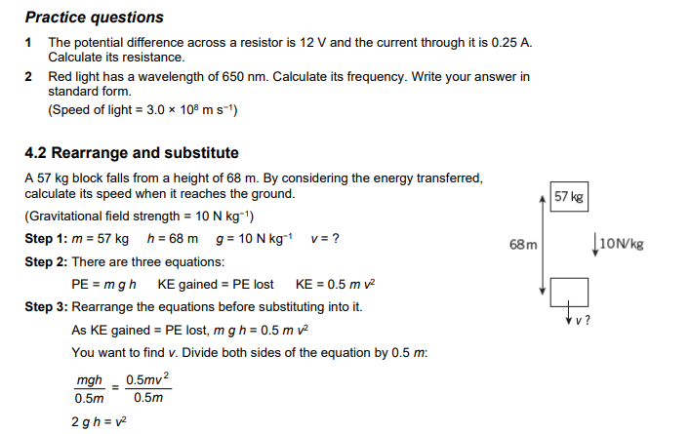
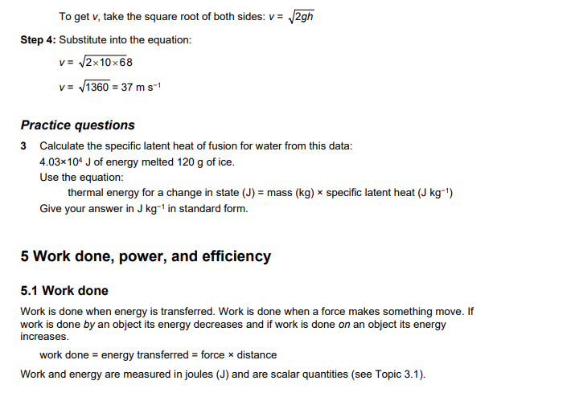
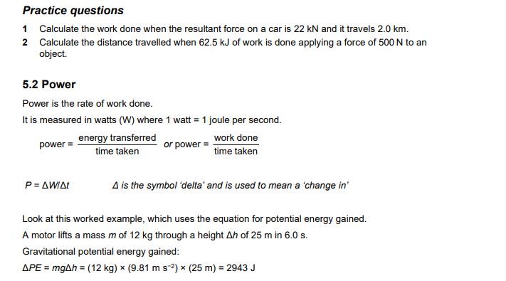
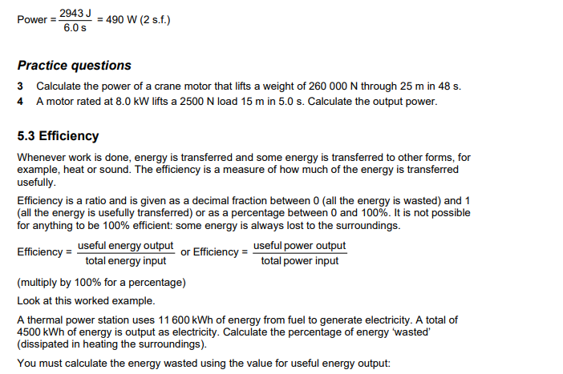
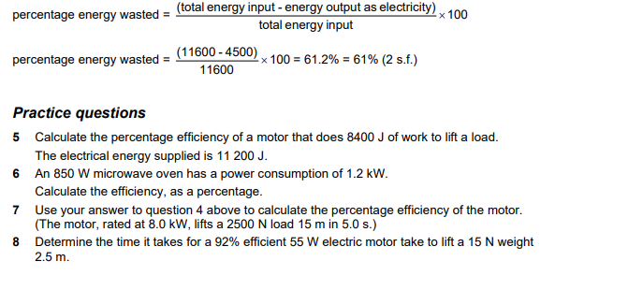
--------------------------------------------------------------------------------------------------------------
Comprehension Physics Task
Read the article below and then prepare written responses to the questions:

Satellites are Objects in Space that Orbit Planets
There are natural satellites, like the moon, and man-made satellites that humans launch into space, like the ones that provide television and telephone service.
In the 1950s, both the United States and the Soviet Union decided to try rocketing objects into space that could be used as spy monitoring devices or maybe as weapons. The very first satellite propelled into space by humans was the Russian-made Sputnik 1, launched in 1957. Today there are thousands of satellites circling Earth.
"We are taught, 'What goes up must come down,' but a satellite doesn't. How does that work?," asked Geza Gyuk, director of the Adler Planetarium in Chicago.
Satellites reach space because they are propelled by rockets that reach speeds of almost 20 thousand miles per hour. Once in space, Gyuk said, "It is constantly 'falling' to the Earth, but it moves sideways so quickly that the Earth curves away beneath it faster than it can fall. Thus it remains in orbit, never hitting the ground."
Satellites that circle the Earth are called geocentric. Satellites that circle the sun are called heliocentric; those that circle the galaxy are called galactocentric and those circling Mars are called areocentric.
Satellites are put into space for a number of different purposes.
"Most satellites derive their usefulness from their position," Gyuk said. "For example, a weather satellite up in geosynchronous orbit, 22,200 miles above Earth, can see about 40 percent of the Earth's surface at once. So a set of only a few satellites can track storms across the entire world or provide communications over many thousands of miles."
Gyuk explained that GPS satellites are used to aid in navigation on Earth.
"Low orbiting satellites sweep around the world every 90 minutes, and in the right orbit can fly over the whole Earth and take pictures every few days. If one wants to monitor how healthy crops are, track forest fires, or of course spy on enemies, a group of satellites like that can be very helpful."
How are satellites powered once they are launched into space? "Most satellites use solar power to produce electricity. A few use nuclear power," Gyuk said.
What if something goes wrong with a satellite?
Gyuk said, "A satellite is very hard to fix if something goes wrong. A few have been fixed in space like the Hubble Space Telescope, and a few have been returned to Earth in the Shuttle cargo bay. Most have lots of redundant parts. If one fails then another can take up the load. Satellites are designed to have as few as possible moving parts. Anything that moves is more likely to break."

QUESTIONS to answer after reading the article:
1. What is a naturally occurring satellite?
2. Which country launched the first satellite into space?
3. What does “geocentric” mean?
4. What are satellites used for?
5. Why does a satellite not fall back down to earth?
6. What powers orbiting satellites?
7. What satellite was repaired in space?

---------------------------------------------------------------------------------------------------------------
EXTENSION WORK:
Advanced Data Handing
- Watch the following videos on ‘The Scientific Method’
https://www.youtube.com/watch?v=UdQreBq6MOY
https://www.youtube.com/watch?v=N6IAzlugWw0&t=137s
Task 1 - Describe what the scientific method is, why it has been developed, and what the core principles are. (Max. 100 words)
Advanced Data Handling: ‘Big Data’
- Watch the following videos on ‘big data’ and critical thinking, and read the web page:
https://www.youtube.com/watch?v=5Zg-C8AAIGg
https://www.youtube.com/watch?v=dItUGF8GdTw
https://www.visionlearning.com/en/library/Process-of-Science/49/Data-Analysis-and-Interpretation/154
Task 2 - What can we learn about interpreting data from the themes discussed in the videos? (Max. 300 words)
Task 3 - What do you need to consider before interpreting data? (Max 50 words)

