Year 11-12 Transition Pack:
A Level
Chemistry

Introduction
Chemistry is a challenging and stimulating subject. It has played a major role in improving living standards and is one of the most successful industries in the UK. This course is about connecting the everyday world to the molecular world. Students will develop an understanding of the fundamental properties of matter and of the chemical reactions that form the building blocks of modern medicine and material science.
An A Level in Chemistry can lead to a career in medicine, engineering, nanotechnology, teaching, accountancy, laboratory research, patenting, law, academic research, economics, business and many others. In most cases, Chemistry is an essential subject for Medicine, Dentistry, Veterinary Science and some Biological Sciences.
Entry requirements:
Grades 6/6 in AQA Science Trilogy or grade 6 in GCSE Chemistry
Grade 5 in GCSE English and Maths

If you have any additional questions, please email Mrs Mandair – d.mandair@georgesalter.com
Course Overview
Over the two years, you will cover all 3 areas of the Chemistry AQA specification:
Units studied
Physical Chemistry
Inorganic Chemistry
Organic Chemistry

Throughout the A-Level, there will be a large emphasis on gaining practical skills, to link theory with practice and to deepen students’ knowledge and understanding. Over the two years, you will have to complete a minimum of 12 required practicals in order to pass the course. These practical skills will also be assessed in the written papers, they will make up at least 15% of the marks. The A-Level is assessed through three exam papers. Overall, at least 20% of the marks in assessments for chemistry will require the use of mathematical skills. These skills will be applied in the context of chemistry and will be at least the standard of higher tier GCSE mathematics.

Good subject combinations
A level Chemistry combines well with Physics, Biology, Maths, Psychology and Geography

Assessment:
You will be examined at the end of the 2 years:
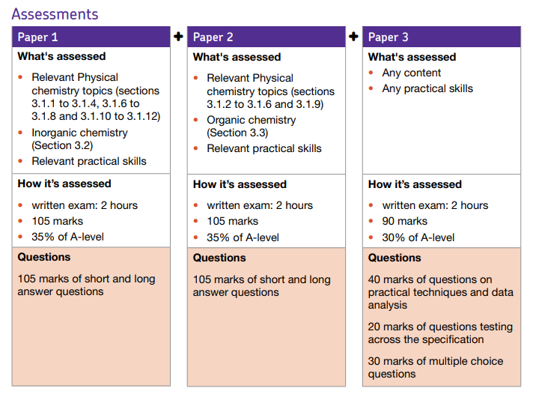
Reading you could do & useful websites:
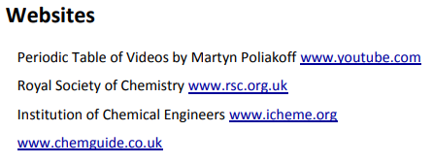
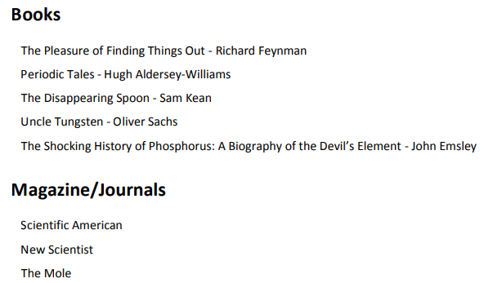

Textbooks
(Please do not buy any of these. Many pages of these can be read on Google Books for free or within your library).

Summer Activity- Due in your first lesson in September
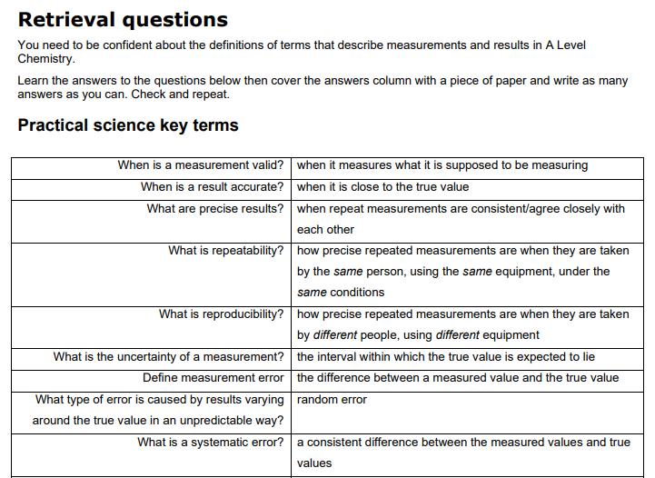
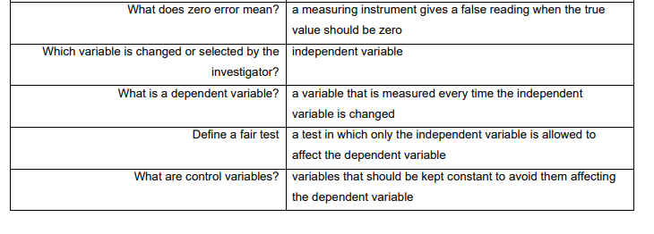
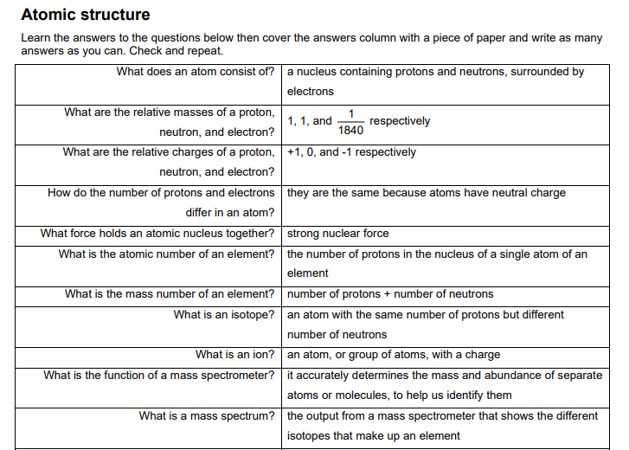
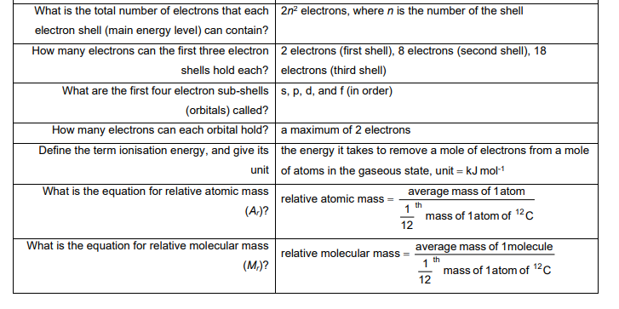
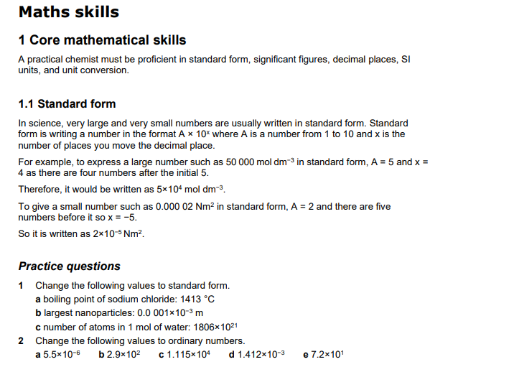
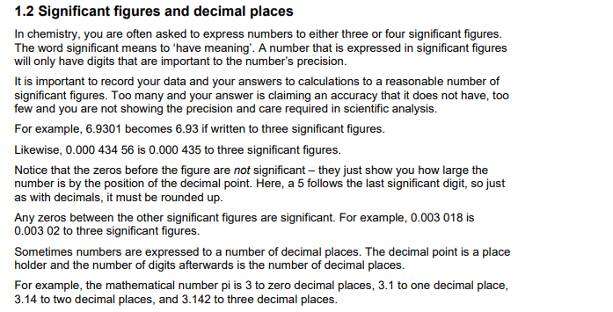
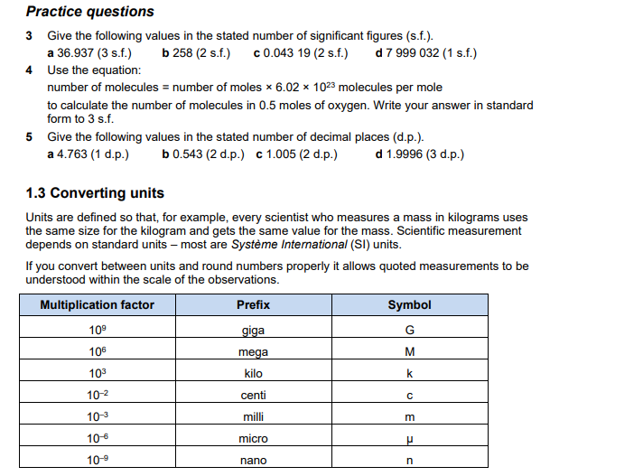
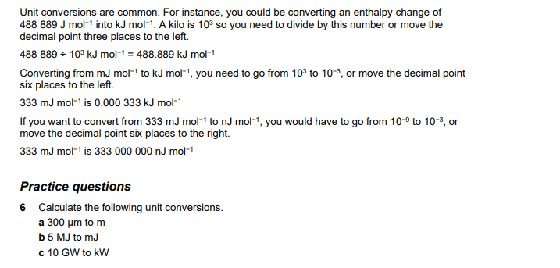
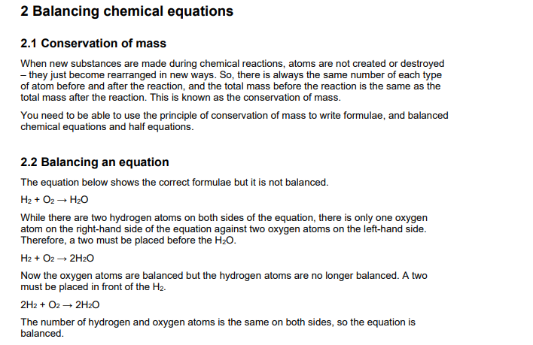
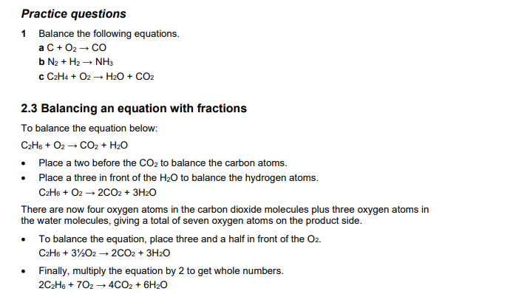
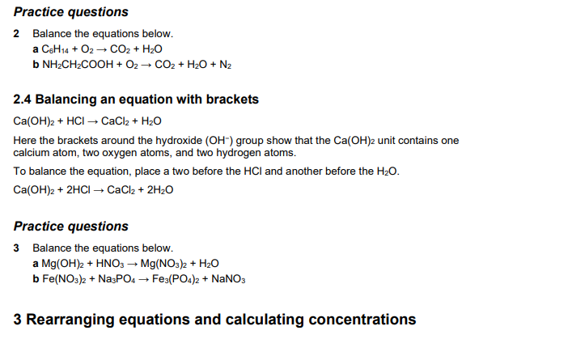
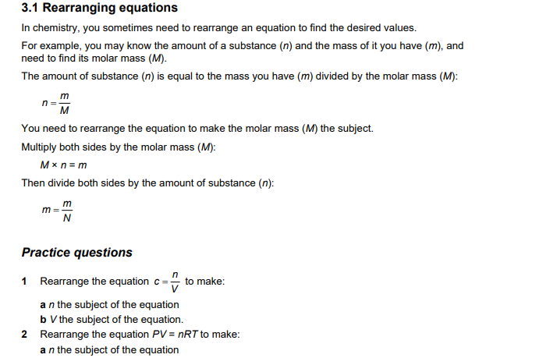
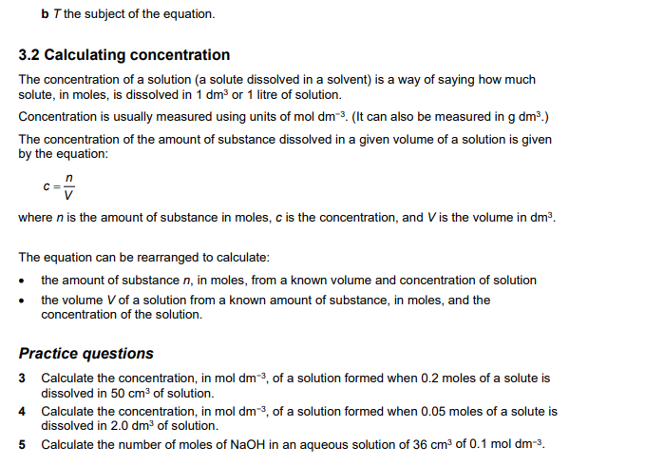
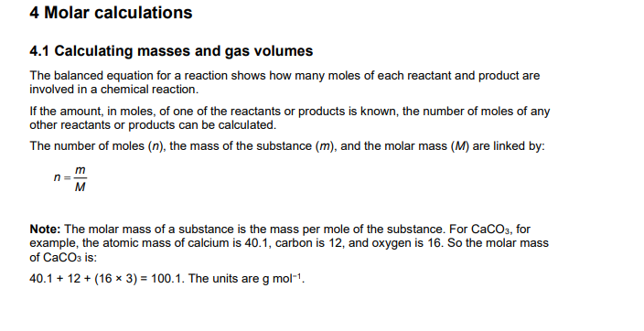
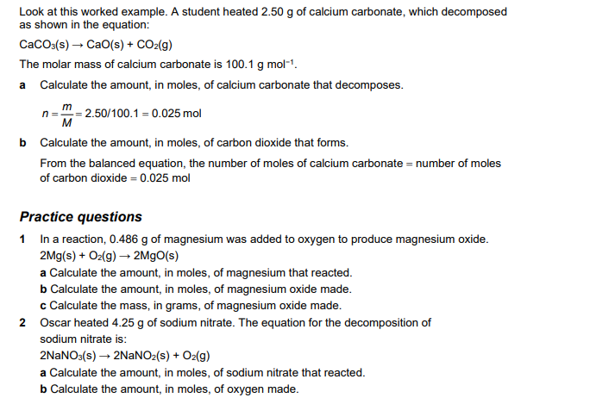
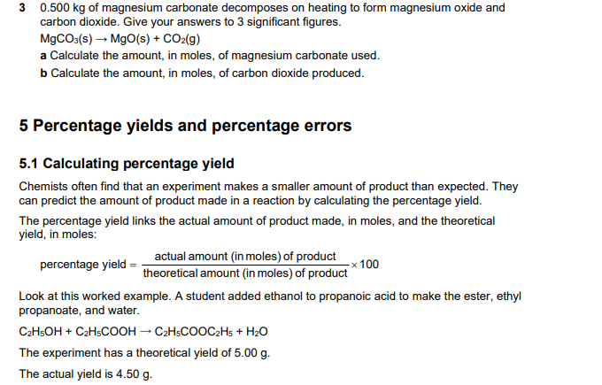
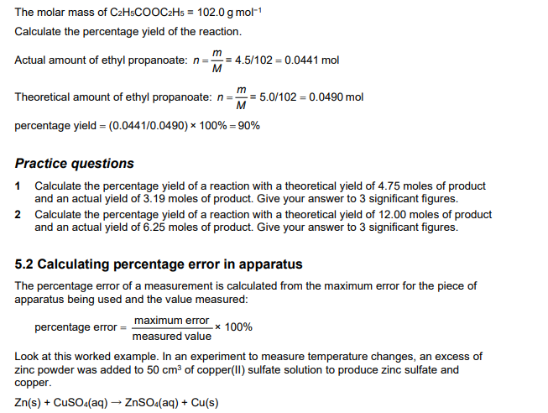
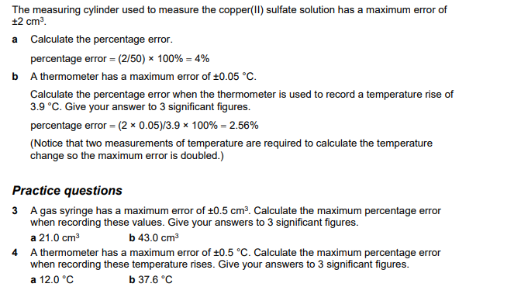
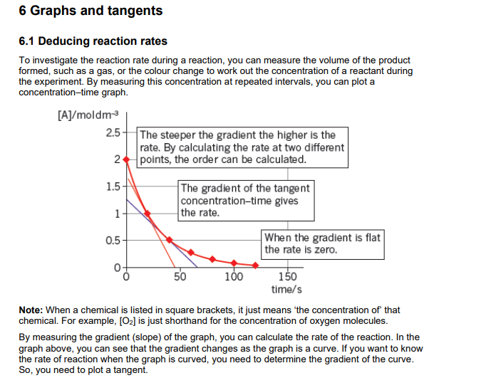
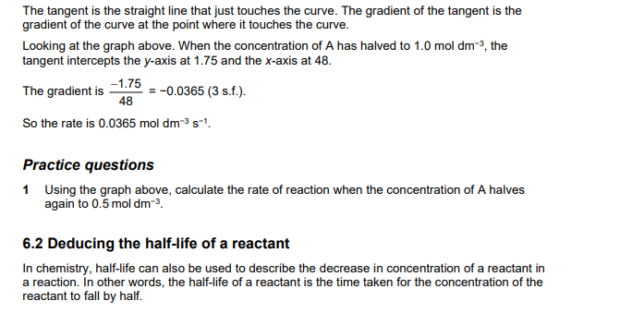
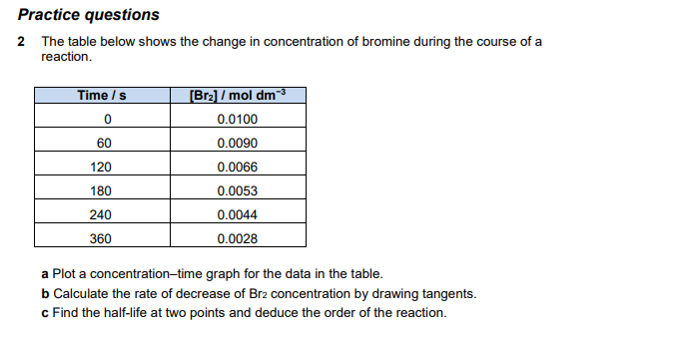

Comprehension Chemistry task
Read this article and then answer the questions using this article to help

How Wood Alcohol Poisonings Advanced Toxicology
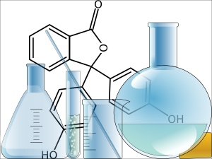
In the days before Prohibition, New York was trying to update it's coroner's office by improving laboratory practices and using science to determine the cause of death and solve crimes. Up until 1917, the coroner was an elected official, and one who had no science or medical background. Murders of all kinds were written off as suicides, or "acts of God." Poisons had become a popular way to rid oneself of a rival or family member because it was unlikely that its effects would be detected.
In 1918, Charles Norris was appointed as the Chief Medical Examiner and was a pioneer in forensic toxicology. He, in turn, hired a chemist named Alexander Gettler who was given the task of developing methods to determine if poisons were the cause of death. Gettler spent time grinding up livers and testing a variety of substances. In the years leading up to the Prohibition, Gettler noted a rise in the number of deaths attributed to wood alcohol poisoning.
------- Excerpt from the Poisoner's Handbook -------
Wood alcohol -- technically known as methyl alcohol, but also as wood spirit, hydroxymethane, carbino, colonial spirit, Columbian spirit, and, some years later, methanol -- was in itself nothing new. The ancient Egyptians had used it in their embalming processes. For centuries it had been the essential ingrediant in homemade whiskey. Its chemical formula had been identified in 1661 by a chemist who called it "spirit of box" because he'd made it by distilling boxwood. The term, methyl was derived from the Greek methy (meaning wine) and hyle (meaning wood, or more precisely, path of trees).
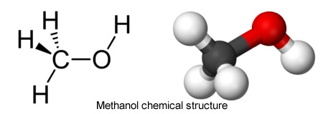
The chemical structure of wood alcohol is simple: three hydrogen atoms bonded to a single carbon atom (in a cluster known as a methyl group), with one oxygen atom and another hydrogen atom tagging along. It is also simple to make, as industrialists and moonshiners had realized, requiring little more than wood and heat. The process was called destructive distillation. Slabs and slices of wood went into a closed container and were heated to at least 400 degrees Fahrenheit (204 degrees Celsius). As the wood cooked into charcoal, its natural liquids vaporized. The vapor could be cooled, condensed, and distilled into a rather murky soup containing methyl alcohol, acetone, and acetic acid. A second distilling would separate out the pure methyl alcohol, a liquid as clear as glass and as odourless as ice, from the other ingredients.
-------------------------------------------------------------------------
"Industrial" alcohol was basically grain alcohol (ethanol) with other chemicals mixed in to make it undrinkable, methanol was one of the common additives. The adding of these chemicals was required by law after Prohibition to prevent industrial alcohol from being used as a beverage. Basically, the government ordered the alcohol to be laced with chemicals that would make it undrinkable. As a result, there were many bootleggers who attempted to make industrial alcohol drinkable and less toxic by redistilling, diluting or mixing it with other chemicals. None of these procedures was particularly effective, and people who chose to drink alcohol illegally would be risking their lives.
Why is methyl alcohol so dangerous when other alcoholic beverages are not? Liquors usually contain about 3% ethanol which is often produced from fermenting grains, fruits, and vegetables. In a way to replace now banned liquors during the era of Prohibition, people turned to questionable distillation methods and drinks that were a mixture of ethanol and methanol. Even small quantities of methanol can be fatal, but the risk did not deter some people.
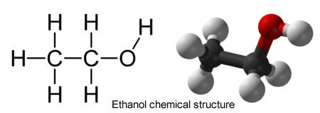
Methanol is toxic when ingested, inhaled or even absorbed in the skin. Methanol , when ingested, breaks down into even more toxic substances, a process called toxification. Enzymes in the liver first convert methanol to formaldehyde which is then converted to formic acid. This process takes up to 30 hours from the initial exposure to methanol, and means that you might not die initially from its consumption, but may experience symptoms a day later. Usually the first sign of methanol poisoning is loss of vision. If the person recovers from the toxins, the blindness is permanent as formic acid actually damages the optic nerve.
As Gettler had predicted, the number of cases of poisoning increased. In 1926, in New York City alone, 1200 became sick by poisonous alcohol and 400 died. Bootlegging of alcohol, much of which contained methanol continued, poisonings became a public health issue. Gettler continued to work these cases, publicizing deaths by alcohol to raise awareness of the problem. In 1933, the 18th amendment was repealed and the program that required industrial alcohol to be made toxic was also ceased.

Questions to answer for the Comprehension Chemistry task:
1. According to the article, which of the following is true?
a) children were most likely to suffer from methanol poisoning b) the Prohibition legalized the use of methyl alcohol
c) the structure of methanol and ethanol is identical d) methyl alcohol is toxic and can cause blindness

2. Select the sentence the supports the central idea of the article.
a) Poisons had become a popular way to rid oneself of a rival or family member because it was unlikely that its effects would be detected.
b) In the years leading up to the Prohibition, Gettler noted a rise in the number of deaths attributed to wood alcohol poisoning.
c) In 1918, Charles Norris was appointed as the Chief Medical Examiner and was a pioneer in forensic toxicology.
d) Liquors usually contain about 3% ethanol which is often produced from fermenting grains, fruits, and vegetables.

3. What best describes the structure of the article? )
a) a description of how medical examination changed in the 1900s
b) a persuasive essay on why the Prohibition was not an economically sound idea
c) a comparison of methyl alcohol to ethyl alcohol and a narrative about why methanol is toxic
d) an opinion piece about what life was like during Prohibition

4. Why did it take so long for a person to die after ingesting a lethal dose of methanol?)
a) it took a while for the poison to circulate throughout the body and reach the brain
b) the poison accumulated in the tissues of the person and sometimes took years to kill them
c) only some people are sensitive to methanol
d) methanol is converted by the liver to an even more toxic substance (toxification)

5. What is the relationship between prohibition and methanol?
a) prohibition caused methanol to be made illegal
b) prohibition resulted in more methanol poisonings
c) prohibition reduced the number of alcohol related deaths
d) prohibition advanced the field of toxicology

6. Which of the following is the best definition of "toxification"?
a) a process where one substance is converted into another substance
b) a series of chemical reactions that occur within the blood
c) a process where one substance is converted into another substance that is more toxic than the first
d) a procedure where a scientist determines how potent a toxin is
7. Which of the following data supports Gettler's prediction that methanol poisonings will increase after prohibition? (Standard 8: Reasoning)
a) a comparison between the number of deaths from methanol poisoning before and after prohibition went into effect
b) a toxicology report on how quickly rats succumb to methanol poisoning
c) a listing of how much alcohol containing methanol was confiscated
d) hospital records showing how many people had been treated for alcohol related illnesses

8. There are two potential sources for a person to acquire methanol, what are they? (circle 2)
a) it can be directly distilled from burning wood
b) it can be harvested from the organs of someone who has died from methanol poisoning
c) it can be fermented using rotting fruit
d) it can be acquired from industrial alcohol that has been contaminated

10. In your own words, describe the difference between a molecule of ethanol and a molecule of methanol.

EXTENSION WORK:
Advanced Data Handing
- Watch the following videos on ‘The Scientific Method’
https://www.youtube.com/watch?v=UdQreBq6MOY
https://www.youtube.com/watch?v=N6IAzlugWw0&t=137s
Task 1 - Describe what the scientific method is, why it has been developed, and what the core principles are. (Max. 100 words)
Advanced Data Handling: ‘Big Data’
- Watch the following videos on ‘big data’ and critical thinking, and read the web page:
https://www.youtube.com/watch?v=5Zg-C8AAIGg
https://www.youtube.com/watch?v=dItUGF8GdTw
https://www.visionlearning.com/en/library/Process-of-Science/49/Data-Analysis-and-Interpretation/154
Task 2 - What can we learn about interpreting data from the themes discussed in the videos? (Max. 300 words)
Task 3 - What do you need to consider before interpreting data? (Max 50 words)

