Year 11-12 Transition Pack:
A Level
Biology

Introduction
Biology is a popular subject taken by students with a wide variety of interests. If you want to know the facts behind GMOs, human cloning and global warming, this is the subject to study. Instead of reading the hype, be informed! This course includes a significant amount of maths and biochemistry; it is a challenging and rewarding subject.
Students with an A-level in Biology have gone on to a wide variety of degree courses including Biological Sciences, Biotechnology, Genetics, Environmental Studies, Medicine, Veterinary Studies, Forensics, Equine Studies, Horticulture and Agriculture, Speech Therapy, Occupational Therapy, Radiography and Law.
Entry requirements:
Grades 6/6 in AQA Science Trilogy or grade 6 in GCSE Biology
Grade 5 in GCSE English and Maths

If you have any additional questions, please email Mrs Mandair – d.mandair@georgesalter.com
Course Overview
Over the two years, you will cover all areas of the Biology AQA specification:
Units studied in year 12 | Units studied in year 13
Biological molecules | Energy transfers
Cell biology | How organisms respond to environments
How organism exchange substances | Genetics, evolution & ecosystems
Genetics & variation | The control of gene expression

Throughout the A-Level, there will be a large emphasis on gaining practical skills, to link theory with practice and to deepen students’ knowledge and understanding. Over the two years, you will have to complete a minimum of 12 required practicals in order to pass the course. These practical skills will also be assessed in the written papers. The A-Level is assessed through three exam papers which will include short and long answer questions, comprehension questions, critical analysis and an essay. Overall, at least 10% of the marks in assessments for biology will require the use of mathematical skills. These skills will be applied in the context of biology and will be at least the standard of higher tier GCSE mathematics.

Good subject combinations
A level Biology combines well with Chemistry, Maths, Psychology and Geography

Assessment:
You will be examined at the end of the 2 years:
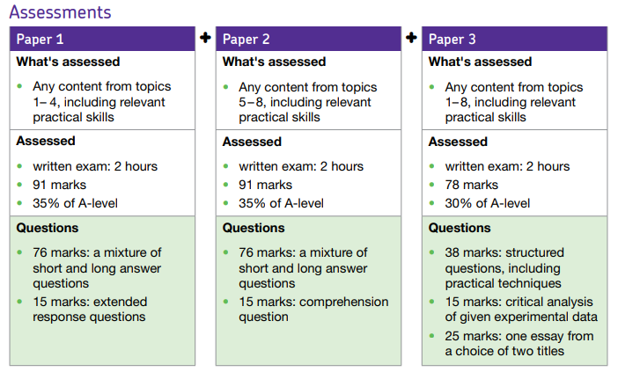
Articles to Read & interesting videos to watch:
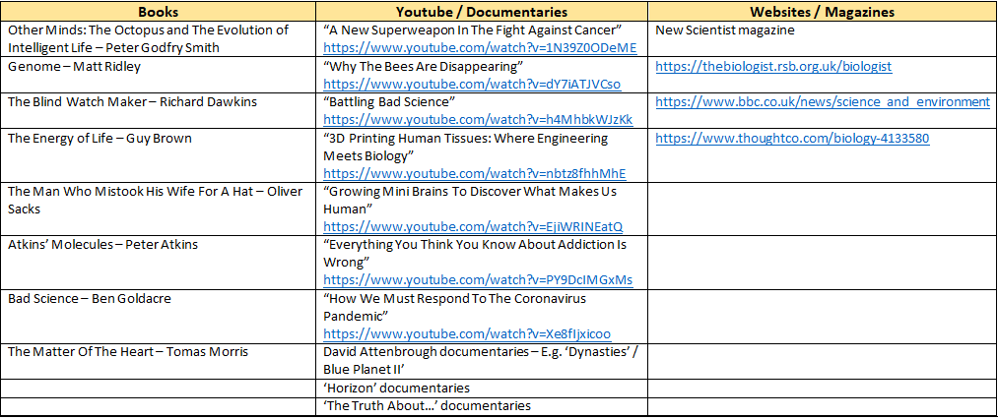
Textbooks
(Please do not buy any of these. Many pages of these can be read on Google Books for free or within your library).

Summer Activity- Due in your first lesson in September
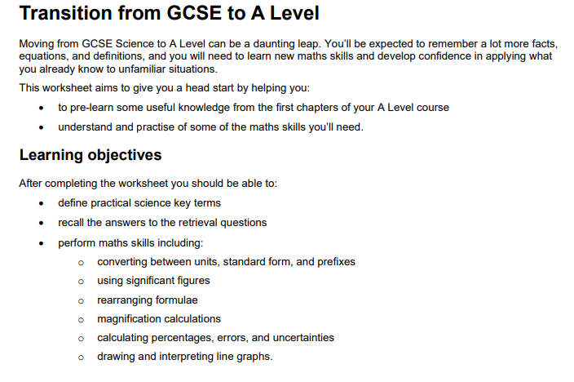
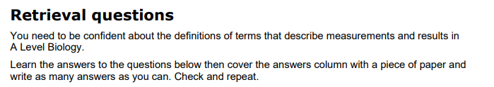
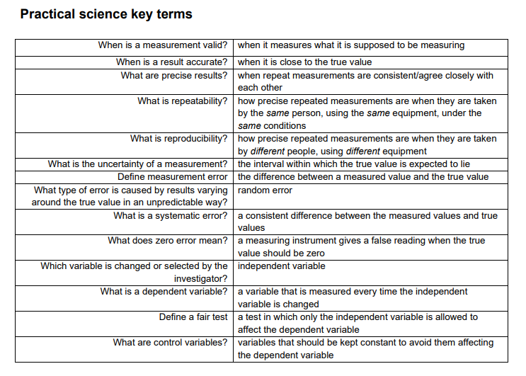
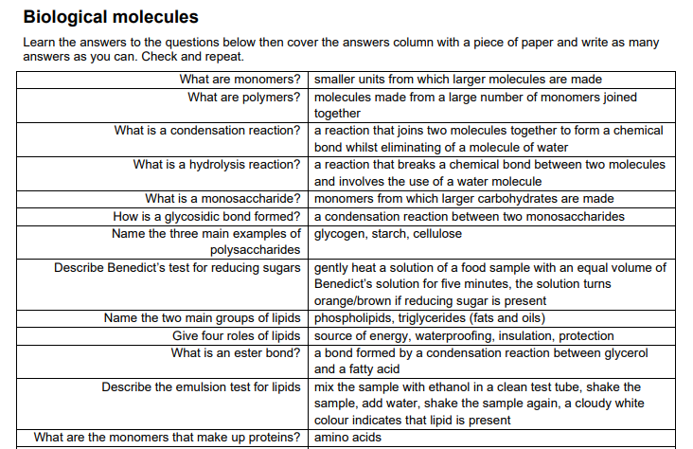
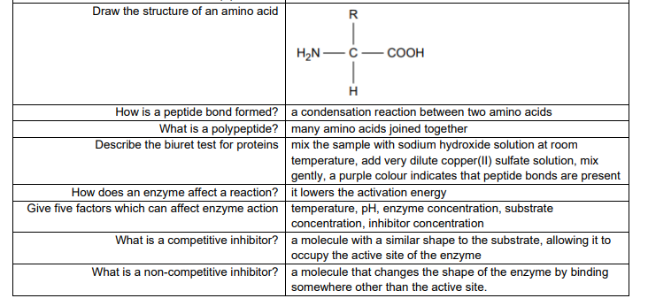
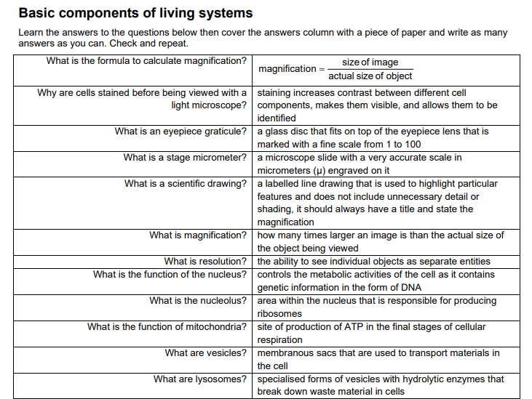
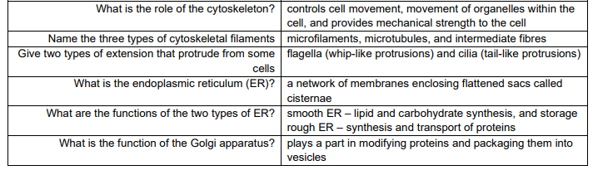
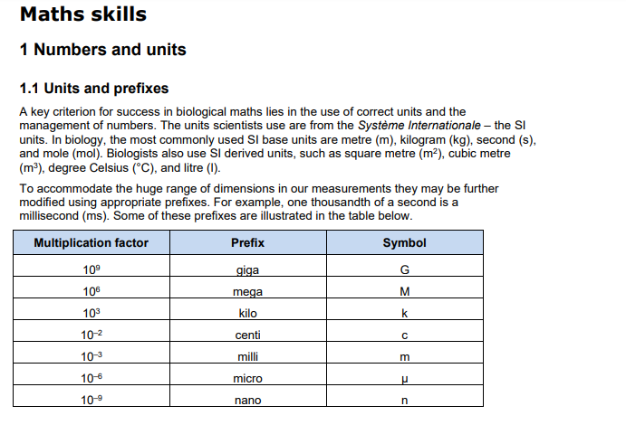
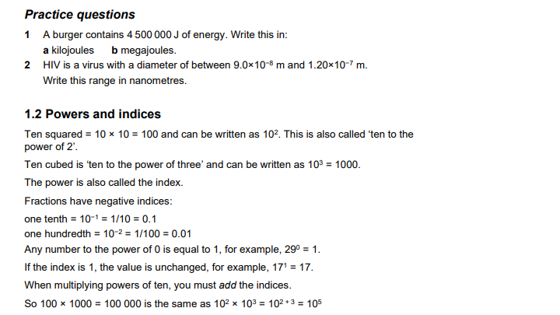
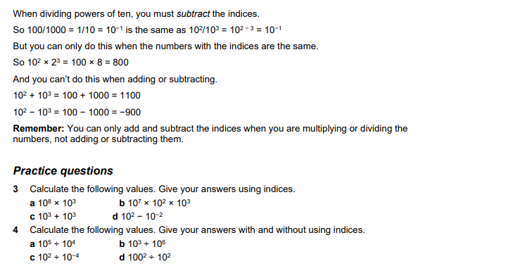
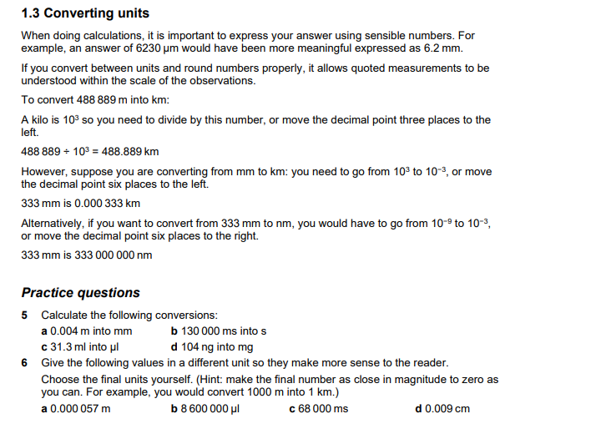
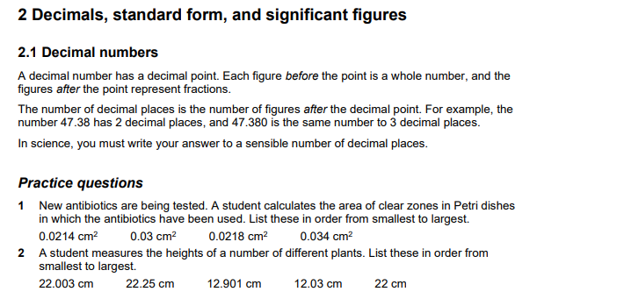
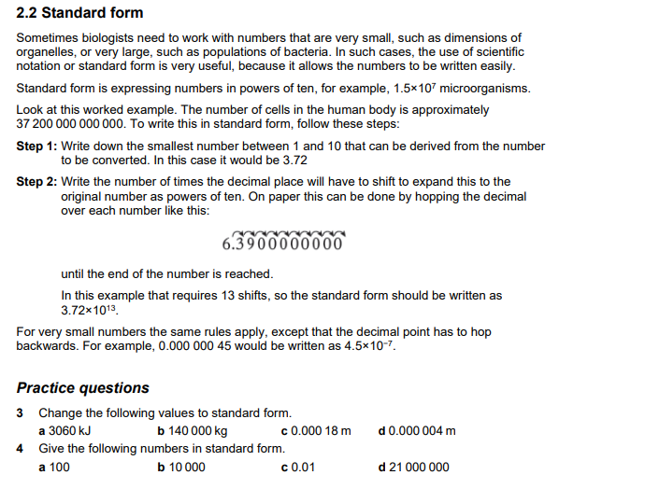
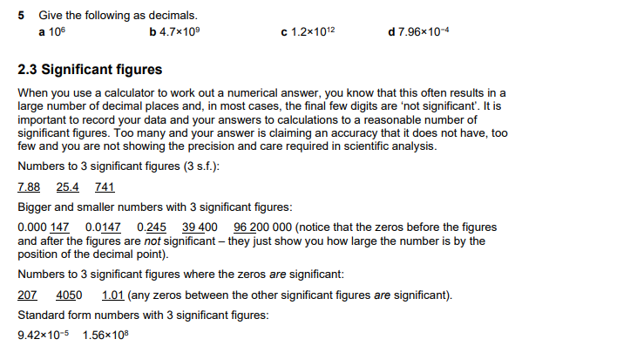
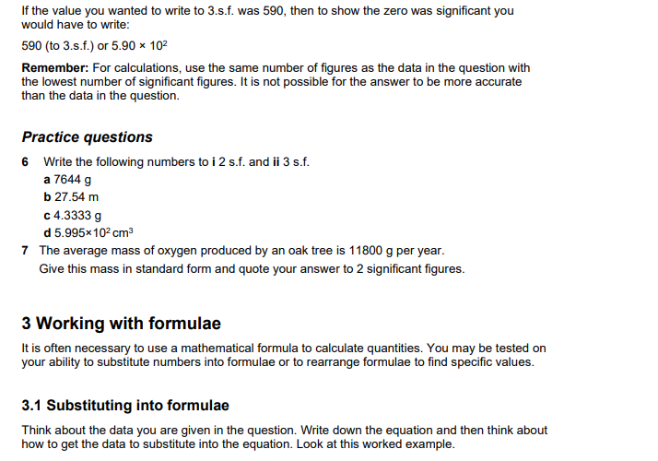
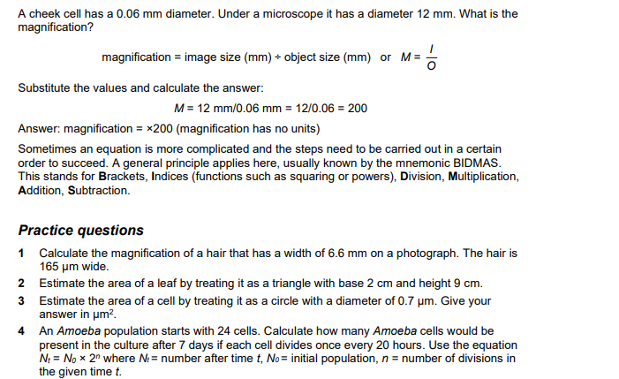
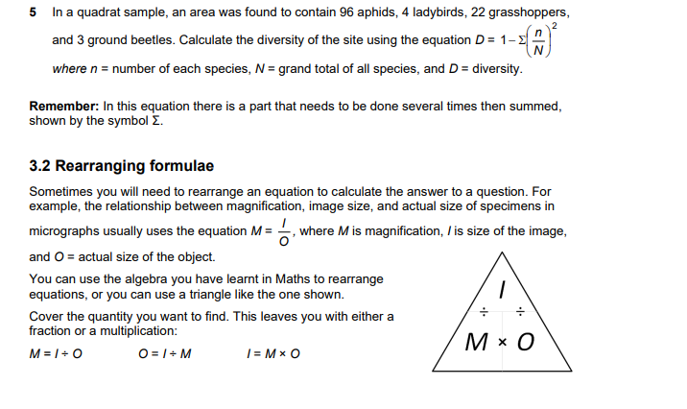
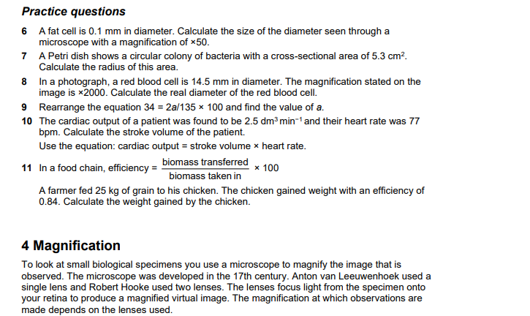
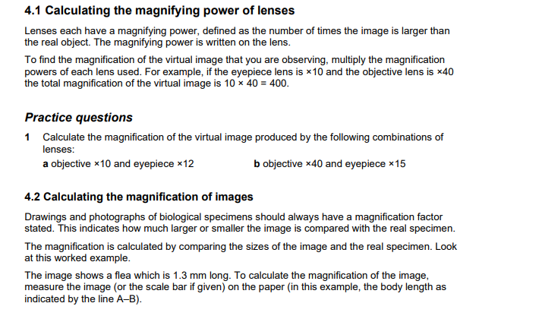
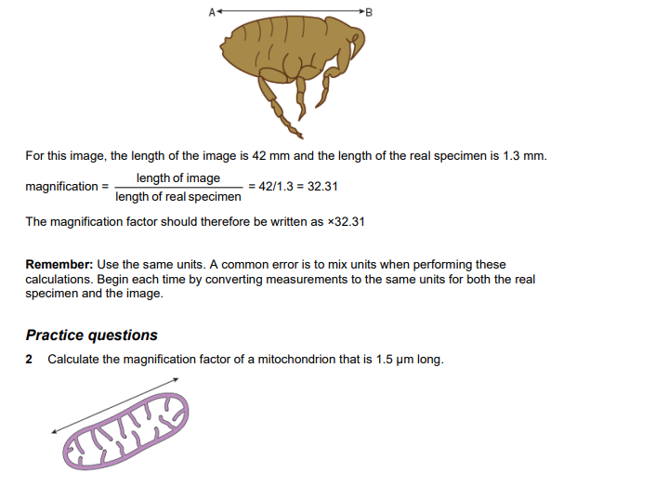
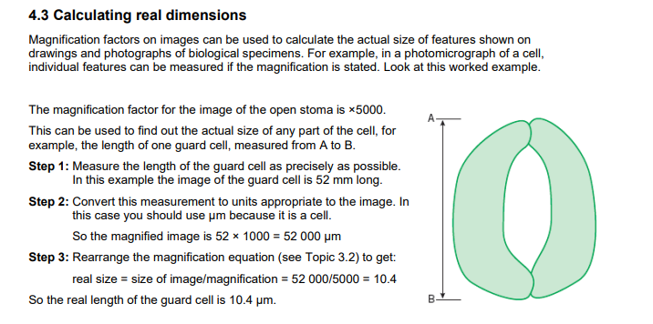
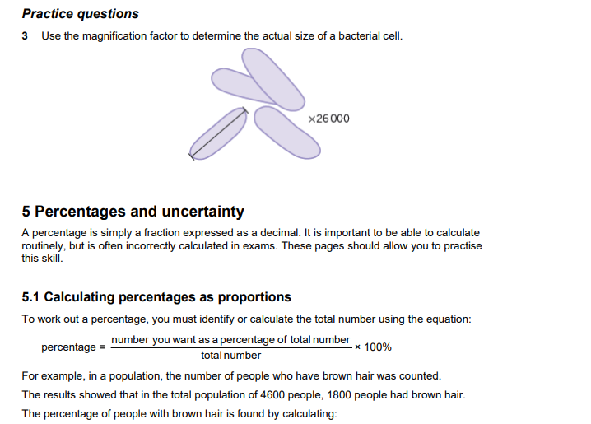
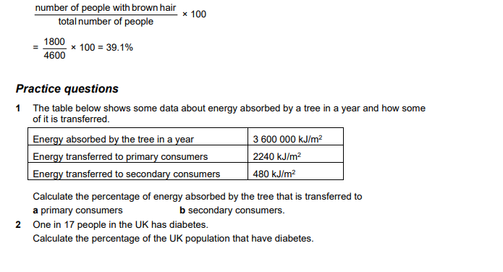
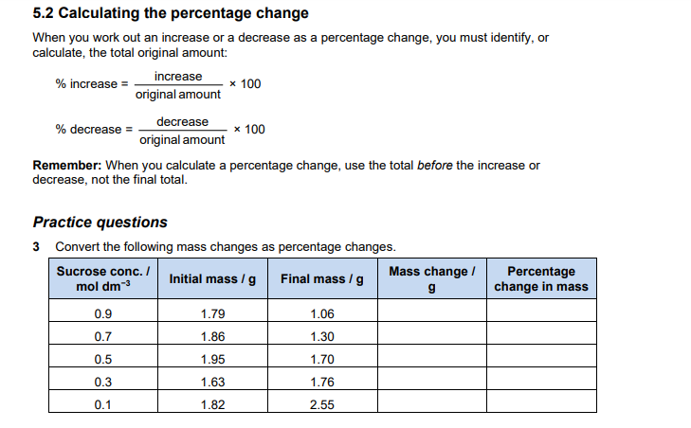
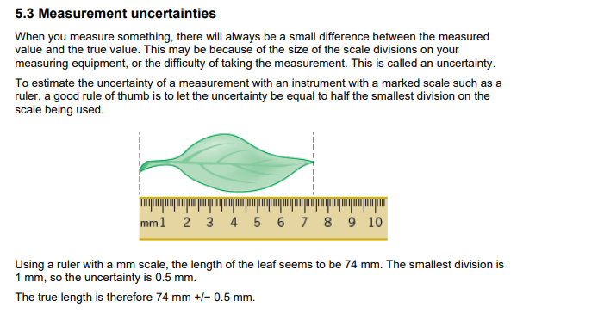
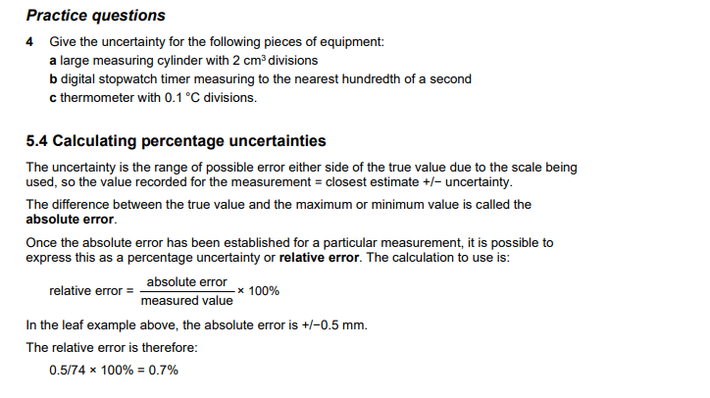
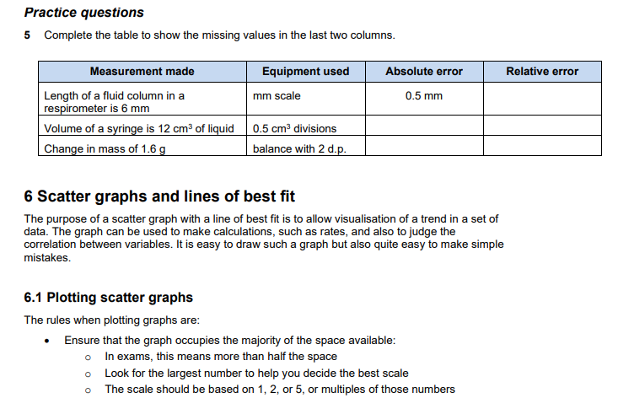
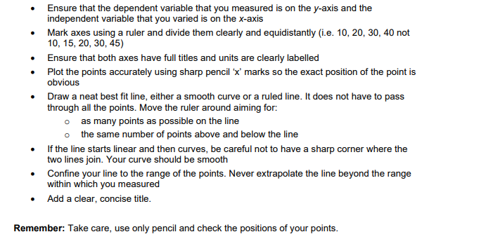
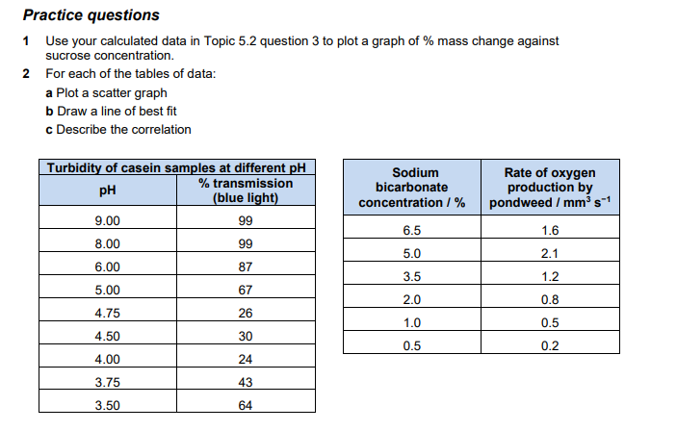

Comprehension Biology task

Read the information from this article and then prepare written responses in full sentences to the questions on the next page.

Cancer: Out of Control Cells
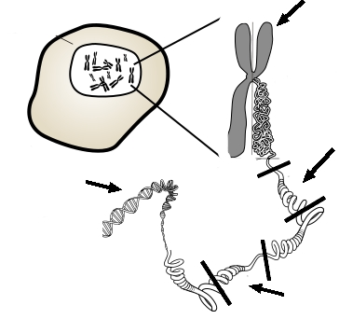
Cells do not live forever, and they will reach a point where they will divide through mitosis, or die through a process called apoptosis. Cancer cells are the exception, these cells do not die and divide uncontrollably as they crowd out healthy, productive cells. Cancer can have many causes, but most are thought to be related to carcinogens in the environment. Carcinogens are chemicals that can damage DNA and interfere with a cell's normal cycle, thus disrupting the cells ability to control when and how often it divides.
While most cells do not live forever, cancer cells do continue to divide as long as they are provided with nutrients. Research has been conducted for many years on an immortal line of cells called HeLa cells, named after Henrietta Lacks, who was a female with cervical cancer. All HeLa cells are derived from the original sample taken from her when she was a patient in 1951; Henrietta Lacks died that same year.

How Cancer Works
Cancerous transformation results from changes of the DNA and the genes that control the cell cycle. Two types of genes normally control the cell cycle: proto-oncogenes, which start cell division and tumour-suppressor genes which turn off cell division. These two genes work together, one turning on cell division when the body needs to repair or replace tissue, and the other turning off cell division when the repairs have been made. If the proto-oncogenes become mutated, they can become oncogenes, genes that lead to uncontrolled cell division. Mutations in the tumour-suppressor genes result in the cell not having the ability to turn off cell division. Oncology is a branch of medicine that deals specifically with cancer.

Cancer Cells
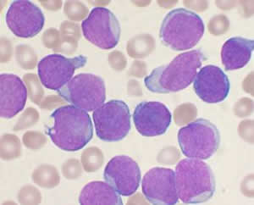
When a cell becomes cancerous, it develops traits that normal cells do not have. For instance, a cancer cell can have unusual number of chromosomes due to incomplete mitosis or cytokinesis. Cancer cells may be abnormally shaped or larger than normal cells. Cancer cells also can lose their attachment to nearby tissue and travel to other parts of the body, where they continue dividing and causing problems at other locations. Secondary growths of cancer at a distance from the primary site are referred to as metastasis. Once a cancer has metastasized, aggressive therapies may be needed to treat the disease. Cancer cells take essential nutrients from the blood to grow and divide and crowd out other cells that have important jobs. In the case of leukaemia, white blood cells grow uncontrollably and crowd out the red blood cells, thus reducing an individual's ability to deliver nutrients to the body and affecting the blood's ability to clot and repair wounds.

Questions for Biology comprehension task:
1. Compare the role of tumour suppressor genes to proto-oncogenes.
2. What are HeLa cells and why are they important?
3. What is the relationship between carcinogens and mutations? How does this in turn affect the development of cancer?
4. Identify the parts on the picture at the top of the article. [ DNA, Chromosome, Tumour Suppressor, Proto-Oncogene, Cell ]
5. In 1951, cells were taken from Henrietta Lacks and used for many years in research. Henrietta did not give permission for her cells to be used, the law did not require that. These cells have been used in over 60,000 research projects, but Henrietta's family has not received any compensation for contribution to the research. Do you think the law should be changed? Should people be compensated for donating their cells to science?

EXTENSION WORK:
Advanced Data Handing
- Watch the following videos on ‘The Scientific Method’
https://www.youtube.com/watch?v=UdQreBq6MOY
https://www.youtube.com/watch?v=N6IAzlugWw0&t=137s
Task 1 - Describe what the scientific method is, why it has been developed, and what the core principles are. (Max. 100 words)
Advanced Data Handling: ‘Big Data’
- Watch the following videos on ‘big data’ and critical thinking, and read the web page:
https://www.youtube.com/watch?v=5Zg-C8AAIGg
https://www.youtube.com/watch?v=dItUGF8GdTw
https://www.visionlearning.com/en/library/Process-of-Science/49/Data-Analysis-and-Interpretation/154
Task 2 - What can we learn about interpreting data from the themes discussed in the videos? (Max. 300 words)
Task 3 - What do you need to consider before interpreting data? (Max 50 words)

