Year 11-12 Transition Pack:
A-LEVEL DANCE

Introduction
Are you passionate about dance? Do you enjoy performing? Do you like to choreograph?
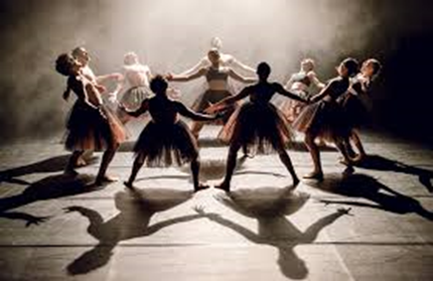
A-level Dance is a dynamic qualification which encourages you to develop your creative and intellectual capacity, alongside transferable skills such as team working, communication and problem solving. All of these are sought after skills by higher education and employers and will help you stand out in the workplace whatever their choice of career. This course is suitable for anyone who is interested in dance performance, choreography and appreciation. It provides the opportunity for you to understand the history of dance, explore a range of practitioners and it offers innovative choreographic and performance tasks.
For further information please contact a.ashmore@georgesalter.com

Course Overview

Component 1: Performance and choreography  - Practical exam  - 80 marks  - 50% of A-level | Component 2: Critical engagement  - Written exam: 2 hours 30 minutes  - 100 marks  - 50% of A-level
- Solo performance linked to a specified practitioner within an area of study  - Performance in a quartet  - Group choreography  Non-examination assessment (NEA) marked by an external assessor from AQA during a visit to  your centre. Visits will normally take place between March and May. | Knowledge, understanding and critical appreciation of two set works.  - One compulsory set work within the compulsory area of study  - One optional set work within the corresponding area of study, from a choice of four.

Articles to Read
Textbooks

Anderson, J. (1992) Ballet and modern dance, a concise history
Anderson, J. (1997) Art without boundaries, the world of modern dance
Au, S. (1988) Ballet and modern dance London
Carter, A. and O’Shea, J. (eds). (2010) The Routledge Dance Studies
Reader
Legg, J. (2011) Introduction to Modern Dance Techniques
Princeton Book Company
Mackrell, J. (1992) Out of Line, The Story of British New Dance
Reynolds, N. and McCormick, M. (2003) No Fixed Points Dance in the
Twentieth Century
Jordan, S. (1992) Striding Out: Aspects of Contemporary and New Dance in Britain
Journals

Dance Study Supplement PartOne: Contemporary Dance Available from the
Dancing Times

Websites

www.britannica.com/biography
www.criticaldance.com/interviews/1999/cbruce990700.html
www.rambert.org.uk
www.rambert.org.uk/explore/rambert-archive/
www.richardalstondance.com
www.sadlerswells.com
www.siobhandavies.com

Summer Activity- Due in your first lesson in September
Solo Performance.
To find, prepare and perform a solo, taken from Nutcracker by Matthew Bourne lasting a minimum of 2 minutes. This could be one of the sweeties Gobstoppers/Marshmallows/ Knickerbocker Glory/ Liquorice Allsorts etc. The entire work is available at https://www.youtube.com/watch?v=1jIeSq2FFhs.
Research Document
A research document on ‘Nutcracker’ and the choreographer ‘Matthew Bourne’ showing understanding of the choreographers context, stylistic features and the professional work.
Essay
A 2000 word essay exploring the following question:
Discuss how Rambert Dance Company (formerly Ballet Rambert) developed during the period 1966 to 2002 through the changes in directorship.

