Year 11-12 Transition Pack:
A-Level
PE

Introduction
The A Level Physical Education course allows you to play to your strengths and gain dynamic theoretical and practical skills for further education or work. It gives you a strong foundation for understanding the main topics within the discipline of Sports Science, underpinning all forms of participation and performance in physical activity and Sport.
Disciplines covered offer a wide range of learning opportunities, including topics like Anatomy and Physiology, looking into the body systems and their impact on exercise; and Sport Psychology, which delves into the mind of performers. With every topic being so different, Physical Education is a subject that opens your eyes up to the world of Sport, whether you're a recreational gym-goer or elite athlete.
This course is a perfect stepping stone if you are interested at working in the sports industry whether that be going to University or hoping to work in the sport and leisure sector. By completing this course you will get a wide range of content across numerous topic areas which will give you the breadth and depth needed to be successful in a number of careers such as PE Teaching, coaching, physiotherapy and many more.
For more information please contact the Head of PE Mrs A. Hill (a.hill@georgesalter.com)
Course Overview
Which topics will you cover?
During the 2 year course you will cover the following topic areas:
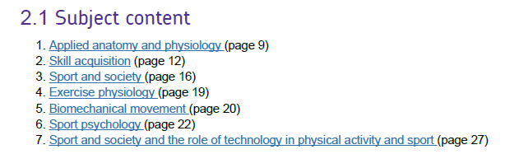
(Page numbers refer to specification – see link below)
How is the course assessed*?
The course is assessed by 2 examinations, a practical assessment and written coursework.
Paper 1 = 2hr exam, 105 marks worth 35% of your grade
Paper 2 = 2hr exam, 105 marks worth 35% of your grade
NEA (Non examined assessment) = 90 marks worth 30% of your grade (coursework and practical assessment in 1 sport only)
*See below for more detail

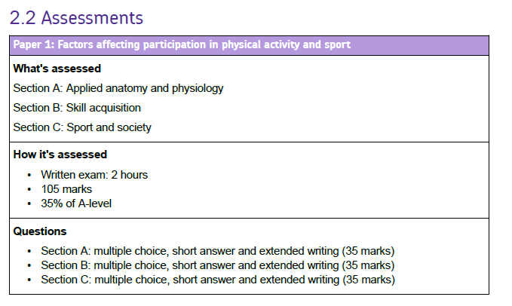
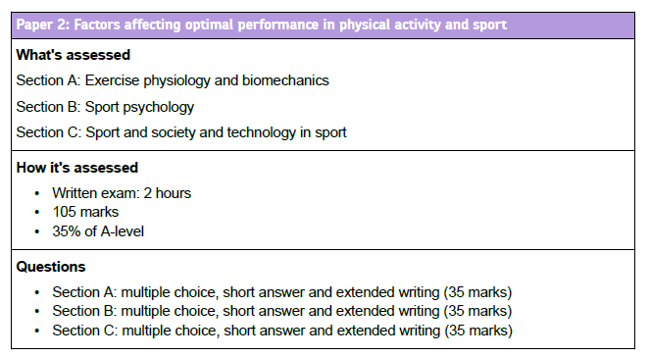
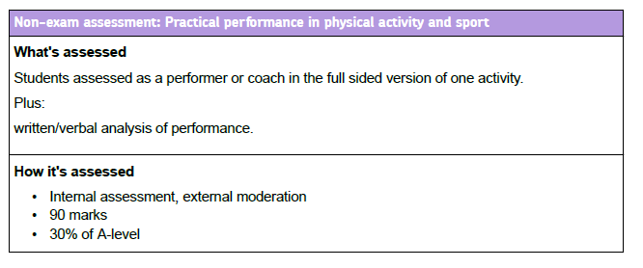
Articles to Read
Specification
https://www.aqa.org.uk/subjects/physical-education/as-and-a-level/physical-education-7582
You can download the specification from here and then research any topics you want to find out more about.

Summer Activity- Due in your first lesson in September
- Look through the specification and RAG rate topic areas to how much you already know (you may have covered certain topic areas in GCSE PE)
- Look through the range of sports you can be assessed in and decide which one you would want to use – you are only assessed in 1 Sport and you must play this outside of school at a good level.
- - For the sport you have chosen have a look at the specification at the skills listed that you would have to demonstrate for that sport.
- Pick one strength and one weakness from area of assessment 1 and write a detailed analysis of why you believe this is a strength/weakness and how this impacts on performance. You should aim to include diagrams where possible of the ‘perfect model/technique’ and compare yourself to elite performers
1 page of size 12 font for strength and 1 page of size 12 font for weakness (2 pages in total and this can include diagrams)
See below for examples in Netball and Football…

Football example
Taken from page 42 of the specification
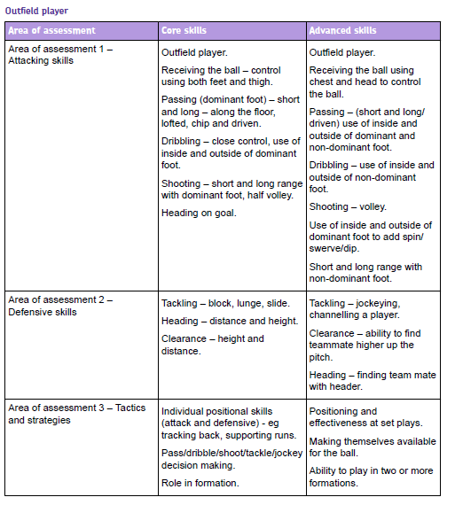
Task is only from area of assessment 1
Example for analysis:
Strength = Passing (short, long, lofted, chip, driven)
Weakness = Shooting (short, long range, half volley, full volley)

Netball example
Taken from page 63 of specification
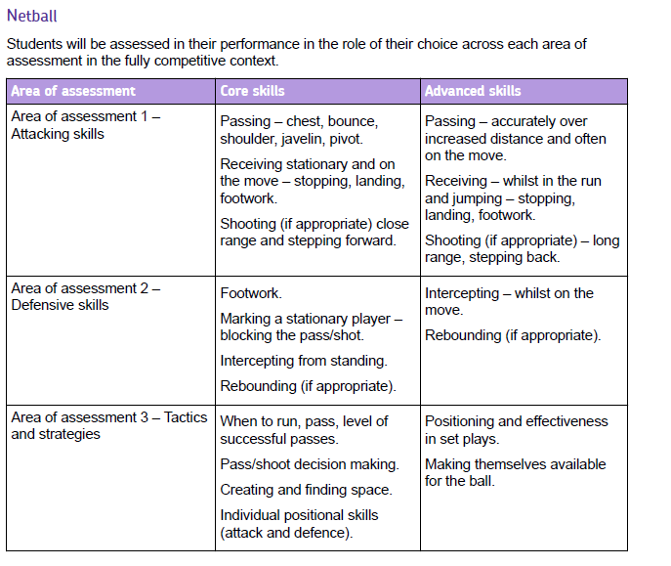
Task is only from area of assessment 1
Example for analysis:
Strength = Passing (chest, shoulder, bounce, javelin pass)
Weakness = Shooting (long and short range, stepping back/forward)

