Year 11-12 Transition Pack
AQA A Level Accounting
2020

Introduction
By studying A Level Accounting, you will delve into a world of accounting!
You will learn the accounting language and puzzle together transactions to complete double entry bookkeeping and understand how these basics lead to the creation of income statements and balance sheets.
As the course commences, you will develop a passion and an eagerness to learn as you solve accounting problems and embark upon more technical parts of accounting, including incomplete records and partnership accounts.

Course Overview
By studying AQA Accounting, you will be looking at two key areas relating to Financial Accounting and Management Accounting.
You will then sit a mock exam at the end of Y12 in the Summer term, with a view to sit your final exams in the Summer at the end of Y13.

Interesting Articles to Read
The Accounting language and requirements are always changing on a universal level. It is important to keep up to date on key changes.
- The Financial Times (particularly the Share Price Section)
- http://www.accaglobal.com/uk/en.html

Useful Websites
Accounts will take you time you understand and I would encourage you to use other sources to help develop key knowledge and understanding. There are a range of useful websites which are listed below:
http://www.thestudentroom.co.uk/wiki/Category:A_Level_Accounts_Revision_Notes
http://alevelaccounts.weebly.com/notes.html
https://getrevising.co.uk
http://www.pwc.co.uk/
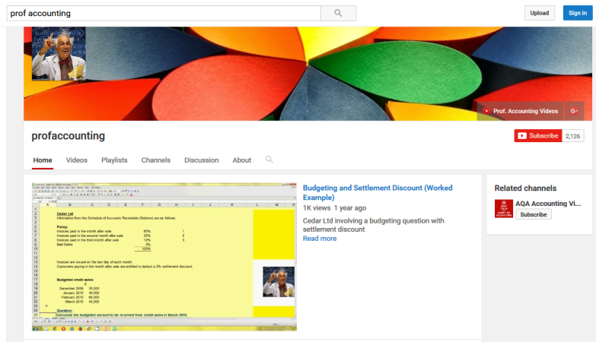
Youtube is also a fabulous way to develop further knowledge; especially some videos provide you with visuals. In particular, Prof Accounting is one to watch as he covers all areas of Accounting for AQA.
https://www.youtube.com/user/profaccounting

Summer Activities
Task 1: Introduction to Accounting
A new student will be joining our accounts lesson in September. You are required to write a 2 page report or produce a presentation on:
- What is accounting?
- An explanation of why businesses record accounting transactions
- Who are the users of accounting records?
- Why the users will find them beneficial?
- An explanation of what Double – Entry Book Keeping is?
You will be marked on your knowledge and understanding of accounting and on the quality of you written response/presentation.

Task 2: Business Documentation
Accounts are generated from Business Documents. Collect or print copies of the following documents
- Invoice
- Credit Notes
- Bank Statement
- Bank Pay in Slip
- Pay in counterfoil
- Cheque Counterfoil
- Receipt
For each document, explain the point of it and the key features of the documents.

